In this project, we will be looking at the player data provided by FIFA which contains information such as personal details, wages, physical attributes, technical skills, potential and their positional strengths. This is primarily data of FIFA 2018.Through this project, you will get a glimpse of insights behind the beautiful game and the kind of information and decisions a football manager goes through. Explore the data and attempt all the below asked questions in a step by step manner:

· Prepare a rank ordered list of top 10 countries with most players. Which countries are producing the most numbers of footballers that plays at this level?

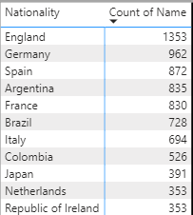

· Plot the distribution of overall rating vs. age of players. Interpret what is the age after which a players stops improving?

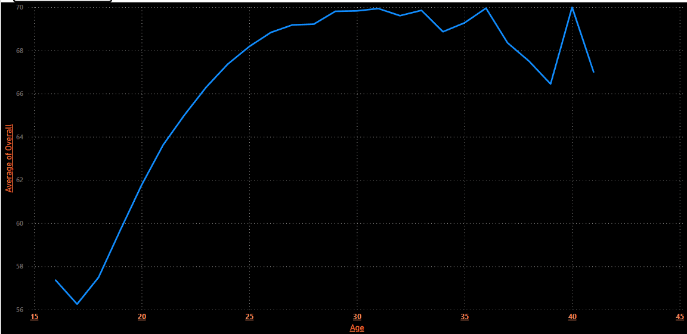

After Age of 36 there’s a considerable drop in overall ratings. Although it shows an unusual peak at 40 years again.

· Which type of offensive players tends to get paid the most: the striker, the right-winger, or the left-winger? Visualize through a scatter plot

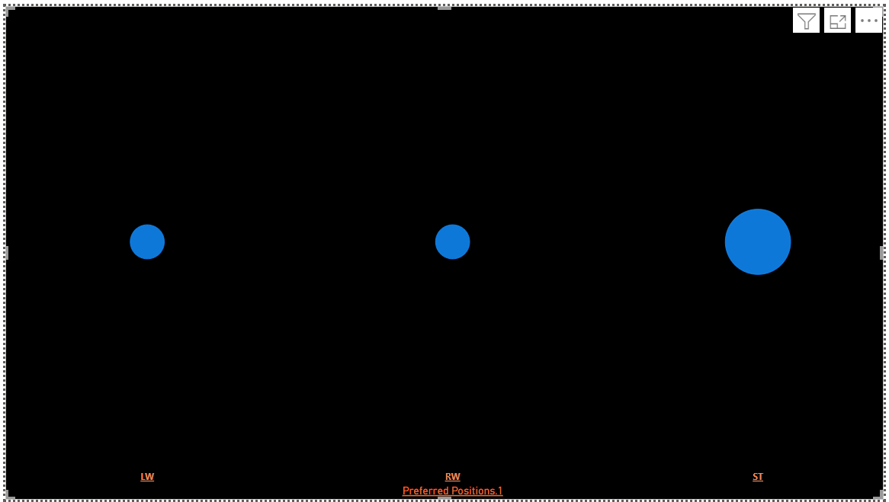

· Top 5 players for every preferred position in terms of overall as well as potential points. Who were the best in 2018? Who were destined to be the future superstars in that year?

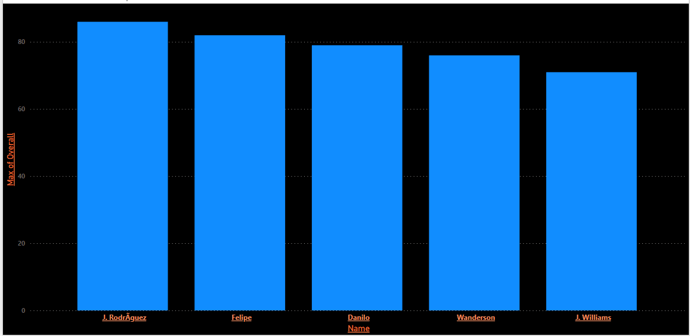

These were the best players of 2018.

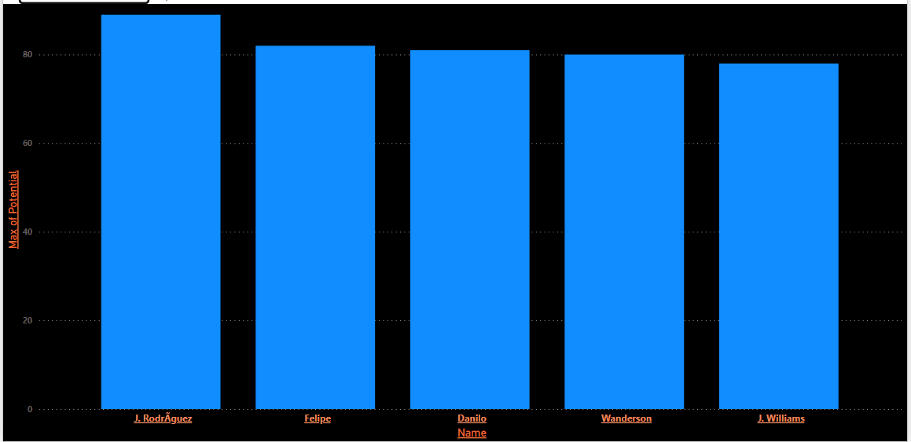

These are the future superstars.

· Which club(s) have the maximum share of players from England? Which club(s) have the maximum share of players from Spain? Which club(s) have the maximum share of players from Germany?

Maximum Player from England

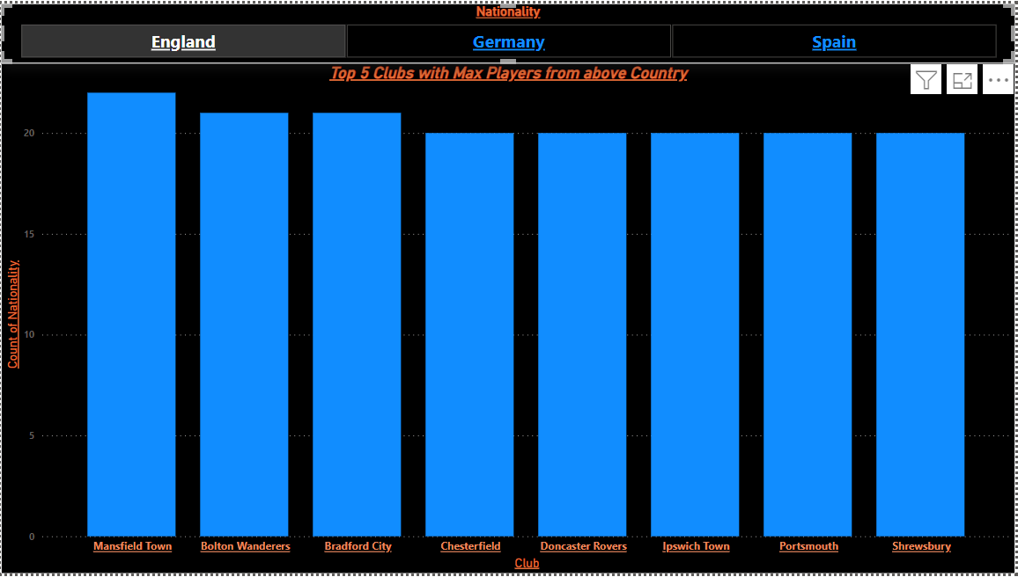

Maximum Player from Germany

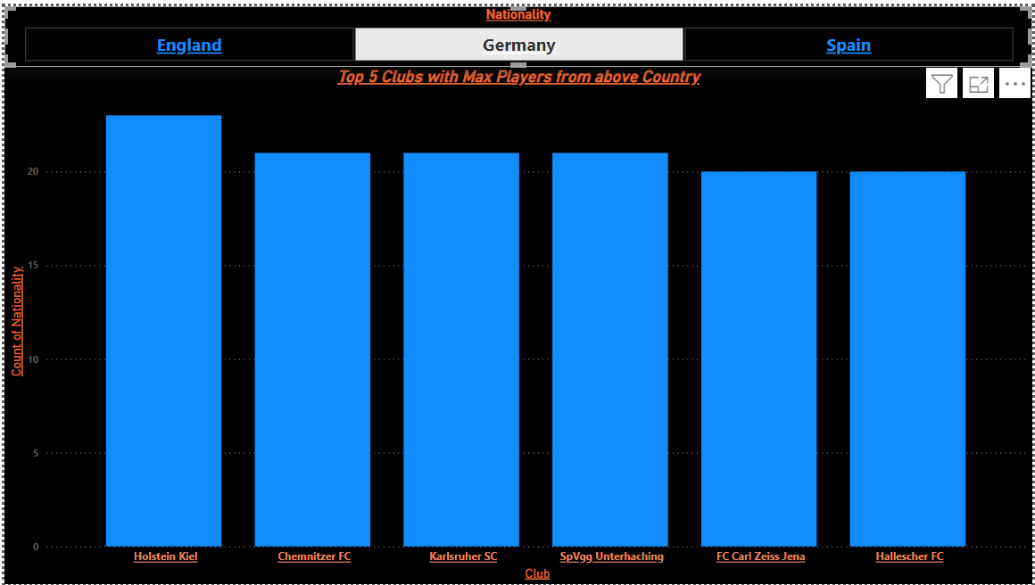

Maximum Players from Spain

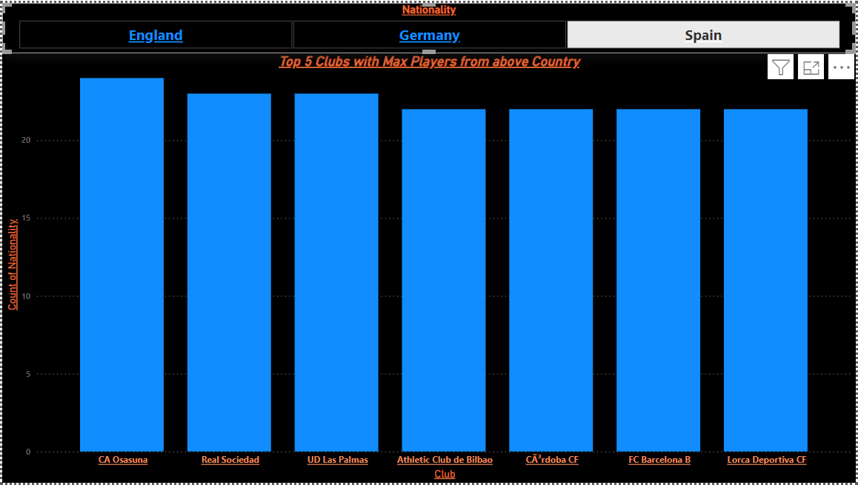

· Are the wages of a player influenced by the potential of a player? Check it out for players with age Between 16 to 28?

Yes, wage of a player is influenced by his potential.

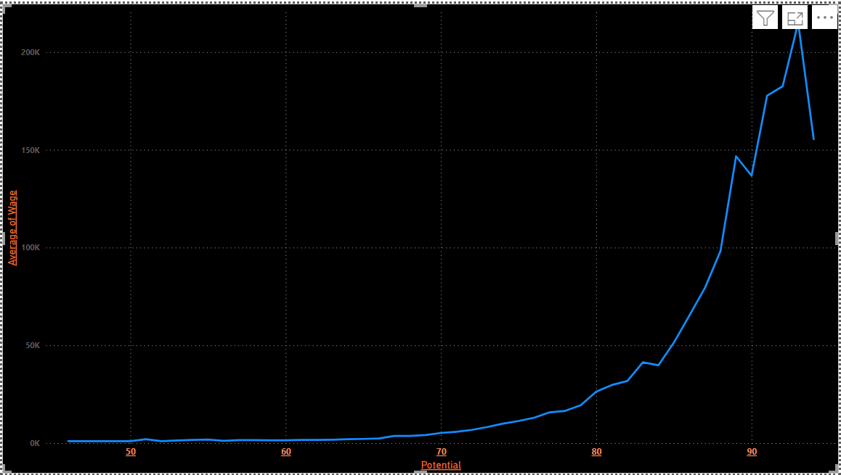

· Do Strikers score higher on "Aggression" than defenders do? Group both the set of players (from an overall score of 80 to 85) and compare their average aggression levels. Which particular position has the highest aggression as a given (players with an overall score of 80 to 90)?

No. Strikers don’t score higher on Aggression than Defenders.

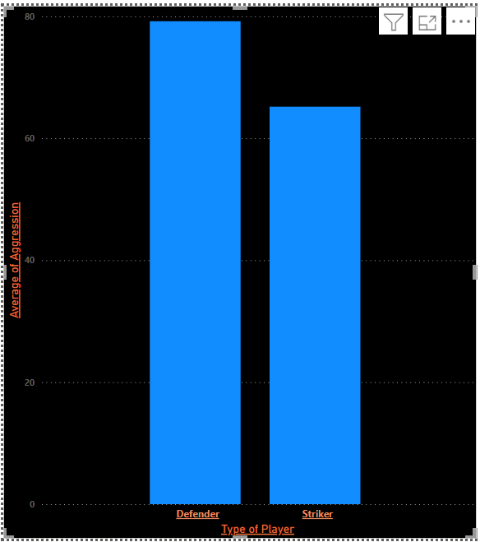

LWB score highest on Aggression.

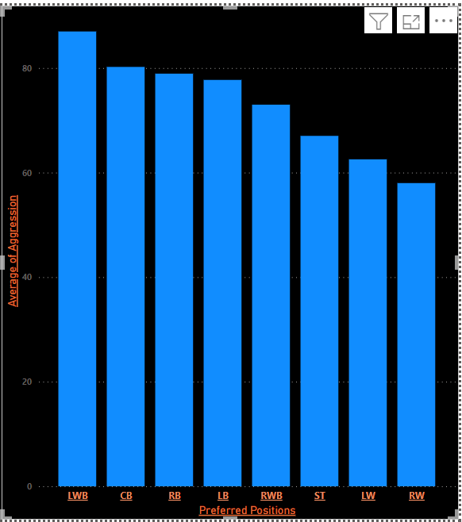

· How based on the positional data, players are profiled for different roles/classes. Plot Aggression, Acceleration, Agility, Balance and Ball Control for strikers and Goal Keepers in a single line/Bar plot to understand the positional difference

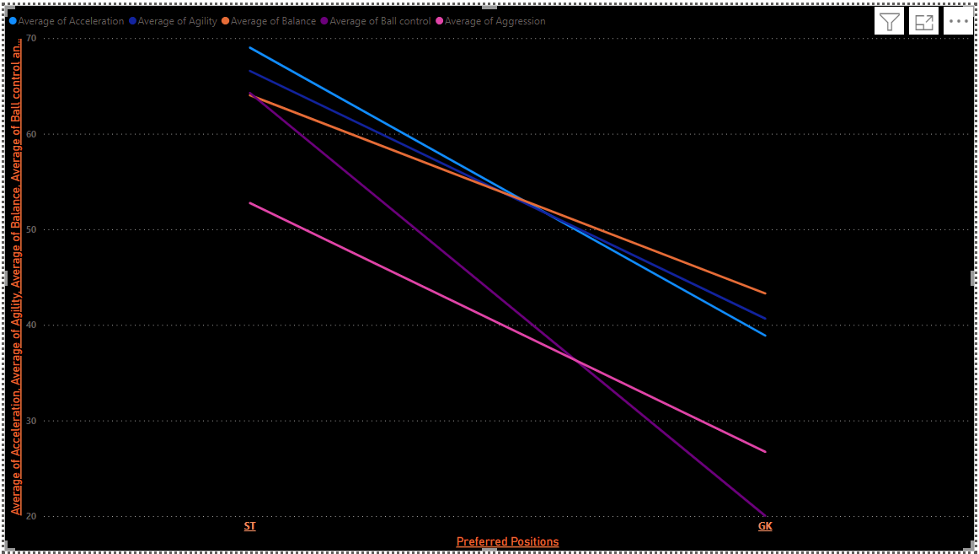

· Which clubs consists of the best future players? Consider only the players with Overall <86 and Potential >= 86, plot a graph to show which are the top 10 clubs with most number of best future players

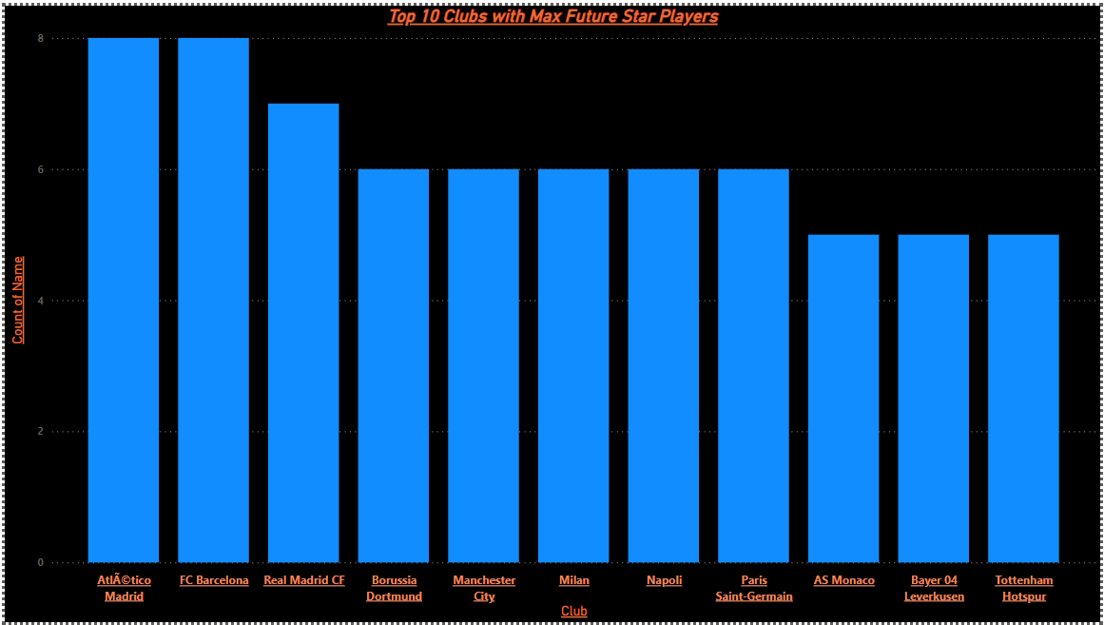

· How the best clubs in the world pay their players? Create a box plot of wages for FC Barcelona, Real Madrid, Paris Saint Germain, Manchester City, Liverpool, Juventus and Bayern Munich

