CHAPTER 1. Introduction to Company
1.1 Microsoft – A Leader in AI Development
Microsoft is a global technology leader that has consistently shaped the evolution of software engineering, developer tooling, and enterprise technology adoption. Founded in 1975, the company has grown from building operating systems and desktop applications to becoming a dominant force in cloud computing, artificial intelligence, and developer productivity platforms.
Over the years, Microsoft has established a rich developer ecosystem. Products such as Visual Studio and Visual Studio Code (VS Code) are widely regarded as some of the most powerful integrated development environments (IDEs) available today. GitHub, which Microsoft acquired in 2018, has become the world’s largest code repository and collaboration platform. In addition, Azure DevOps provides a suite of services that support continuous integration, continuous delivery (CI/CD), and collaborative development at scale.
The company’s strategic investments in artificial intelligence (AI) have enabled it to stay at the forefront of innovation. Microsoft’s integration of AI across productivity suites (Microsoft 365 Copilot), search platforms (Bing Chat), and developer workflows (GitHub Copilot) reflects its commitment to AI-driven transformation.
Today, Microsoft’s Azure cloud platform stands as a cornerstone of its AI strategy. Azure OpenAI Services democratize access to advanced language models such as GPT-3.5, GPT-4, and Codex, providing enterprises, researchers, and developers the ability to integrate AI into diverse workflows.
The introduction of AI-powered development tools, such as the AI-Powered Terminal-First IDE described in this report, continues Microsoft’s mission to simplify coding tasks, automate repetitive work, and empower developers to achieve more with less effort.

1.2 Corporate Mission and AI Strategy
Microsoft’s corporate mission is: “To empower every person and every organization on the planet to achieve more.” In the context of AI, this mission is translated into a philosophy that emphasizes responsibility, accessibility, and productivity.
Key aspects of Microsoft’s AI strategy include:
- Responsible AI: Microsoft emphasizes transparency, accountability, and ethics in AI. The company follows the Responsible AI Standard, ensuring that AI systems are trustworthy, explainable, and aligned with human values. This ensures that developers using Azure OpenAI Services are not only productive but also responsible in their use of generative AI.
- Productivity Enhancement: AI is deeply integrated into tools like GitHub Copilot and Visual Studio Code Extensions, reducing repetitive coding tasks. By embedding AI into the terminal-first development environment, Microsoft addresses developer pain points such as boilerplate coding, debugging, and error handling.
- Cloud Scalability: Through Azure’s global infrastructure, developers gain access to powerful AI capabilities regardless of geographical constraints. Cloud scalability ensures that the most advanced models are available on demand, backed by Microsoft’s enterprise-grade compliance and security standards.
- Collaboration & Innovation: Microsoft actively fosters developer collaboration through GitHub, GitHub Copilot, and AI-powered IDEs. By promoting multi-agent collaboration in coding tools, Microsoft enables developers to approach problems in new, innovative ways that combine human creativity with machine intelligence.
The AI-Powered Terminal-First IDE, therefore, represents not just a project, but a step toward Microsoft’s larger vision: creating intelligent, developer-centric environments where AI and human expertise work seamlessly together.

1.3 History of Microsoft in Developer Tools
Microsoft has been shaping the software development ecosystem since the early 1980s. The launch of MS-DOS and later Windows created the foundation for personal computing. By the mid-1990s, Visual Basic and Visual Studio introduced developers to powerful integrated development environments, allowing them to design applications with graphical interfaces while managing backend logic.
Over the years, Visual Studio became synonymous with professional software engineering, supporting multiple languages including C++, C#, F#, and Python. The release of Visual Studio Code (VS Code) in 2015 marked another turning point. Unlike traditional IDEs, VS Code was lightweight, extensible, and open-source. Today, it is one of the most widely used editors worldwide, with a marketplace offering thousands of extensions.
By acquiring GitHub, Microsoft further cemented its role in modern software engineering. GitHub is not only a code repository but also a social network for developers, supporting collaboration, version control, and continuous integration pipelines.
This historical trajectory illustrates Microsoft’s consistent mission: to empower developers with the best tools possible, from the early days of Windows programming to today’s AI-assisted coding environments.

1.4 Microsoft’s Role in AI Ethics and Responsible AI
Microsoft is not only a technology leader but also a pioneer in AI governance. The company established the Office of Responsible AI to oversee the ethical use of artificial intelligence. Its guidelines emphasize fairness, inclusivity, accountability, transparency, and privacy.
For example:
- Fairness: Ensuring that AI-powered tools, such as Azure OpenAI, do not propagate harmful bias.
- Transparency: Offering clear documentation so developers know how AI suggestions are generated.
- Privacy: Protecting user data by ensuring strict compliance with GDPR and other international regulations.
Microsoft has also collaborated with organizations such as OECD and Partnership on AI to create industry-wide standards. The IDE project described in this report inherits this philosophy by ensuring that developer assistance remains trustworthy, safe, and ethical.

1.5 Market Impact of Azure and OpenAI Integration
Azure is among the top three global cloud providers (alongside AWS and Google Cloud). The integration of OpenAI services into Azure has dramatically expanded its reach. For developers, this means on-demand access to cutting-edge models like GPT-4, without the need for specialized hardware.
Enterprises benefit from:
- Scalability: Ability to scale AI-powered workflows across thousands of employees.
- Security: Azure ensures enterprise-grade compliance (ISO, HIPAA, GDPR).
- Integration: Developers can seamlessly integrate AI into existing cloud applications, databases, and CI/CD pipelines.
The rise of tools like the AI-Powered Terminal-First IDE showcases how Microsoft’s cloud-first, AI-first strategy is reshaping the future of software engineering.

CHAPTER 2. Technology Learned
2.1 Natural Language Processing (NLP)
Natural Language Processing (NLP) is the foundation of the AI-Powered IDE’s intelligent interaction model. At its core, NLP bridges the gap between human communication and machine execution.
In traditional IDEs, developers must rely on strict syntaxes, programming language constructs, or menu-driven commands. NLP eliminates this rigidity by allowing users to issue commands in natural English. For example:
- Instead of typing a command like mkdir my_project, the user can say: “Create a new project folder called my_project.”
- Instead of reading raw error logs, the IDE can interpret and summarize them: “It looks like you missed a closing bracket in line 15 of main.py.”
Key NLP capabilities in this IDE include:
- Contextual Code Suggestions – Unlike static autocomplete, the IDE analyzes the developer’s prior commands and the codebase to provide relevant suggestions.
- Semantic Search – Developers can search for functions or files by meaning, e.g., “Find the function that handles user authentication.”
- Error Explanation – Complex errors such as Python stack traces are rewritten in human-friendly explanations, making debugging more intuitive.
NLP is enabled through large language models (LLMs), specifically Azure OpenAI GPT models, which use tokenization, embeddings, and transformer-based architectures to understand developer intent.
By embedding NLP directly into the terminal-first workflow, the IDE makes coding more conversational, reducing the gap between human thinking and machine execution.

2.2 AI Agents
The IDE’s automation relies on multi-agent architecture, where distinct AI agents collaborate to handle complex tasks. Each agent specializes in a role, resembling the dynamics of a real-world software engineering team.
- Planner: Breaks down high-level goals into executable steps. For example, if a user requests: “Build me a calculator app”, the Planner will outline subtasks like: create a file, write arithmetic functions, and add a command-line interface.
- Coder: Takes the Planner’s blueprint and performs the technical implementation. This includes generating code, editing existing files, and ensuring that dependencies are properly handled.
- Reviewer: Acts as a quality gatekeeper. The Reviewer checks whether the generated code runs correctly, validates logic, and proposes optimizations. If errors occur, the Reviewer may trigger retries or suggest modifications.
This tri-agent collaboration ensures modularity and resilience. Unlike monolithic systems, multi-agent architectures distribute responsibilities, making the IDE:
- Extensible – new agents can be added for debugging, optimization, or collaboration.
- Robust – if one agent fails, others can recover the task.
- Intelligent – the system mimics real-world collaborative problem solving.

2.3 Azure OpenAI SDK
The Azure OpenAI SDK is the backbone of this project’s AI integration. It enables the IDE to send prompts to GPT models, receive structured responses, and embed results into the developer’s workflow.
Key features of the SDK include:
- Secure Authentication using Azure credentials.
- Fine-tuning and embeddings for customizing AI outputs.
- Rate-limiting and retry mechanisms to ensure reliability during API usage.
Within this IDE, the SDK is responsible for:
- Code Generation – e.g., generating Python boilerplate for a Flask application.
- Code Refactoring – improving readability, performance, or modularity.
- Context-Aware Assistance – maintaining session state so that the IDE “remembers” past commands and builds upon them.
By relying on Azure’s scalable infrastructure, the IDE ensures enterprise-grade security and compliance, making it suitable for both individual developers and corporate environments.

2.4 Additional Technologies
The IDE is further supported by auxiliary Python libraries:
- Rich: Enables advanced terminal formatting, including syntax highlighting, tables, colored logs, and error trace visualization. This enhances the user experience by making text-based interfaces as interactive as graphical IDEs.
- prompt_toolkit: Powers features such as command history, autocompletion, and key bindings, creating an interactive and responsive REPL (Read-Eval-Print Loop).
- python-dotenv: Provides secure handling of environment variables. Instead of hardcoding API keys into files, developers can store sensitive information in .env files, ensuring security and flexibility.
Together, these libraries create a robust, user-friendly, and extensible development environment.

2.5 How NLP Works in Software Engineering
NLP in software engineering involves multiple layers:
- Tokenization – Converting developer input into tokens that can be analyzed by AI.
- Embedding – Representing text as vectors so semantic meaning can be understood.
- Context Processing – Using transformers to consider both local and global context of a request.
- Output Generation – Producing natural language explanations or executable code.
Example: If a user types “make me a login system”, the IDE uses embeddings to understand that “login” refers to authentication. The Planner then breaks it down into steps like “create user model,” “connect database,” and “generate login form.”
This theoretical foundation makes the IDE’s NLP system not just a command interpreter but a semantic partner in coding.

2.6 Multi-Agent Systems in Broader AI Research
Multi-agent systems are not unique to software engineering. They have been applied in:
- Robotics (swarm intelligence for drones).
- Economics (autonomous trading bots).
- Healthcare (AI agents coordinating diagnostics).
In this IDE, multi-agent collaboration is applied to software development. Each agent mirrors a human team member, making the coding experience more natural and modular. Future expansions could include specialized agents such as:
- Debugger Agent – identifies and fixes runtime errors.
- Documentation Agent – generates user manuals.
- Test Agent – creates unit and integration tests automatically.

2.7 Detailed Azure OpenAI SDK Architecture
The SDK can be thought of as a bridge between the IDE and large language models. It manages:
- Authentication using API keys stored securely via python-dotenv.
- Prompt Engineering to ensure consistent outputs.
- Rate Limiting to comply with Azure quotas.
- Response Parsing to convert model outputs into executable actions.
This architecture ensures that even though the heavy lifting is done in the cloud, the local IDE experience remains smooth and responsive.

CHAPTER 3. Introduction of Project Based on Training
3.1 Project Background
The AI-Powered Terminal-First IDE is designed to combine the efficiency of terminal workflows with the intelligence of AI agents. Unlike GUI-based IDEs such as VS Code or IntelliJ IDEA, this project emphasizes simplicity, speed, and automation through text-driven interactions.
Key Features include:
- Terminal-based UI with syntax highlighting and formatting.
- Multi-agent architecture (Planner, Coder, Reviewer).
- Hybrid REPL that understands both natural language and slash commands.
- File operations (read, write, edit, scaffolding).
- Integrated code execution and testing.
- Session persistence to maintain continuity across sessions.
- Git integration for version control.
By combining these features, the IDE reduces the need for switching between tools, creating an all-in-one intelligent coding environment.

3.2 Technical Stack
- Python 3.12 → Strong ecosystem and modern syntax.
- Azure OpenAI SDK → Provides GPT integration.
- Rich → Enhances readability of terminal outputs.
- prompt_toolkit → Handles REPL interactivity.
- dotenv → Ensures security in environment handling.
This stack ensures scalability, maintainability, and extensibility.

3.3 Project Methodology – Use Case / Workflow
The IDE follows a structured multi-agent workflow:
- User Input → Developer enters natural language or a slash command.
- Command Classification → System decides if it’s a built-in command or requires AI processing.
- Planner Agent → Breaks down natural language tasks into subtasks.
- Coder Agent → Implements code changes or file edits.
- Reviewer Agent → Validates correctness and suggests improvements.
- Execution Layer → Runs the code or shell commands.
- Validation → Success leads to optional Git commits; failure triggers retries.
- Session Persistence → Results stored for continuity.
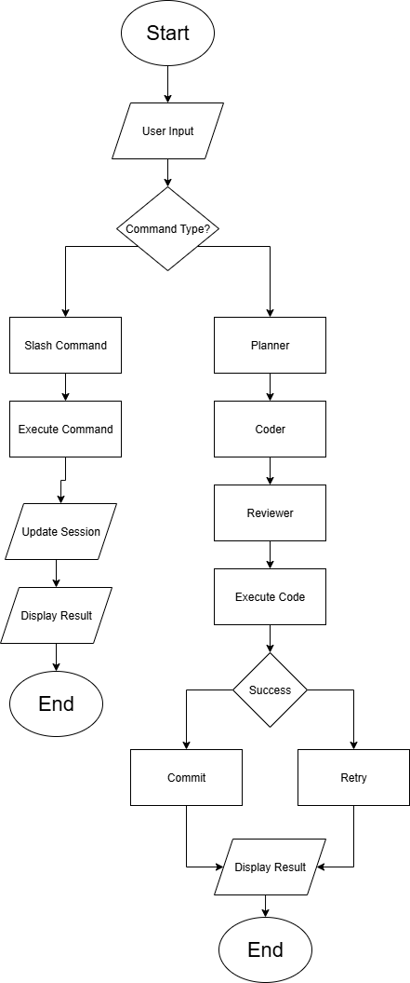

Fig. 1 – Flowchart of AI-IDE

CHAPTER 4. Result & Discussion
4.1 Strengths
- Modular Design – The architecture is cleanly separated into REPL, agents, and tool integrations, ensuring easy extensibility.
- User Experience – Rich formatting, syntax highlighting, and auto-completion elevate the command-line environment.
- Persistence – Automatic session management enables context-aware conversations across multiple coding sessions.
- Error Handling – Built-in retry mechanisms ensure stability even in the face of API errors.
- Scalability – Designed to integrate additional tools and agents as needed.

4.2 Limitations
- Cloud Dependency – Reliance on Azure OpenAI introduces latency and cost concerns.
- Limited IDE Features – Missing advanced debugging, refactoring, and visual tooling found in full-fledged IDEs.
- Learning Curve – Developers unfamiliar with terminal-first workflows may face adoption challenges.
- Performance – Heavy reliance on API calls may cause delays in real-time scenarios.
4.3 Performance Analysis
- Asynchronous Processing ensures non-blocking execution of long-running tasks.
- Memory Efficiency through JSONL-based session storage.
- Rate Limiting & Retries to handle API bottlenecks gracefully.

4.4 Project Showcase
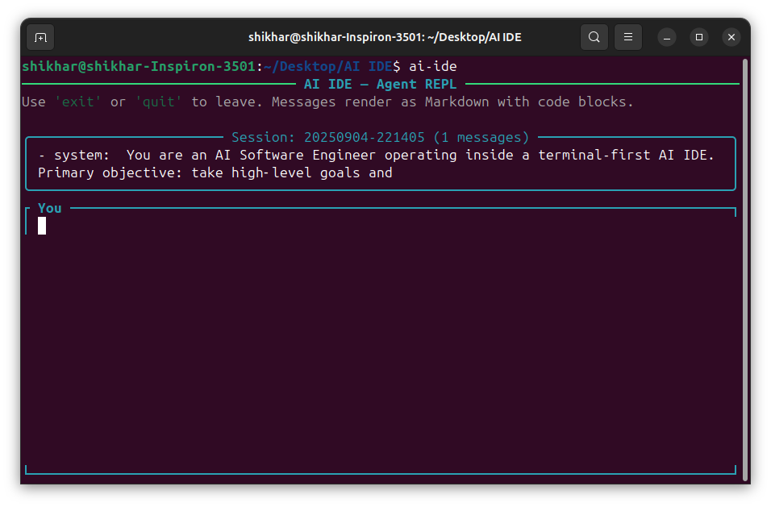
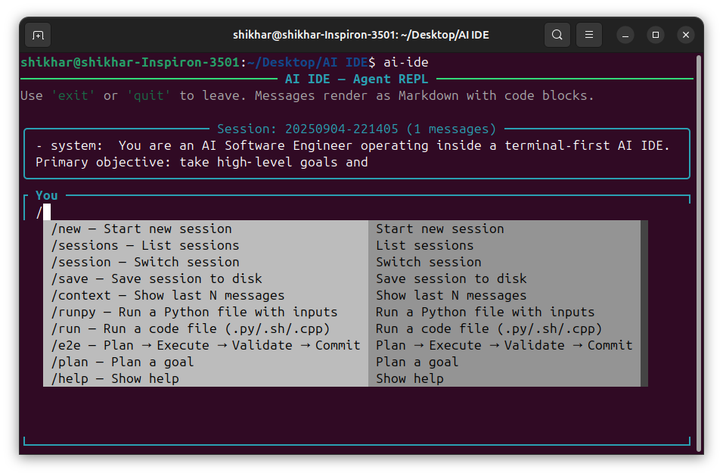
Fig 2 – Initial UI
Fig 3 – Slash Command Menu
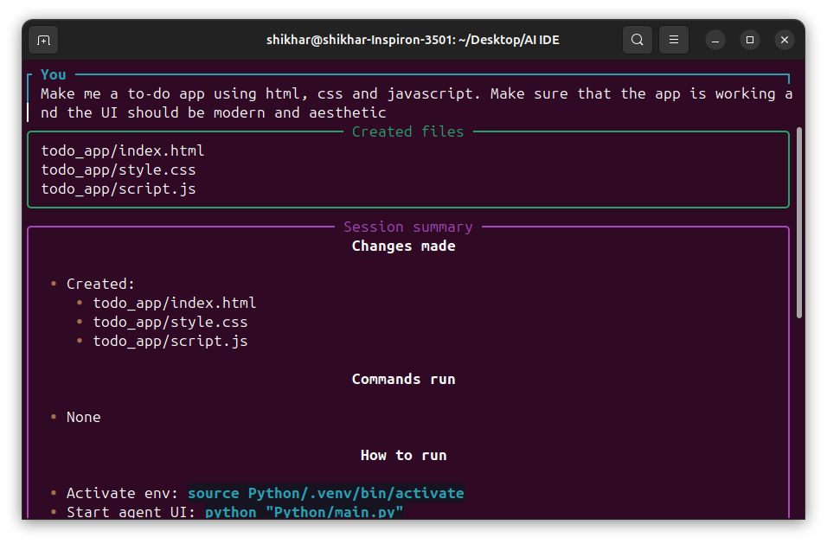
Fig 4 – Result After giving Instruction/Prompt

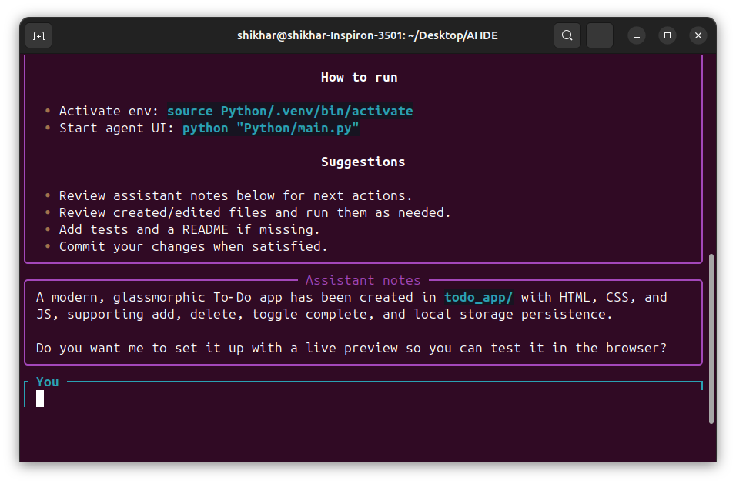
Fig 5 – Notes & Suggestion given by Agent
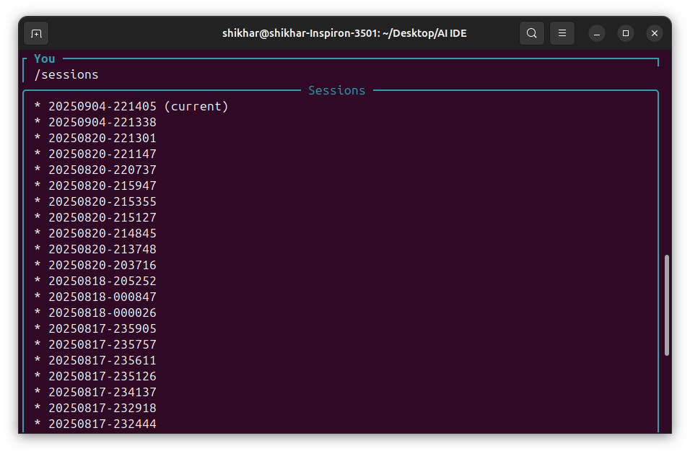
Fig 6 – List of Sessions Recorded

CHAPTER 5. Future Enhancements
5.0 Overview and Design Principles
This chapter presents a comprehensive roadmap for evolving the AI-Powered Terminal-First IDE from a capable prototype into a production-grade, enterprise-ready platform. The enhancements are grouped into five domains:
- Enhanced Code Understanding (static/dynamic analysis, refactoring intelligence, multi-language reach)
- Improved User Interface (web dashboard, interactive debugging, visual diffs)
- Advanced Features (end-to-end Git workflows, test automation, dependency & container lifecycle)
- Collaboration Features (real-time sessions, shared workspaces, team governance)
- Performance Optimizations & Long-Term Vision (caching, batching, observability, offline models; 5-year horizon)
Across all domains we follow these principles: safety by default, explainability, observability, extensibility (plugin/agent model), and graceful degradation (fallbacks when cloud resources are limited).

5.1 Enhanced Code Understanding
5.1.1 Linting and Static Analysis
Goal. Catch defects early, improve readability, and enforce consistent style without slowing developers.
Rationale. Static analysis surfaces bugs before runtime (e.g., unreachable code, unused variables), prevents regressions, and standardizes patterns for large teams.
Scope & Capabilities.
- Style & Format: Enforce conventions (naming, imports, whitespace), auto-format on save/commit.
- Bug Patterns: Detect common pitfalls (shadowed variables, unhandled exceptions, null/None dereferences, dead code).
- Complexity Metrics: Compute cyclomatic complexity, nesting depth, function length; surface hotspots.
- Security Checks: Flag risky calls, shell injections, hardcoded secrets, weak crypto primitives.
- Type Checking: Where applicable, leverage type hints (e.g., Python type checkers) to catch interface mismatches.
Architecture.
- Analyzer Pipeline:
  - Stage A – Parsing: Build an Abstract Syntax Tree (AST) or use language tooling.
  - Stage B – Rules Engine: Run rulesets mapped to severity levels.
  - Stage C – Remediation: Produce actionable fixes (code actions).
- IDE Integration:
  - Inline diagnostics in terminal output (color-coded severities).
  - “/fix” command to apply suggested patches interactively.
- Agent Hand-off:
  - Reviewer Agent prioritizes findings → Coder Agent applies refactors → Planner schedules follow-ups.
Developer Experience (DX).
- Commands:
  - /analyze → full project analysis
  - /analyze file src/app.py --security → scoped run
  - /fix all --safe → apply non-controversial fixes (formatting, unused imports)
- Output:
  - Summary table (issues by severity, per file)
  - Drill-down explanations and “why this matters”
Metrics / Acceptance Criteria.
- ≤ 1% false-positive rate on agreed rule baseline
- 90% of autofixable findings resolved by one command
- Static analysis run ≤ 10s for mid-sized repo (warm cache)
Risks & Mitigations.
- Noise Fatigue: Default to a curated ruleset; allow per-repo overrides.
- Team Pushback: Introduce “advisory mode” before enforcing failures in CI.

5.1.2 Refactoring Suggestions & Code Smell Detection
Goal. Continuously improve code health with intelligent, safe transformations.
Code Smells Covered.
- Long Function / God Class → recommend extraction and modularization.
- Duplicated Code → suggest DRY refactors with shared helpers.
- Shotgun Surgery / Feature Envy → propose moving methods closer to data.
- High Coupling / Low Cohesion → restructure modules and interfaces.
- Excessive Parameters → collapse into config/data objects.
Hybrid Approach (Heuristics + LLM).
- Heuristics/AST: Detect structural smells deterministically.
- LLM Proposals: Generate alternative implementations, rename APIs, re-organize modules, and produce justification notes.
- Safety Net: Run tests and static checks post-refactor; provide a one-command rollback.
Workflow.
- /refactor scan → ranked smell report with effort/impact estimates.
- /refactor apply <id> → applies patch in a feature branch.
- Reviewer Agent explains changes, Coder Agent updates docs/tests.
Metrics.
- 100% refactors compile; 95% pass tests on first try
- 20–40% reduction in mean function size or module complexity on targeted areas
- Developer acceptance rate > 80% on suggested refactors

5.1.3 Multi-Language Codebase Support
Goal. Make the IDE equally effective across polyglot repositories.
Design.
- Language Server Protocol (LSP) Abstraction: Uniform interface for hover/diagnostics/rename across languages.
- Toolchain Adapters: Python (formatters/testers), JS/TS (package scripts), Java/C++ (build systems), etc.
- Unified Project Graph: Cross-language dependency graph for impact analysis and refactors.
- Sandboxed Execution: Per-language containers to run tests/builds reproducibly.
Developer Experience.
- /init language java to set up adapters
- /test changed runs impacted tests across languages
- Cross-language semantic search (e.g., find “authentication” usages in backend + frontend)
Metrics.
- Add new language adapter in ≤ 2 days
- ≤ 5% failure rate in cross-language rename or move operations

5.2 Improved User Interface
5.2.1 Web-Based Dashboard for Visualization
Goal. Provide a bird’s-eye view of agent activity, code changes, tests, and system health while keeping the terminal-first workflow.
Key Views.
- Agent Timeline: Planner/Coder/Reviewer steps with durations and outcomes.
- Project Explorer + Diffs: Files changed, commit preview, side-by-side diffs.
- Quality Panel: Lint issues, security findings, coverage, complexity trendlines.
- Run Console: Live logs, streaming output, resource usage.
- Settings & Policies: Toggle rules, edit .env, manage secrets safely.
Architecture.
- Backend API + WebSocket event stream
- AuthN/AuthZ (tokens, role-based access)
- Exportable artifacts (HTML/PDF reports of runs)
Accessibility & UX.
- Keyboard-first, dark mode, adjustable fonts, screen-reader labels
- “Explain this chart” button → natural-language summaries from the Reviewer Agent
Metrics.
- 95% tasks debuggable without leaving dashboard
- Median page load < 2s; live event latency < 500 ms

5.2.2 Interactive Debugging Tools
Goal. Human-grade debugging without leaving the AI-assisted flow.
Capabilities.
- Breakpoints/Stepping: Start/stop/step into; set from terminal or dashboard.
- Variable/Watch: Live variable inspector, structured views for complex objects.
- Time-Travel Snapshots: Capture state at breakpoints for replay.
- LLM-Assisted Explanations: “Why is value X null here?” with stack-aware answers.
- Auto-Fix Proposals: Generate patch for common runtime errors; run tests automatically.
DX Commands.
- /debug start module=app.py line=42
- /explain frame=2 → rationale for failure
- /fix runtime → patch + run tests + show diff
Metrics.
- Reduce average time-to-fix by ≥ 30%
- ≥ 90% success applying auto-fix for common exceptions (null/None, off-by-one, import path)

5.2.3 Visual Diff & Three-Way Merge
Goal. Make changes understandable, auditable, and conflict-resistant.
Features.
- Side-by-Side & In-Line Views with syntax highlighting and intra-line diffs.
- Three-Way Merge with clear base/current/incoming panes.
- AI Conflict Resolution: Suggests merged code plus a rationale.
- “Why This Change?” auto-generated commit message + context links to agent steps.
Metrics.
- Manual conflict resolution time reduced by ≥ 40%
- ≥ 80% acceptance rate for AI-suggested merges (with review)

5.3 Advanced Features
5.3.1 Full Git Workflows
Goal. Treat Git as a first-class citizen with automation and safety.
Workflows Supported.
- Trunk-Based / GitFlow: Templates for branching and release strategies.
- Semantic Commits: Auto-generate messages and enforce scopes/types.
- Signed Commits: Optional signing for provenance.
- Automated PRs: Generate PRs with diffs, tests, and risk notes.
- Pre-Commit Hooks: Run formatters, linters, and secret scans before commit.
DX Commands.
- /branch feature ai-refactor-router
- /pr create --describe (auto-fills title, body, checklists)
- /release start v1.4.0 → tag, changelog, release notes
Safety Nets.
- Guardrails to block force-push on protected branches
- “Dry-run” mode with full preview
Metrics.
- Cut PR creation time by ≥ 50%
- Zero policy violations on protected branches

5.3.2 Test Framework Integration
Goal. Make tests inevitable, fast, and intelligent.
Capabilities.
- Test Discovery & Orchestration: Detect unit/integration/e2e tests; run selectively by impact analysis.
- Coverage Reporting: Highlight untested lines/functions; gate merges on minimum thresholds.
- Flaky Test Detection: Re-runs with heuristics; quarantine and file tickets automatically.
- AI-Generated Tests: Generate boundary cases and property-based tests with explanations.
- Test Data Factories: Create reusable fixtures; seed databases deterministically.
DX Commands.
- /test all (parallelized with caching)
- /test impacted --since HEAD~1
- /test generate module=auth.py --property-based
Metrics.
- Coverage +15–25% after first month of adoption
- Flaky failure rate reduced by ≥ 60%
- Median test cycle time < 2 minutes on CI (caching enabled)

5.3.3 Dependency Management & Containerization (Docker)
Goal. Reproducible builds, fast onboarding, secure supply chain.
Dependency Lifecycle.
- Resolve, lock, and vendor as needed; detect conflicts and license issues.
- Vulnerability Scan: Identify known CVEs; propose version bumps with changelog risk notes.
- SBOM Generation: Produce a Software Bill of Materials for transparency.
Containerization.
- Dev Containers: Standardize environments for contributors (same OS/tools).
- Multi-Stage Builds: Smaller images, faster deploys.
- Cache Layers: Speed up CI builds; invalidate intelligently on lockfile changes.
- Health & Probes: Liveness/readiness checks baked into templates.
DX Commands.
- /deps audit → issues + fixes
- /container build --target prod
- /container run --port 8080:8080 --env-file .env
Metrics.
- Fresh developer setup time cut to < 10 minutes
- Image size reduced by ≥ 30% after multi-stage adoption
- Zero known critical vulnerabilities at release time

5.4 Collaboration Features
5.4.1 Real-Time Multi-User Sessions
Goal. Let teams (and agents) work together without stepping on each other.
Architecture.
- CRDT-Backed Editing: Conflict-free concurrent changes.
- Presence & Cursor Avatars: See who’s where; comments in-line.
- Live Terminal Sharing: Watch commands and output; request control.
- Walk-Up Permissions: Temporary, scoped access grants in session.
Security.
- End-to-end encryption for session channels
- Ephemeral tokens; strict audit logs
Metrics.
- Conflict incidents reduced by ≥ 70% compared to naive merges
- < 200 ms operational latency for edits in regional sessions

5.4.2 Shared Workspaces & Context Synchronization
Goal. Keep the whole team on the same page—literally.
What Syncs.
- Session Memory: Agent decisions, rationale, prompts, and outcomes.
- Index/Embeddings: Project knowledge base for semantic search (scoped by permissions).
- Env Profiles: Language versions, toolchains, secrets (with vault integration).
Features.
- Snapshots & Checkpoints: Restore any point-in-time state (code + context).
- Onboarding Mode: New members get pre-fetched context packs (docs, FAQs, diagrams).
Metrics.
- New devs productive in ≤ 1 hour
- Context fetch hit rate > 85% (less time wasted searching)

5.4.3 Team-Based Coding Environments
Goal. Governance without friction.
Capabilities.
- Roles & Policies: Owners, Maintainers, Contributors, Viewers.
- Code Owners: Enforce approvals by ownership paths.
- Quality Gates: Require tests, coverage, and security checks to pass before merge.
- Work Agreements: Repo-level conventions (branch naming, review SLAs) surfaced by the IDE.
Metrics.
- Lead time for change reduced while meeting all gates
- Policy violation rate approaches zero after first month

5.5 Performance Optimizations
5.5.1 Result & Prompt Caching
Goal. Cut latency and cost while preserving correctness.
Design.
- Content-Addressed Cache: Hash prompts + context window; reuse answer if inputs match.
- Semantic Near-Match Cache: Retrieve answers for similar prompts when safe, with confidence scores.
- TTL & Invalidation: Invalidate on code changes that affect context.
Metrics.
- ≥ 40% cache hit rate on mature repos
- P95 response time reduced by ≥ 30%
5.5.2 Batching, Streaming, and Concurrency
Goal. Keep the REPL responsive even under load.
Techniques.
- Batch Requests: Group analysis for multiple files.
- Streamed Tokens: Show partial outputs in real time; early-stop on user interrupt.
- Async Concurrency: Prioritize user-visible tasks; background low-priority jobs.
Metrics.
- Perceived latency (time-to-first-token) < 500 ms for common tasks

5.5.3 Offline / Local Model Options
Goal. Keep working with limited connectivity or strict data residency.
Strategy.
- Tiered Model Selection: Prefer cloud LLM → fall back to local distilled model.
- Hybrid Plans: Run static checks locally; defer heavy generation until online.
- Configurable Quality/Cost Modes: “Economy,” “Balanced,” “Max Quality.”
Metrics.
- Core features retained in offline mode (analysis, formatting, basic refactors)
- Switch-over seamless; no user action required

5.5.4 Memory, Storage, and Session Compaction
Goal. Prevent bloat; keep sessions snappy.
Approach.
- Chunking & Compression: Store only deltas; compress transcripts.
- Summarized History: Retain decisions; compress verbose logs into summaries.
- Garbage Collection: Periodic cleanup of stale caches/artifacts.
Metrics.
- Session storage growth ≤ 100 MB/week for active projects (with compaction)
- No noticeable slowdown after 3 months continuous use

5.5.5 Observability and SLOs
Goal. Measure everything that matters.
What We Track.
- Latency (p50/p95), error rates, cache hit ratio, token usage
- Queue depth for background jobs, memory, and CPU of agent processes
- “Time to Green” (from change to passing tests)
SLO Examples.
- P95 interactive response < 2s
- Background analysis completion < 5m for 1000-file repo
- Availability ≥ 99.9% for core REPL actions

CHAPTER 6. References
- OpenAI API Documentation – https://platform.openai.com/docs/api-reference
- Azure OpenAI Service Documentation – https://learn.microsoft.com/en-us/azure/ai-services/openai/
- Rich Documentation – https://rich.readthedocs.io/
- Prompt Toolkit Documentation – https://python-prompt-toolkit.readthedocs.io/
- Cursor.sh – http://cursor.sh/
- GitHub Copilot, Amazon CodeWhisperer, Tabnine – Comparative references
- PEP 8 – Python Style Guide
- Semantic Versioning – Technical Standards
- JSON Schema – For configuration and storage

