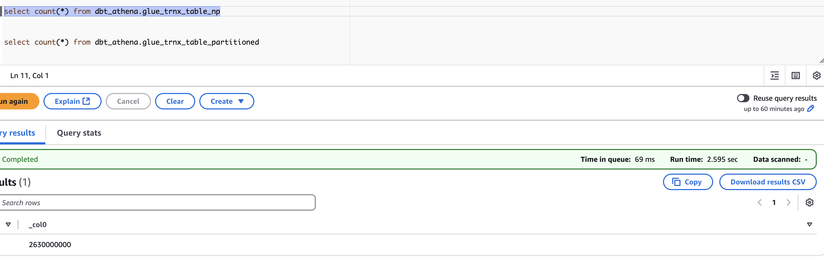

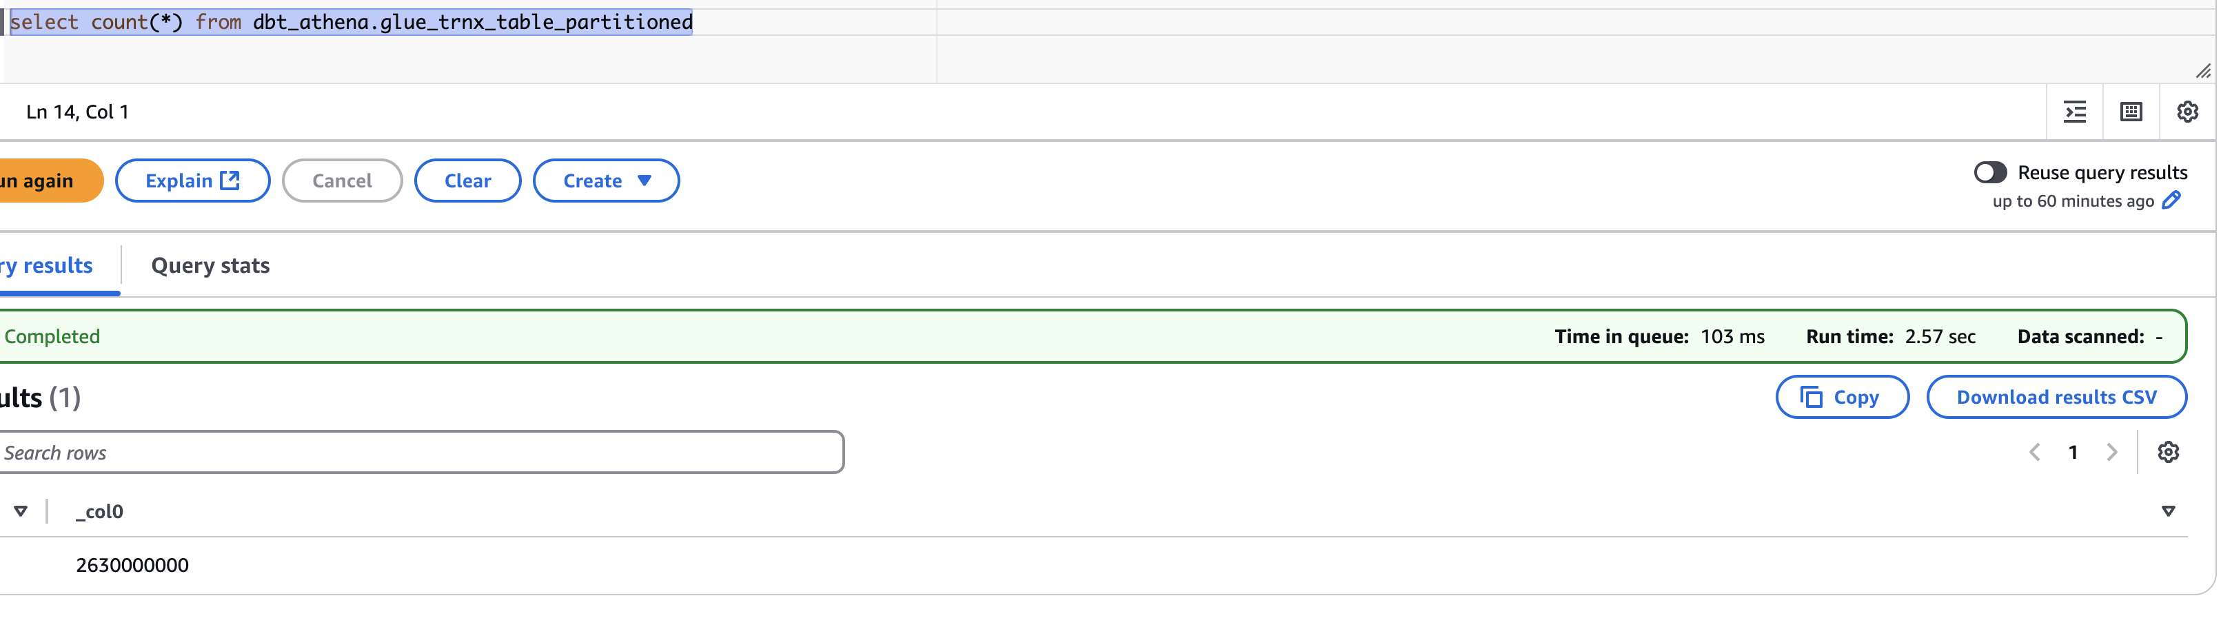

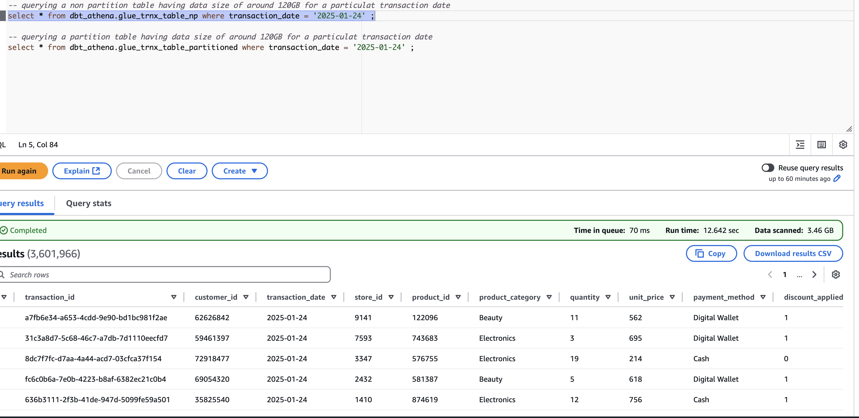

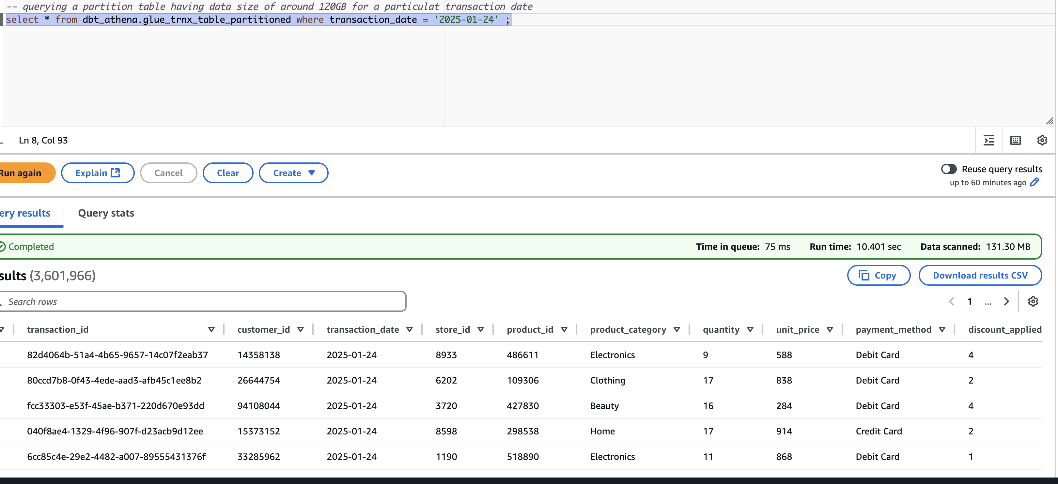

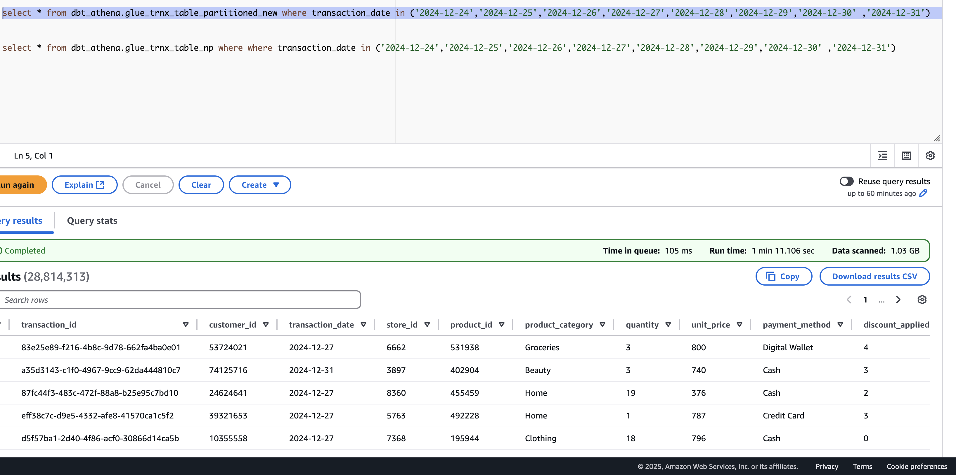

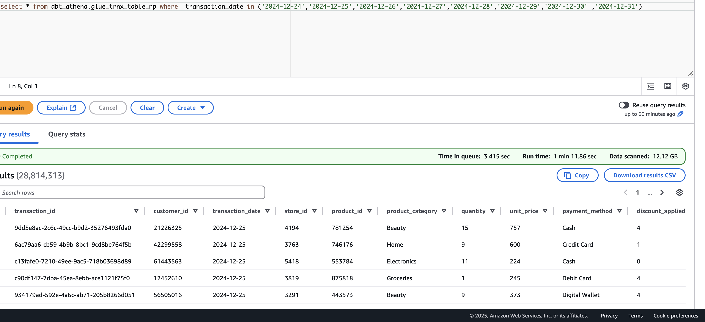

Why Partitioning Helps in Iceberg (especially on S3):
- Improved Query Performance
  - Partitioning allows Iceberg to skip files that don’t match the query predicate.
  - For example, if you partition by dt, and your query has a filter like WHERE dt = '2025-04-08', Iceberg reads only the relevant data files.
- Reduced Metadata Size
  - Partitioning keeps the metadata size manageable, which is important since Iceberg keeps metadata about all data files.
- Efficient Compaction & Maintenance
  - Tools like Apache Spark or Flink can more easily manage partitions for optimizations (like compaction, clustering, etc.)

What's happening under the hood:
1. Query Execution Time
Both tables return data at about the same speed because:
- Iceberg uses a metadata layer (manifest & manifest list files) to quickly locate the data files to be read.
- Even for large datasets, Iceberg does a fast lookup on those metadata files.
So the time might be similar especially on small/medium datasets.
2. Data Scanned
Partitioned table scans less data, and here's why:
- Iceberg stores a partition spec and file-level statistics.
- During query planning, it skips files that don’t belong to the matching partition.
- For example, if your table is partitioned by dt and your query is:
- sql

- SELECT * FROM my_table WHERE dt = '2025-04-08';
- → Only the partition folder
- dt=2025-04-08 is scanned.
# Data Partitioning Strategy in Apache Iceberg

## Overview
Apache Iceberg is a table format designed for large analytic datasets that brings ACID guarantees and innovative features to data lakes. Partitioning in Iceberg is particularly powerful as it supports hidden partitioning, partition evolution, and time travel capabilities.

## Understanding Iceberg Partitioning

### Core Concepts
- **Hidden Partitioning**: Partition fields are stored in metadata, not in the data files
- **Schema Evolution**: Can change partition specs without data migration
- **Partition Evolution**: Supports adding/removing partitions without table rebuilds
- **Time Travel**: Query data as it existed at a specific point in time

### Iceberg Partition Types

1. **Identity Partitioning**
```sql
-- Example: Direct value partitioning
CREATE TABLE customer_events (
customer_id bigint,
event_time timestamp,
event_type string)
PARTITIONED BY (event_type);
```

2. **Transform Partitioning**
```sql
-- Example: Date transformation
CREATE TABLE events (
id bigint,
timestamp timestamp,
user_id string)
PARTITIONED BY (year(timestamp), month(timestamp), day(timestamp));
```

### Supported Partition Transforms
- **Temporal**: `year`, `month`, `day`, `hour`
- **Truncate**: `truncate(value, width)`
- **Bucket**: `bucket(value, num_buckets)`

## Benefits of Iceberg Partitioning

### 1. Performance Advantages
- **Partition Pruning**: Eliminates irrelevant data files automatically
- **Z-ordering**: Optimized data organization for multi-dimensional queries
- **Metadata Filtering**: Quick partition elimination using metadata

### 2. Data Management Benefits
- **Snapshot Isolation**: Read consistency across queries
- **Roll-back Capability**: Can revert to previous versions
- **Incremental Planning**: Efficient processing of data changes

### 3. Operational Efficiency
- **Optimize Write Operations**: Better write performance through clustering
- **Reduced Storage Costs**: Efficient file organization
- **Simplified Maintenance**: Self-managing partitions

## Implementing Partitioning Strategy in Iceberg

### Key Considerations

1. **Partition Design**
```sql
-- Example: Multi-level partitioning
CREATE TABLE sales_events (
sale_id bigint,
sale_time timestamp,
region string,
amount decimal(10,2))
PARTITIONED BY (
year(sale_time),
month(sale_time),
region);
```

2. **Partition Granularity**
- Balance between query performance and maintenance
- Consider data volume per partition
- Account for data distribution

### Best Practices

1. **Partition Selection**
```sql
-- Example: Effective partition for time-series data
CREATE TABLE metrics (
metric_id bigint,
metric_time timestamp,
value double)
PARTITIONED BY (
bucket(metric_id, 16),
day(metric_time));
```

2. **Optimization Techniques**
```sql
-- Example: Partition optimization
ALTER TABLE sales_events
SET TBLPROPERTIES (
'write.target-file-size-bytes'='536870912', -- 512MB
'write.distribution-mode'='hash'
);
```

## Query Optimization with Iceberg Partitioning

### Example Queries

1. **Efficient Date Range Queries**
```sql
SELECT *
FROM events
WHERE date(timestamp) BETWEEN '2024-01-01' AND '2024-03-31';
```

2. **Multi-partition Queries**
```sql
SELECT region, sum(amount)
FROM sales_events
WHERE year(sale_time) = 2024
AND month(sale_time) = 3
GROUP BY region;
```

## Maintenance and Monitoring

### Regular Operations

1. **Compaction**
```sql
CALL system.rewrite_data_files(
table => 'sales_events',
strategy => 'binpack'
);
```

2. **Expire Snapshots**
```sql
CALL system.expire_snapshots(
table => 'sales_events',
retention_threshold => 'T7D' -- 7 days retention
);
```

### Performance Monitoring
1. **Metrics to Track**
- Number of files per partition
- Partition size distribution
- Scan efficiency
- Query performance patterns

2. **Optimization Commands**
```sql
-- Remove orphan files
CALL system.remove_orphan_files('sales_events');

-- Analyze table statistics
ANALYZE TABLE sales_events COMPUTE STATISTICS;
```

## Advanced Features

### Time Travel
```sql
-- Query data as of specific timestamp
SELECT *
FROM sales_events VERSION AS OF '2024-04-01 00:00:00';

-- Query by snapshot ID
SELECT *
FROM sales_events FOR SYSTEM_VERSION AS OF 1234567;
```

### Partition Evolution
```sql
-- Add new partition field
ALTER TABLE events
ADD PARTITION FIELD bucket(user_id, 16);

-- Remove partition field
ALTER TABLE events
DROP PARTITION FIELD bucket(user_id, 16);
```

## Conclusion
- Iceberg partitioning provides powerful capabilities for large-scale data management
- Enables efficient query performance through smart partition pruning
- Supports evolving requirements through flexible partition schemes
- Maintains data reliability with ACID guarantees

### Key Takeaways
1. Choose partition strategy based on query patterns
2. Leverage Iceberg's hidden partitioning for flexibility
3. Regular maintenance ensures optimal performance
4. Monitor and adjust based on usage patterns

This structure provides a comprehensive guide for implementing and managing partitioning in Iceberg tables. You can adapt and modify the content based on your specific use cases and requirements.

