SUDHANSHU RAJ  📞 +91 7061698950  📧 rajsudhanshu987@gmail.com  🔗 github.com/rajsudhanshu987-cmyk | 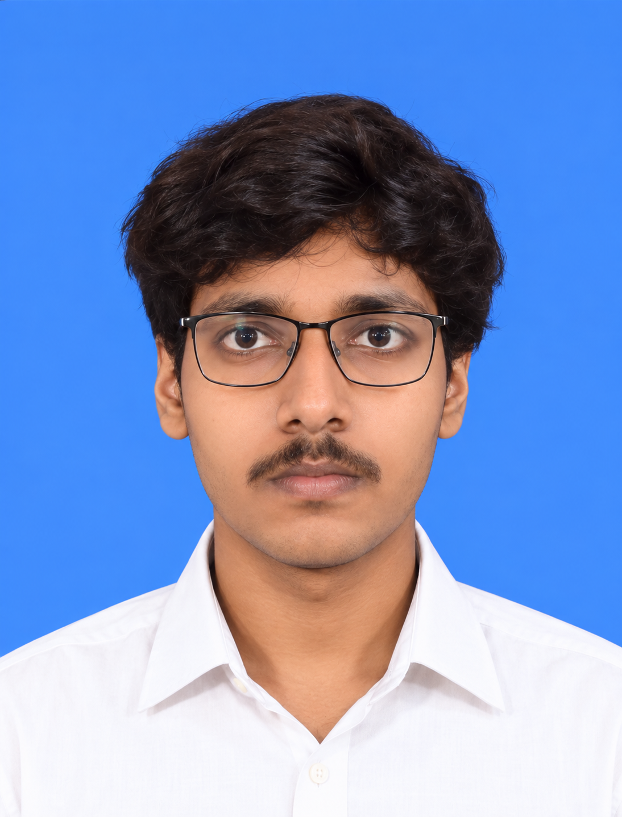

CAREER OBJECTIVE
Motivated BCA first-semester student with a strong interest in software development and web technologies. Seeking opportunities to enhance technical skills, gain practical experience, and contribute to real-world projects.
EDUCATION
Qualification | Institution | Board | Year | Result
BCA (1st Semester) | ITM University Gwalior | ITM University | 2026-2029 | Pursuing
Class XII | BSEB | Bihar Board | 2025 | 65.6%
Class X | BSEB | Bihar Board | 2023 | 60%
TECHNICAL SKILLS
Python, JavaScript, C Programming, HTML5, CSS3, Bootstrap, Tailwind CSS, Git, GitHub, VS Code
PROJECTS
Project | Technology | Description
Campus Placement Website | HTML, CSS, JavaScript, Tailwind CSS | Website for placement updates and opportunities.
Resume Builder | HTML, CSS, JavaScript | Application for creating professional resumes.
Personal Portfolio Website | HTML, CSS, JavaScript | Portfolio showcasing skills and projects.
CERTIFICATIONS
- 5-Day AI Agents: Intensive Vibe Coding Course – Google × Kaggle (2026)
- Python (Basic) – HackerRank (2026)
- Web Development Internship Certificate – InAmigos Foundation (2026)
ACHIEVEMENTS
- Successfully completed Web Development Internship.
- Built multiple academic web development projects.
- Actively learning programming and software development.
STRENGTHS
Communication, Teamwork, Problem Solving, Leadership, Adaptability, Time Management
PERSONAL DETAILS
Nationality: Indian | Languages: English, Hindi | Interests: Web Development, Programming
DECLARATION
I hereby declare that the information provided above is true and correct to the best of my knowledge and belief.
Sudhanshu Raj

