Joblib

Joblib is a library in Python that provides tools to create lightweight pipelines, perform parallel computing, and save memory by efficiently storing and retrieving Python objects (like NumPy arrays, Pandas DataFrames, etc.). It's commonly used in machine learning for tasks such as caching, parallelization, and serialization of objects.

Here's a brief overview of its main functionalities:

1. Caching: Joblib offers a Memory class that helps in caching function calls. It's particularly useful when dealing with computationally expensive functions by caching their results.

2. Parallelization: Joblib provides utilities for parallel execution of tasks using simple APIs like Parallel and delayed, enabling faster processing of tasks that can be done concurrently.

3. Serialization: It allows you to efficiently serialize and deserialize Python objects, making it easier to save machine learning models, especially those built using libraries like scikit-learn.

Serialization of machine learning models refers to the process of converting a trained model (which exists in memory) into a format that can be easily stored, transported, and reconstructed later for predictions or further training.

Serialization is crucial because it allows you to:

1. Store Models: Saving a trained model allows you to reuse it later without having to retrain from scratch, which can be time-consuming and resource-intensive.
2. Share Models: Serialized models can be easily shared with others or deployed to production environments for making predictions without needing access to the original training data or environment.
3. Version Control: Models can be versioned, allowing you to track changes, experiment with different variations, and revert to previous versions if needed.
4. Scalability: Serialized models can be easily distributed across multiple machines in a distributed computing environment for parallel processing.

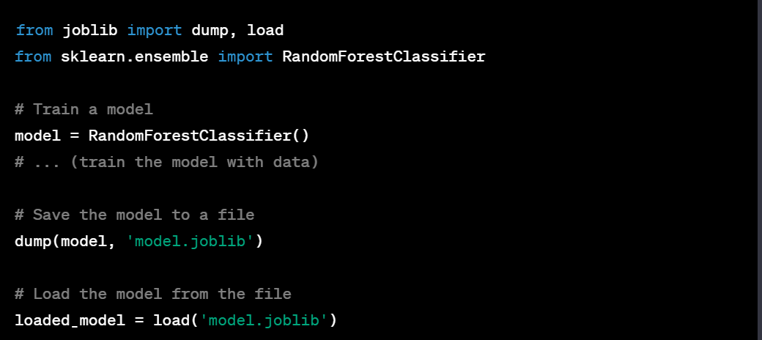

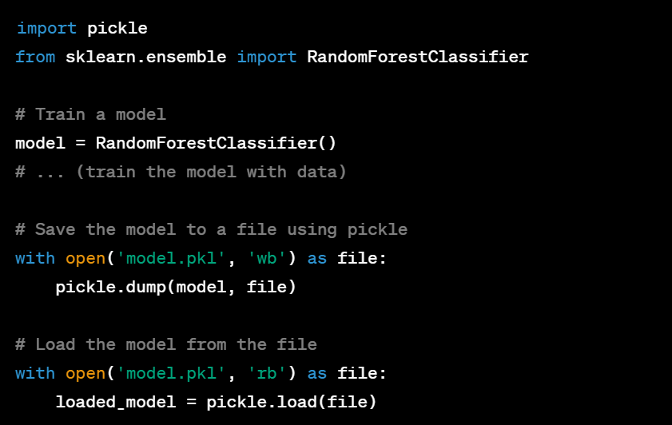

Difference between Joblib and Pickle

Joblib:

1. Efficiency: Joblib is optimized for efficiently handling large NumPy arrays and is generally faster than Pickle, especially for big data.
2. Memory: It's more memory efficient when dealing with large objects due to its memory mapping capabilities.
3. Use Cases: Joblib is commonly used in the scientific Python ecosystem, especially in machine learning workflows involving large datasets or complex models.

Pickle:

1. Versatility: Pickle can serialize almost any Python object, whereas Joblib is specialized for certain types of objects like NumPy arrays.
2. Python-specific: Pickle is a part of Python's standard library, making it more universally available without additional installations.
3. Compatibility: Pickle's serialized files might not always be backward-compatible between different versions of Python.

When to Use Which:

1. Joblib: Ideal for serializing large NumPy arrays and complex objects typically encountered in machine learning tasks. Use Joblib when dealing with larger data where efficiency and memory optimization are important.
2. Pickle: Suitable for general-purpose serialization of Python objects. If you need to serialize a variety of objects or compatibility across different Python versions is crucial, Pickle might be more suitable.

In summary, Joblib is often preferred in machine learning tasks involving large datasets and complex models due to its efficiency and memory optimization. Pickle, on the other hand, is more versatile and can be used for a broader range of Python objects but might not be as efficient for handling large datasets or complex structures.