CTF Challenge Report - PicoCTF 2025

# 1. Challenge Overview

Challenge Name: Fantasy CTF

Platform: PicoCTF 2025

Category: General Skills

Difficulty: Easy

This challenge introduced players to terminal-based interaction within a CTF. The goal was to register correctly and uncover a hashed password, ultimately capturing the flag.

# 2. Game Interaction via Netcat

The challenge required connecting to a game session using netcat:  
$ nc verbal-sleep.picoctf.net 52486  
  
The terminal presented a choice to register. The correct choice was:  
C) Register a single, private account  
  
This choice reflects fair CTF behavior and avoids disqualification.

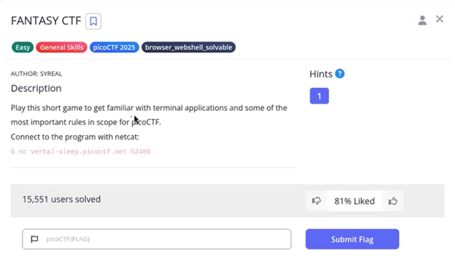

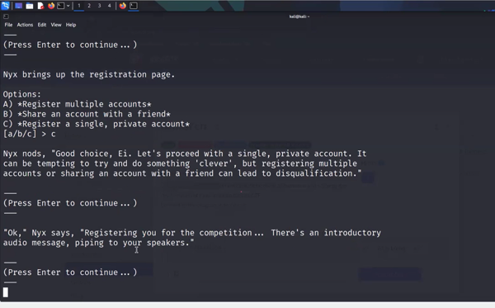

# 3. Cracking the Password Hash

During the session, a hash `482c811da5d5b4bc6d497ffa98491e38` was provided. Using CrackStation.net, the hash was identified as:  
  
Plaintext: password123  
  
Hash Type: MD5

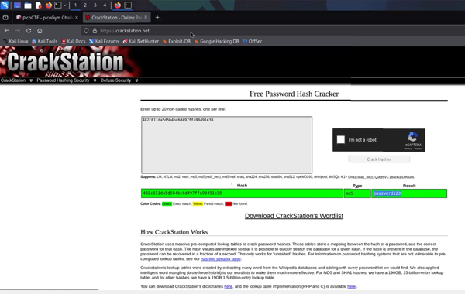

# 4. Captured Flag and Conclusion

Captured Flag: picoCTF{password123}

This challenge served as an excellent entry point for new CTF participants. It involved terminal usage, CTF ethics, and basic password hash cracking — all of which are valuable foundational skills.