Crypto Analysis Using CyberChef

Name: Shimon Talukder Raj

Date: May 09, 2025

Objective

The objective of this task is to perform cryptographic analysis using CyberChef. The task involves decoding a Base64-encoded string and analysing the output, which is expected to be an image.

# Tools Used

CyberChef (https://gchq.github.io/CyberChef/) - a web-based application for encryption, encoding, compression, and data analysis.

# Steps Performed

1. Opened CyberChef in a web browser (https://gchq.github.io/CyberChef/).

2. Applied the 'From Base64' operation to decode the given Base64 string.

3. Enabled the 'Remove non-alphabet chars' checkbox to clean the input.

4. Added the 'Render Image' operation to visualize the decoded data.

5. Observed the output image, which appeared to be a barcode.

# Base64 Encoded String Used

iVBORw0KGgoAAAANSUhEUgAAAMkAAAAjAQAAAAAWYhNMAAAALklEQVR4XmPQfSdyfdm3uKqz0md515t2bhOOu3ybW988XaSBYVRqVGpUapBJAQD/Y6EOyJKSeQAAAABJRU5ErkJggg==

# Output

The decoded output revealed an image that resembles a barcode, as shown in the screenshot below:

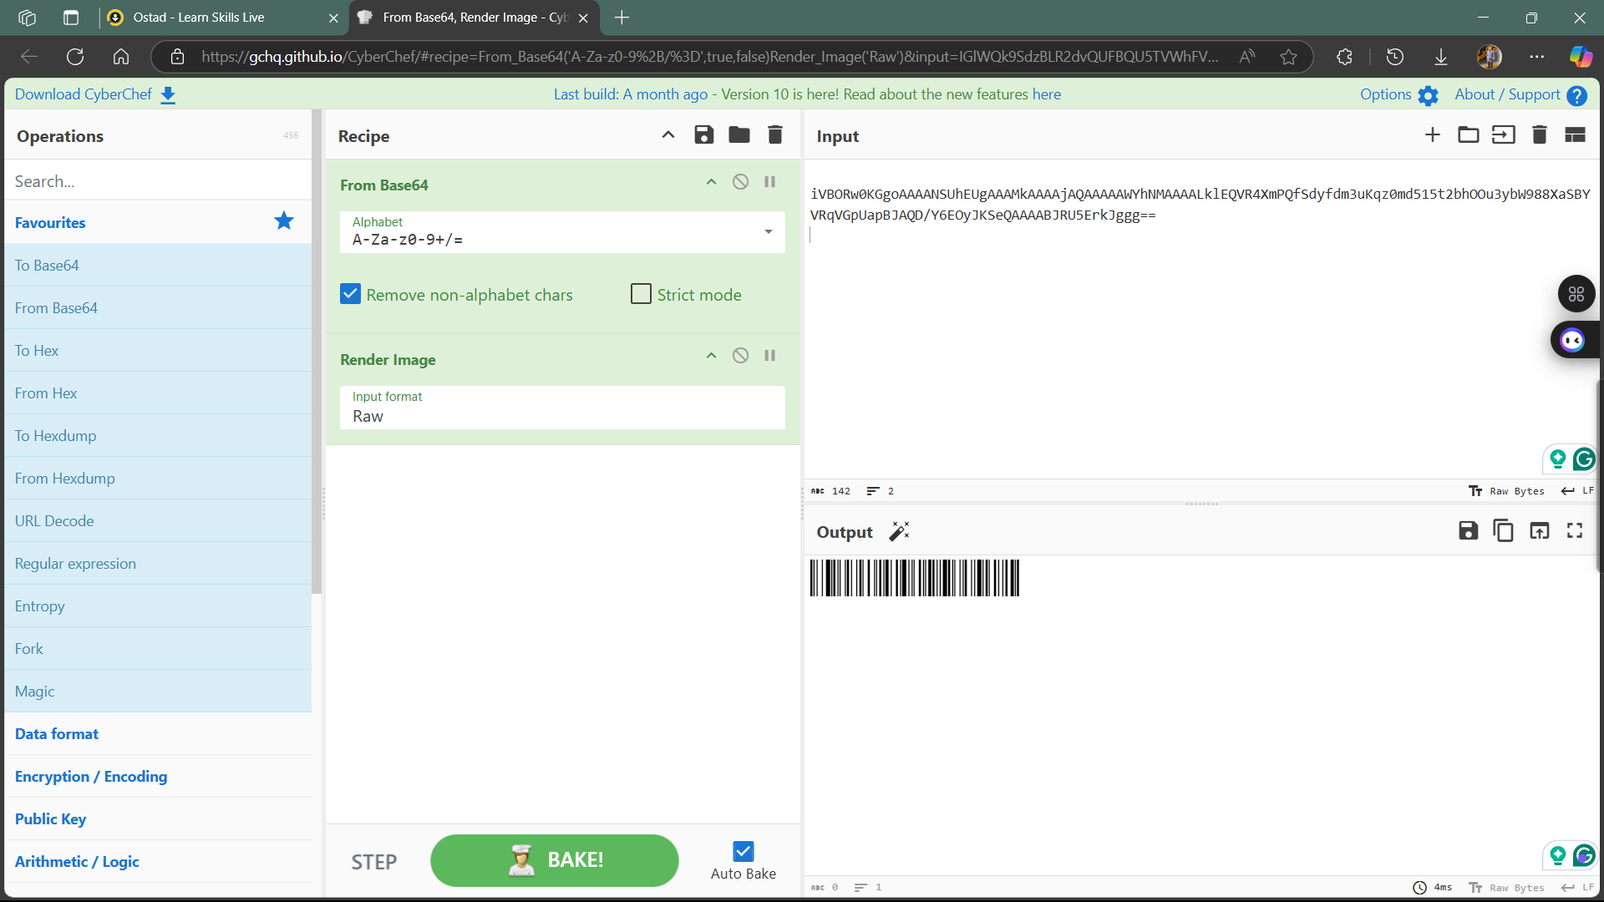

# Analysis of the Decoded Image

The rendered output image appears to be a barcode. This suggests that the Base64 string encoded binary image data, possibly representing an identification number, product code, or encrypted metadata. Such barcodes are often used in packaging, digital identification, and inventory systems.

# References

CyberChef Documentation: https://gchq.github.io/CyberChef/