

**International University of Business Agriculture and Technology**

Assignment No. 01

Topic: Drawing of Niger National Flag in C++ by using OpenGL

Course Code: CSC-455

Course Name: Computer Graphics

Prepared For

Mr. Krishna Das

Assistant Professor,

Department of Computer Science and Engineering

Prepared By

Asfak Hossain Raju

ID: 17103120

Section: A

Program: BCSE

Date of Submission:

31/03/2022

**Drawing of**

**Niger National Flag**

**in C++**

**By using OpenGL**

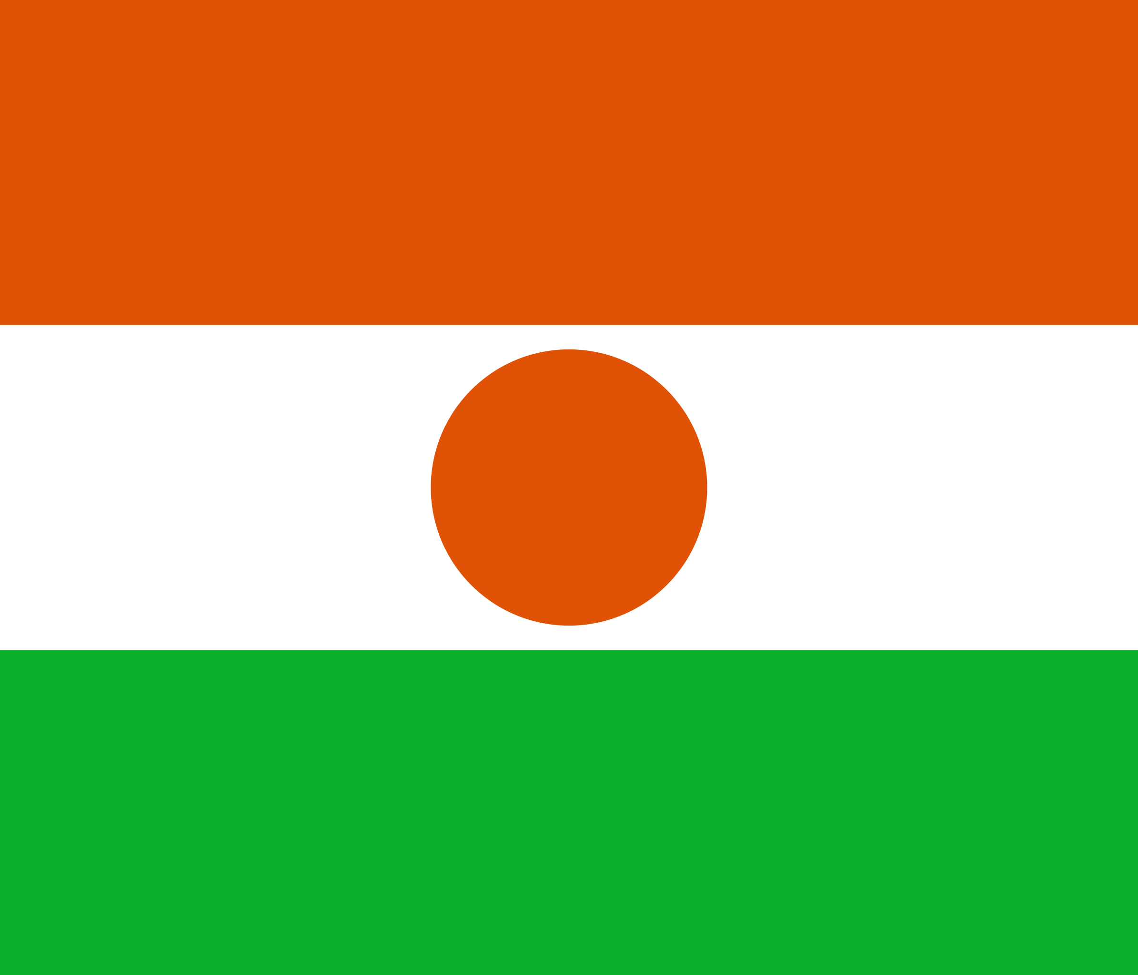



***Figure***: Niger National Flag

In this flag there are four primitives are used. All of them is Quad.

**Assignment’s Description:**

This Computer Graphics Assignments as mentioned above draw Flag of Niger. As we can see in the Assignments output image above. In this Assignment, there is no user interaction as well as the Assignment is static one. A basic OpenGL program has included header files, global variable declaration, draw function, init function and main function. This program has only these basic functions, since it not required having anything else. Just draw the primitives to give a proper shape of flag.

**Drawing Function for Geometrical Primitives:**

For drawing this flag, we need only four geometrical primitives, all of them is quad.

All objects in this Assignment are included in draw function. As we can see the flag has four parts of different color. We have use the **glBegin(GL_QUADS)** to draw the quad shapes.

**First Primitives (1st Quad):**

Here is the graph for first primitives of the flag

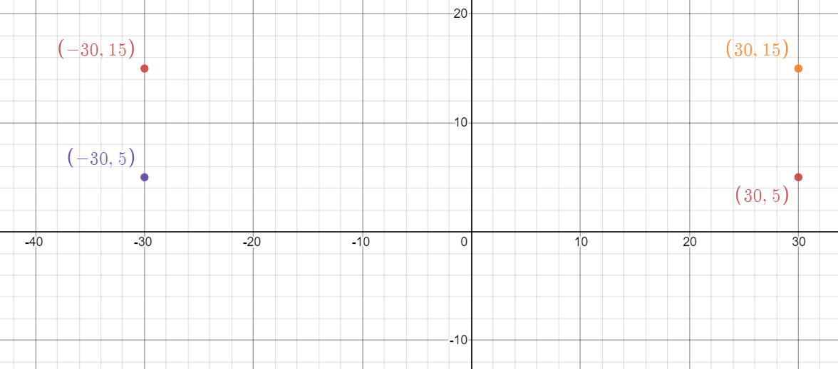

Code for this primitive:

glColor3f(255,140,0);

glBegin(GL_QUADS);

glVertex2d(30.0,15.0);

glVertex2d(30.0,5.0);

glVertex2d(-30.0,5.0);

glVertex2d(-30.0,15.0);

glEnd();

glFlush();

***Second Primitives (2nd Quad):***

Here is the graph for first primitives of the flag

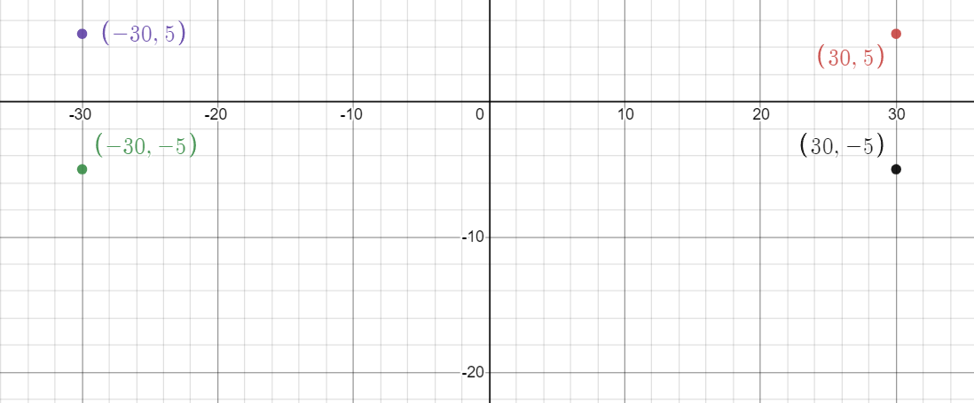

Code for this primitive:

glColor3f(255,255,255);

glBegin(GL_QUADS);

glVertex2d(30.0,5.0);

glVertex2d(30.0,-5.0);

glVertex2d(-30.0,-5.0);

glVertex2d(-30.0,5.0);

glEnd();

glFlush();

***Third Primitives (3rd Quad)***:

Here is the graph for third primitives of the flag

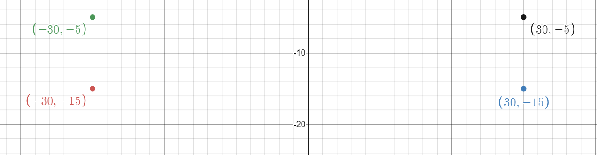

Code for this primitive:

glColor3f(0,100,0);

glBegin(GL_QUADS);

glVertex2d(30.0,-5.0);

glVertex2d(30.0,-15.0);

glVertex2d(-30.0,-15.0);

glVertex2d(-30.0,-5.0);

glEnd();

glFlush();

***Fourth Primitive (Circle)***:

Here is the graph for fourth primitives of the flag

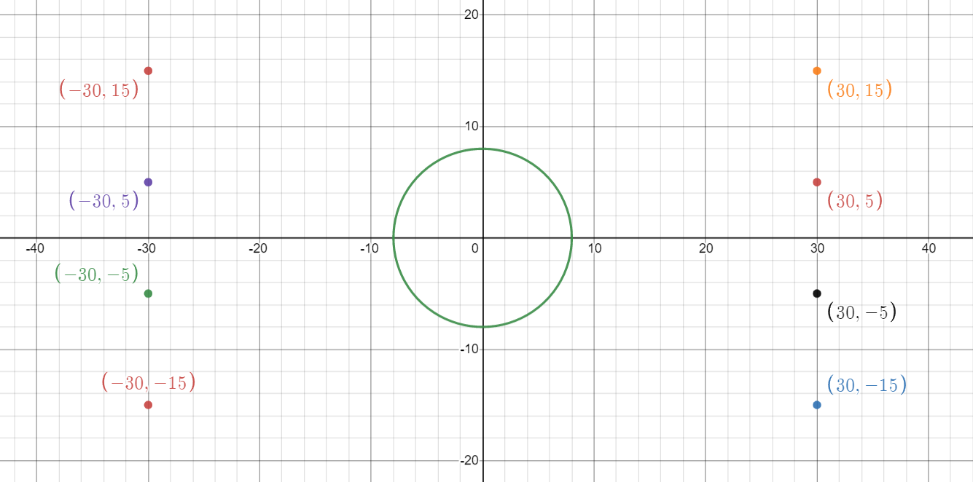

Code for this primitive:

glPushMatrix();

glColor3f(255,140,0);

glScalef(1.9,1.5,2.0);

glutSolidSphere(3,50.5,15);

glPopMatrix();

glEnd();

glFlush();

**Code**:

Name: Asfak Hossain Raju

ID: 17103120

Niger Flag:

#include<windows.h>

#include<GL/glut.h>

void flag()

{

//First Quards

glClear(GL_COLOR_BUFFER_BIT);

glColor3f(255,140,0);

glBegin(GL_QUADS);

glVertex2d(30.0,15.0);

glVertex2d(30.0,5.0);

glVertex2d(-30.0,5.0);

glVertex2d(-30.0,15.0);

glEnd();

glFlush();

//2Nd Quards

glColor3f(255,255,255);

glBegin(GL_QUADS);

glVertex2d(30.0,5.0);

glVertex2d(30.0,-5.0);

glVertex2d(-30.0,-5.0);

glVertex2d(-30.0,5.0);

glEnd();

glFlush();

//3rd Quards

glColor3f(0,100,0);

glBegin(GL_QUADS);

glVertex2d(30.0,-5.0);

glVertex2d(30.0,-15.0);

glVertex2d(-30.0,-15.0);

glVertex2d(-30.0,-5.0);

glEnd();

glFlush();

//Circle Point

glPushMatrix();

glColor3f(255,140,0);

glScalef(1.9,1.5,2.0);

glutSolidSphere(3,50.5,15);

glPopMatrix();

glEnd();

glFlush();

}

void Initialize()

{

glMatrixMode(GL_PROJECTION);

glLoadIdentity();

glClearColor(0.96,0.87,0.70,0);

glOrtho(-40,40,-20,20,-20,20);

}

int main(int argc, char** argv)

{

glutInitDisplayMode(GLUT_SINGLE|GLUT_RGB);

glutInitWindowSize(1120,720);

glutInitWindowPosition(50,50);

glutCreateWindow("Raju");

Initialize();

glutDisplayFunc(flag);

glutMainLoop();

return 0;

}

