**Core Java Project-1**

**Guesser Game**

**Blue Print**

**(Vikram Khandelwal(Mentor))**







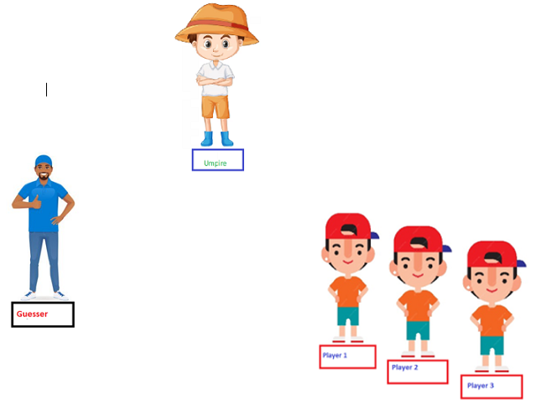

**2**



**2**

**2**



**5**

**2**

**5**

**8**



**2**



**5**

**8**

**3**

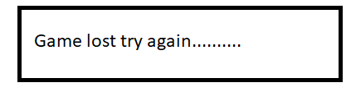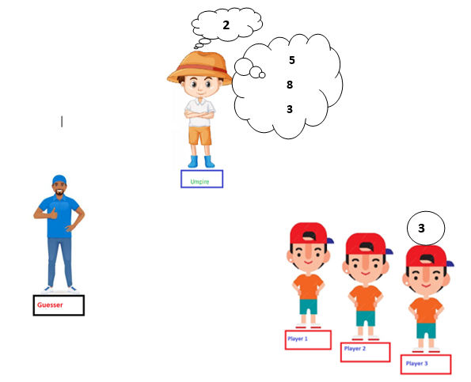

**7**



**7**

**7**

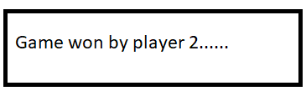

**4**

**7**

**6**

In that project,we take

number of classes------guesser----------player----umpire

guesser---------1-method

player----------2-method

Umpire----3-method

main mrthod------class

total classes--4