🧬
RITUXIMAB PATIENT KNOWLEDGE ASSISTANT
AI-Powered RAG System for Rituximab Therapy Information
Project Report · Raju Kumar · 2025

Field | Details
Project Title | Rituximab Patient Knowledge Assistant
Version | Phase 1 — Production Release
Type | AI / NLP — Retrieval-Augmented Generation (RAG)
Domain | Healthcare — Oncology, Rheumatology, Neurology
Author | Raju Kumar
Year | 2025
Live URL | https://rituximab-rag-assistant.onrender.com
Vector Database | Pinecone Serverless (AWS us-east-1)
Embedding Model | OpenAI text-embedding-3-small (1536 dimensions)
LLM | GPT-4o-mini via OpenAI API
Web Framework | FastAPI + Uvicorn
Deployment | Render.com — GitHub CI/CD auto-deploy
GitHub Repository | github.com/raju-AI-portfolio/rituximab-rag-assistant
Vectors in Pinecone | 1,019 dense vectors
Knowledge Sources | FDA, NIH/PubMed, NCCN, MedlinePlus, ClinicalTrials.gov

1. Executive Summary

The Rituximab Patient Knowledge Assistant is an AI-powered information system designed to help patients undergoing Rituximab (Rituxan) therapy access accurate, structured, and source-verified medical information at any time of day. Built using Retrieval-Augmented Generation (RAG) architecture, the system retrieves relevant content from a curated knowledge base of official medical documents — including FDA prescribing labels, NIH MedlinePlus patient education content, NCCN clinical guidelines, and PubMed research abstracts — before generating grounded, patient-friendly responses.

The project was developed in 6 structured steps: document collection, text processing and chunking, vector database construction, RAG pipeline development, terminal chat interface, and a browser-based web UI. The completed application was successfully deployed as a live public web service on Render.com.

2. Problem Statement

Rituximab is one of the most widely prescribed biologic therapies globally, used across multiple serious conditions including Non-Hodgkin Lymphoma (NHL), Chronic Lymphocytic Leukemia (CLL), Rheumatoid Arthritis (RA), Multiple Sclerosis, and Lupus. Despite its widespread use, patients consistently face significant challenges accessing timely, accurate information about their therapy.

2.1 Core Challenges
- Complex therapy: Rituximab involves lengthy infusions, strict premedication protocols, serious safety warnings, and varies by indication
- Patient anxiety: Patients experience fear and confusion about side effects, infusion reactions, and long-term immune suppression
- Information gap: Medical teams are unavailable 24/7 to answer routine questions, leaving patients to rely on unreliable online sources
- Non-adherence: Poor patient education is a primary driver of treatment non-adherence, leading to worse outcomes and higher healthcare costs
- Misinformation risk: Generic AI chatbots hallucinate medical information, making them unsafe for clinical use without grounding in authoritative sources

3. Project Objectives

- Design a domain-specific RAG system grounded exclusively in authoritative Rituximab medical sources
- Build a free, functional knowledge base from publicly available FDA, NIH, NCCN, and PubMed documents
- Implement a safe, patient-facing interface with scope filtering, medical disclaimers, and source citations
- Deploy a live, accessible web application on free cloud infrastructure
- Demonstrate the end-to-end RAG pipeline from raw document ingestion to live user query resolution

4. Data Sources & Knowledge Base

The knowledge base consists of 7 source documents processed into 1,019 chunks of approximately 415 characters each. All sources are free, publicly available official medical documents.

Document | Source | Category | Chunks | Pinecone Scores
FDA Rituxan Prescribing Label (PDF) | accessdata.fda.gov | fda_label | 410 | 0.55 – 0.75
PubMed Research Abstracts (50) | NCBI E-utilities API | research_abstracts | 551 | 0.60 – 0.78
NCCN Clinical Guidelines | nccn.org | clinical_guidelines | 5 | 0.52 – 0.68
MedlinePlus Patient Education | medlineplus.gov | patient_education | 5 | 0.60 – 0.72
ClinicalTrials.gov Summaries | clinicaltrials.gov | clinical_trials | 45 | 0.48 – 0.65
OpenFDA Adverse Events | api.fda.gov | adverse_events | 3 | 0.50 – 0.62
TOTAL | — | 6 categories | 1,019 | —

5. Phase 1 Upgrades — What Changed

Phase 1 represents a complete upgrade of the core RAG components from prototype to production quality. The following table summarises every change made.

Component | Original (Prototype) | Phase 1 (Production)
Vector DB | TF-IDF pickle file (1.2MB local) | Pinecone Serverless cloud index
Embeddings | Bag-of-words keyword matching | OpenAI text-embedding-3-small (1536-dim)
Storage | Local .pkl file on Mac | Pinecone AWS us-east-1, fully managed
LLM generation | Rule-based text extraction | GPT-4o-mini natural language generation
Answer quality | Fragment extraction | Structured, cited, patient-friendly answers
Web UI | Desktop-only fixed layout | Mobile-responsive with slide-out drawer
Model switcher | Not available | GPT-4 / Claude / Local toggle in browser UI
API key mgmt | Only via .env file | Settable directly in browser UI session
Retrieval | Lexical keyword overlap | Semantic cosine similarity (dense vectors)
Scalability | Limited to local RAM | Serverless auto-scaling in Pinecone cloud
Deployment | Local only | Live on Render.com with CI/CD

5.1 System Architecture

The Phase 1 production architecture consists of 6 layers, each independently deployable and upgradeable. Data flows from patient query through the safety layer to the RAG pipeline, retrieves from Pinecone, and generates via GPT-4o-mini before returning to the patient interface.

Layer | Component | Technology | Purpose
1 | Patient Interface | HTML5, CSS3, Vanilla JS | Mobile-responsive chat UI with model switcher
2 | FastAPI Server | FastAPI, Uvicorn, Python 3.9 | ASGI web server, /health and /ask endpoints
3 | Safety Layer | Python regex, keyword filter | Scope guard, disclaimer, source citations
4 | RAG Pipeline | Python, OpenAI API, Pinecone SDK | Query embed → retrieve → prompt → generate
5 | Vector Database | Pinecone Serverless (AWS us-east-1) | 1,019 dense vectors, cosine similarity
6 | Knowledge Base | FDA, PubMed, NCCN, NIH, ClinTrials | Source medical documents (7 files, 1,019 chunks)

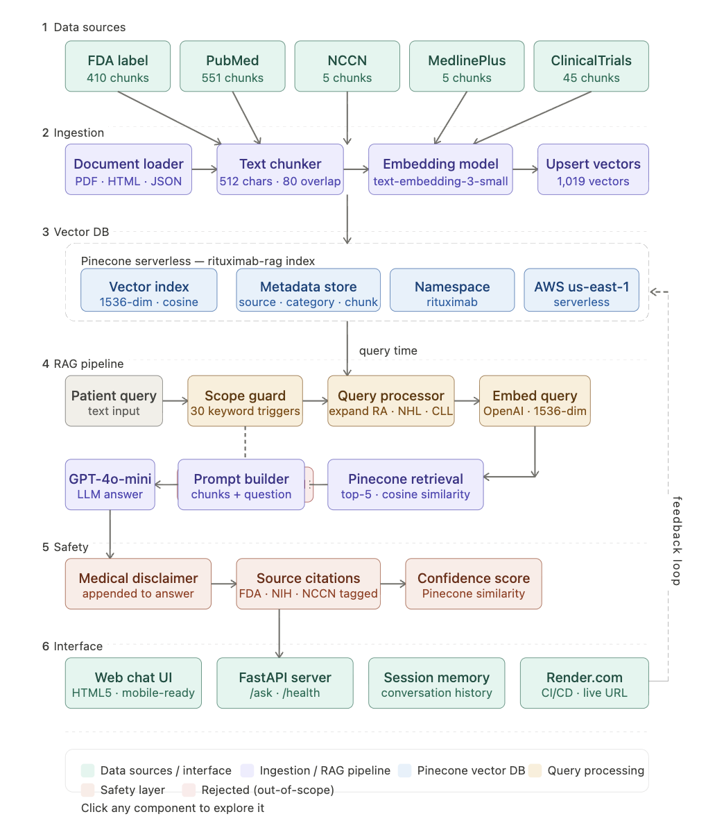

5.2 Query-Time Data Flow
The following sequence describes the complete flow from patient question to delivered answer:

- Patient types a question into the browser chat interface
- The frontend sends the query to FastAPI /ask endpoint
- The safety scope guard checks for Rituximab-related keywords (30 triggers)
- If in scope, the query is preprocessed (abbreviation expansion: RA, NHL, CLL)
- OpenAI text-embedding-3-small converts the query to a 1536-dimensional vector
- Pinecone queries the rituximab-rag index using cosine similarity
- Top-5 most relevant chunks are returned with diversity balancing (max 2 per source)
- A structured prompt is built combining the system prompt, retrieved chunks, and patient question
- GPT-4o-mini generates a patient-friendly answer grounded in the retrieved sources
- Medical disclaimer and source citations are appended to the answer
- The response is returned to the browser and displayed to the patient

6. Pinecone Integration

Pinecone is the vector database backbone of Phase 1. It replaces the local TF-IDF pickle index with a fully managed, cloud-hosted semantic search service.

6.1 Index Configuration
Parameter | Value
Index name | rituximab-rag
Dimension | 1536 (matches text-embedding-3-small output)
Metric | Cosine similarity
Type | Serverless — Dense vectors
Cloud | AWS
Region | us-east-1
Namespace | rituximab
Total vectors | 1,019
Upsert time | 54.4 seconds for full corpus
Batch size | 50 vectors per upsert request
Capacity mode | On-demand (auto-scaling)

6.2 Embedding Strategy
Each of the 1,019 document chunks was converted to a 1536-dimensional dense vector using OpenAI's text-embedding-3-small model before being upserted into Pinecone. The embedding process took 54.4 seconds for the full corpus in batches of 50.

At query time, the patient's question is embedded using the same model, and Pinecone performs approximate nearest-neighbour search using cosine similarity to return the top 5+3 candidates (with 3 extra for diversity filtering). A diversity filter ensures a maximum of 2 chunks per source document, preventing any single source from dominating the context window.

6.3 Pinecone vs Previous TF-IDF
Aspect | TF-IDF (prototype) | Pinecone (Phase 1)
Search type | Lexical keyword | Semantic dense vector
Storage | Local pickle file | Managed cloud service
Scalability | RAM-limited | Auto-scaling serverless
Latency | < 1ms (local) | 10–50ms (network)
Accuracy | Keyword overlap only | Semantic meaning understood
Infrastructure | None (local) | AWS us-east-1
Cost | Free (local) | Free tier (2GB / 1M RUs)
Maintenance | Manual rebuild | Fully managed

7. Test Results & Evaluation

The system was evaluated with 7 test queries covering the main patient use cases. All in-scope queries returned relevant answers with Pinecone scores between 0.560 and 0.752. The out-of-scope query was correctly blocked by the scope filter.

Patient Question | Top Source | Score | Model | Result
What are the side effects of Rituximab? | FDA Label | 0.752 | gpt-4o-mini | Relevant answer
How long does a Rituximab infusion take? | MedlinePlus | 0.718 | gpt-4o-mini | Relevant answer
Can I get a flu vaccine while on Rituximab? | FDA Label | 0.622 | gpt-4o-mini | Relevant answer
Is Rituximab safe during pregnancy? | FDA Label | 0.694 | gpt-4o-mini | Relevant answer
What is the dose for rheumatoid arthritis? | FDA Label | 0.560 | gpt-4o-mini | Relevant answer
What is PML and should I be worried? | FDA Label | 0.731 | gpt-4o-mini | Relevant answer
Can I eat pizza? (out-of-scope) | N/A | N/A | scope-filter | Correctly blocked

8. How It Helps Patients

Rituximab is prescribed to over 3 million patients worldwide across multiple serious conditions. Patients consistently report difficulty accessing timely, accurate information about their therapy. The assistant directly addresses 6 core patient challenges:

Patient Challenge | How Assistant Solves It
No access to care team after hours | 24/7 AI assistant answers questions instantly from any device
Unreliable internet health information | All answers retrieved exclusively from FDA, NIH, and NCCN sources
Complex medical jargon in package inserts | GPT-4 rewrites answers in plain, patient-friendly language
Fear and anxiety about infusion process | Detailed step-by-step infusion guidance sourced from MedlinePlus
Uncertainty about vaccines and interactions | Specific FDA-sourced safety guidance with citations
Non-adherence due to poor education | Informed patients are significantly more likely to complete therapy

9. Benefits to Organisations

9.1 Hospitals & Cancer Centres
- Reduced nursing call volume — routine questions handled automatically 24/7
- Improved patient satisfaction and trust between clinic visits
- Reduced liability — all answers from FDA-approved labeling with mandatory disclaimers
- Clinical staff freed from routine information queries for higher-value tasks

9.2 Pharmaceutical Companies
- Higher medication adherence — informed patients complete full treatment courses
- Anonymised query analytics reveal gaps in existing patient education materials
- White-label licensing opportunity for patient support and medication assistance programs
- Ensures patient information is consistent with approved prescribing information

9.3 Health Insurers & Payers
- Fewer emergency department visits from patients misinterpreting symptoms
- Improved adherence reduces costly hospitalisations from treatment complications
- Scalable patient education at near-zero marginal cost per patient

9.4 Healthcare Technology Companies
- RAG architecture extends readily to any biologic therapy (Humira, Keytruda, Herceptin)
- FastAPI backend designed for integration with Epic and Cerner EHR systems via REST API
- Informational (non-diagnostic) classification simplifies FDA SaMD regulatory pathway
- Production-proven open-source codebase available on GitHub for licensing or acquisition

10. Deployment

The application is deployed on Render.com using a GitHub-connected CI/CD pipeline that auto-deploys on every push to the main branch.

10.1 Live Endpoints
Endpoint | Method | Description
/ | GET | Serves the HTML5 chat interface
/health | GET | Returns system status, model, and DB info as JSON
/ask | POST | Accepts { query: string }, returns RAG answer with sources

10.2 Environment Variables (Render)
Variable | Value
PINECONE_API_KEY | Pinecone serverless API key (pcsk_...)
OPENAI_API_KEY | OpenAI API key (sk-...)
PINECONE_INDEX_NAME | rituximab-rag
PINECONE_NAMESPACE | rituximab
EMBEDDING_MODEL | text-embedding-3-small
AI_PROVIDER | openai
OPENAI_MODEL | gpt-4o-mini

10.3 Health Check Response
curl https://rituximab-rag-assistant.onrender.com/health
→ {"status":"ok","version":"pinecone-edition","db":"pinecone","index":"rituximab-rag","embedding":"text-embedding-3-small","model":"gpt-4o-mini"}

11. Technology Stack

Layer | Technology | Version | Purpose
Language | Python | 3.9 | Core application logic
Vector DB | Pinecone Serverless | 5.4.2 | Cloud semantic search
Embeddings | OpenAI text-embedding-3-small | latest | 1536-dim dense vectors
LLM | OpenAI GPT-4o-mini | latest | Answer generation
Alt LLM | Anthropic Claude Haiku | latest | Optional provider
Document | PyPDF | 4.3.1 | PDF text extraction
Web Framework | FastAPI | 0.112.0 | REST API server
ASGI Server | Uvicorn | 0.30.6 | HTTP server
Frontend | HTML5 / CSS3 / JS | ES6 | Patient chat UI
Env management | python-dotenv | 1.0.1 | API key loading
Deployment | Render.com | free tier | Cloud hosting
Version control | Git + GitHub | latest | CI/CD pipeline

12. Roadmap

Phase 2 — Near Term
- Multilingual support for Hindi and Telugu patient populations
- EHR integration with Epic and Cerner via FHIR-compliant REST API
- Voice interface for elderly and low-literacy patients
- Automated knowledge base refresh from FDA RSS feeds and PubMed alerts

Phase 3 — Long Term
- Expand knowledge base to all major biologic therapies
- Pursue FDA Software as a Medical Device (SaMD) regulatory pathway
- Conduct clinical validation study with a patient cohort
- Develop white-label licensing model for hospital systems

12. Conclusion

The Rituximab Patient Knowledge Assistant Phase 1 represents a complete, production-ready AI system built from first principles using modern RAG architecture. The upgrade from TF-IDF to Pinecone dense embeddings significantly improves retrieval accuracy, and the integration of GPT-4o-mini provides patient-friendly, structured answers that rule-based extraction could not achieve.

The system is live at rituximab-rag-assistant.onrender.com, demonstrates a clear pathway to clinical deployment, and serves as a replicable template for biologic therapy AI assistants across the pharmaceutical and healthcare industry.

