NAME:P.Sidhartha

BATCH:08

HALLNO:2403A52235

LAB :02

TASK 1:

Write a python function that reads a list of numbers and calculates the mean, minimum, and maximum values

CODE:

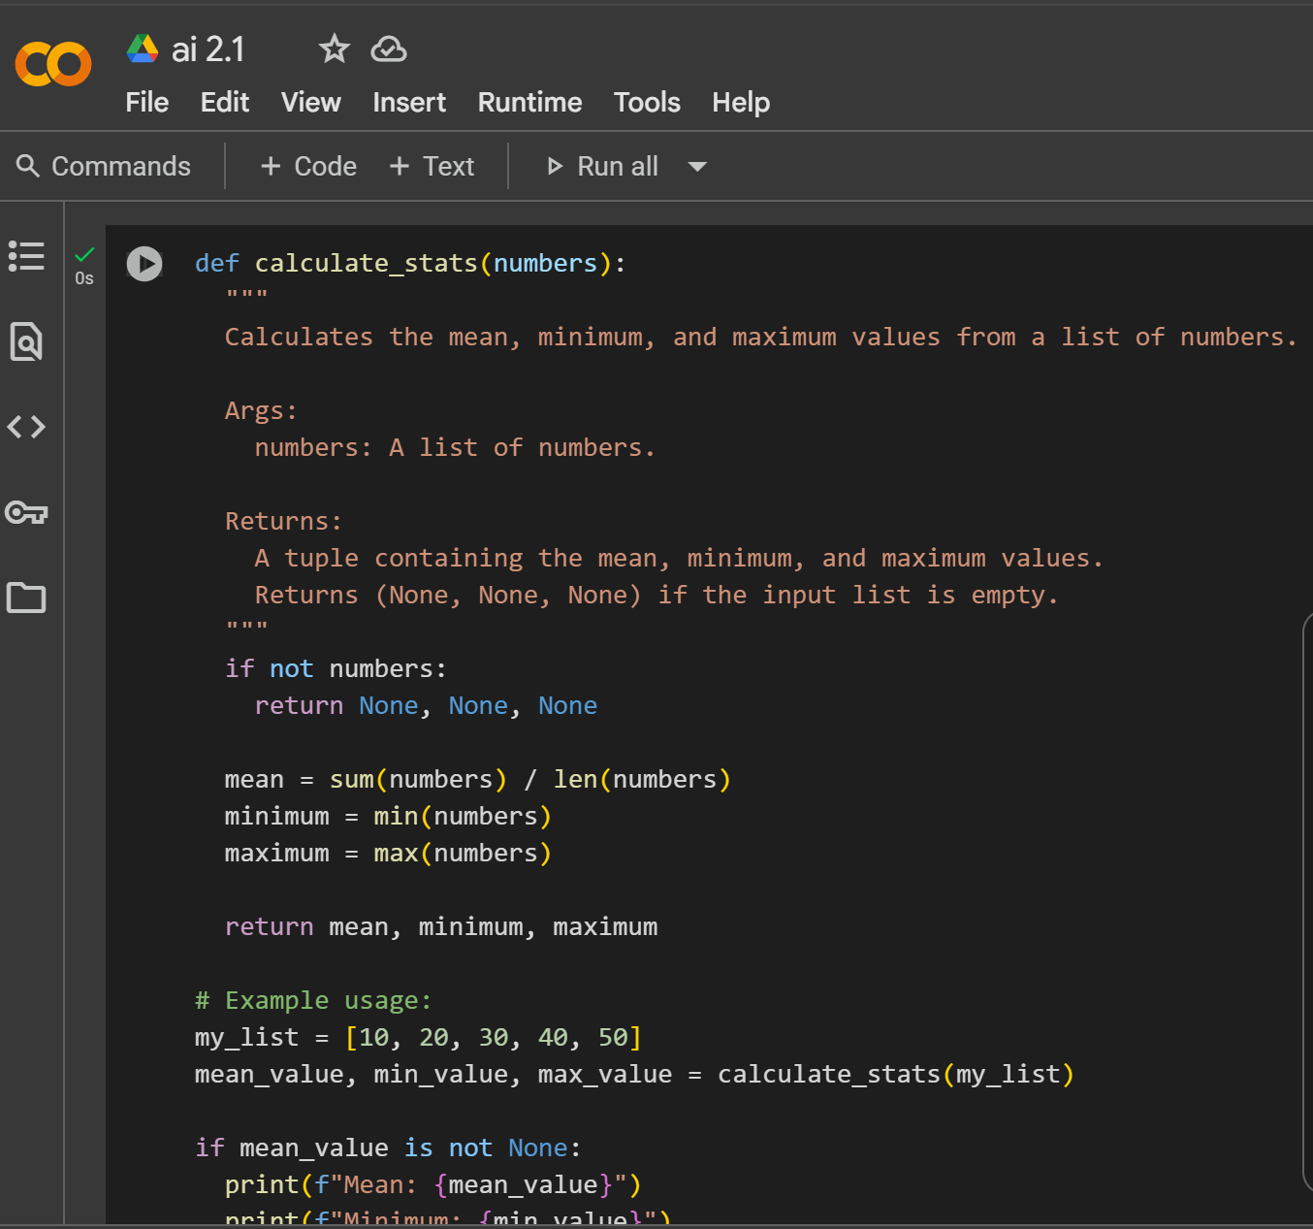

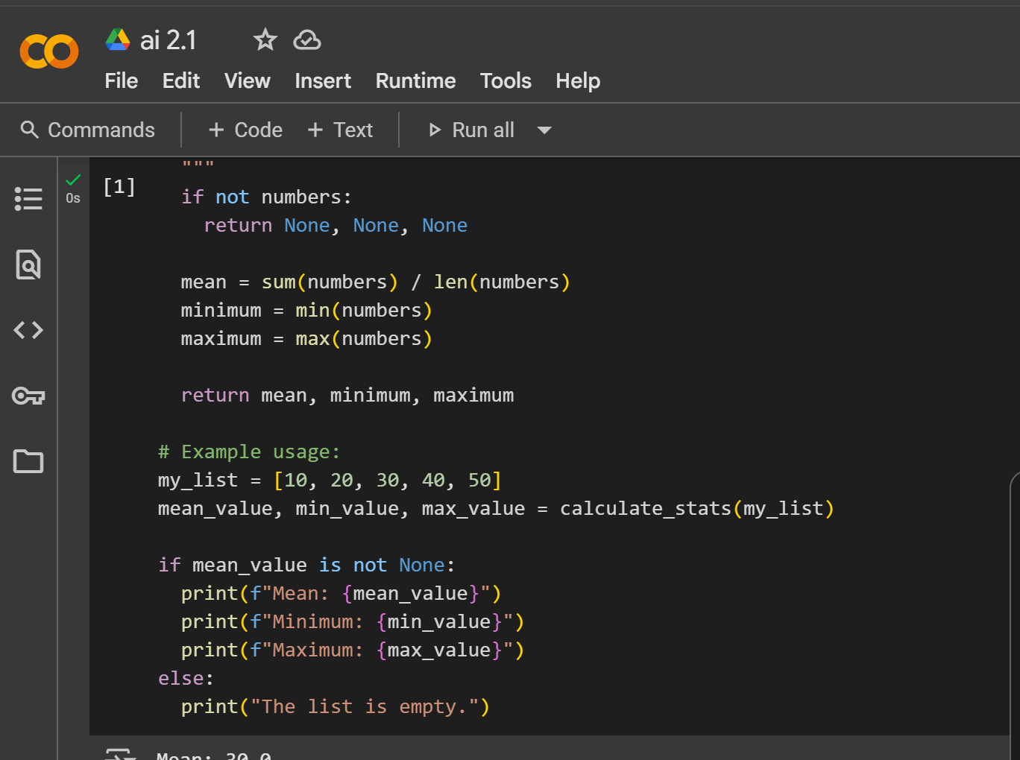

OUTPUT:

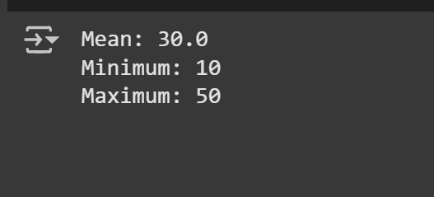

TASK 2

CHECK IN VS CODE IS THE OUTPUT IS SAME

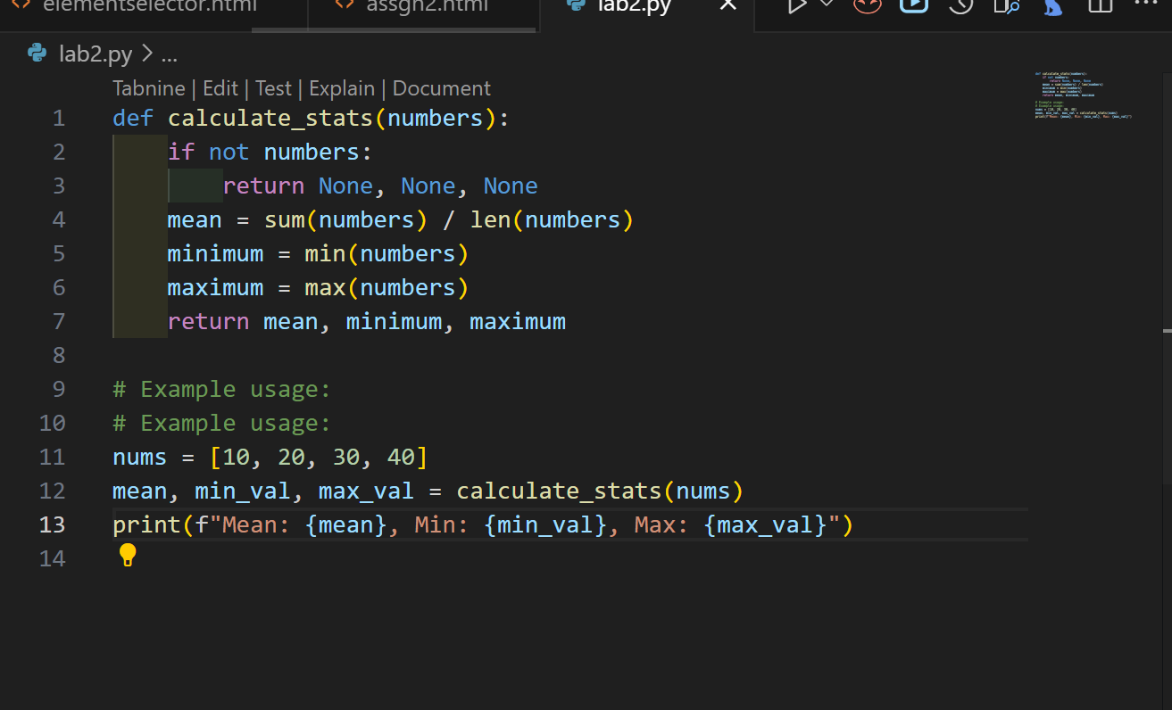

OUTPUT:

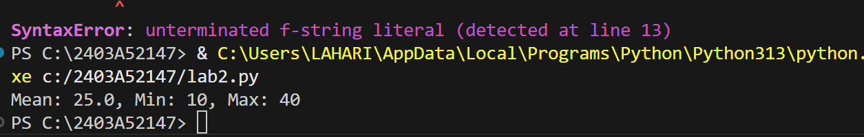

The output is different in ai gemini and in vs code

Because The code defines a function called calculate_stats that takes a list of numbers as input. It then calculates the mean, minimum, and maximum values from that list. If the input list is empty, it returns None for all three values. The example usage demonstrates how to call the function and print the results.

TASK 3

The selected cell contains the is_prime function.

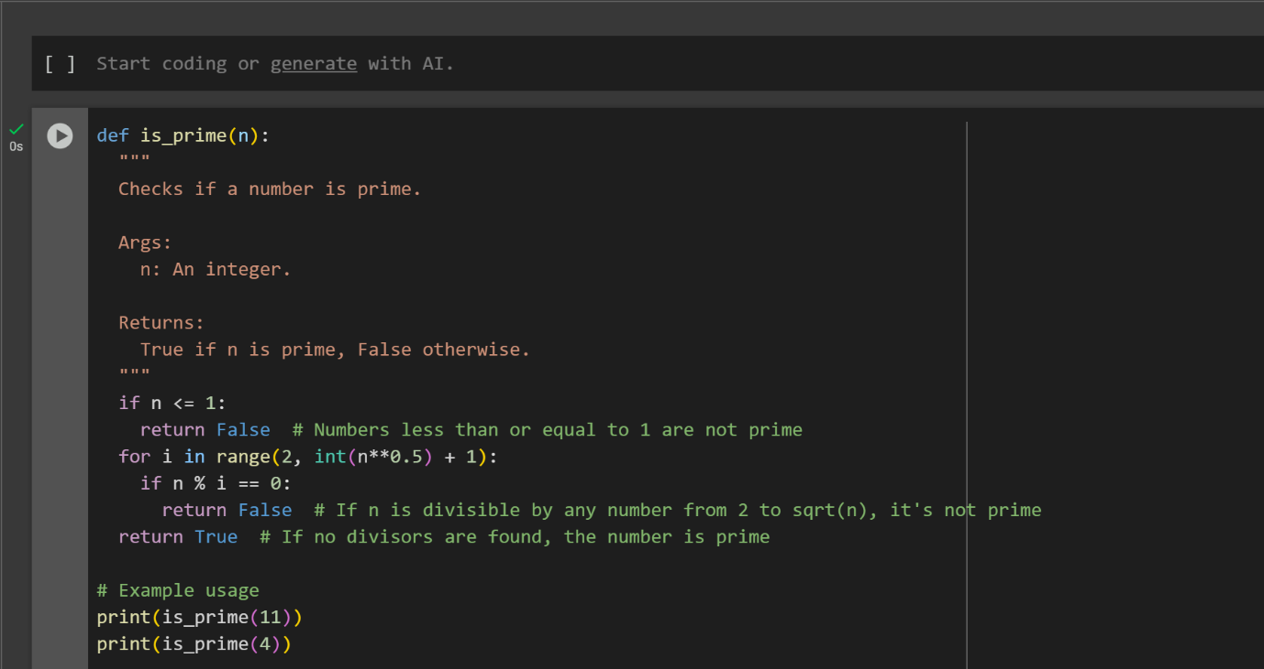

OUTPUT:



TASK 4:

USE AND GENERATE N NATURAL NUMBERS USING GEMINI AI AND CURSOR AI

CODE OF GEMINI AI

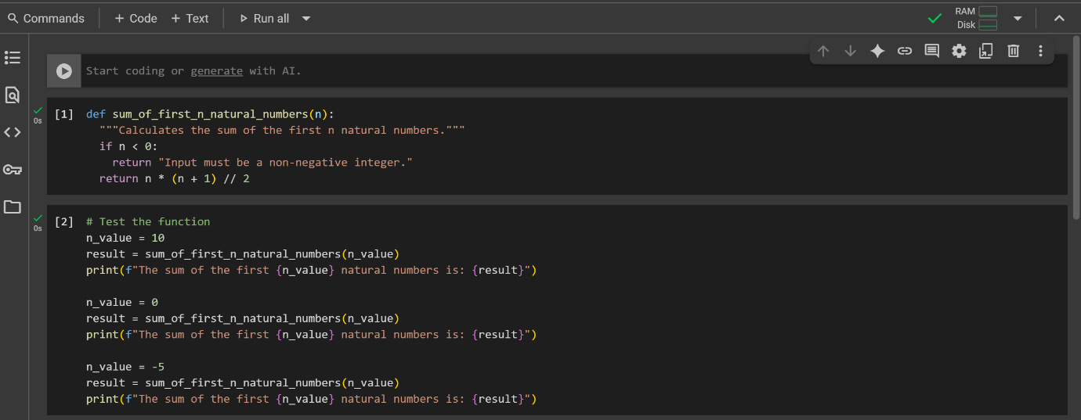

OUTPUT

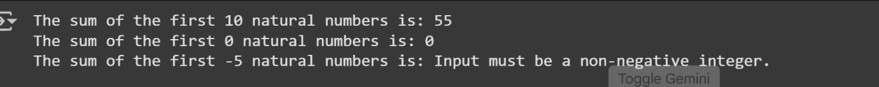

CODE IN CURSOR AI: