Week 1: Data Cleaning and Preliminary Analysis with R
Dataset: Titanic Passenger Data
Virtual R Data Analyst Internship Program
Submitted by: Raju Kumar Maurya
Tool Used: R (v4.3.3)

1. Overview of the Chosen Dataset
For this week's task, I selected the Titanic passenger dataset, a widely used public dataset that records information about the passengers aboard the RMS Titanic, including whether they survived the disaster. The dataset was sourced from a public GitHub data repository (originally derived from the well-known Kaggle Titanic competition dataset) and contains 891 observations across 12 original variables.
This dataset was chosen specifically because it satisfies the complexity requirements for this task:
- Missing values: The Age column has 177 missing entries (19.87%), the Cabin column has 687 missing entries (77.10%), and embarked has 2 missing entries.
- Mixed variable types: It contains numerical variables (Age, Fare, SibSp, Parch) and categorical variables (Sex, Embarked, Pclass, Cabin).
- Real-world messiness: Inconsistent completeness across columns, a heavily right-skewed Fare distribution, and potential outliers make it a realistic candidate for a full cleaning pipeline.

1.1 Variable Dictionary
Variable | Type | Description
PassengerId | Numeric | Unique identifier for each passenger
Survived | Categorical (0/1) | Survival outcome — target variable
Pclass | Categorical (1/2/3) | Ticket class (proxy for socio-economic status)
Name | Text | Passenger full name
Sex | Categorical | male / female
Age | Numeric | Age in years (has missing values)
SibSp | Numeric | Number of siblings/spouses aboard
Parch | Numeric | Number of parents/children aboard
Ticket | Text | Ticket number
Fare | Numeric | Passenger fare paid
Cabin | Categorical | Cabin number (mostly missing)
Embarked | Categorical | Port of embarkation (C/Q/S)

2. Data Cleaning Process
The cleaning process was carried out in R and followed a structured sequence: inspect the raw data, quantify missingness, treat missing values using method appropriate to each variable's type and missingness pattern, detect and treat outliers, normalize numeric features, and encode categorical variables for downstream analysis.

2.1 Initial Inspection
The dataset was loaded and inspected using str() and dim() to understand variable types and overall size.
df <- read.csv("titanic.csv", stringsAsFactors = FALSE)
str(df)
dim(df)
'data.frame': 891 obs. of 12 variables:
$ PassengerId: int 1 2 3 4 5 6 7 8 9 10 ...
$ Survived : int 0 1 1 1 0 0 0 0 1 1 ...
$ Pclass : int 3 1 3 1 3 3 1 3 3 2 ...
$ Sex : chr "male" "female" "female" "female" ...
$ Age : num 22 38 26 35 35 NA 54 2 27 14 ...
$ Fare : num 7.25 71.28 7.92 53.1 8.05 ...
$ Cabin : chr "" "C85" "" "C123" ...
$ Embarked : chr "S" "C" "S" "S" ...
[1] 891 12

2.2 Detecting Missing Values
Missing values were identified using is.na() combined with a check for empty strings, since categorical fields such as Cabin and Embarked store missing entries as blank strings rather than NA.
missing_summary <- sapply(df, function(x) sum(is.na(x) | x == ""))
print(missing_summary)
round(100 * missing_summary / nrow(df), 2)
PassengerId Survived Pclass Name Sex Age SibSp Parch Ticket Fare Cabin Embarked
0 0 0 0 0 177 0 0 0 0 687 2
Percentage missing:
Age: 19.87% Cabin: 77.10% Embarked: 0.22%

2.3 Handling Missing Values
Different imputation strategies were applied depending on each variable's data type and the extent of missingness:
- Age (19.87% missing, numeric): Imputed using the median (28 years) rather than the mean, since Age is right-skewed and the median is more robust to that skew and to the outliers detected in Section 2.4.
- Embarked (0.22% missing, categorical): Only 2 values were missing, so these were imputed with the mode (the most frequent port, 'S' — Southampton), which is a safe and standard approach for a small number of missing categorical entries.
- Cabin (77.10% missing, categorical): Given that over three-quarters of values are missing, direct imputation would be unreliable and could introduce significant bias. Instead of imputing or dropping the column outright, a new binary feature HasCabin was engineered (1 if a cabin number was recorded, 0 otherwise), preserving the signal that cabin data presence itself might correlate with passenger class or survival.

age_median <- median(df$Age, na.rm = TRUE) # 28
df$Age[is.na(df$Age)] <- age_median
embarked_mode <- names(which.max(table(df$Embarked[df$Embarked != ""]))) # "S"
df$Embarked[df$Embarked == ""] <- embarked_mode
df$HasCabin <- ifelse(df$Cabin == "", 0, 1)
Median Age used for imputation: 28
Embarked distribution: C: 168 Q: 77 S: 644
Mode of Embarked used for imputation: S
Missing values after cleaning:
Age Embarked
0 0

2.4 Outlier Detection
Outliers in the two key continuous variables (Age and Fare) were detected using the IQR (interquartile range) method: any value below Q1 - 1.5*IQR or above Q3 + 1.5*IQR was flagged.
detect_outliers_iqr <- function(x) {
q1 <- quantile(x, 0.25, na.rm = TRUE); q3 <- quantile(x, 0.75, na.rm = TRUE)
iqr <- q3 - q1
sum(x < (q1 - 1.5*iqr) | x > (q3 + 1.5*iqr), na.rm = TRUE)
}
detect_outliers_iqr(df$Fare) # 116 outliers
detect_outliers_iqr(df$Age) # 66 outliers
Fare summary: Min 0.00 | Median 14.45 | Mean 32.20 | Max 512.33
Number of Fare outliers (IQR method): 116
Age summary: Min 0.42 | Median 28.00 | Mean 29.36 | Max 80.00
Number of Age outliers (IQR method): 66

Fare had a substantial number of high-value outliers (116), consistent with a small number of first-class passengers who paid very high fares (up to 512.33, versus a median of only 14.45). Rather than deleting these rows and losing information, Fare was winsorized: values above the 99th percentile (249.01) were capped at that value, retaining all 891 records while limiting the influence of extreme values on later scaling and modeling steps.
fare_cap <- quantile(df$Fare, 0.99, na.rm = TRUE) # 249.01
df$Fare_capped <- ifelse(df$Fare > fare_cap, fare_cap, df$Fare)

2.5 Normalization
Age and the capped Fare were scaled to a common [0, 1] range using min-max normalization. This step is important before certain modeling techniques (planned for Week 3) since Fare and Age originally sit on very different numeric scales.
min_max_scale <- function(x) (x - min(x, na.rm=TRUE)) / (max(x, na.rm=TRUE) - min(x, na.rm=TRUE))
df$Age_scaled <- min_max_scale(df$Age)
df$Fare_scaled <- min_max_scale(df$Fare_capped)
Age_scaled: Min 0.000 | Median 0.347 | Mean 0.364 | Max 1.000
Fare_scaled: Min 0.000 | Median 0.058 | Mean 0.125 | Max 1.000

2.6 Encoding Categorical Variables
To make categorical fields usable in downstream statistical analysis and modeling, three encoding strategies were applied depending on the variable's structure:
- Sex: Binary label encoding (male = 1, female = 0), since it has exactly two categories.
- Embarked: One-hot encoding into three dummy columns (Embarked_C, Embarked_Q, Embarked_S), since it is an unordered categorical variable with three levels.
- Pclass: Converted to a labeled factor (First/Second/Third) for readability in plots and tables, while retaining the original numeric column since class has a natural order.
df$Sex_encoded <- ifelse(df$Sex == "male", 1, 0)
embarked_dummies <- model.matrix(~ Embarked - 1, data = df)
df <- cbind(df, embarked_dummies)
df$Pclass_label <- factor(df$Pclass, levels = c(1,2,3),
labels = c("First","Second","Third"))
Sex Sex_encoded Embarked Embarked_C Embarked_Q Embarked_S Pclass_label
1 male 1 S 0 0 1 Third
2 female 0 C 1 0 0 First
3 female 0 S 0 0 1 Third
4 female 0 S 0 0 1 First

3. Exploratory Data Analysis and Initial Insights
With the dataset cleaned, exploratory analysis was performed using summary(), str(), table(), prop.table(), and cor(), supported by visualizations to surface patterns in the data.

3.1 Descriptive Statistics
summary(df[, c("Survived","Pclass","Age","SibSp","Parch","Fare","HasCabin")])
Survived: Mean 0.384 (38.4% overall survival rate)
Pclass: Mean 2.309 (skewed toward 3rd class passengers)
Age: Median 28.00, Mean 29.36 (post-imputation)
SibSp: Median 0, Mean 0.523
Parch: Median 0, Mean 0.382
Fare: Median 14.45, Mean 32.20 (right-skewed)
HasCabin: Mean 0.229 (22.9% of passengers have a recorded cabin)

3.2 Survival Patterns by Sex and Class
prop.table(table(df$Sex, df$Survived), margin = 1) * 100
prop.table(table(df$Pclass_label, df$Survived), margin = 1) * 100
Survival rate by Sex:
female: 74.2% survived
male: 18.9% survived
Survival rate by Class:
First: 63.0% survived
Second: 47.3% survived
Third: 24.2% survived
These figures reveal two of the most well-documented patterns in the Titanic disaster: women were far more likely to survive than men (74.2% vs 18.9%), and survival rate declined sharply moving from First to Third class (63.0% down to 24.2%), consistent with historical accounts of "women and children first" evacuation priority and unequal access to lifeboats across classes.

3.3 Correlation Analysis
A correlation matrix was computed across the key numeric and encoded variables to quantify relationships with the Survived outcome.

num_vars <- df[, c("Survived","Pclass","Age","SibSp","Parch","Fare","HasCabin","Sex_encoded")]
round(cor(num_vars, use = "complete.obs"), 2)
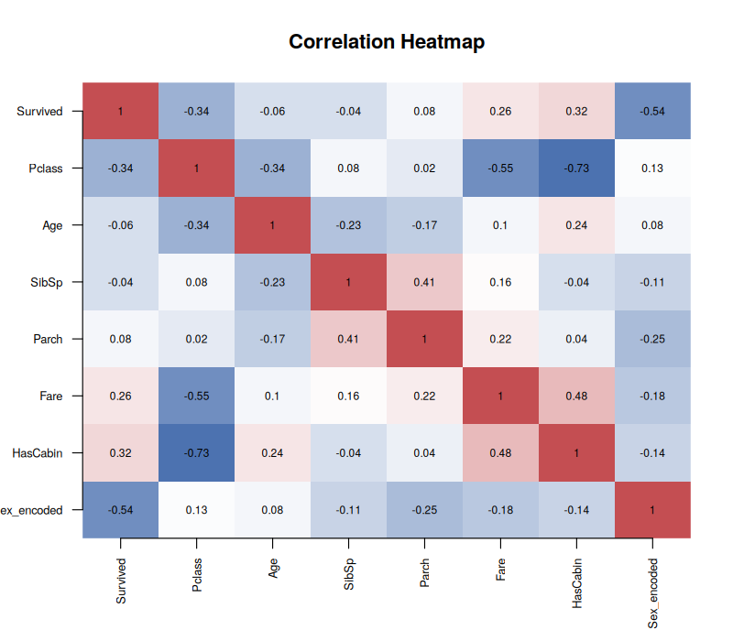
Figure 1: Correlation heatmap of key numeric variables
Sex_encoded shows the strongest correlation with Survived (-0.54), confirming that being male was strongly associated with lower survival. Pclass (-0.34) and HasCabin (0.32) are also meaningfully correlated with survival, while Age and family-size variables (SibSp, Parch) show weaker relationships. Notably, Pclass and HasCabin are strongly negatively correlated (-0.73), which makes sense: cabin numbers were recorded far more often for higher-class (lower Pclass number) passengers.

3.4 Visualizations
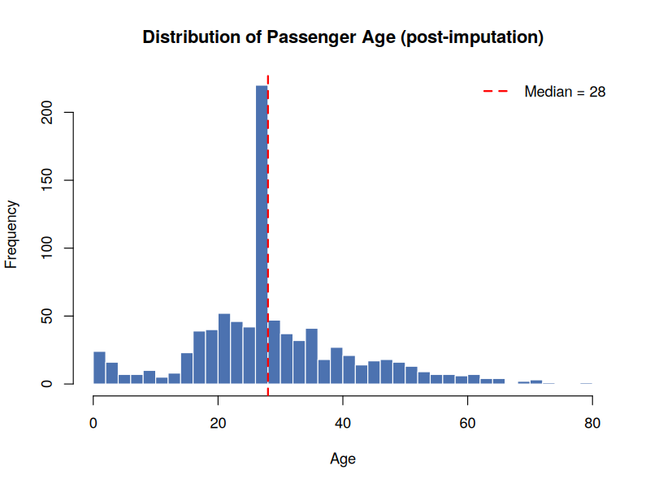
Figure 2: Distribution of passenger age after median imputation. The spike at age 28 reflects the 177 imputed values.
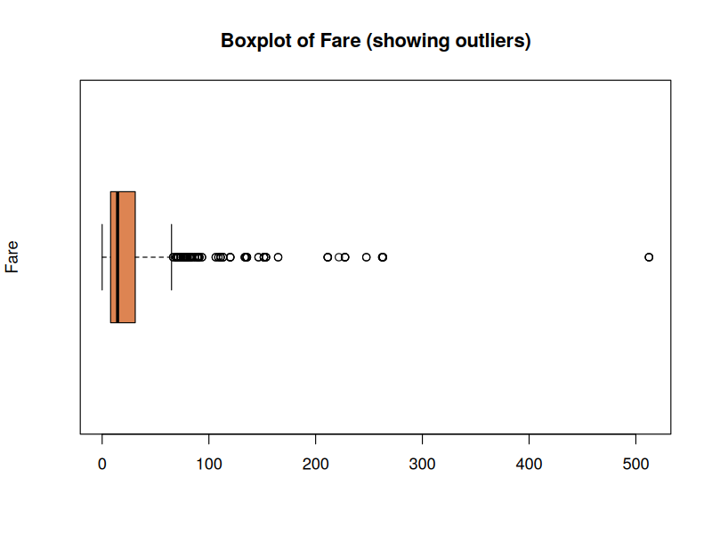
Figure 3: Boxplot of Fare, illustrating the long right tail and high-value outliers prior to capping.
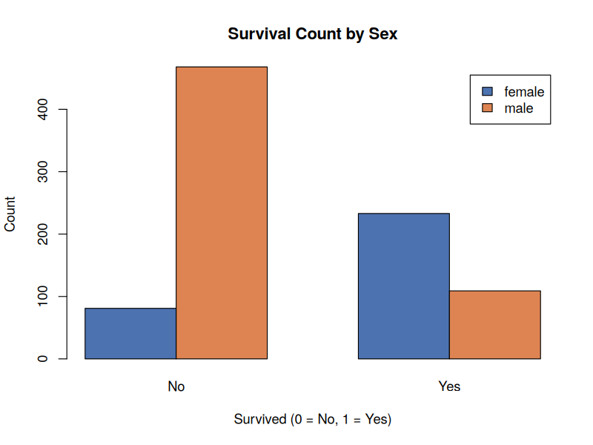
Figure 4: Survival counts by sex, showing markedly higher survival among female passengers.
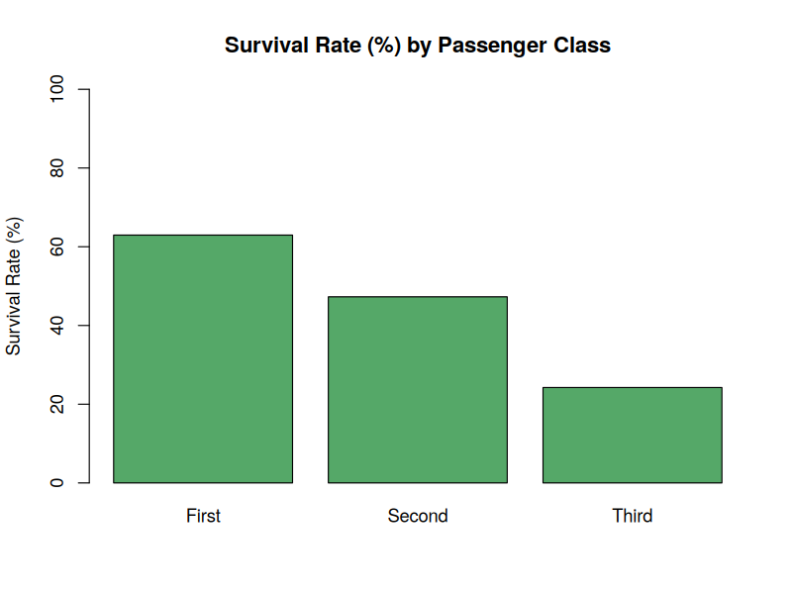
Figure 5: Survival rate (%) by passenger class, showing a clear decline from First to Third class.

4. Summary of Key Insights
- The dataset required targeted, type-appropriate cleaning: median imputation for skewed numeric data (Age), mode imputation for a near-complete categorical field (Embarked), and feature engineering rather than imputation for a mostly-missing field (Cabin → HasCabin).
- Fare contained significant high-end outliers, addressed via winsorization at the 99th percentile rather than row deletion, preserving the full sample of 891 passengers.
- Overall survival rate was 38.4%, but this varied enormously by sex (74.2% for women vs 18.9% for men) and by class (63.0% First class vs 24.2% Third class).
- Sex and passenger class emerged as the two variables most strongly correlated with survival, setting up promising predictors for the classification modeling task planned in Week 3.
- The cleaned, encoded dataset (21 variables, 891 rows, zero missing values in Age/Embarked) has been saved as titanic_cleaned.csv for use in subsequent weeks.

Tool used throughout: R version 4.3.3, base R functions only (no external packages required for this stage).

