Week 2: Data Visualization and Insight Communication using R
Dataset: Titanic Passenger Data
Virtual R Data Analyst Internship Program
Submitted by: Raju Kumar Maurya
Tool Used: R (v4.3.3) with ggplot2 (v3.4.4)

1. Data Overview
This week's visualization task continues with the Titanic passenger dataset that was cleaned in Week 1. The cleaned dataset (891 rows, 22 columns) has no missing values in Age or Embarked, includes an engineered HasCabin indicator, and has categorical variables already encoded alongside human-readable labels (Pclass_label, Survived_label).
Six visualizations were built using ggplot2, R's grammar-of-graphics visualization library, covering bar charts, a scatter plot, histograms, a line chart, and a boxplot — deliberately varying chart type to match the nature of each question being asked of the data.

1.1 Key Variables Used for Visualization
Variable | Type | Role in this week's charts
Survived_label | Categorical | Outcome of interest — colored/grouped across most charts
Pclass_label | Categorical (ordinal) | First / Second / Third — grouping variable
Sex | Categorical | male / female — grouping variable
Age | Numeric | Distribution, scatter, and age-group trend charts
Fare | Numeric | Scatter plot and boxplot by class
AgeBin | Categorical (engineered) | Age grouped into 7 bins for the survival-rate trend line

library(ggplot2)
df <- read.csv("titanic_cleaned.csv", stringsAsFactors = FALSE)
df$Pclass_label <- factor(df$Pclass_label, levels = c("First","Second","Third"))
df$Survived_label <- factor(df$Survived, levels = c(0,1),
labels = c("Did not survive","Survived"))

2. Visualization 1 — Bar Chart: Survival Counts by Class
A grouped bar chart was chosen to compare raw survival counts across the three passenger classes, since bar charts are the clearest way to compare counts across a small number of discrete categories.
ggplot(df, aes(x = Pclass_label, fill = Survived_label)) +
geom_bar(position = "dodge", width = 0.7) +
scale_fill_manual(values = c("Did not survive"="#C44E52","Survived"="#4C8C4C")) +
labs(title = "Survival Counts by Passenger Class",
x = "Passenger Class", y = "Number of Passengers")
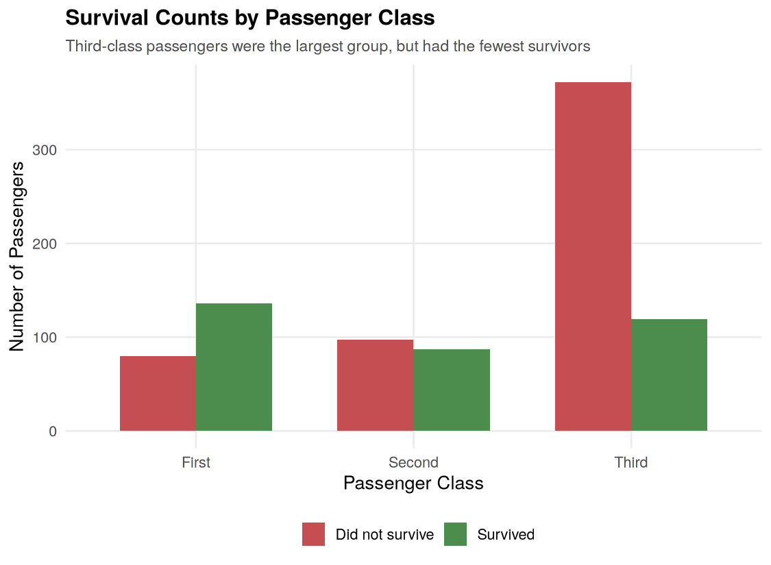
Figure 1: Survival counts by passenger class
Did not survive Survived
First 80 136
Second 97 87
Third 372 119
Insight: Third class carried by far the most passengers (491 total) yet produced the fewest survivors (119) — fewer than First class's 136 survivors despite First class carrying under half as many people overall. This chart was selected specifically because it makes the disproportionate impact on Third-class passengers immediately visible through simple side-by-side bar comparison.

3. Visualization 2 — Scatter Plot: Age vs. Fare by Survival
A scatter plot was used to examine the relationship between two continuous variables (Age and Fare) simultaneously, with color used as a third dimension to show survival outcome — a natural fit for scatter plots, which excel at revealing relationships between two numeric variables.
ggplot(df, aes(x = Age, y = Fare, color = Survived_label)) +
geom_point(alpha = 0.6, size = 2) +
scale_color_manual(values = c("Did not survive"="#C44E52","Survived"="#4C8C4C")) +
labs(title = "Age vs. Fare, Colored by Survival Outcome")
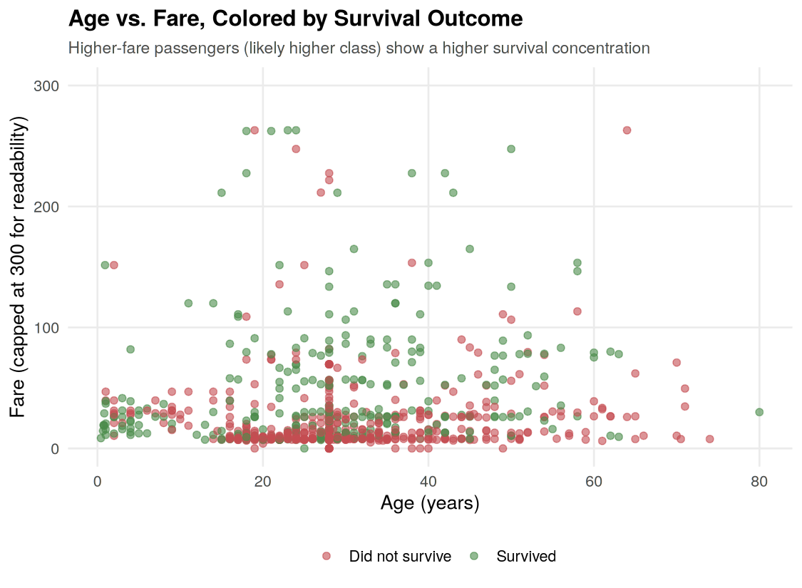
Figure 2: Age vs Fare scatter plot, colored by survival
Correlation between Age and Fare: 0.097 (very weak positive relationship)
Insight: There is only a very weak correlation (0.097) between Age and Fare — age alone does not predict how much a passenger paid. However, the color overlay shows a visibly denser cluster of green (survived) points at higher fare levels, reinforcing that Fare (a proxy for class and wealth) mattered more to survival than Age did on its own.

4. Visualization 3 — Histogram: Age Distribution by Survival
Histograms are the standard choice for visualizing the shape of a single numeric variable's distribution. Faceting by survival outcome allows direct visual comparison of two distributions without overlapping bars obscuring each other.
ggplot(df, aes(x = Age, fill = Survived_label)) +
geom_histogram(binwidth = 5, color = "white", alpha = 0.85) +
facet_wrap(~Survived_label, ncol = 1) +
labs(title = "Age Distribution by Survival Outcome")
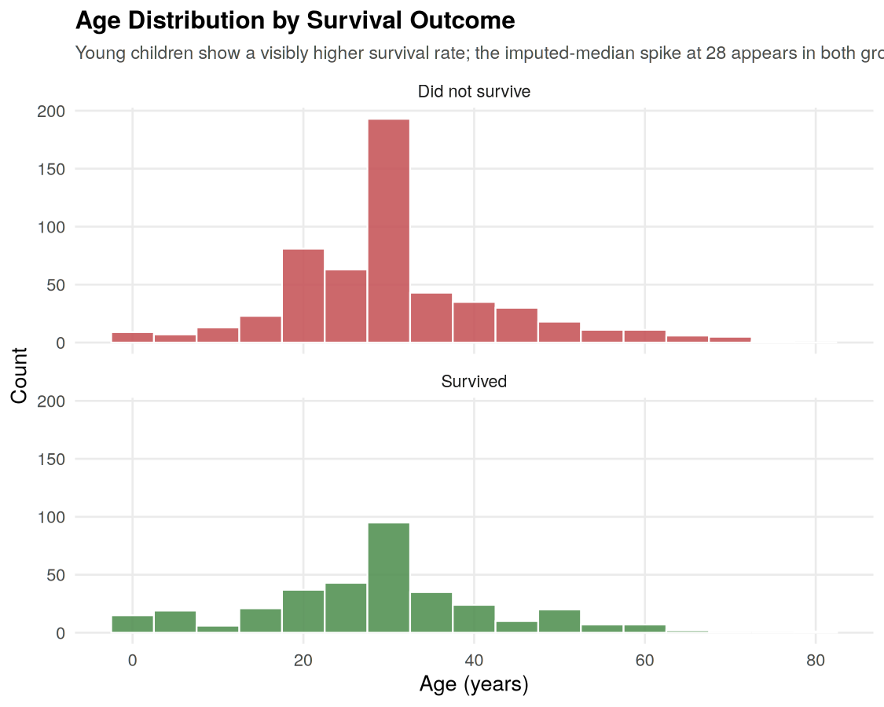
Figure 3: Age distribution, faceted by survival outcome
Survival rate for passengers aged 12 or under: 58.0%
Survival rate for passengers over 12: 36.7%
Insight: Children aged 12 and under survived at 58.0%, compared to 36.7% for everyone older — a clear signal of the "children first" evacuation priority. The histogram also shows the imputation spike at age 28 (from Week 1's median-fill strategy) appearing in both panels, which is worth noting transparently as an artifact of the cleaning process rather than a genuine data pattern.

5. Visualization 4 — Line Chart: Survival Rate Trend by Age Group
A line chart was used to show survival rate as a trend across ordered age groups. Line charts communicate trends across an ordered sequence more clearly than bar charts, since the connecting line draws the eye along the trajectory of the rate as age increases.
df$AgeBin <- cut(df$Age, breaks = c(0,5,12,18,30,45,60,80),
labels = c("0-5","6-12","13-18","19-30","31-45","46-60","61-80"))
age_surv_rate <- aggregate(Survived ~ AgeBin, data = df, FUN = mean)
ggplot(age_surv_rate, aes(x = AgeBin, y = Survived*100, group = 1)) +
geom_line(color = "#4C72B0", linewidth = 1.2) +
geom_point(size = 3) +
labs(title = "Survival Rate Trend Across Age Groups")
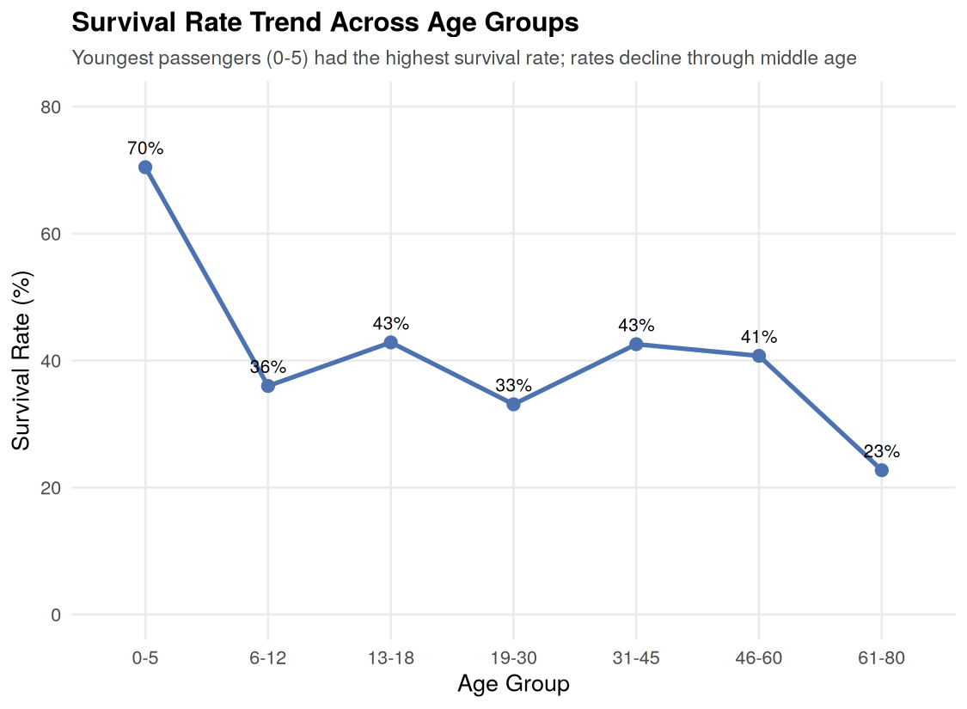
Figure 4: Survival rate (%) trend across age groups
AgeBin SurvivalPct
0-5 70.5%
6-12 36.0%
13-18 42.9%
19-30 33.1%
31-45 42.6%
46-60 40.7%
61-80 22.7%
Insight: Survival rate peaks sharply for the youngest group (0-5 years, 70.5%), drops for older children and young adults, fluctuates in a fairly narrow band through middle age, and falls to its lowest point for passengers over 60 (22.7%) — plausibly reflecting both fewer elderly passengers overall and reduced mobility during evacuation.

6. Visualization 5 — Grouped Bar Chart: Survival Rate by Sex and Class
This chart combines two categorical grouping variables (Sex and Class) against a computed rate (not a raw count), using a grouped bar chart with data labels so the exact percentage is readable at a glance — important for a chart intended to be understood by a non-technical audience.
sex_class_surv <- aggregate(Survived ~ Sex + Pclass_label, data = df, FUN = mean)
ggplot(sex_class_surv, aes(x = Pclass_label, y = Survived*100, fill = Sex)) +
geom_col(position = "dodge", width = 0.65) +
geom_text(aes(label = paste0(round(Survived*100,0),"%")),
position = position_dodge(width = 0.65), vjust = -0.5) +
labs(title = "Survival Rate (%) by Sex and Passenger Class")
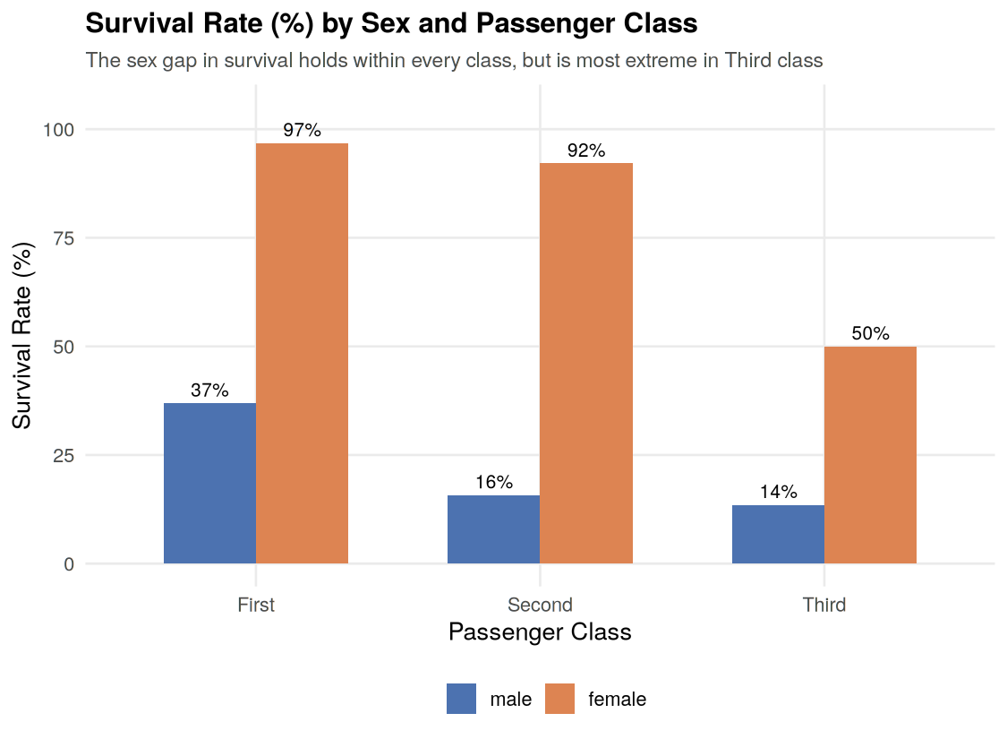
Figure 5: Survival rate (%) by sex and passenger class
Sex Class SurvivalPct
male First 36.9%
female First 96.8%
male Second 15.7%
female Second 92.1%
male Third 13.5%
female Third 50.0%
Insight: This is the single most important chart in the analysis — it shows that the female survival advantage holds within every class, but the gap is most extreme in Third class (50.0% for women vs just 13.5% for men — a 36.5 percentage-point gap), compared to a 59.9-point gap in First class. First-class women survived at a remarkable 96.8% rate, while Third-class men survived at only 13.5%, illustrating how sex and class compounded together to determine survival odds.

7. Visualization 6 — Boxplot: Fare Distribution by Class
A boxplot was chosen to summarize and compare the spread, median, and outliers of Fare across the three classes simultaneously — boxplots are well suited to comparing a numeric distribution across several categorical groups in a single compact chart.
ggplot(df, aes(x = Pclass_label, y = Fare, fill = Pclass_label)) +
geom_boxplot(alpha = 0.8, outlier.color = "#C44E52") +
labs(title = "Fare Distribution by Passenger Class")
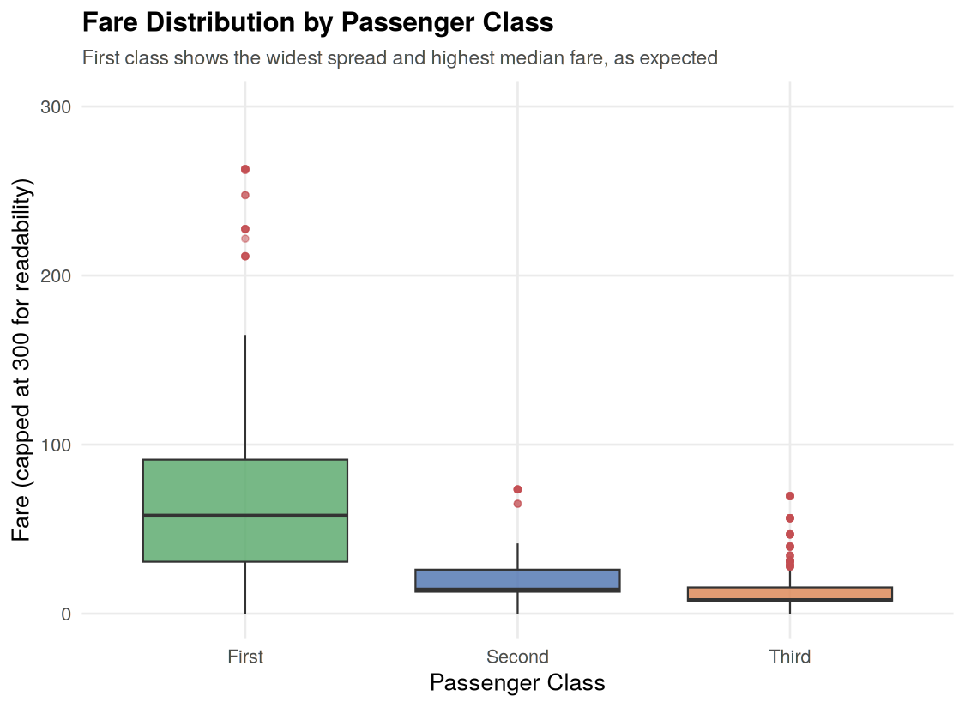
Figure 6: Fare distribution by passenger class
Median Fare by Class:
First: 60.29
Second: 14.25
Third: 8.05
Insight: The median First-class fare (60.29) was over 4 times the Second-class median (14.25) and roughly 7.5 times the Third-class median (8.05). First class also shows by far the widest spread and the most high-value outliers, consistent with Fare acting as a strong proxy for socio-economic status — and, combined with the earlier charts, helping explain why Fare and HasCabin were both meaningfully correlated with survival in Week 1's analysis.

8. Summary of Key Insights
- Third-class passengers made up the largest group aboard but had the fewest survivors in absolute terms, despite outnumbering First class more than 2-to-1.
- Age and Fare are only weakly correlated (0.097); Fare (and by extension, class) was a far stronger survival factor than Age on its own.
- Children aged 12 and under survived at 58.0% versus 36.7% for older passengers, and the youngest age band (0-5) had the single highest survival rate of any group (70.5%).
- The female survival advantage held in every class but widened dramatically moving from First to Third class, showing sex and class effects compounded rather than acted independently.
- Fare distributions confirm a clear economic hierarchy across classes (median fares of 60.29 / 14.25 / 8.05 for First/Second/Third), reinforcing Fare as a reliable proxy for socio-economic status in this dataset.
- Chart type was deliberately varied to match the analytical question: bar charts for categorical counts, a scatter plot for two-numeric-variable relationships, histograms for distribution shape, a line chart for an ordered trend, and a boxplot for distributional comparison across groups.

Tool used throughout: R version 4.3.3 with ggplot2 version 3.4.4.

