Week 3: Statistical Analysis and Predictive Modeling using R
Dataset: Titanic Passenger Data
Virtual R Data Analyst Internship Program
Submitted by: Raju Kumar Maurya
Tool Used: R (v4.3.3), base R statistical functions

1. Dataset and Rationale
This week's task builds directly on the Titanic dataset cleaned in Week 1 and visualized in Week 2 (891 passengers, 21 cleaned/engineered variables). The dataset is well suited to predictive modeling because it has a well-defined binary outcome (Survived), a mix of strong and weak candidate predictors established in prior weeks (Sex and Pclass showed the strongest associations with survival), and enough observations (891) to support a meaningful train/test split and cross-validation.
The goal this week is twofold: (1) formally test, using hypothesis tests rather than visual inspection alone, whether the patterns observed in Week 2 are statistically significant; and (2) build a classification model that predicts survival from passenger characteristics, and evaluate how well it performs on unseen data.

2. Exploratory Statistical Analysis and Hypothesis Testing

2.1 Normality Testing (Shapiro-Wilk)
Before choosing between parametric and non-parametric tests, the Shapiro-Wilk test was used to check whether Age and Fare follow a normal distribution.
shapiro.test(df$Age)
shapiro.test(df$Fare)
Age -> W = 0.9541 p-value = 4.651e-16
Fare -> W = 0.5219 p-value < 2.2e-16
Both p-values are far below 0.05, so the null hypothesis of normality is rejected for both variables. This confirms what Week 2's histograms suggested visually: Fare is heavily right-skewed, and Age carries an artificial spike at the median (28) introduced by Week 1's imputation. This result determines the choice of test in Section 2.2 below — a non-parametric test is more appropriate than a t-test for Fare.

2.2 Fare by Survival Status (Wilcoxon Rank-Sum Test)
Since Fare is non-normally distributed, the Wilcoxon rank-sum test (a non-parametric alternative to the independent t-test) was used to test whether Fare differs between survivors and non-survivors.
wilcox.test(Fare ~ Survived, data = df)
H0: Fare distribution is the same for survivors and non-survivors
H1: Fare distribution differs between survivors and non-survivors
W = 57806, p-value < 2.2e-16
The p-value is far below 0.05, so H0 is rejected: survivors paid significantly higher fares than non-survivors, statistically confirming the pattern observed in Week 2's scatter plot and boxplot.

2.3 Survival vs. Sex (Chi-Square Test of Independence)
chisq.test(table(df$Sex, df$Survived))

H0: Survival is independent of Sex
H1: Survival is associated with Sex
X-squared = 260.72, df = 1, p-value < 2.2e-16
H0 is decisively rejected. This is one of the strongest results in the entire analysis and statistically confirms the large survival gap between men and women observed throughout Weeks 1–2.

2.4 Survival vs. Passenger Class (Chi-Square Test of Independence)
chisq.test(table(df$Pclass_label, df$Survived))
H0: Survival is independent of Passenger Class
H1: Survival is associated with Passenger Class
X-squared = 102.89, df = 2, p-value < 2.2e-16
H0 is again rejected, confirming that passenger class is significantly associated with survival — consistent with the class-based survival gaps shown in Week 2.

2.5 Age–Fare Correlation Significance
cor.test(df$Age, df$Fare)
r = 0.097, 95% CI [0.031, 0.161], p-value = 0.0039
Although statistically significant (p = 0.004) due to the large sample size, the correlation itself is very weak (r = 0.097). This is an important nuance: statistical significance does not imply practical importance — Age and Fare are essentially unrelated in any meaningful sense, consistent with Week 2's finding.

3. Predictive Model Building

3.1 Train/Test Split
The cleaned dataset was randomly split into a 70% training set and a 30% held-out test set, with a fixed random seed for reproducibility. The model is trained only on the training set; the test set is used exclusively for final, unbiased evaluation.
set.seed(42)
train_idx <- sample(seq_len(nrow(df)), size = 0.7 * nrow(df))
train <- df[train_idx, ]
test <- df[-train_idx, ]
Training set: 623 rows
Test set: 268 rows

3.2 Model Choice and Specification
Since the target variable Survived is binary (0/1), logistic regression was selected as the modeling approach — the standard, interpretable method for binary classification, and well suited to a dataset of this size. The model includes passenger class, sex, age, family-size variables (SibSp, Parch), fare, and the HasCabin indicator engineered in Week 1.
model <- glm(Survived ~ Pclass_label + Sex + Age + SibSp + Parch + Fare + HasCabin,
data = train, family = binomial(link = "logit"))
summary(model)

Coefficients:
Estimate Std.Error z value Pr(>|z|)
(Intercept) 0.2721 0.5813 0.468 0.6397
Pclass_labelSecond -0.3295 0.4579 -0.720 0.4718
Pclass_labelThird -1.3325 0.4665 -2.856 0.0043 **
Sexfemale 2.7949 0.2374 11.773 < 2e-16 ***
Age -0.0430 0.0101 -4.255 2.1e-05 ***
SibSp -0.3826 0.1274 -3.002 0.0027 **
Parch -0.0023 0.1552 -0.015 0.9881
Fare 0.0037 0.0028 1.306 0.1916
HasCabin 0.8300 0.3960 2.096 0.0361 *
Null deviance: 822.63 on 622 degrees of freedom
Residual deviance: 535.25 on 614 degrees of freedom
AIC: 553.25
Sex, Age, SibSp, Third class, and HasCabin are all statistically significant predictors (p < 0.05). Fare and Parch are not significant once the other variables are controlled for — notably, Fare's predictive power appears to be largely captured by Pclass and HasCabin once those are included together, since fare, class, and cabin presence are all correlated proxies for the same underlying socio-economic status.

3.3 Odds Ratios
Exponentiating the model coefficients converts them into odds ratios, which are more intuitively interpretable than log-odds coefficients.
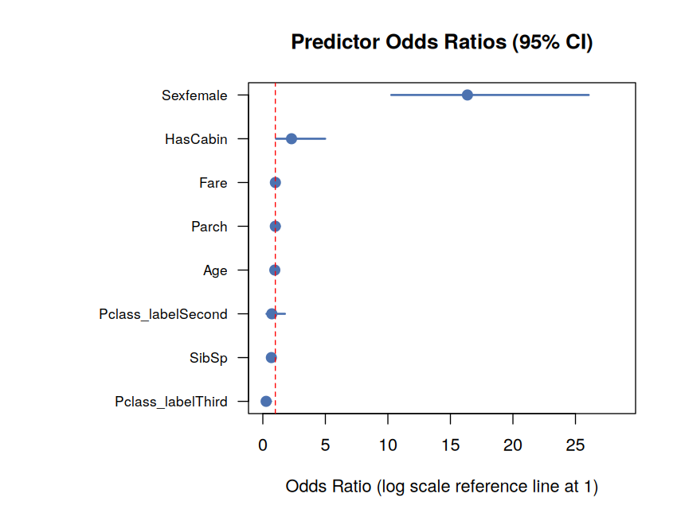
Figure 1: Predictor odds ratios with 95% confidence intervals (dashed line = no effect)
Sexfemale: OR = 16.36 [10.27, 26.06] -> being female multiplies survival odds ~16x
HasCabin: OR = 2.29 [ 1.06, 4.98] -> having a recorded cabin roughly doubles odds
Pclass_labelThird: OR = 0.26 [ 0.11, 0.66] -> Third class cuts odds to ~1/4 of First class
SibSp: OR = 0.68 [ 0.53, 0.88] -> each additional sibling/spouse lowers odds ~32%
Age: OR = 0.96 [ 0.94, 0.98] -> each additional year lowers odds slightly
The magnitude of the Sex effect stands out clearly: all else being equal, being female was associated with roughly 16 times higher odds of survival than being male — by far the strongest predictor in the model, consistent with the hypothesis test results in Section 2.3.

3.4 Cross-Validation
To check that the model's performance is stable and not dependent on one particular train/test split, 5-fold cross-validation was performed on the training set.
folds <- sample(rep(1:5, length.out = nrow(train)))
# fit model on 4 folds, predict on the held-out fold, repeat 5 times
Per-fold accuracy: 0.840, 0.832, 0.776, 0.815, 0.742
Mean CV accuracy: 0.801 (SD: 0.041)
The model achieves a consistent ~80% accuracy across folds, with moderate variability (SD 4.1 percentage points), suggesting the model generalizes reasonably well rather than overfitting to one particular subset of the training data.

4. Model Diagnostics and Evaluation on Test Set

4.1 Confusion Matrix
The trained model was applied to the held-out 268-row test set (never seen during training) using a 0.5 probability threshold to classify predictions.
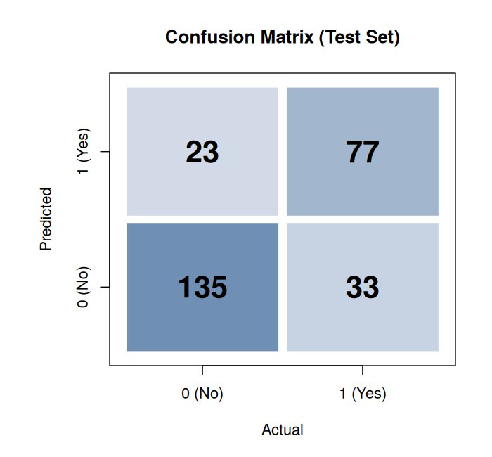
Figure 2: Confusion matrix on the test set
Accuracy : 0.791
Precision : 0.770 (of predicted survivors, 77% actually survived)
Recall : 0.700 (of actual survivors, 70% were correctly identified)
Specificity: 0.854 (of actual non-survivors, 85% were correctly identified)
F1 Score : 0.733
The model correctly classified 79.1% of test-set passengers. It is somewhat better at identifying non-survivors (85.4% specificity) than survivors (70.0% recall), meaning the model is more cautious about predicting survival — it misses some true survivors (23 false negatives) more often than it wrongly predicts survival for someone who didn't (33 false positives).

4.2 ROC Curve and AUC
The ROC curve plots the true positive rate against the false positive rate across all possible classification thresholds, and the Area Under the Curve (AUC) summarizes overall discriminative ability independent of any single threshold choice.
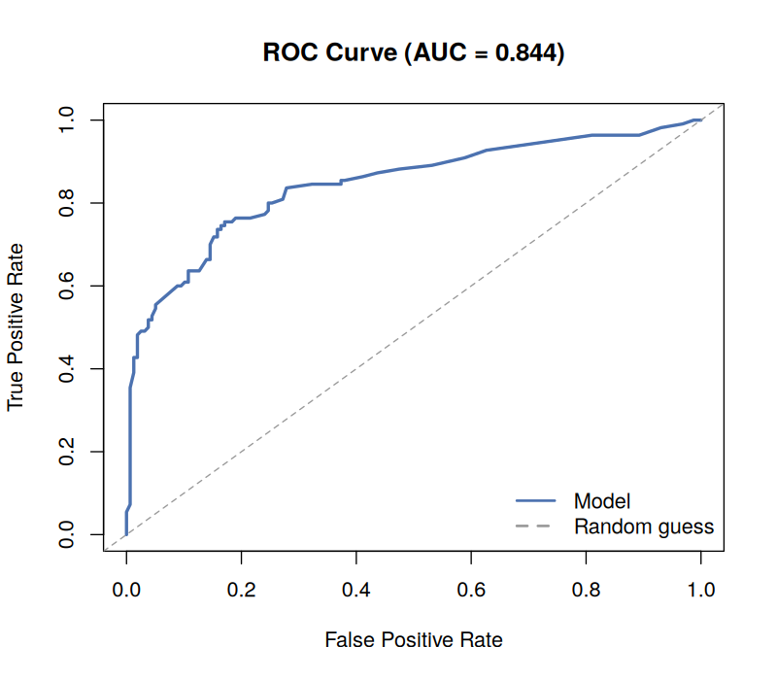
Figure 3: ROC curve for the logistic regression model
AUC (Area Under ROC Curve): 0.844
An AUC of 0.844 indicates good discriminative ability (a value of 0.5 would represent no better than random guessing, and 1.0 would be perfect separation). This means that, given a random survivor and a random non-survivor from the test set, the model assigns a higher predicted probability to the actual survivor about 84% of the time.

4.3 Residual Diagnostics
Deviance residuals were plotted against fitted values to check for systematic patterns that might indicate poor model fit.
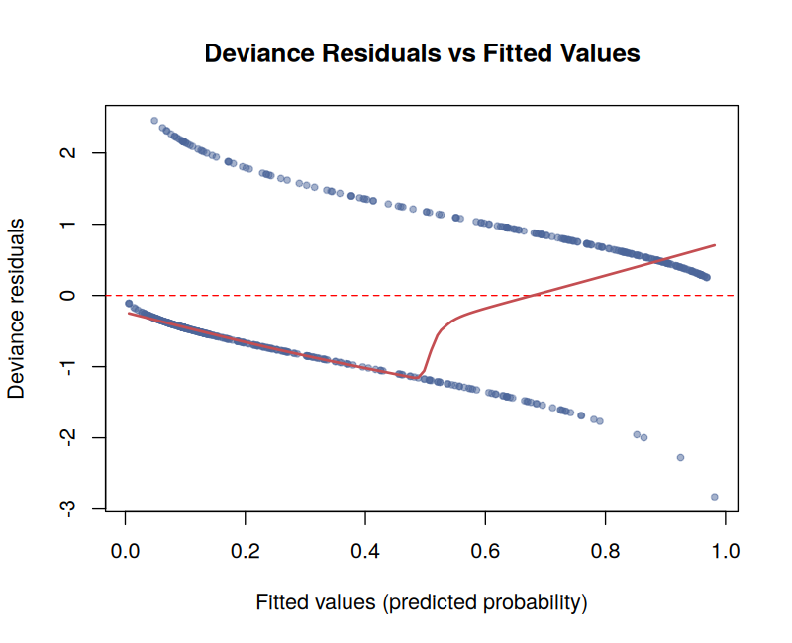
Figure 4: Deviance residuals vs fitted values
The two visible diagonal bands are expected and characteristic of logistic regression residual plots for a binary outcome — one band corresponds to actual Survived = 1 cases and the other to Survived = 0 cases, since the residual for each observation depends only on its fitted probability and its single binary outcome. This banding pattern is normal for logistic regression and does not by itself indicate poor fit; a smoothed trend line (red) close to zero across most of the fitted-value range indicates no severe systematic bias.

4.4 Predicted Probability Distribution by Actual Outcome
As a final sanity check, predicted probabilities were compared against actual outcomes: a well-calibrated model should predict higher probabilities for passengers who actually survived.
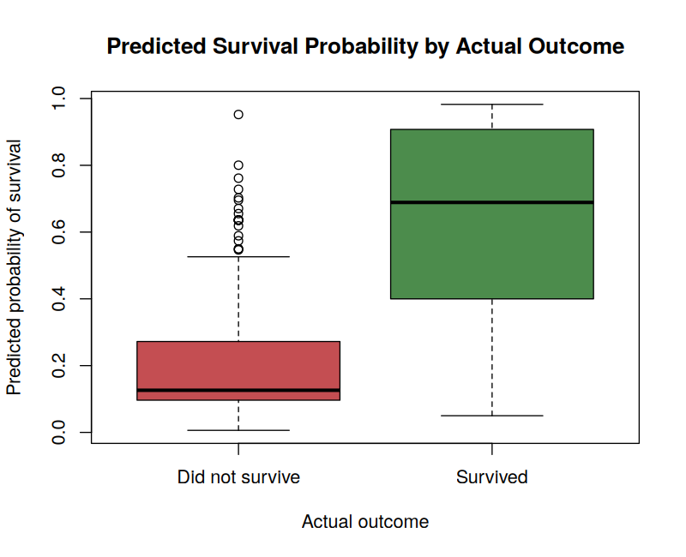
Figure 5: Predicted survival probability, grouped by actual outcome
The boxplot confirms good separation: passengers who actually survived have a visibly higher median predicted probability than those who did not, though there is some overlap — consistent with the model's 79.1% accuracy rather than perfect classification.

5. Summary: Model Strengths and Areas for Improvement

5.1 Strengths
- All four hypothesis tests (Fare, Sex, Class, and the Age-Fare correlation) returned statistically significant results (p < 0.05), giving a rigorous statistical foundation to the patterns first observed visually in Week 2.
- The model achieves 79.1% test accuracy and an AUC of 0.844, both solid results for a relatively simple 8-predictor logistic regression on this dataset.
- 5-fold cross-validation confirms the model is stable (mean 80.1% accuracy, SD 4.1%) rather than a result of a lucky train/test split.
- Odds ratios are highly interpretable: Sex (OR ≈ 16.4) and HasCabin (OR ≈ 2.3) increase survival odds, while Third class (OR ≈ 0.26) and each additional sibling/spouse aboard (OR ≈ 0.68 per unit) decrease them.

5.2 Potential Improvements
- Recall (70.0%) is noticeably lower than specificity (85.4%) — the model under-identifies survivors. Adjusting the classification threshold below 0.5, or using a cost-sensitive approach, could improve recall if identifying survivors is the priority.
- Fare and Parch were not statistically significant in the full model, likely due to overlap with Pclass and HasCabin; testing a simplified model or examining multicollinearity (e.g. variance inflation factors) could clarify whether they add value.
- Only a linear logistic specification was tested; non-linear alternatives (e.g. a decision tree, random forest, or including interaction terms such as Sex × Pclass) could potentially capture the compounding sex/class effect noted in Week 2 more precisely and may improve accuracy further.
- The Age imputation strategy from Week 1 (median fill) introduces an artificial spike at age 28, visible in the residual plot's data density; a more sophisticated imputation method (e.g. predictive imputation using Pclass and Sex) could reduce this artifact's influence on the model.

Tool used throughout: R version 4.3.3, base R statistical and modeling functions (glm, chisq.test, wilcox.test, shapiro.test, cor.test) — no external modeling packages required.

