Analyzing Titanic Passenger Survival:
A Complete Data Analysis Workflow in R
Final Comprehensive Report — Weeks 1 through 4
Virtual R Data Analyst Internship Program
Submitted by: Raju Kumar Maurya
Tool Used: R (v4.3.3) with ggplot2 (v3.4.4) and base R statistical functions

1. Introduction
This report consolidates four weeks of work analyzing the Titanic passenger dataset using R, presenting a complete, end-to-end data analysis workflow: data cleaning and preprocessing, exploratory visualization, statistical hypothesis testing, and predictive modeling.
The Titanic dataset was selected in Week 1 specifically because it satisfies the internship's requirement for a realistically complex, publicly available dataset — one with meaningful missing data, a mix of numerical and categorical variables, and a genuine analytical question (what factors determined who survived the disaster) that a data-driven approach can meaningfully answer.
The dataset comprises 891 passenger records from the RMS Titanic, sourced from a public GitHub data repository (originally derived from the well-known Kaggle Titanic competition), with 12 original variables covering passenger demographics, ticket information, and survival outcome.

1.1 Objectives Across the Four Weeks
Week | Focus | Key Output
1 | Data cleaning & preprocessing | Missing value treatment, outlier handling, normalization, encoding
2 | Data visualization | Six ggplot2 visualizations communicating survival patterns
3 | Statistical analysis & modeling | Hypothesis tests + logistic regression classifier
4 | Comprehensive reporting | This consolidated report, integrating Weeks 1–3

2. Methodology
The analysis followed a standard data science pipeline, with each week's output feeding directly into the next:
- Week 1 — Data Preparation: Loaded the raw 891-row dataset, quantified missingness, applied type-appropriate imputation, detected and treated outliers, normalized numeric features, and encoded categorical variables — producing a clean 21-variable dataset used unchanged in every subsequent week.
- Week 2 — Exploratory Visualization: Built six ggplot2 visualizations (bar charts, scatter plot, histograms, line chart, boxplot) chosen specifically to match each analytical question, surfacing patterns in survival by class, sex, age, and fare.
- Week 3 — Statistical Validation and Modeling: Formally tested the patterns observed in Week 2 using hypothesis tests (Shapiro-Wilk, Wilcoxon, Chi-square, Pearson correlation), then built and evaluated a logistic regression classifier using a 70/30 train-test split and 5-fold cross-validation.
- Week 4 (this report) — Synthesis: Integrates the cleaning methodology, key visual findings, and modeling results into a single narrative, with a discussion of business/historical implications and recommendations for further analysis.
All analysis was performed in R (version 4.3.3), using base R functions throughout Weeks 1 and 3, and the ggplot2 package (version 3.4.4) for Week 2's visualizations. No external datasets or manual data entry were used — all figures in this report are reproducible directly from the attached R scripts.

3. Data Preparation
The raw dataset contained 891 rows and 12 columns with three fields having missing data: Age (177 missing, 19.87%), Cabin (687 missing, 77.10%), and Embarked (2 missing, 0.22%). Each was treated with a method appropriate to its type and extent of missingness.
age_median <- median(df$Age, na.rm = TRUE) # 28
df$Age[is.na(df$Age)] <- age_median
embarked_mode <- names(which.max(table(df$Embarked[df$Embarked != ""]))) # "S"
df$Embarked[df$Embarked == ""] <- embarked_mode
df$HasCabin <- ifelse(df$Cabin == "", 0, 1) # engineered feature
Variable | Missing % | Method | Rationale
Age | 19.87% | Median imputation | Robust to right-skew and outliers
Embarked | 0.22% | Mode imputation | Only 2 rows; safe for near-complete field
Cabin | 77.10% | Feature engineering (HasCabin) | Too sparse to impute reliably

Outliers in Fare were detected using the IQR method (116 flagged) and treated via winsorizing at the 99th percentile (capping at 249.01) rather than deletion, preserving the full sample. Age and capped Fare were then min-max normalized to a [0,1] range, and categorical variables were encoded: Sex via binary label encoding, Embarked via one-hot encoding, and Pclass as a labeled ordinal factor.
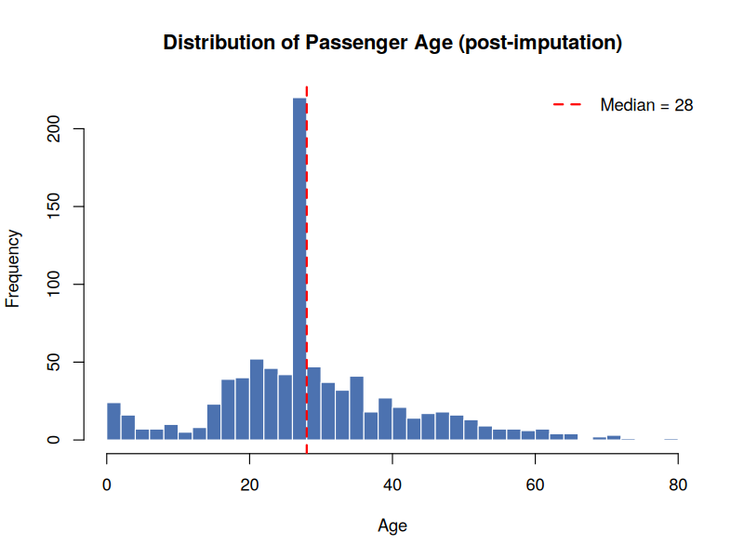
Figure 1: Age distribution after median imputation (Week 1)

4. Data Visualization and Key Findings
Six visualizations were built to explore survival patterns from multiple angles, deliberately varying chart type to match each question. The two most decisive findings are reproduced below; the complete set of six charts with full R code is included in the Week 2 report.

4.1 Survival by Sex and Class Compound Strongly
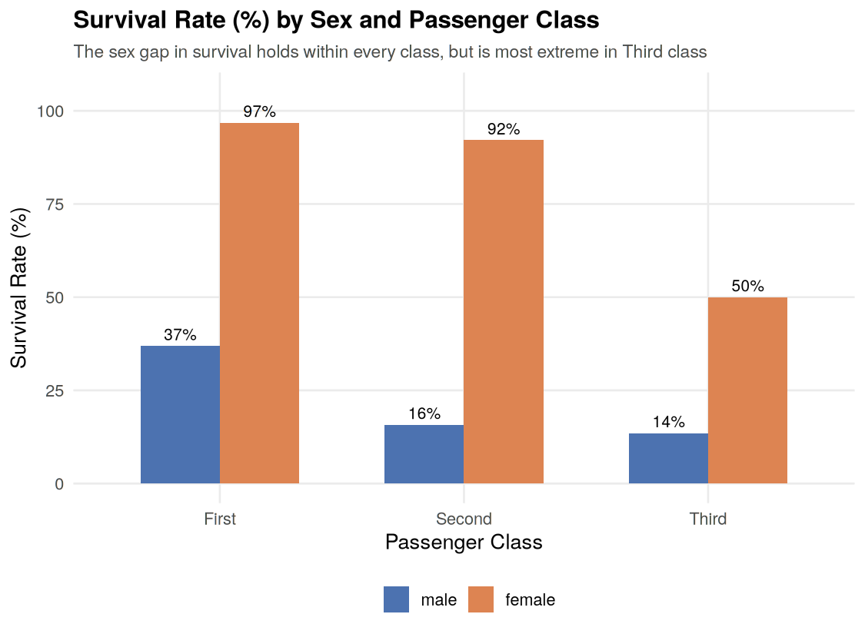
Figure 2: Survival rate (%) by sex and passenger class (Week 2)
The female survival advantage held within every passenger class, but widened dramatically moving from First to Third class — from a 59.9 percentage-point gap in First class (96.8% women vs 36.9% men) to a still-substantial but narrower 36.5-point gap in Third class (50.0% women vs 13.5% men). This is the clearest evidence that sex and class did not act independently, but compounded to determine survival odds.

4.2 Age Mattered Most at the Extremes
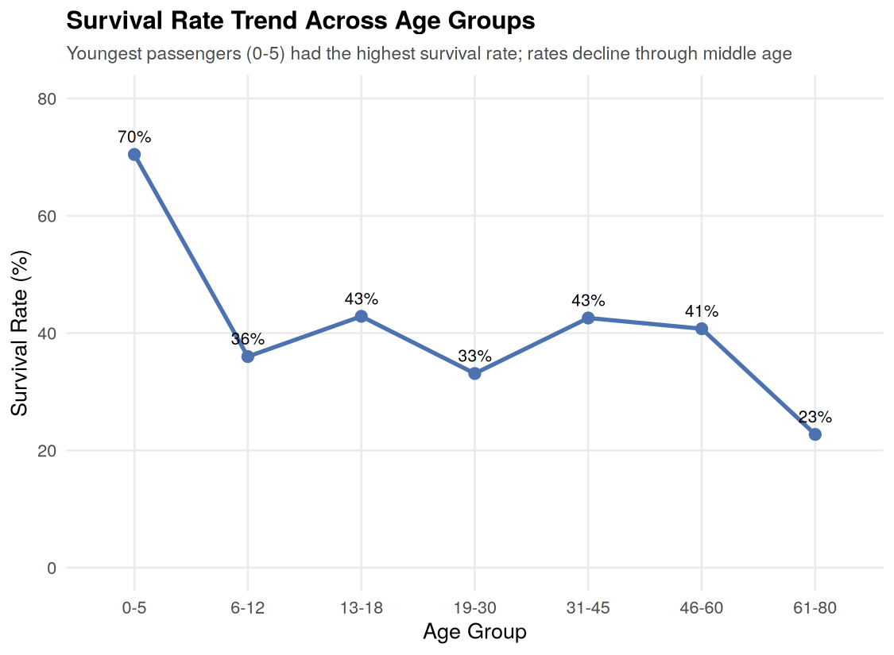
Figure 3: Survival rate (%) trend across age groups (Week 2)
Survival rate peaked sharply for the youngest passengers (70.5% for ages 0-5) and fell to its lowest point for the oldest (22.7% for ages 61-80), with a relatively flat, noisier band in between (33–43%) for teens through late middle age. This is consistent with an evacuation process that prioritized young children, without an equally strong or consistent protective effect for other age groups.

4.3 Fare Distribution Confirms the Economic Hierarchy
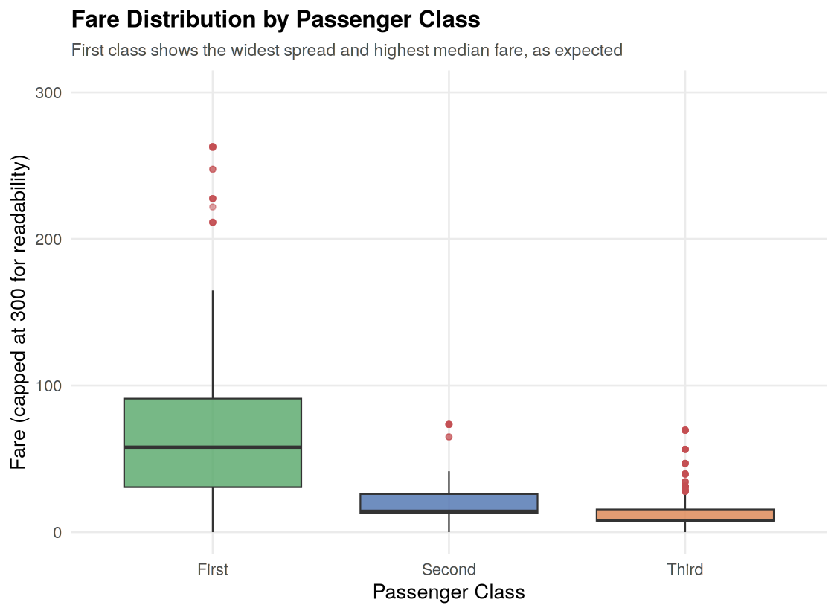
Figure 4: Fare distribution by passenger class (Week 2)
Median fares of 60.29 (First), 14.25 (Second), and 8.05 (Third) confirm Fare as a reliable proxy for socio-economic status in this dataset — a relationship that becomes central to interpreting the predictive model in Section 5.

5. Statistical Analysis and Predictive Modeling

5.1 Hypothesis Testing Confirms Visual Patterns
Four hypothesis tests were used to formally validate the patterns observed through visualization, since a pattern that looks compelling in a chart is not necessarily statistically significant:
Test | Question | Result | Conclusion
Wilcoxon rank-sum | Does Fare differ by survival? | p < 2.2e-16 | Yes — survivors paid significantly more
Chi-square | Is survival associated with Sex? | p < 2.2e-16 | Yes — very strong association
Chi-square | Is survival associated with Class? | p < 2.2e-16 | Yes — strong association
Pearson correlation | Are Age and Fare related? | r = 0.097, p = 0.004 | Statistically significant but practically negligible

Every test relevant to the Week 2 visual findings returned a statistically significant result, giving a rigorous quantitative foundation to conclusions that were initially drawn from charts alone. The Age-Fare test is a useful cautionary example: with 891 observations, even a very weak relationship (r = 0.097) can reach statistical significance, underscoring that significance and practical importance are not the same thing.

5.2 Predictive Model: Logistic Regression
A logistic regression model was built to predict Survived from passenger class, sex, age, family-size variables, fare, and the engineered HasCabin indicator, using a 70/30 train-test split (623 training rows, 268 test rows) with a fixed random seed for reproducibility.

model <- glm(Survived ~ Pclass_label + Sex + Age + SibSp + Parch + Fare + HasCabin,
data = train, family = binomial(link = "logit"))
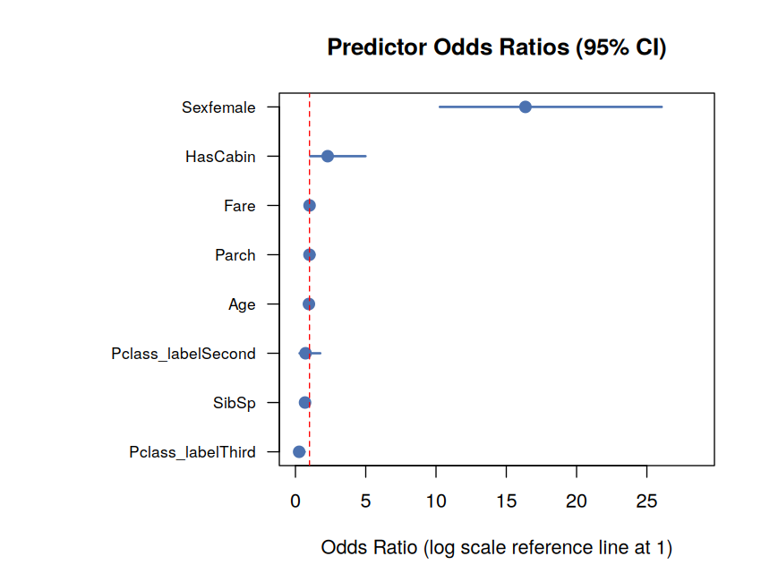
Figure 5: Predictor odds ratios with 95% confidence intervals (Week 3)
Sex emerged as by far the strongest predictor: being female multiplied a passenger's odds of survival by roughly 16 times (OR = 16.36, 95% CI [10.27, 26.06]), holding all other variables constant. Having a recorded cabin number roughly doubled survival odds (OR = 2.29), while being in Third class cut the odds to about a quarter of First class (OR = 0.26). Fare and number of parents/children aboard (Parch) were not statistically significant once class, sex, and cabin status were accounted for — their predictive signal appears to be absorbed by those more direct proxies for socio-economic status.

5.3 Model Performance
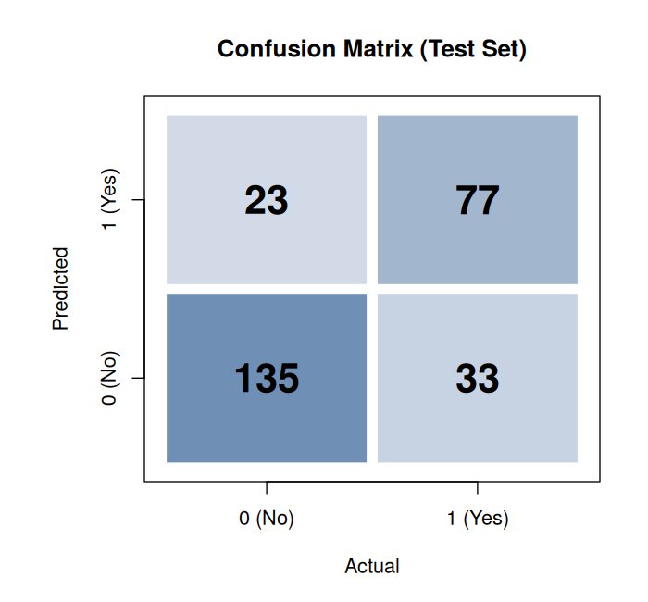  Figure 6: Confusion matrix (test set) | 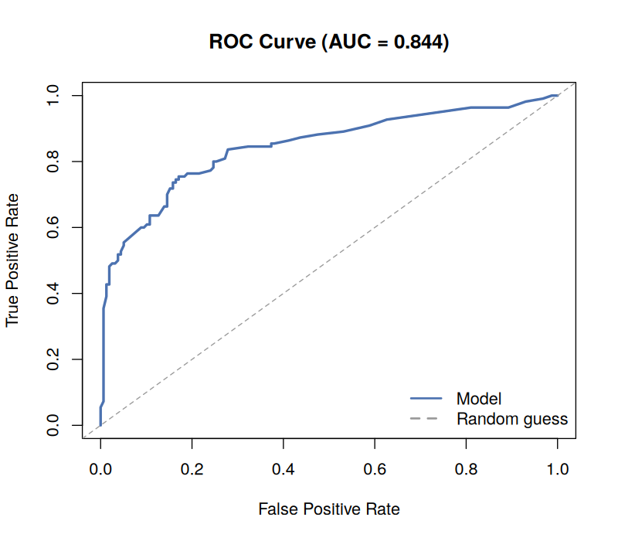  Figure 7: ROC curve (AUC = 0.844)
Test set (268 held-out passengers):
Accuracy : 79.1%
Precision : 77.0%
Recall : 70.0%
Specificity : 85.4%
F1 Score : 0.733
AUC : 0.844
5-fold cross-validation on training set:
Mean accuracy: 80.1% (SD: 4.1%)
The model achieved 79.1% accuracy on data it had never seen during training, with an AUC of 0.844 indicating good discriminative ability. Cross-validation confirmed this performance is stable across different subsets of the training data (mean 80.1%, SD 4.1%) rather than a result of a fortunate train/test split. The model is somewhat more conservative about predicting survival (85.4% specificity) than about correctly identifying it (70.0% recall) — meaning it more often misses a true survivor than it falsely predicts survival for a non-survivor.

6. Discussion: Patterns, Significance, and Implications
Taken together, the four weeks of analysis tell a consistent and historically grounded story. The strongest and most statistically robust finding across every stage of analysis — visualization, hypothesis testing, and modeling — is that sex was the single dominant factor in survival, consistent with the historical account of a 'women and children first' evacuation protocol. Passenger class (and its close correlates, Fare and HasCabin) was the second major factor, reflecting unequal access to lifeboats and proximity to the deck across different accommodation tiers. Age contributed a smaller but still meaningful effect, concentrated specifically at the youngest ages rather than as a smooth trend across the full age range.
A methodological theme worth highlighting is the importance of not relying on any single analytical technique in isolation. Week 2's visualizations were suggestive but not conclusive on their own; Week 3's hypothesis tests provided the statistical rigor to confirm those visual impressions were not due to chance; and the predictive model in Week 3 went a step further, quantifying not just whether each factor mattered but by how much (via odds ratios) and how well the combination of factors could predict an individual passenger's fate (79.1% test accuracy).
From a practical standpoint, this kind of analysis — while applied here to a historical dataset — mirrors real-world workflows in risk modeling, insurance underwriting, or any domain where the goal is to identify which factors most strongly predict a binary outcome and to build a model that can be validated on unseen data rather than just fit to historical patterns.

7. Challenges Encountered
- Missing data required different strategies for different variables rather than one blanket approach: median imputation suited Age's skew, mode imputation suited Embarked's near-complete data, but Cabin's 77% missingness made any direct imputation unreliable, leading to the HasCabin engineering decision instead.
- The median-imputation approach for Age (Week 1) introduced an artificial spike at age 28 that is visible in later analysis (the Week 2 histogram and the Week 3 residual plot); this is a known trade-off of simple imputation methods and is documented transparently rather than hidden.
- Several candidate predictors (Fare, Pclass, HasCabin) are correlated proxies for the same underlying concept — socio-economic status — which complicated interpretation of the regression model, since some of these variables (Fare, Parch) lost statistical significance once other correlated variables were included.
- Choosing the right hypothesis test required first checking distributional assumptions (Section 5.1's Shapiro-Wilk test), since Fare's strong right-skew ruled out a standard t-test in favor of the non-parametric Wilcoxon test.

8. Conclusion and Recommendations for Further Analysis
This four-week analysis successfully took the Titanic dataset from raw, incomplete data through to a validated predictive model, demonstrating a complete and reproducible R-based data analysis workflow. The central finding — that sex, class, and to a lesser extent age determined survival, and that these effects compound rather than act independently — was established through three complementary layers of evidence: visual exploration, statistical hypothesis testing, and predictive modeling, each reinforcing the same conclusion.

8.1 Recommendations for Further Analysis
- Model refinement: Test an interaction term (Sex × Pclass) explicitly in the logistic regression to directly quantify the compounding effect visualized in Figure 2, rather than inferring it only from separate main effects.
- Alternative models: Compare the logistic regression against a decision tree or random forest classifier, which might capture non-linear relationships or interactions automatically and could improve on the current 79.1% test accuracy.
- Threshold tuning: Given the model's lower recall (70.0%) than specificity (85.4%), explore adjusting the classification threshold below 0.5 if correctly identifying survivors is prioritized over avoiding false positives.
- Improved imputation: Replace Week 1's simple median imputation for Age with a model-based approach (e.g., predicting Age from Pclass, Sex, and SibSp/Parch), which would reduce the artificial spike at age 28 and could improve downstream model accuracy.
- Family-based features: Explore whether combining SibSp and Parch into a single "family size" feature, or flagging passengers traveling alone, adds predictive power beyond the two variables considered separately in this analysis.

All R scripts, cleaned datasets, and full-resolution charts referenced in this report are available as separate attachments corresponding to each week's work. Tool used throughout: R version 4.3.3 with ggplot2 version 3.4.4.

