Pages Required:

1. Login page
2. Main page with hyperlinks for other pages
3. Products Update
4. Customer update
5. Delivery Note generation
6. Invoice generation
7. Receipts for bill paid in instalment
8. Software owner info page
9. User creation page.

Database tables:

1. User table -> User_TBL
2. Login details -> Cred_tbl
3. Customer table - > Cust_TBL
4. Products Table -> Prod_tbl
5. Delivery note table -> DEL_TBL
6. Invoice table -> INV_TBL
7. State table -> State_TBL

**Front End and back end connectivity**

1. **User page and User table**

From the home page while clicking on User management

* Add user
* Edit User

**User Table -> USER_TBL**

Table where all the users who should be using the application are stored should be created with below column values

|  |  |  |  |  |  |
| --- | --- | --- | --- | --- | --- |
| S. No. | Column Name | Description | Data type | Key | Comments |
| 1 | User_ID | Unique Ids for users using this application | String/varchar | Yes | autogenerated |
| 2 | User_name | Name of the user | String | No | Entered manually |
| 3 | Address | Address of the user | VARCHAR | No | Entered manually |
| 4 | Phone | Phone number of the user | String | No |  |
| 5 | Status | User status | Char | No | 1. Active ,I-Inactive |
| 6. | Start_date | Date from which user started | Date | Yes |  |
| 7. | User_type | Access is defined here | String | No | User,admin_user,Super_user |

**Validations :**

**Logic:**

1. **Login Page and Cred_TBL :** Page to login into application

* Based on user type defined in the user_tbl (User,admin_user,Super_user). Page access to be defined in later part

Cred_tbl:

|  |  |  |  |  |  |
| --- | --- | --- | --- | --- | --- |
| S.No | Column Name | Description | Data type | Key | Comments |
|  | User ID | UserID | String | Yes | User ID stored in user_tbl |
|  | Password | Password | VARCHAR | No | Password given |

**Validations :**

* Login page should allow only users who are active(as per user status in user table) and password matching the “*Cred_TBL”*

1. **Products page and Prod_TBL :** Page where products are added.

|  |  |  |  |  |  |
| --- | --- | --- | --- | --- | --- |
| S. No. | Column Name | Description | Data type | Key | Comments |
| 1 | PROD_ID | Unique Ids for Products using this application | String/varchar | Yes | Entered manually |
| 2 | PROD_DESC | Name of the product | VARCHAR | No | Entered manually |
| 3 | GST | GST for the product | NUMBER | No | Entered manually |
| 4 | OTHER_PROD_CODE/  HSN Number | Other codes like HSN number | VARCHAR | No | Entered manually |
| 5 | Other_Product_Details | NA | varchar |  | Entered manually |
| 6 | Status | Product status | Char | No | 1. Active ,I-Inactive |
| 7. | Effective date | To maintain history | Date | Yes | This will be used in future, as of this version we aren’t using this |
| 7. | Product type | Product type | Varchar | No | Like product category |

**Validations** : Unique Product code, GST should be number.

**Logic :**  No Logic as of now. Just hit the products to the data base.

1. **Customer Update page and Cust_TBL**

Table where all the users who should be using the application are stored should be created with below column values

|  |  |  |  |  |  |
| --- | --- | --- | --- | --- | --- |
| S. No. | Column Name | Description | Data type | Key | Comments |
| 1 | CUST_ID | Unique Ids for customer using this application | String/varchar | Yes | Auto generated |
| 2 | Cust_name | Name of the Customer’s Organisation | String | No | Entered manually |
| 3 | Address | Address of the Customer | VARCHAR | No | Entered manually |
| 4 | Phone | Phone number of the Customer | String | No |  |
| 5 | Status | User status | Char | No | 1. Active ,I-Inactive |
| 6. | Start_date | Date from which Customer started | Date | Yes |  |
| 7. | GST | GST for the Customer | VARCHAR | No | Entered manually |
| 8. | PAN | Customer’s PAN | VARCHAR | Yes | Entered Manually |
| 9 | Cust_SPOC | Spoc from customer side | Varchar | No | Entered Manually |
| 10 | State | Customers State | String | No | Should get drop down or lookup from state table |

**Validations :**

**Logic:**

* state should be auto populated from State_TBL where states are defined.
* Customer ID auto generated

**Delivery Note and invoice model:** Logic to be discussed soon. As per this Version of Technical design Document, front to be designed.

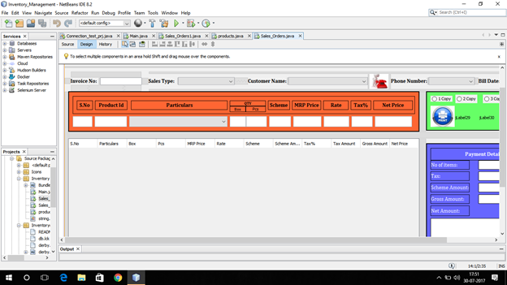

**User Table**