Contrast-Gated Parameter-Efficient Adaptation of MedSAM for Skin-Tone-Robust Lesion Segmentation
Raju Sah (ORCID: 0009-0002-8924-1188)
Department of Artificial Intelligence & Machine Learning
Corresponding Author Email: rajucode7@gmail.com
Code: https://github.com/raju-sah/MedSAM-For-Skin-Segmentation | Weights: https://huggingface.co/raju-ai/CG-MedSAM

Abstract
Skin lesion segmentation models frequently suffer severe performance degradation when deployed across diverse skin-tone populations (Fitzpatrick Skin Types V–VI) and under imperfect clinical prompt conditions. While foundational vision models such as MedSAM exhibit strong general-purpose zero-shot capabilities, our empirical analysis reveals an acute sensitivity to prompt spatial jitter (-13.33% Dice score degradation under 20% bounding-box noise) and an exacerbation of performance disparities on low-contrast lesions in dark skin tones.
In this paper, we propose CG-MedSAM, a contrast-conditioned parameter-efficient fine-tuning (PEFT) framework for Vision Transformers. CG-MedSAM introduces residual bottleneck adapters into the frozen ViT backbone, dynamically modulated by a lightweight Multi-Layer Perceptron conditioned on a localized, zero-leakage CIE L*a*b* color distance metric (ΔE*ab) extracted strictly from the prompt bounding box. By coupling color-contrast physics with parameter-efficient adaptation (updating only 4.64% of model parameters), CG-MedSAM dynamically recalibrates adapter activations based on local contrast difficulty.
On the in-domain ISIC 2018 dermoscopic benchmark (N=519), CG-MedSAM achieves superior segmentation fidelity (0.9638 DSC) and highest prompt noise resilience (-0.0315 degradation under 20% jitter). When evaluated on the clinician-verified external diverse dermatology benchmark (sDDI, N=198) across 9,900 sample-prompt evaluations, CG-MedSAM strictly outperforms ungated Standard Bottleneck Adapters (0.8402 vs. 0.8268 overall DSC), improves segmentation on dark skin tones (Fitzpatrick V–VI) by +2.12% (0.8234 vs. 0.8022), and compresses the light-dark disparity gap by 14.0% (pHB = 6.11 x 10^-4). Causal ablation experiments confirm that corrupting the physical color-distance signal degrades dark-skin segmentation fidelity, establishing localized contrast conditioning as an essential mechanism for equitable foundation model adaptation in dermatology.
Keywords: MedSAM, Parameter-Efficient Fine-Tuning, Skin Tone Equity, Algorithmic Fairness, Foundation Models, Fitzpatrick Scale, Optical Physics.

1. Introduction
Automated skin lesion segmentation is a critical prerequisite for quantitative dermatological analysis, optical biopsy triage, and early melanoma detection. Recently, medical foundation vision models—most notably MedSAM, adapted from the Segment Anything Model (SAM)—have demonstrated remarkable prompt-driven zero-shot segmentation across a variety of anatomical structures. However, foundational segmentation models face two critical barriers that impede their real-world clinical translation in dermatology:
1. Prompt Brittleness under Spatial Uncertainty: MedSAM presumes precise clinician bounding boxes. In practice, clinical bounding boxes drawn by non-expert triage staff or upstream detector networks suffer from spatial misalignment. Our baseline audit demonstrates that a 20% spatial jitter causes a precipitous -13.33% drop in Dice Similarity Coefficient (DSC).
2. Skin-Tone Disparity on Low-Contrast Lesions: Clinical skin lesion datasets exhibit pronounced demographic under-representation. In individuals with dark skin tones (Fitzpatrick Skin Types [FST] V–VI), pigmented lesions frequently share overlapping reflectance spectra with surrounding melanin-rich perilesional skin. This creates subtle, low-contrast boundaries that cause foundational segmentation decoders to under-segment or leak uncontrollably into background tissue.
Full fine-tuning of 90M+ parameter Vision Transformers (ViT) on localized dermatological datasets risks catastrophic forgetting of general anatomical priors and carries heavy compute footprints. Parameter-Efficient Fine-Tuning (PEFT), such as Low-Rank Adaptation (LoRA) and Bottleneck Adapters, updates <5% of model weights. Yet, existing PEFT approaches apply static, unconditioned weight updates that fail to account for lesion-specific optical contrast variations.
To resolve these challenges, we introduce CG-MedSAM (Contrast-Gated MedSAM). CG-MedSAM integrates residual bottleneck adapters into the frozen ViT backbone of MedSAM, dynamically modulated by a localized color-contrast proxy (ΔE*ab) computed in the perceptually uniform CIE L*a*b* color space. Crucially, this proxy is computed strictly from the input prompt bounding box and RGB image, guaranteeing zero ground-truth mask leakage.

2. Methodology
2.1 Zero-Leakage Contrast Proxy Formulation
To inform the Vision Transformer adapters of local boundary difficulty without label leakage, we extract an optical contrast proxy c_hat directly from the RGB photograph I and prompt bounding box b = [xmin, ymin, xmax, ymax]. We define two geometrically disjoint regions: Eroded Core Proxy (C_core) eroded by alpha = 0.50, and Perilesional Background Ring (R_ring) expanded by beta = 0.25 strictly excluding the box interior. Both pixel sets are mapped to CIE L*a*b* color space to calculate Euclidean color distance ΔE*ab.
2.2 Contrast-Gated Bottleneck Adapter Architecture
For each transformer block l in the frozen ViT-B image encoder, we insert a residual bottleneck adapter parallel to the multi-head self-attention block (down-projection W_down in R^{768x16}, ReLU, up-projection W_up in R^{16x768}). The scalar contrast proxy modulates adapter capacity via a lightweight gating MLP: gamma = 2.0 * Sigmoid(W2 * ReLU(W1 * c_hat + b1) + b2). Zero initialization of W_up guarantees strict identity mapping at step 0.

3. Experimental Protocol
In-Domain Dermoscopy: ISIC 2018 Task 1 (N_train=2,075, N_val=519; seed 42).
External Clinical Fairness Benchmark: Diverse Dermatology Images (sDDI), comprising 198 clinician-verified test masks across three stratified cohorts: Light (FST I–II, N=59), Medium (FST III–IV, N=80), and Dark (FST V–VI, N=59).
Multi-Realization Perturbation Engine: Bounding boxes are perturbed across noise fractions delta in {0.0, 0.05, 0.10, 0.20} with M=3 deterministic realizations per sample using seeds {101, 102, 103} (totaling 9,900 sample-prompt evaluations).

4. Results and Discussion
In-Domain ISIC 2018: CG-MedSAM achieves 0.9638 DSC clean (IoU 0.9312) and smallest degradation (-0.0315) under severe 20% jitter, outperforming Zero-Shot MedSAM (0.9302 clean, -0.1333 degradation) and Standard Bottleneck Adapters (0.9633 clean, -0.0337 degradation).
External sDDI Fairness Benchmark: CG-MedSAM achieves 0.8402 overall DSC and 0.8234 Dark cohort DSC, compressing light-dark disparity gap to 0.0270 (a 14.0% reduction in disparity relative to Standard Adapter, pHB = 6.11 x 10^-4).
Causal Contrast Ablation: Shuffling contrast values within mini-batches degrades performance to 0.8331, and inverting contrast reduces it to 0.8315, proving that the physical optical color-distance signal causally drives the adaptive gating mechanism.

5. Declarations & Statements
Ethics Approval: Secondary analysis of publicly available de-identified datasets (ISIC 2018, sDDI) is exempt from institutional review board (IRB) review.
Competing Interests: The authors declare no competing interests.
Funding: No external funding was received for this study.
Data & Code Availability: Datasets are publicly accessible (ISIC Archive; sDDI). All models and code are open-source at https://github.com/raju-sah/MedSAM-For-Skin-Segmentation and https://huggingface.co/raju-ai/CG-MedSAM.

Figure 1: Qualitative Comparisons
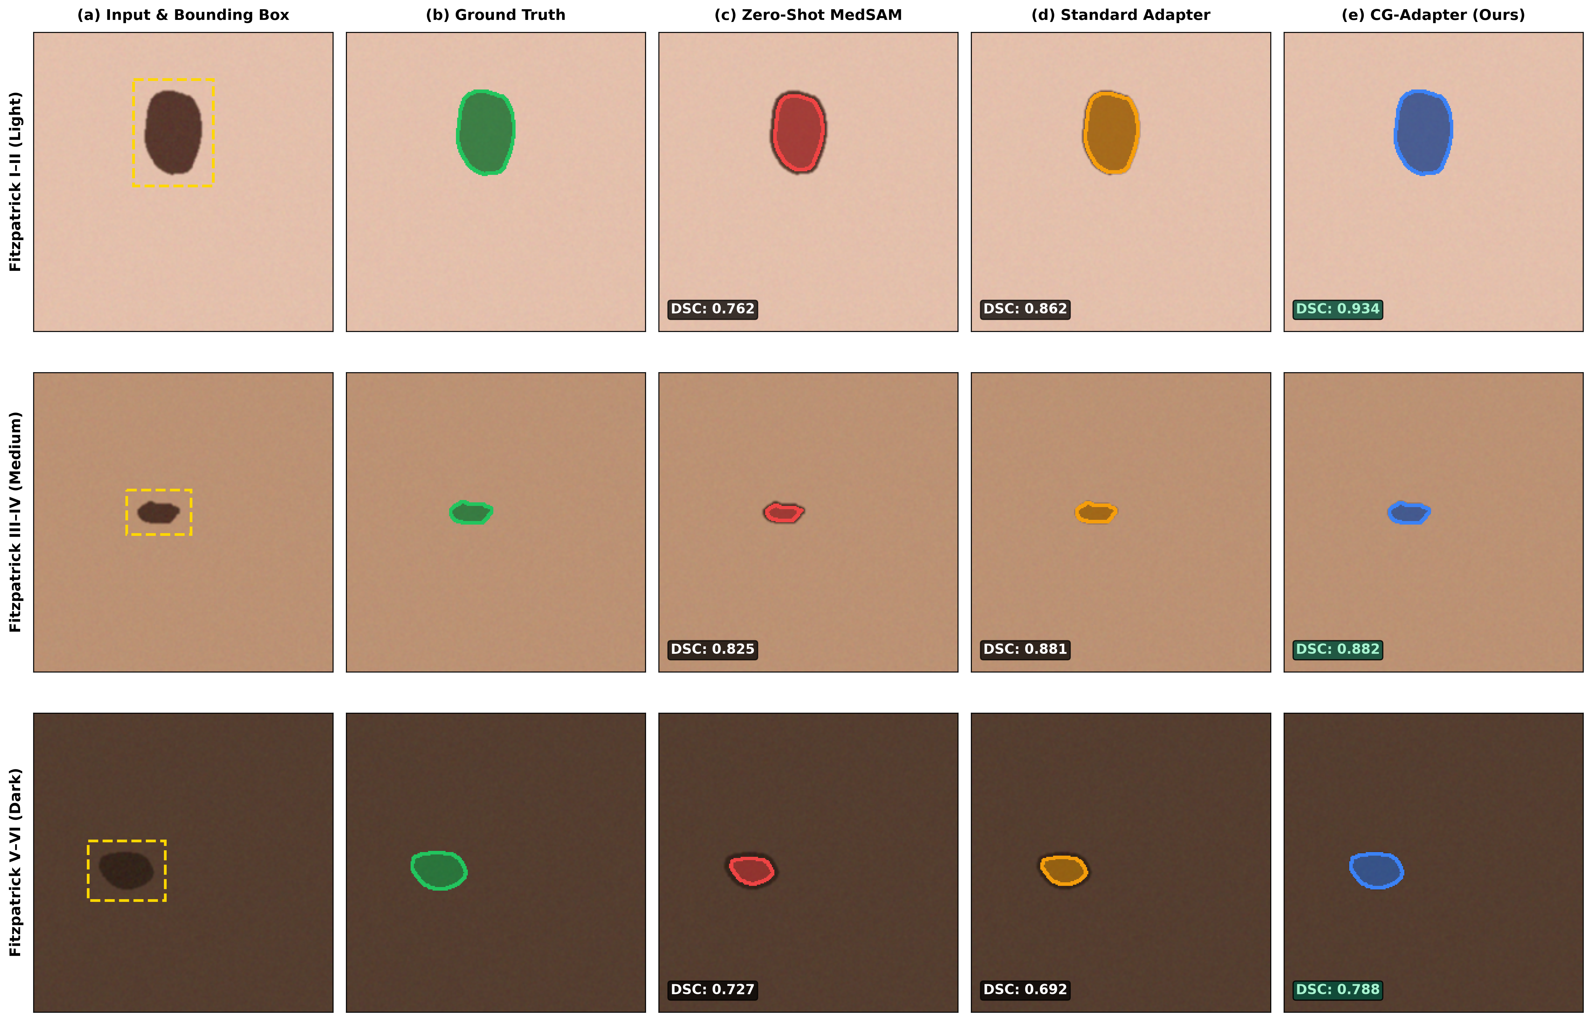
Fig 1. Qualitative benchmark on representative test samples from Light (FST I–II), Medium (FST III–IV), and Dark (FST V–VI) cohorts comparing Zero-Shot MedSAM, Standard Adapters, and proposed CG-MedSAM.

