**VISVESVARAYA TECHNOLOGICAL UNIVERSITY**

**“JNANA SANGAMA”, BELAGAVI - 570018, KARNATAKA**



**Project Report On**

**"Online Voting System"**

***In the partial fulfilment of the requirement for the award of degree***

**BACHELOR OF TECHNOLOGY IN**

**COMPUTER SCIENCE AND ENGINEERING**

***Submitted by***

|  |  |
| --- | --- |
| **D P Kavya** | **4VZ22CS009** |
| **Mayank** | **4VZ22CS016** |
| **Pratheeksha R M** | **4VZ22CS021** |
| **Sharanabasavaraj A D** | **4VZ22CS025** |

***Under the guidance of***

**Dr. G F Ali Ahammed**

**Program Coordinator,**

**Dept. of Computer Science and Engineering VTU, Regional Office, Mysore.**

**DEPARTMENT OF COMPUTER SCIENCE AND ENGINEERING VISVESVARAYA TECHNOLOGICAL UNIVERSITY**

**Centre for Post Graduate Studies, Sathagalli, Mysuru – 570029.**

**2024 – 2025**

**VISVESVARAYA TECHNOLOGICAL UNIVERSITY**

# DEPARTMENT OF COMPUTER SCIENCE AND ENGINEERING

**Centre for Post Graduate Studies, Sathagalli, Mysuru – 570029.**

**2024 – 2025**



**CERTIFICATE**

This is to certify that the Project work entitled "Online Voting System" is a bonafied work carried out by **D P Kavya, Mayank, Pratheeksha R M, Sharanabasavaraj A D** bearing **USN 4VZ22CS009, 4VZ22CS016, 4VZ23CS021, 4VZ22CS025** at Department of Computer Science and Engineering, Visvesvaraya Technological University, Centre for Post Graduate Studies, Mysuru in partial fulfilment for the award of Bachelor of Technology in Computer Science and Engineering, Visvesvaraya Technological University, Belagavi during the academic year 2024 - 2025. It is certified that all the corrections/suggestions indicated during Internal Assessment have been incorporated in the report. The Mini Project report has been approved as it satisfies the academic requirements in respect of Project work prescribed for the Bachelor of Technology degree.

**Signature of the Guide**

**Dr. G. F ALI AHAMMED**

**Program Coordinator,**

**Dept. of CS&E,**

**VTU, CPGS Mysuru – 570029**

**Name of the Examiner**

1. **..................................**
2. **..................................**

**Signature of Program Coordinator**

**Dr. G. F ALI AHAMMED**

**Program Coordinator, Dept. of CS&E,**

**VTU, CPGS Mysuru – 570029**

**Signature with Date**

**ACKNOWLEDGEMENT**

The satisfaction and euphoria that accompany the completion of any task would be incomplete without the mention of the people who made it possible, whose constant guidance and encouragement ground our efforts with success.

We express our sincere thanks to **Dr. G. F ALI AHAMMED, Program Coordinator, PG Studies, Department of Computer Science & Engineering, VTU Regional Centre, Mysuru** for his kind help and constant encouragement and for providing us necessary facilities for carrying out this work successfully.

In particular, We would like to take this opportunity to express our Honor, Respect, Deepest Gratitude and Genuine Regards to our guide, **Dr. G. F ALI AHAMMED**, **Program Coordinator**, Department of Computer Science and Engineering, VTU Regional Centre, for giving us all guidance required for our project apart from being a constant source of inspiration and motivation.

We owe our special thanks to **Our Parents** for their moral support and warm wishes and finally We would like to express appreciation to all **Our Friends** for their unconditional support which helped us to complete this work successfully.

|  |  |
| --- | --- |
| **D P Kavya** | **4VZ22CS009** |
| **Mayank** | **4VZ22CS016** |
| **Pratheeksha R M**  **Sharanabasavaraj A D** | **4VZ22CS021**  **4VZ22CS025** |

**DECLARATION**

We **D P Kavya, Mayank, Pratheeksha R M, Sharanabasavaraj A D** bearing **USN 4VZ22CS009, 4VZ22CS016, 4VZ23CS021, 4VZ22CS025** hereby declare that this project work entitled **" Online Voting System",** is a bona fide work carried out by us under the guidance and supervision of **Dr. G.F Ali Ahammed** Program Coordinator, Department of Computer Science and Engineering, VTU, CPGS, Mysore. This project work is submitted to **Visvesvaraya Technological University, Belagavi** in partial fulfilment of the requirements for the award to degree of **Bachelor of Technology in Computer Science and Engineering during the academic year 2024 - 2025**.

|  |  |
| --- | --- |
| **D P Kavya** | **4VZ22CS009** |
| **Mayank** | **4VZ22CS016** |
| **Pratheeksha R M**  **Sharanabasavaraj A D** | **4VZ22CS021**  **4VZ22CS025** |

**ABSTRACT**

The online voting system is a revolutionary platform that allows eligible voters to cast their votes securely and conveniently over the internet without visiting physical polling stations. Designed to enhance accessibility, it enables participation even from remote areas, ensuring inclusivity for all voters. By using voter ID and password authentication, the system guarantees security, privacy, and legitimacy in the voting process. With features like real-time monitoring and automated vote counting, it ensures transparency and accuracy while significantly reducing election costs and environmental impact. Despite challenges like the digital divide and cybersecurity concerns, the system holds immense potential to modernize elections, making the democratic process more efficient and accessible.

**TABLE OF CONTENTS**

|  |  |  |
| --- | --- | --- |
| **Chapter No.** | **Title** | **Page No.** |
| 1. | Introduction   * 1. Aim   2. Motivation   3. The problem statement   4. Summary | 01-02 |
| 2. | Literature Survey   * 1. Existing System   2. Proposed System | 03-04 |
| z | System Requirement specification   * 1. Hardware specification   2. Software specification   3. Functionality requirements   4. Non- Functionality requirements | 05-07 |
| 4. | System Architecture  4.1 ER Diagram  4.2 Use case  4.3 Activity Diagram | 08  09  09 |
| 5. | System Design | 10-11 |
| 6. | Implementation   * 1. Packages   2. Functions   3. Pseudocode | 12-17 |
| 7. | Testing | 18-22 |
| 8. | Results | 22-27 |
| 9. | Conclusion | 28 |

**LIST OF FIGURES**

|  |  |  |
| --- | --- | --- |
| **Figure No.** | **Title** | **Page No.** |
| Figure 8.1 | Voter Login Page | 21 |
| Figure 8.2 | User Dashboard Page | 21 |
| Figure 8.3 | Service Page | 22 |
| Figure 8.4 | Voting Page | 22 |
| Figure 8.5 | Admin Login Page | 23 |
| Figure 8.6 | Admin Dashboard Page | 23 |
| Figure 8.7 | Candidate Registration Page | 24 |
| Figure 8.8 | User Registration Page | 24 |
| Figure 8.9 | Message Page | 25 |
| Figure 8.10 | AI Assistant Page | 25 |
| Figure 8.11 | Result page | 26 |
| Figure 8.12 | About Us Page | 26 |
| Figure 8.13 | Support Page | 27 |

**LIST OF TABLES**

|  |  |  |
| --- | --- | --- |
| **Serial No.** | **Title** | **Page No.** |
| Table 5.1 | Database Table Structure | 10-12 |
| Table 7.1 | Test Cases for Functional Requirements | 17 |
| Table 7.2 | Data Integrity | 18 |
| Table 7.3 | Scalability | 18 |
| Table 7.4 | User Experience | 19 |
| Table 7.5 | Hardware Requirements | 19 |
| Table 7.6 | Software Requirements | 20 |
| Table 7.7 | Test Cases for Voting Functionality | 20 |

**CHAPTER 1**

**INTRODUCTION**

* 1. **Aim of the project**

To create a robust and secure online voting system that ensures transparent, efficient, and accessible elections by leveraging modern web technologies. The platform will facilitate seamless participation, protect against fraudulent activities, and provide real-time management of election data.

* 1. **Motivation**

The motivation for developing an online voting system stems from the limitations and inefficiencies of traditional voting methods. Physical polling stations often pose challenges such as long queues, logistical complexities, and restricted accessibility for people in remote areas, those with disabilities, or individuals living abroad. Additionally, manual voting processes are time-consuming, costly, and prone to errors or tampering. By leveraging digital technologies, an online voting system provides a convenient, secure, and cost-effective alternative that empowers voters to participate from anywhere with an internet connection. This project aims to modernize the electoral process, reduce environmental impact by eliminating paper ballots, and enhance inclusivity, thereby promoting a more efficient and democratic voting experience.

* 1. **The Problem Statement**

The key challenges with traditional voting systems include logistical complexities, limited accessibility, high operational costs, and vulnerabilities to tampering or errors. Developing an online voting system involves addressing the following concerns:

* + 1. Authentication: Ensuring only eligible voters can participate while preventing multiple votes from the same individual.
    2. Data Integrity: Protecting against hacking or unauthorized access to voter and candidate data.
    3. Scalability: Designing the system to handle high voter traffic efficiently.
    4. User Experience: Ensuring a simple, intuitive interface for users across all demographics.
  1. **Scope of the project**

The scope of the Voting Management System project is to develop a secure, efficient, and user-friendly platform for managing the voting process in small to medium-scale elections. The system will enable voter registration, authentication, and electronic voting while ensuring data security and voter anonymity. It will provide features like eligibility verification, vote submission, and real-time result generation. The platform aims to simplify election management, eliminate manual errors, and enhance transparency. Role-based access will be implemented, restricting voters, administrators, and candidates to their specific functionalities. It will be scalable, accessible on multiple devices, and designed with robust security protocols. The system does not cater to large-scale national elections but lays the foundation for future enhancements, such as blockchain integration and AI-powered fraud detection. This project is intended to streamline voting processes, save time, and build trust in election outcomes. Future iterations could include multilingual support and advanced analytics for better insights.

**CHAPTER 2**

**LITERATURE SURVEY**

* 1. **Existing system**

Online voting systems have revolutionized the electoral process by enabling eligible voters to conveniently cast their votes through the internet. Neeraj Gutgutia, the founder and CEO of the Right2Vote project, introduced a platform where users can log in using their email ID or phone number. Remarkably, this system permits multiple users to access the same email ID or phone number and even allows voters to change their votes before the poll closes, enhancing flexibility. On the other hand, Neeraj Sawant's Nevon project offers an advanced login mechanism through fingerprint authentication, ensuring a higher level of security.

While these systems enhance convenience, they also pose challenges, such as the potential for hacking candidates' or voters' accounts, raising concerns about data integrity and security. A robust encryption mechanism and frequent system audits can mitigate these vulnerabilities. Moreover, educating users on secure login practices is crucial. Despite these challenges, such systems hold the potential to significantly modernize and democratize the voting process.

**Limitations of Existing System**

* + - Using the same email ID and phone number for multiple users in online voting systems increases the risk of security and privacy,Identity Verification Challenges.
    - The ability to change votes can lead to loss of vote integrity, challenges in vote counting, confusion and complexity.
    - Fake fingerprints can be used to spoof fingerprint systems, enabling unauthorized people to vote. The system may not recognize the voter if their finger pattern is severed or otherwise damaged.
    - Hacking can expose sensitive personal data, including voter identification and preferences, compromising voter privacy and security
  1. **Proposed system**

The online voting system project aims to create a secure, efficient, and user-friendly platform for conducting elections. This system will streamline the voting process, enhance accessibility, and ensure the integrity of votes cast. Implementing this system can improve voter engagement and streamline electoral processes while addressing challenges related to security and accessibility.

**Advantages of the proposed system**

* + - Convenience: Voters can participate from any location with internet access. This flexibility encourages higher voter turnout.
    - Efficiency: Reduces waiting times at polling stations and speeds up vote counting. The automated tallying of votes allows for immediate processing and reporting of results.
    - Accessibility: Increases voter participation as it eliminates the need to travel to physical polling booths. The platform can offer support in multiple languages, ensuring that non-native speakers can understand and participate in the voting process.
    - Security and privacy: Utilizes secure authentication methods to prevent fraud and multiple voting attempts. This technique ensures that votes are encrypted from the moment they are cast until they are counted

**CHAPTER 3**

**SYSTEM REQUIREMENT SPECIFICATION**

To support the proposed Agro-culture database system effectively, the following hardware requirements are essential. These requirements ensure that the system operates efficiently, securely, and reliably, meeting the performance needs.

* 1. **Hardware Specification**

Processor: Intel/AMD RAM: 512MB or more

Keyboard: RS/32 or USB/normal Mouse: compatible mouse

* 1. **Software Specification**

Back-end: MySQL

Font-end: Html, CSS, JavaScript Server: XAMPP

Code editor: VS code

* 1. **Functionality Requirements**

1. Data Management:
   * Enable users to create, retrieve, update, and delete voter records, candidates, and election details in an online voting system.
   * Enable efficient storage and retrieval of data using MySQL as the backend database.
2. User Interface:
   * Provide a web-based user interface designed with HTML, CSS, and JavaScript for easy interaction with the system.
   * Support user-friendly navigation for accessing different modules like user login and result analysis.
3. Data Security:
   * Ensure secure data transactions through encrypted connections.
   * Implement user authentication mechanisms to protect access to sensitive data.
4. Compatibility:
   * Ensure the system works with standard input devices like RS/32 or USB keyboards and compatible mice.
5. Server Functionality:
   * Use the XAMPP server to manage the web server and database connection seamlessly.
   * Support concurrent user access without performance degradation.
6. Code Editing and Maintenance:
   * Allow ease of development and code maintenance using VS Code as the primary code editor.
   1. **Non-Functionality Requirements**
7. Performance:

* The system should operate efficiently with a minimum of 512MB RAM, ensuring responsiveness even with basic hardware configurations.
* Handle up to a specific number of simultaneous users without significant lag.

1. Reliability:

* The system must be reliable with minimal downtime during regular operations or maintenance.
* Ensure consistent data integrity, even in case of unexpected server crashes or restarts.

1. Usability:

* The interface must be intuitive and accessible to users with minimal training or technical knowledge.
* Provide responsive design for compatibility across different screen sizes.

1. Scalability:

* The system should support future upgrades to handle larger datasets or more complex queries.
* Ensure ease of scaling the database and server configuration as the user base grows.

1. Security:

* Protect against common vulnerabilities like SQL injection and cross-site scripting (XSS).
* Ensure regular updates to the server and codebase to address potential security risks.

1. Maintainability:

* The codebase should be modular and well-documented for ease of debugging and future enhancements.
* Allow seamless integration of new features without disrupting existing functionality.

**CHAPTER 4**

**4.1 ER Diagram**

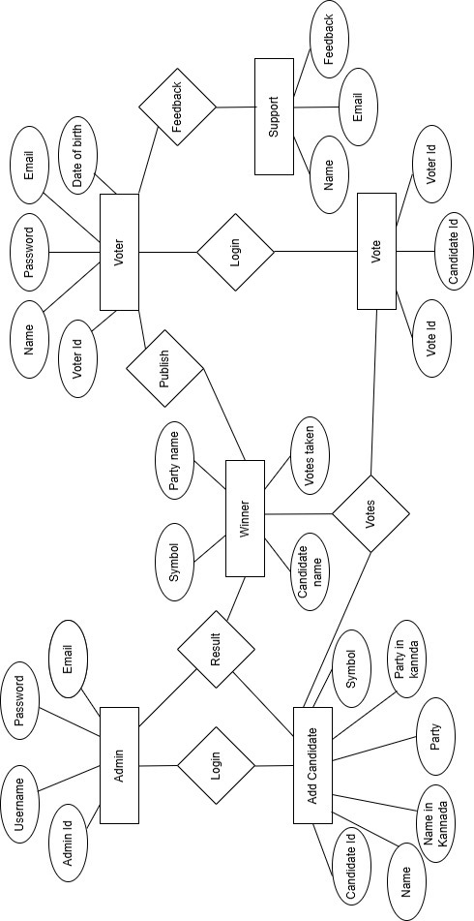

**SYSTEM ARCHITECTURE**

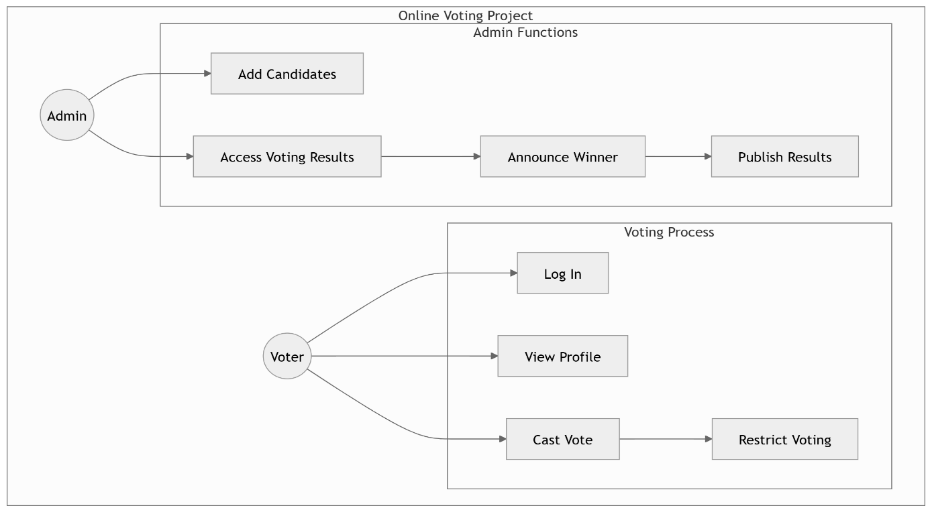**4.2 Use case Diagram**

**4.3 Activity Diagram**

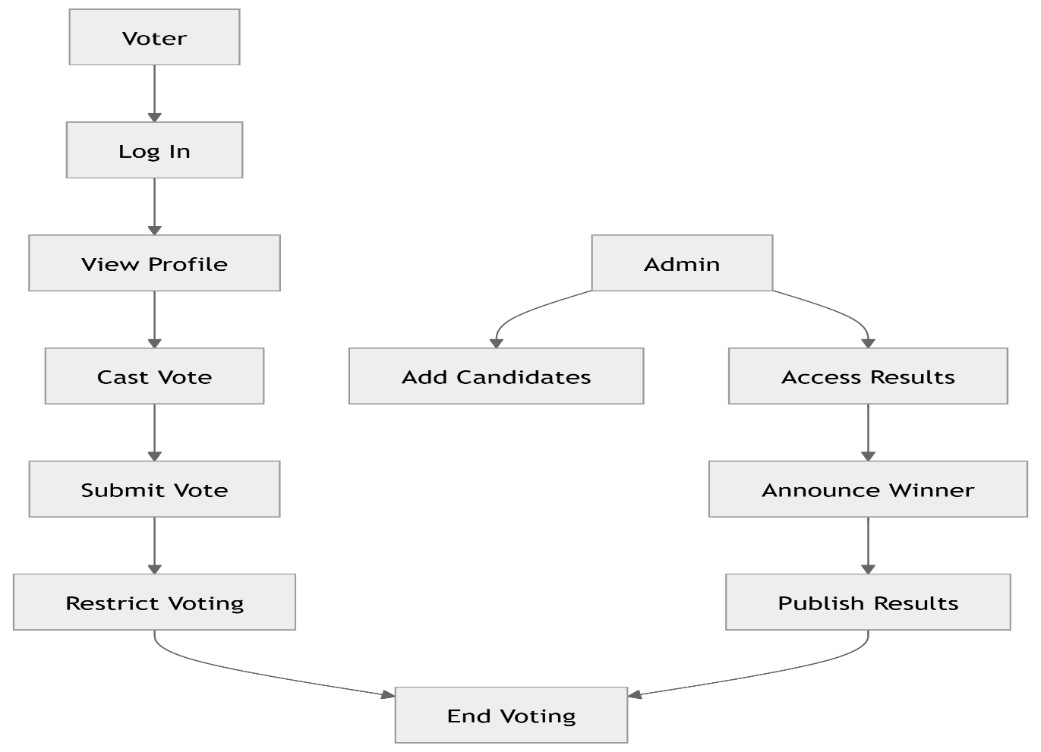

**CHAPTER 5**

**SYSTEM DESIGN**

**5.1 Database Table Structure**

|  |  |  |  |  |
| --- | --- | --- | --- | --- |
| **admin_id** | **username** | **password** | **email** | **created_at** |
| 1 | Admin | password | [admin@gmail.com](mailto:admin@gmail.com) | 2024-11-14 00:00:00 |

Table 5.1

|  |  |  |  |  |  |  |
| --- | --- | --- | --- | --- | --- | --- |
| **cand idate**  **_id** | **name** | **name_in**  **_kannad a** | **party** | **party_in_k annada** | **symbol_path** | **bio** |
| 9001 | Narendra | ನರ'ೇದ್ರ | Bharatiya Janata Party | ಭಾರತೇಯ ಜನತಾ ಪಕ್ಷ | 6c93c7acd9dd15c41e97790 eb93cd524 | Ab ki Baar 400 Paar |
| 9002 | Aravind Kejrwal | ಅರವಿಂದ್ ಕ'ೇಜ್ರರವಾಲ | Aam Aadmi Party | ಆಮ್ ಆದ್ಮಿ ಪಕ್ಷ | d2de0700511a97cf42b8c6b 9450ef463 | bustling, 24x7 hospitable city |
| 9003 | Kapil Sharma | ಕಪೇಲ  ಶಮ೯ | Samaj Seva Party | ಸಮಾಜ  ಸ'ೇವಾ ಪಾರ್ಟಿ | 2a1e9bde72cc7c0b4b68069 af10bab43 | Vote for Future |
| 9004 | Suresh Patil | ಸುರ'ೇಶ  ಪಾರ್ಟೇಲ | Liberty Party | ಲಿಬರ್ಟಿ ಪಾರ್ಟಿ | 91b276d660a17a15908f0c5  be2649f84 | Vote For Liberty |
| 9005 | Smrithi Jadhav | ಸ್ಮ್ಿಿ ತ  ಜಾದ್ವ | Samajavad i Party | ಸಮಾಜವಾದ್ಮ  ಪಕ್ಷ | cef74389fd72e4ec9ff1f09b 28d7f1ee | Vote for Equality |
| 9007 | Chandrababu | ಚಿಂದ್ರಬಾ ಬು | Swachatha Party | ಸವಚಚತಾ ಪಕ್ಷ | cea36aafd7d14d83fc3c23b 7cb5ca699 | Vote to control Pollution |
| 9008 | Shivakumar Singh | ಶಿವಕುಮಾ  ರ್ ಸ್ಮ್ಿಂಗ್ | Jan Jeevan Party | ಜನ ಜ್ರೇವನ್  ಪಾರ್ಟಿ | 19206dd7defb0d8c0a24fcb 080b5b007 | Vote |

Table 5.2

|  |  |  |
| --- | --- | --- |
| **Name** | **Email** | **message** |
| Raju | [raju@gmail.com](mailto:raju@gmail.com) | It was nice |
| Mayank | [mayankbhandari647@gmail.com](mailto:mayankbhandari647@gmail.com) | How to vote |

Table 5.3

|  |  |  |  |  |  |  |
| --- | --- | --- | --- | --- | --- | --- |
| **vote_**  **id** | **Voter**  **name** | **Pass word** | **email** | **registration_**  **date** | **adhar_no** | **fingerprint** |
| 10001 | Arjun | 1234 | [arjun@example.com](mailto:arjun@example.com) | 1995-07-15 | 415738861233 | NULL |
| 10002 | Priya | 1234 | priyaexample.com | 1990-09-25 | 203948573829 | NULL |
| 10003 | Rahul | 1234 | [rahul@example.com](mailto:rahul@example.com) | 1998-12-05 | 640937462810 | NULL |
| 10004 | Meera | 1234 | [meera@example.com](mailto:meera@example.com) | 1993-03-18 | 402944534929 | NULL |
| 10005 | Vikram | 1234 | [vikram@example.com](mailto:vikram@example.com) | 1992-11-22 | 203948273892 | NULL |
| 10006 | Anjali | 1234 | [anjali@example.com](mailto:anjali@example.com) | 1997-08-30 | 847203927182 | NULL |
| 10007 | Rohan | 1234 | [rohan@example.com](mailto:rohan@example.com) | 1994-01-10 | 647110292832 | NULL |
| 10008 | Sohan | 1234 | [sohan@example.com](mailto:sohan@example.com) | 1996-06-15 | 192847369502 | NULL |
| 10009 | Aditya | 1234 | [aditya@example.com](mailto:aditya@example.com) | 1991-04-20 | 39029383928 | NULL |
| 10010 | karthik | 1234 | [karthik@example.com](mailto:karthik@example.com) | 1999-02-14 | 098736482738 | NULL |
| 10011 | Mayank | 1234 | [mayank@example.com](mailto:mayank@example.com) | 1999-02-14 | 214729375839 | NULL |
| 10012 | Ravi | 1234 | [ravi@example.com](mailto:ravi@example.com) | 1999-02-04 | 298346485032 | NULL |
| 10013 | Vikas | 1234 | [Vikas@example.com](mailto:Vikas@example.com) | 1999-12-14 | 381020293009 | NULL |
| 10014 | Varun | 1234 | [varun@example.com](mailto:varun@example.com) | 1999-05-14 | 987402936483 | NULL |
| 10015 | Pavan | 1234 | [pavan@example.com](mailto:pavan@example.com) | 1994-02-14 | 102938291247 | NULL |
| 10016 | Ramesh | 1234 | [ramesh@gmail.com](mailto:ramesh@gmail.com) | 1997-10-13 | 920382754678 | NULL |
| 10017 | Vishvas | 1234 | [vishwas@gmail.com](mailto:vishwas@gmail.com) | 1998-07-13 | 478392678353 | NULL |
| 10018 | Rishabh | 1234 | [rishi@gmail.com](mailto:rishi@gmail.com) | 1994-07-12 | 283728467383 | NULL |
| 10020 | Pavan | 1234 | [pavan@gmail.com](mailto:pavan@gmail.com) | 2004-06-07 | 209485789643 | NULL |
| 10021 | Rani | 1234 | [vikas@gmail.com](mailto:vikas@gmail.com) | 2002-09-24 | 456785545562 | NULL |
| 10022 | Ravi | 1234 | [ravi@email.com](mailto:ravi@email.com) | 2003-11-05 | 993930039282 | NULL |

Table 5.4

|  |  |  |  |
| --- | --- | --- | --- |
| **vote_id** | **voter_id** | **candidate_id** | **voted_at** |
| 30 | 10002 | 9001 | 2024-11-30 16:26:33 |
| 31 | 10003 | 9001 | 2024-12-01 10:09:48 |
| 32 | 10006 | 9001 | 2024-12-03 19:53:19 |
| 33 | 10007 | 9001 | 2024-12-03 19:54:04 |
| 34 | 10022 | 9001 | 2024-12-12 19:51:23 |
| 35 | 10001 | 9005 | 2024-12-17 18:43:03 |
| 36 | 10010 | 9003 | 2024-12-17 18:43:51 |
| 37 | 10012 | 9008 | 2024-12-17 18:44:12 |
| 38 | 10013 | 9002 | 2024-12-17 18:44:32 |
| 39 | 10016 | 9008 | 2024-12-17 18:44:54 |

Table 5.5

**CHAPTER 6**

* 1. **Packages**

**IMPLEMENTATION**

# Express

* + Description: Express is a web application framework for Node.js that simplifies the process of building web applications and APIs. It provides robust routing and middleware options.
  + Usage:
    1. Define application routes (e.g., GET, POST, etc.).
    2. Handle HTTP requests and responses.
    3. Serve static files like images, CSS, and JavaScript.

# EJS (Embedded JavaScript)

* + Description: EJS is a template engine for rendering HTML pages dynamically. It allows you to embed JavaScript logic into HTML templates for dynamic content generation.
  + Usage:
    1. Render dynamic HTML pages with data passed from the server.
    2. Use loops and conditions directly in the template for customization.

# Express-Session

* + Description: Express-Session is a middleware for managing user sessions in an Express app. It stores session data on the server-side and provides session management for user authentication and state persistence.
  + Usage:
    1. Track logged-in users across multiple requests.
    2. Store temporary user-specific data like cart details or preferences.

# Multer

* + Description: Multer is a middleware for handling file uploads in Node.js. It is used to process multipart/form-data, which is primarily used for file uploading.
  + Usage:
    1. Handle file uploads from forms.
    2. Save uploaded files to a specific directory or database.

# MySQL

* + Description: MySQL is a Node.js package that allows interaction with a MySQL database.
  + Usage:
    1. Connect to the database and execute queries.
    2. Perform CRUD operations on tables.

# Body-Parser

* + Description: Body-Parser is middleware that parses incoming request bodies in a middleware before your handlers. It parses JSON, URL-encoded, and other data formats.
  + Usage:
    1. Parse JSON and form data from HTTP POST requests.
    2. Extract data from the req.body object in Express.
  1. **Functions**

# use

Purpose: Attaches middleware to the Express app. Middleware functions are executed sequentially to process requests and responses.

# set

Purpose: Used to set application settings or configurations in an Express app.

# get

Purpose: Defines a route to handle HTTP GET requests.

# post

Purpose: Defines a route to handle HTTP POST requests, often used for form submissions or API calls.

# listen

Purpose: Starts the server and listens for incoming connections on a specified port.

# require

Purpose: Imports external modules or files into your Node.js application.

* 1. **Pseudocode for Backend Implementation**

1. **Use method** app.use(cors()); app.use(bodyParser.json());

app.use(bodyParser.urlencoded({ extended: true })); app.use(express.static("public"));

# Set method

// Set EJS as the view engine app.set("view engine", "ejs");

app.set("views", "./views");

# Get method

app.get("/", (req, res) => { res.render("user_login"); // Render login page

});

# Post method

app.post("/user_login" , (req, res) => {

const { voter_id, voter_name, email, dob, aadhar_no, password, fingerprint_data } = req.body; const query = `

INSERT INTO users (voter_id, votername, email, registration_date, aadhar_no, password, fingerprint)

VALUES (?, ?, ?, ?, ?, ?, ?) `;

conn.query(query, [voter_id, voter_name, email, dob, aadhar_no, password, fingerprint_data], (error, result) => {

if (error) {

console.error("Error inserting data:", error); res.status(500).send("Failed to insert data.Email Exists");

} else {

console.log("Data successfully inserted"); res.send(`<script>

alert("You are Successfully registered"); window.location.href = "/";

</script>`);

}

});

});

# Listen method

// Start the server const PORT = 3000;

app.listen(PORT, () => {

console.log(Server is running on [http://localhost:$](http://localhost/){PORT});

});

# CreateConnection method

createConnection method

const conn = mysql.createConnection({ host: "localhost",

user: "root",

password: "", database: "voting1", port: "3311",

});

**CHAPTER 7**

**TESTING**

* 1. **Test Cases for Functional Requirements**

|  |  |  |  |  |
| --- | --- | --- | --- | --- |
| **Test Case ID** | **Description** | **Input** | **Expected Result** | **Status** |
| TC001 | Verify login with valid credentials | Email: [test@example.com](mailto:test@example.com) Password: 123456 | User is successfully logged in | Pass/Fail |
| TC002 | Verify login with invalid credentials | Email: [test@example.com](mailto:test@example.com) Password: wrongpass | Error message: "Invalid email or password" | Pass/Fail |
| TC003 | Ensure only one vote per voter | Cast vote twice using same account | Second attempt is rejected, error message displayed | Pass/Fail |
| TC004 | Verify logout functionality | Click logout button | User is redirected to the login page | Pass/Fail |

* 1. **Data Integrity**

|  |  |  |  |  |
| --- | --- | --- | --- | --- |
| **Test Case ID** | **Description** | **Input** | **Expected Result** | **Status** |
| TC005 | Verify data is encrypted during transmission | Monitor network traffic | Data packets should be encrypted | Pass/Fail |
| TC006 | Ensure database integrity after a vote is cast | Cast a vote | Vote is recorded correctly in the database | Pass/Fail |
| TC007 | Test for SQL injection vulnerability | Enter malicious input: ';DROP TABLE  votes;-- | Input is sanitized, system handles safely | Pass/Fail |

* 1. **Scalability**

|  |  |  |  |  |
| --- | --- | --- | --- | --- |
| **Test Case ID** | **Description** | **Input** | **Expected Result** | **Status** |
| TC008 | Test system performance under high traffic | Simulate 1000 concurrent users | System remains responsive, no crashes | Pass/Fail |
| TC009 | Verify database can handle multiple votes concurrently | Cast votes from multiple users simultaneously | Votes are recorded correctly | Pass/Fail |

* 1. **User Experience**

|  |  |  |  |  |
| --- | --- | --- | --- | --- |
| **Test Case ID** | **Description** | **Input** | **Expected Result** | **Status** |
| TC010 | Verify responsiveness of the UI | Open on different devices (desktop, tablet, mobile) | UI adjusts appropriately to screen size | Pass/Fail |
| TC011 | Ensure error messages are user-friendly | Enter invalid input in any form | User-friendly error message displayed | Pass/Fail |
| TC012 | Test navigation between pages | Click on various links/buttons | Pages load without errors | Pass/Fail |

* 1. **Hardware Requirements**

|  |  |  |  |  |
| --- | --- | --- | --- | --- |
| **Test Case ID** | **Description** | **Input** | **Expected Result** | **Status** |
| TC013 | Test system functionality on minimum hardware | System with 512MB RAM | System operates without performance degradation | Pass/Fail |

* 1. **Software Requirements**

|  |  |  |  |  |
| --- | --- | --- | --- | --- |
| **Test Case ID** | **Description** | **Input** | **Expected Result** | **Status** |
| TC014 | Verify compatibility with the specified server | Deploy on XAMPP server | Application works correctly | Pass/Fail |
| TC015 | Verify database connection | Start XAMPP, query MySQL DB | Database connects successfully | Pass/Fail |

* 1. **Test Cases for Voting Functionality**

|  |  |  |  |  |
| --- | --- | --- | --- | --- |
| **Test Case ID** | **Description** | **Input** | **Expected Result** | **Status** |
| TC016 | Verify the AI tool assists users with queries about online voting system | User asks, “how to register for the online voting system?” and some others | The AI tool provides clear and accurate registration instructions | Pass/Fail |
| TC017 | Ensure vote count updates correctly | Cast a vote | Candidate’s vote count increases by 1 | Pass/Fail |

These test cases ensure the system is robust, user-friendly, secure, and meets both functional and non-functional requirements.

**CHAPTER 8**

**RESULT**

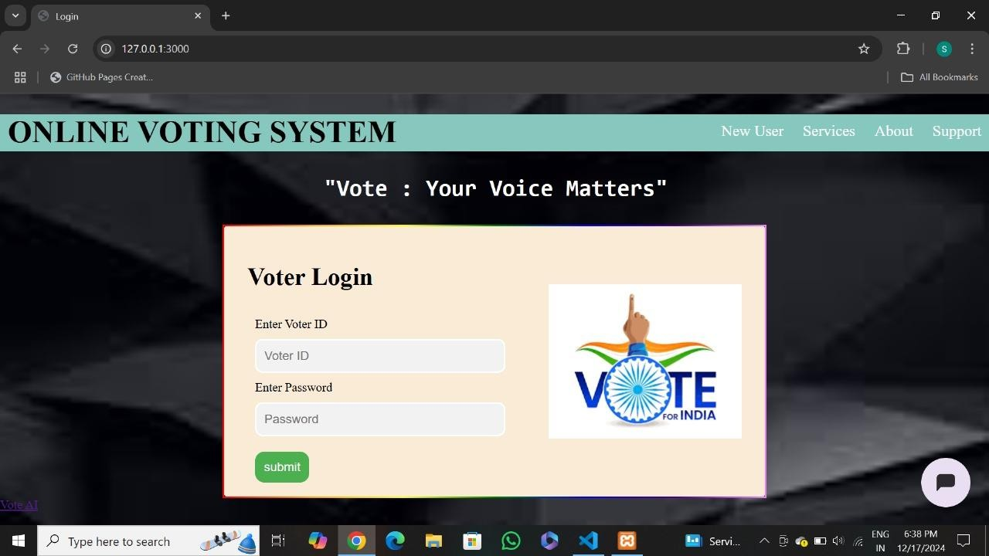

Figure 8.1

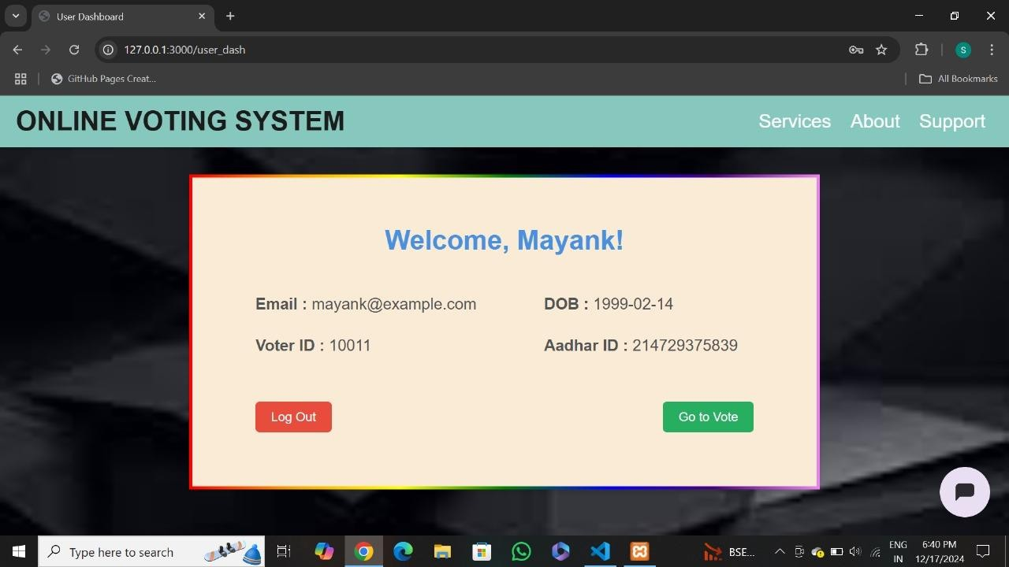

Figure 8.2

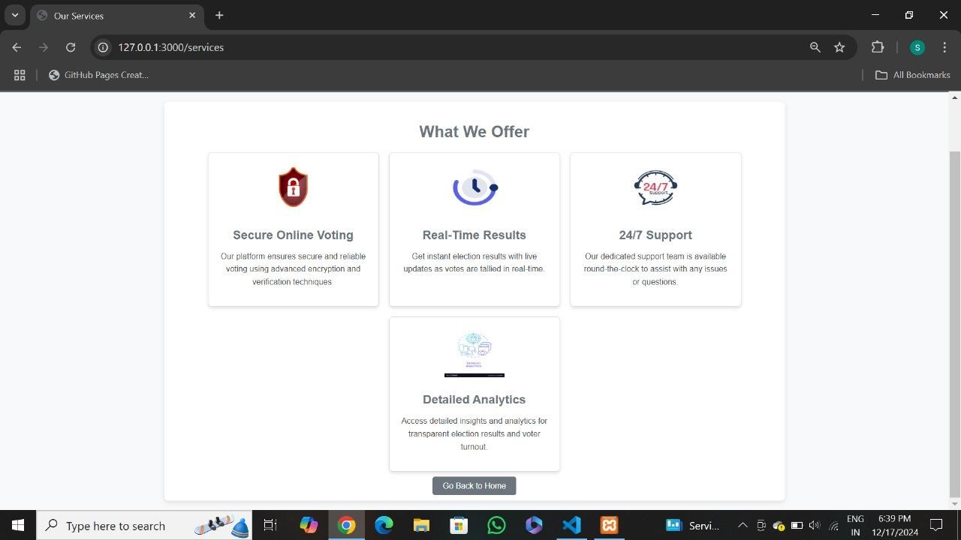

Figure 8.3

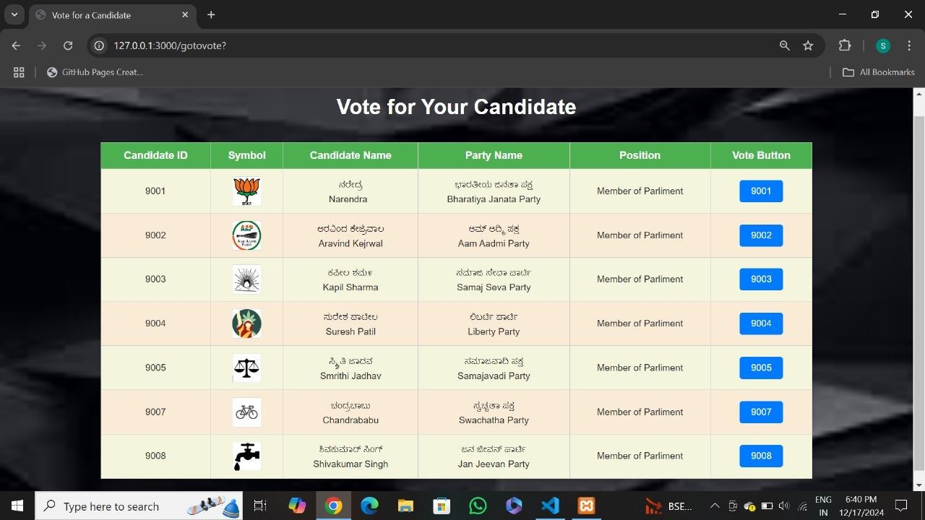

Figure 8.4

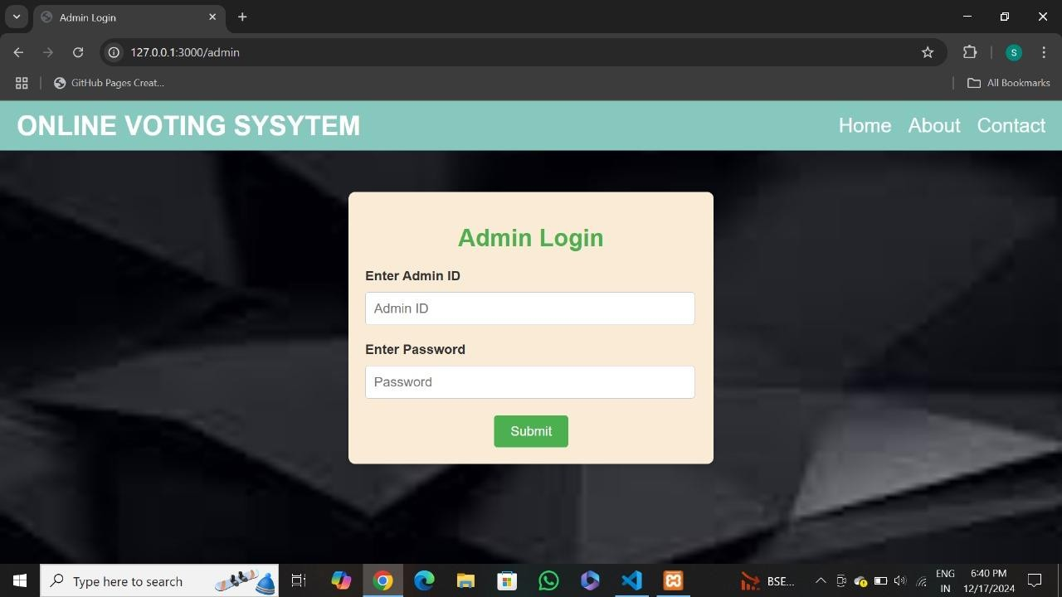

Figure 8.5

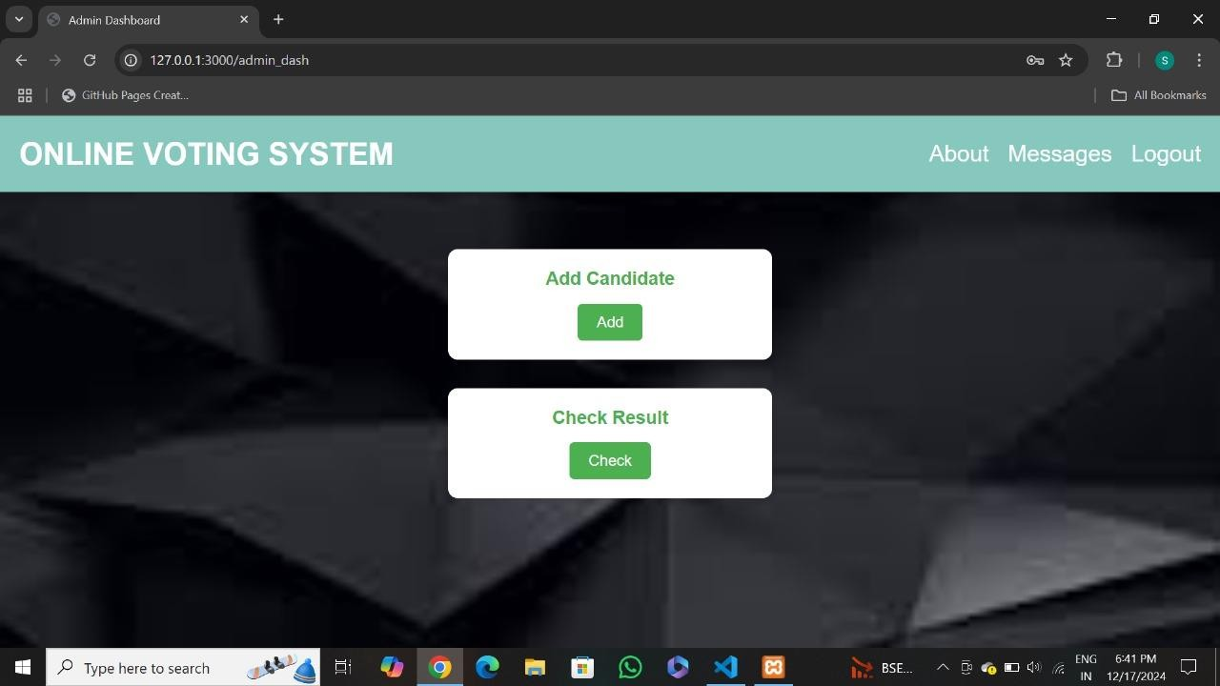

Figure 8.6

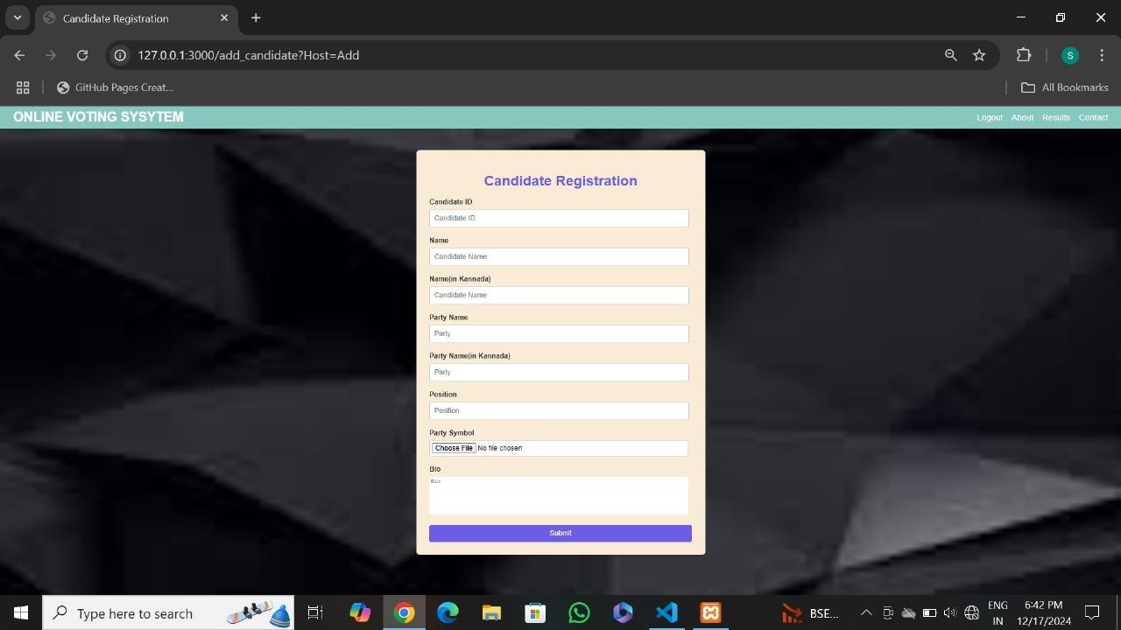

Figure 8.7

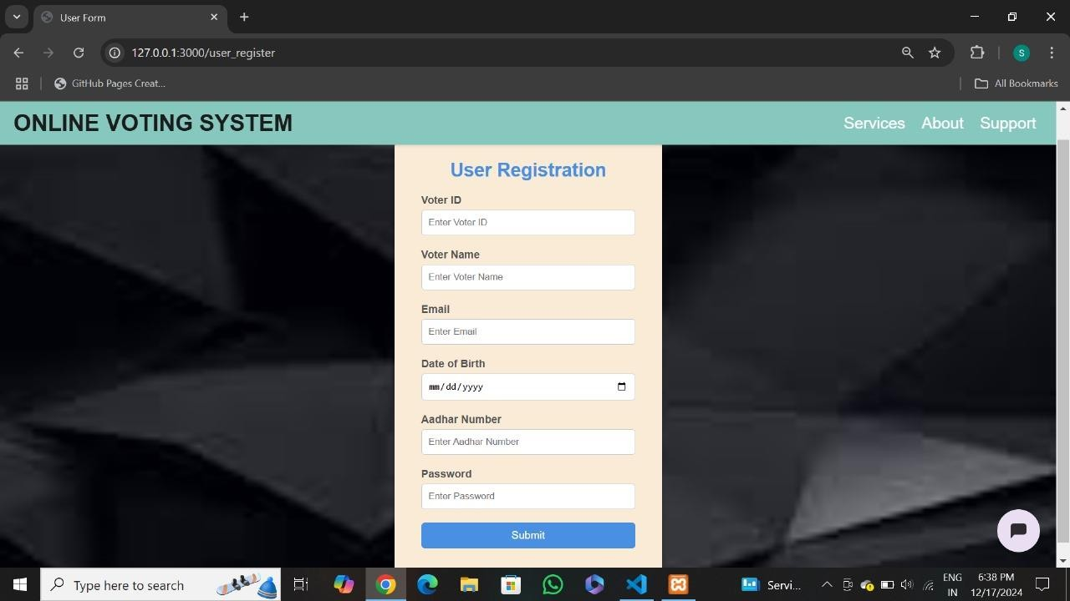

Figure 8.8

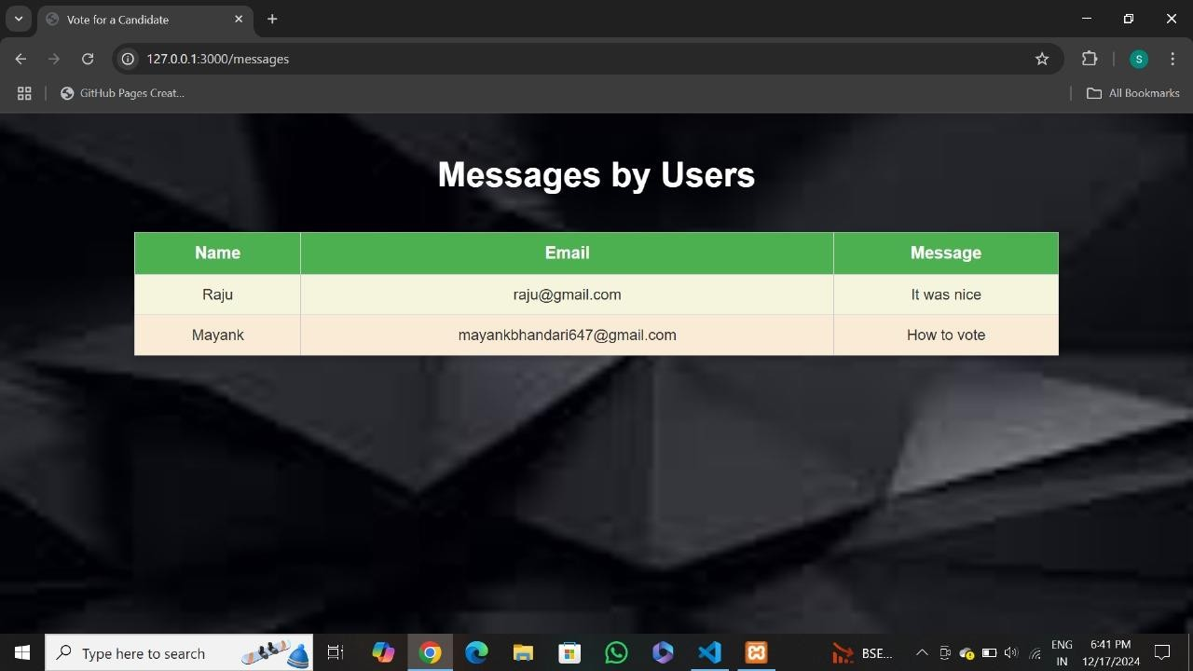

Figure 8.9

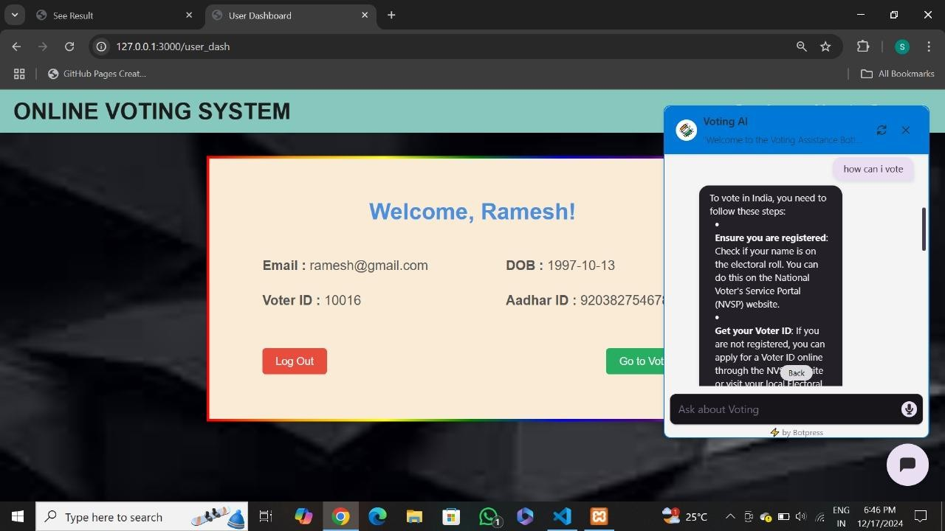

Figure 8.10

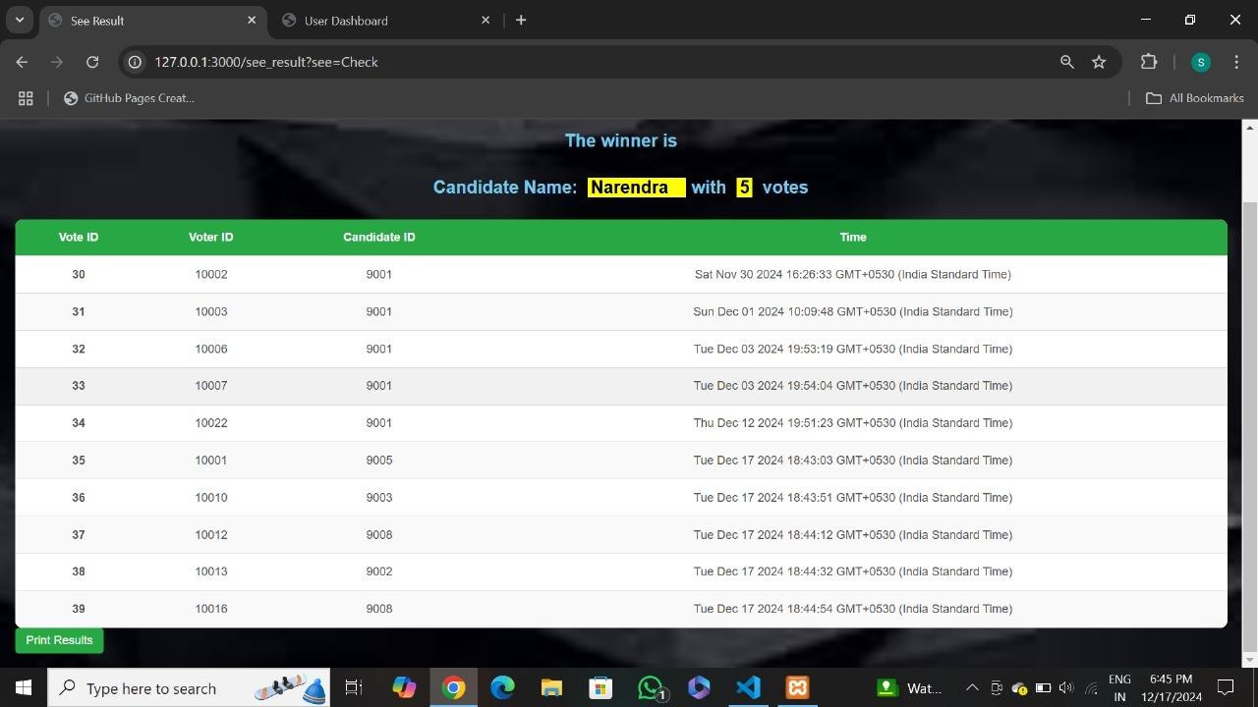

Figure 8.11

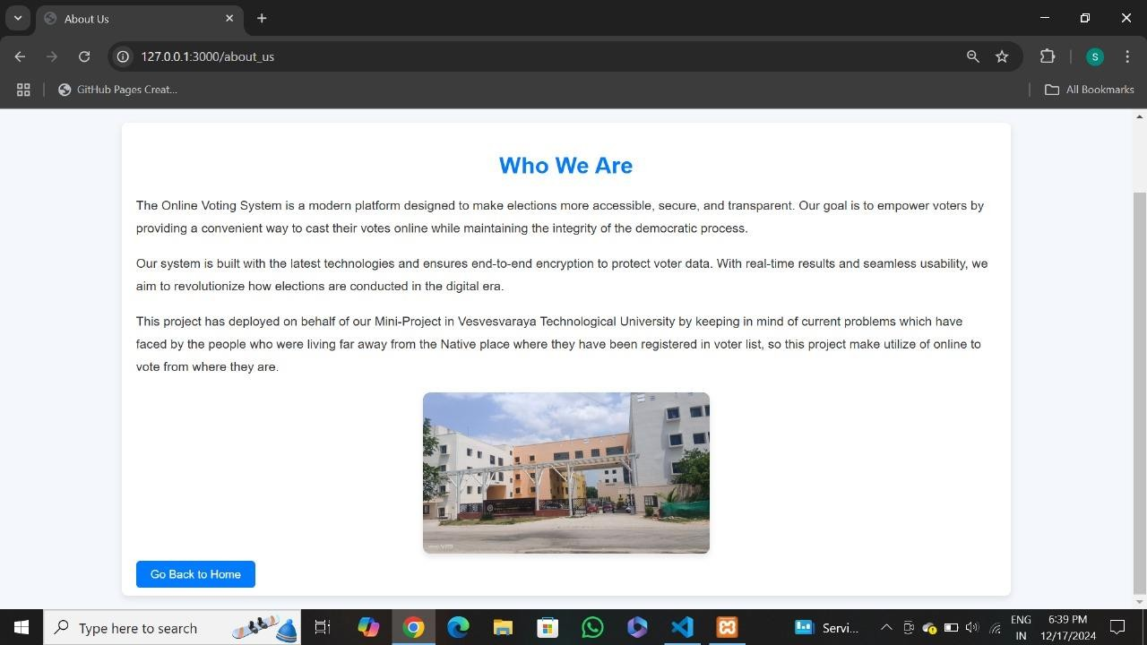

Figure 8.12

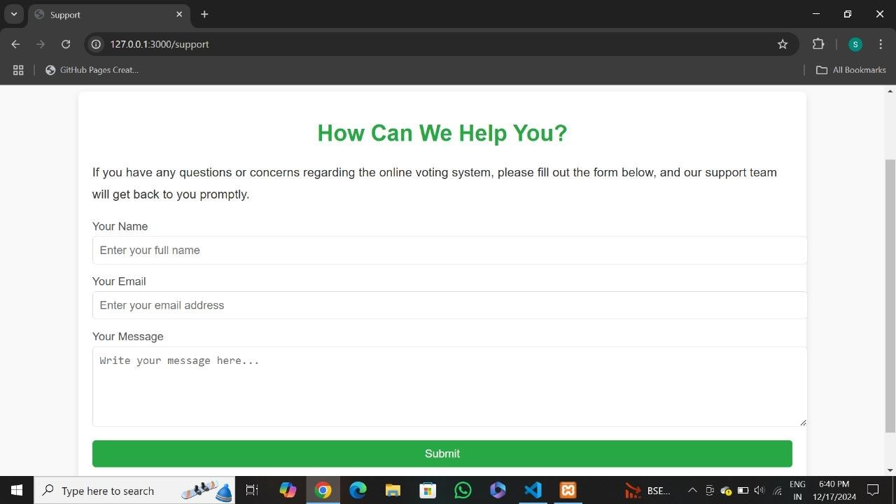

Figure 8.13

**CHAPTER 9**

**CONCLUSION**

The development of an Online Voting System represents a significant advancement in the electoral process, providing a secure, efficient, and accessible method for conducting elections. This project aims to address the limitations of traditional voting systems by integrating modern technology to enhance voter participation and ensure the integrity of the voting process. It offers a modern solution to electoral challenges by combining security, accessibility, and efficiency. It not only facilitates a more inclusive voting experience but also enhances the reliability of election outcomes. As technology continues to evolve, further improvements and adaptations can be made to this system to address ongoing concerns about security and voter confidence. The future of elections may very well depend on embracing these digital innovations to foster greater democratic participation and integrity in the electoral process.

**REFERENCES**

1. **An Electronic Voting System: A Case Study of St. Mary's Heritage College** [**https://www.researchgate.net/publication/375962885_AN_ELECTRONIC_VOTI**](https://www.researchgate.net/publication/375962885_AN_ELECTRONIC_VOTING_SYSTEMA_CASE_STUDY_OF_ST_MARYS_HERITAGE_COLLEGE-_KAWEMPE)[**NG_SYSTEMA_CASE_STUDY_OF_ST_MARYS_HERITAGE_COLLEGE-**](https://www.researchgate.net/publication/375962885_AN_ELECTRONIC_VOTING_SYSTEMA_CASE_STUDY_OF_ST_MARYS_HERITAGE_COLLEGE-_KAWEMPE)

# [_KAWEMPE](https://www.researchgate.net/publication/375962885_AN_ELECTRONIC_VOTING_SYSTEMA_CASE_STUDY_OF_ST_MARYS_HERITAGE_COLLEGE-_KAWEMPE)

1. **Online Voting System Using Cloud** [**https://www.researchgate.net/publication/340972420_Online_Voting_System_usi**](https://www.researchgate.net/publication/340972420_Online_Voting_System_using_Cloud)[**ng_Cloud**](https://www.researchgate.net/publication/340972420_Online_Voting_System_using_Cloud)

# Web and Mobile Platforms for Managing Elections Based on IoT and Machine Learning Algorithms

[**https://arxiv.org/abs/2303.09045**](https://arxiv.org/abs/2303.09045)

1. **Electronic Voting - Overview and Implementations** [**https://en.wikipedia.org/wiki/Electronic_voting**](https://en.wikipedia.org/wiki/Electronic_voting)
2. **Politics and Technology - Blockchain Voting Platforms** [**https://en.wikipedia.org/wiki/Politics_and_technology**](https://en.wikipedia.org/wiki/Politics_and_technology)
3. **Design and Development of Secure E-Voting Systems** [**https://www.academia.edu/41492694/Design_and_Development_of_Secure_E_Vo**](https://www.academia.edu/41492694/Design_and_Development_of_Secure_E_Voting_Systems)[**ting_Systems**](https://www.academia.edu/41492694/Design_and_Development_of_Secure_E_Voting_Systems)