Instructions:

Perquisites: Please make sure JDK installed in the system and set the path variable

If JDK is installed then it can be found in ProgramFiles/Java folder

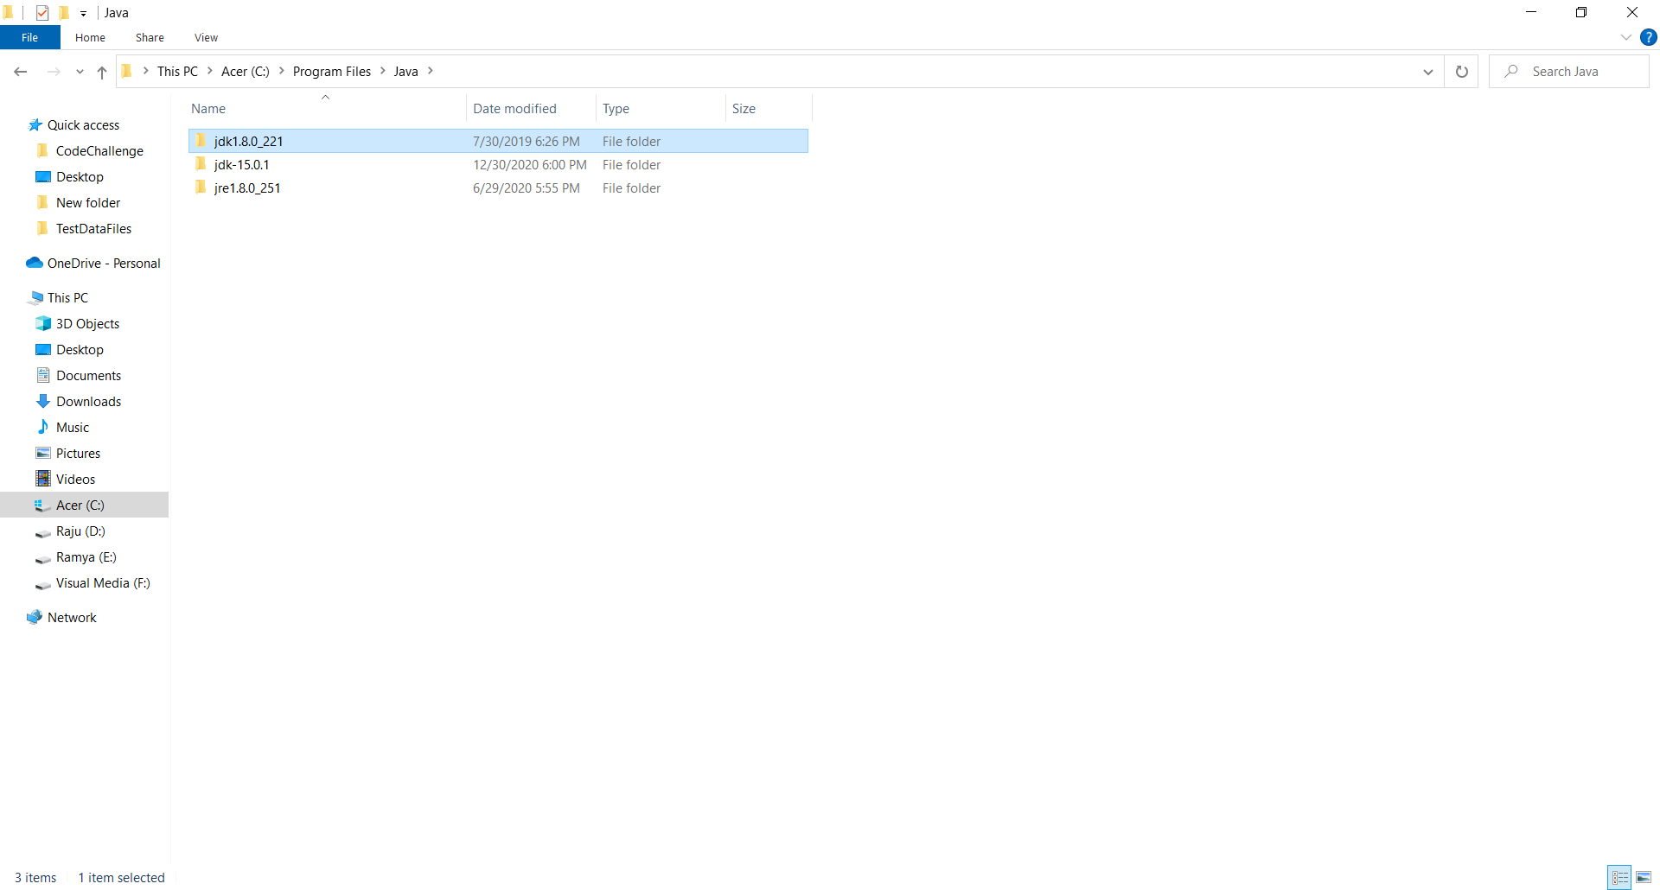

Set the Path environment variable as below

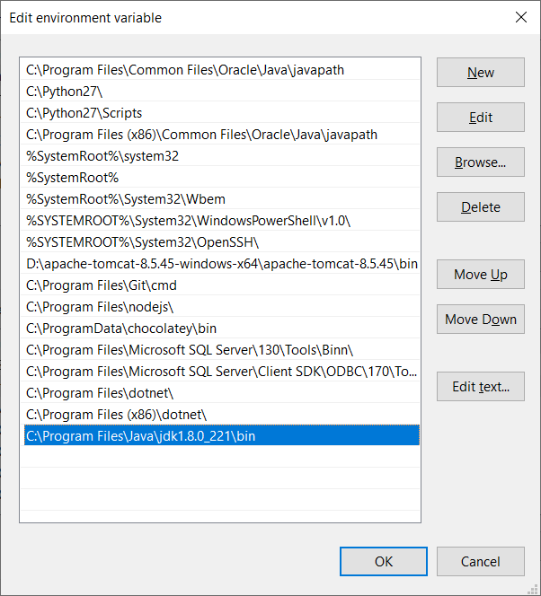

1. Download the files from Github link

<https://github.com/raju1284/CodeChallenge.git>

1. Folders Structure will be displayed as below once it is downloaded and extracted

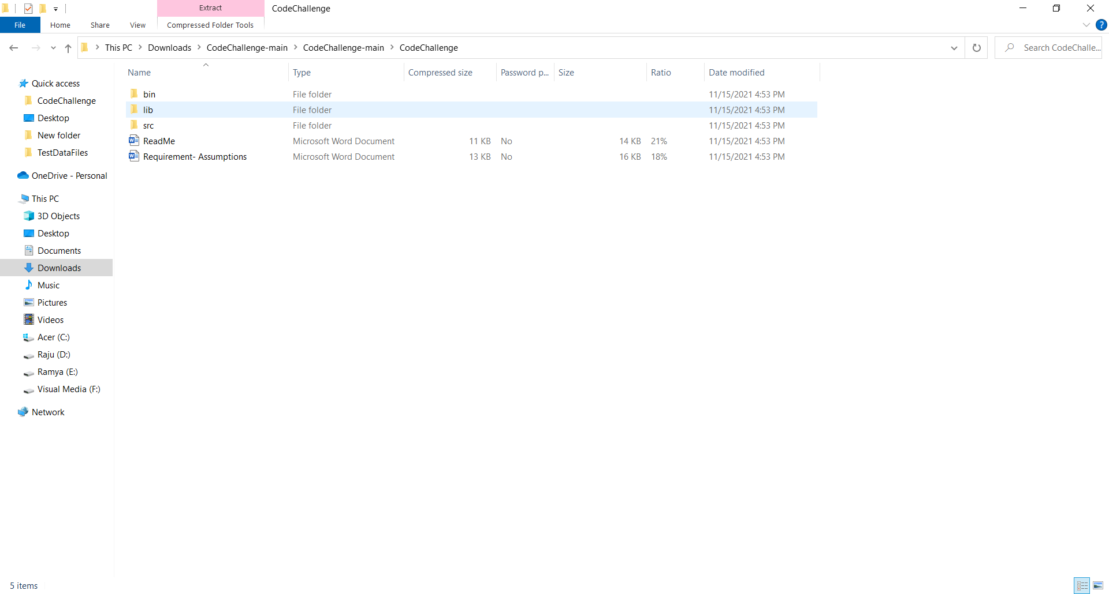

1. Folder- “src”: All coded java classes placed in this folder
2. Folder- “lib”: All reuired junit librarys to run the tests placed in this folder
3. Folder – bin: All compiled java classes placed in this folder
4. Folder- TestDataFiles: text files with different test data placed in this folder
5. Open the Comman prompt through start menu

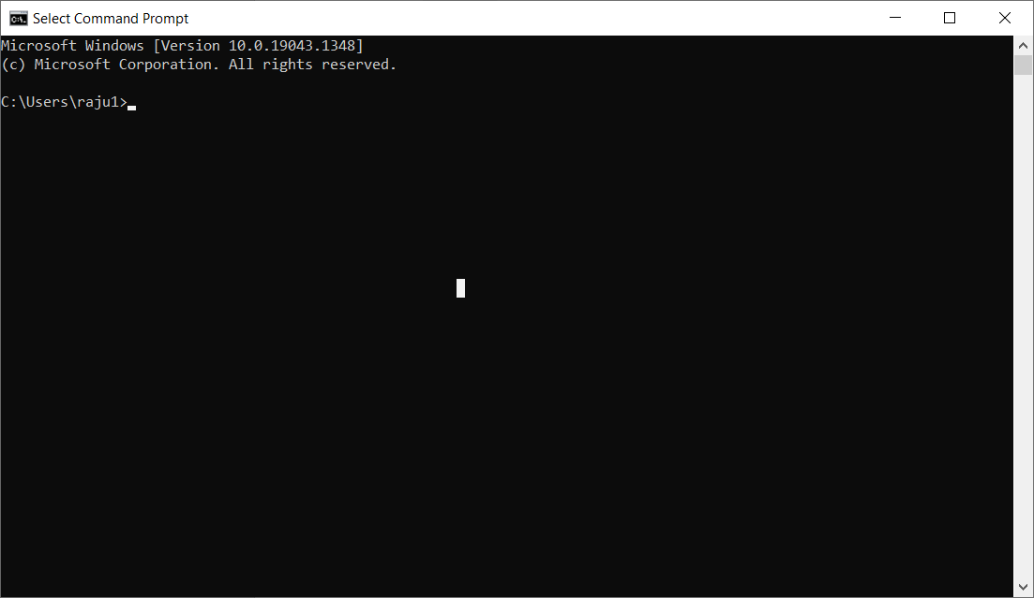

1. Go to directory where the codechallenge folder placed

Enter cd <Path of the folder>

Example: cd C:\Users\raju1\Desktop\CodeChallenge

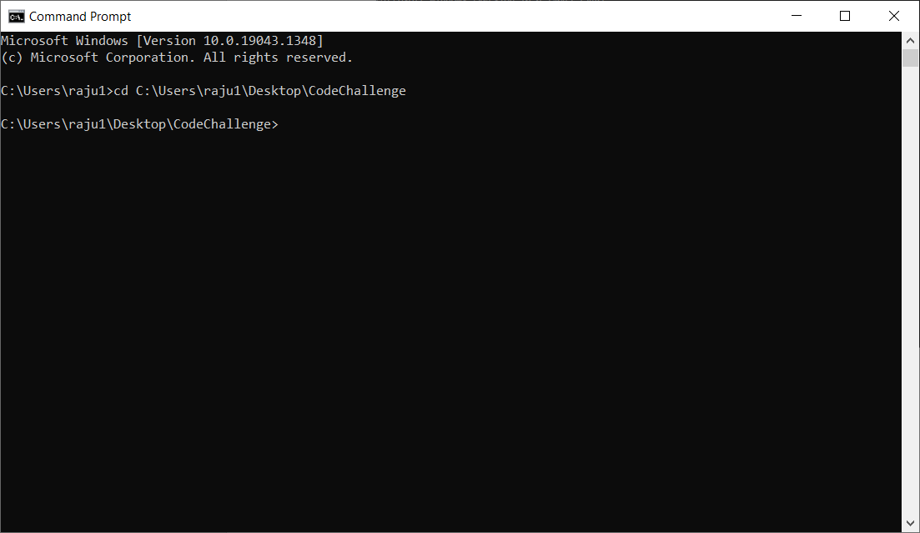

1. Comiple Java files using the below commands

javac -d bin -sourcepath src -cp lib/junit-4.13.2.jar src/TransposeLongestWord.java

javac -d bin -sourcepath src -cp lib/junit-4.13.2.jar src/JunitTest.java

javac -d bin -sourcepath src -cp lib/junit-4.13.2.jar src/TestRunner.java

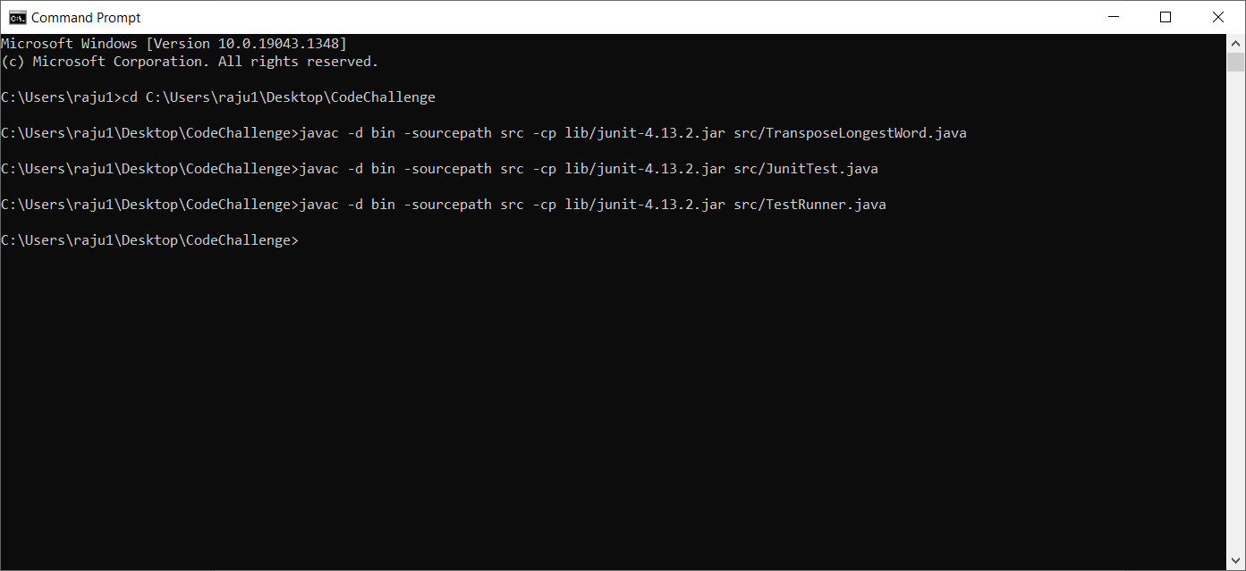

1. Once the files compiled successfully Run the below commands to execute the class files

To execute the TestRunner Main Class for running all junit tests, run the below command

java -cp bin/;lib/\* TestRunner

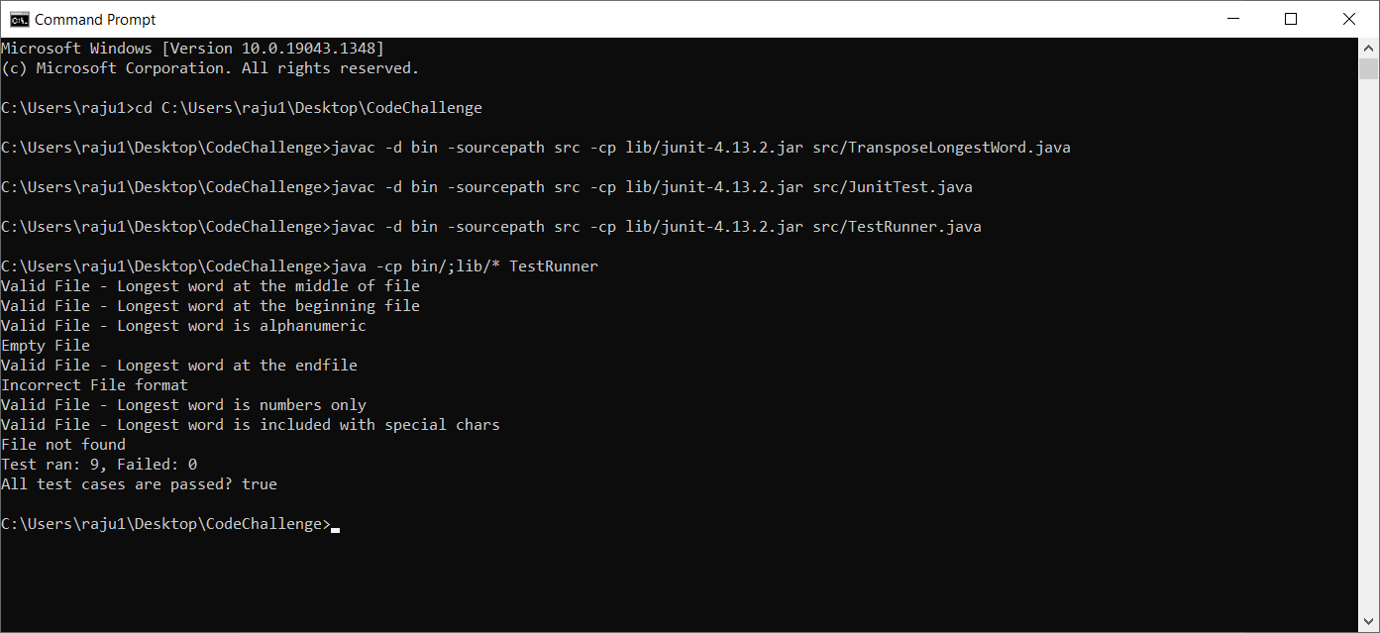

To execute the TransposeLongestWord Main Class run the below command

java -cp bin/;lib/\* TransposeLongestWord

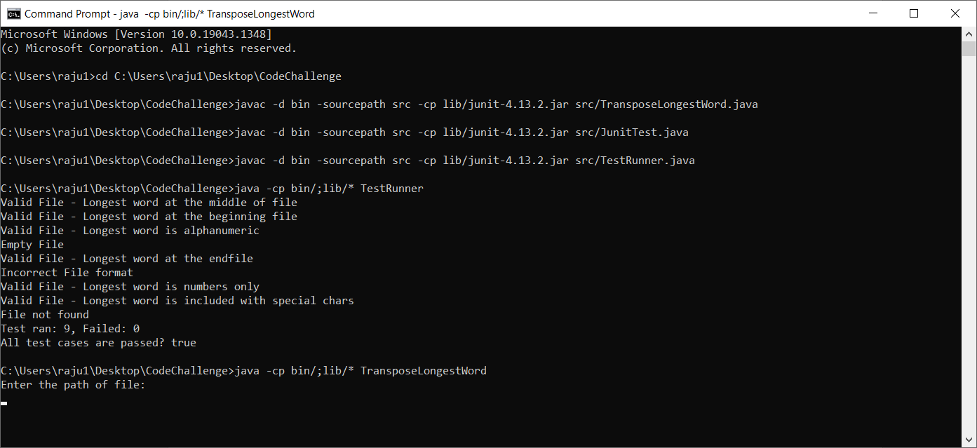

After user enter the path of a text file with words(Use TestDataFiles folder for sample files)

