

Ahsanullah University of Science and Technology

Department of Computer Science & Engineering

DATABASE LAB

CSE - 3104

Introductory Project Report

Parking Spot Finder

Submitted by

Student - 1 17.01.04.059

Student - 2 17.01.04.065

Student - 3 17.01.04.077

Contents

1. Introduction
2. Objective
3. Entity-Relationship Diagram
4. Entity and it’s attributes
5. Entity-01: User
6. Entity-02: Parking Spot Owner
7. Entity-03: Vehicle Owner
8. Entity-04: Parking Spot
9. Entity-05: Vehicle
10. Entity-06: Parking Records
11. Entity-07: Parking Requests

3.2 Relationship

3.2.1 Relationship-01: is a

3.2.2 Relationship-02: is a

3.2.3 Relationship-03: has

3.2.4 Relationship-04: has

3.2.5 Relationship-05: receives

3.2.6 Relationship-06: adds

3.2.7 Relationship-07: has

3.2.8 Relationship-08: has

1. Conclusion

1 Introduction

2 Objective

3 Entity-Relationship Diagram

4 Conclusion

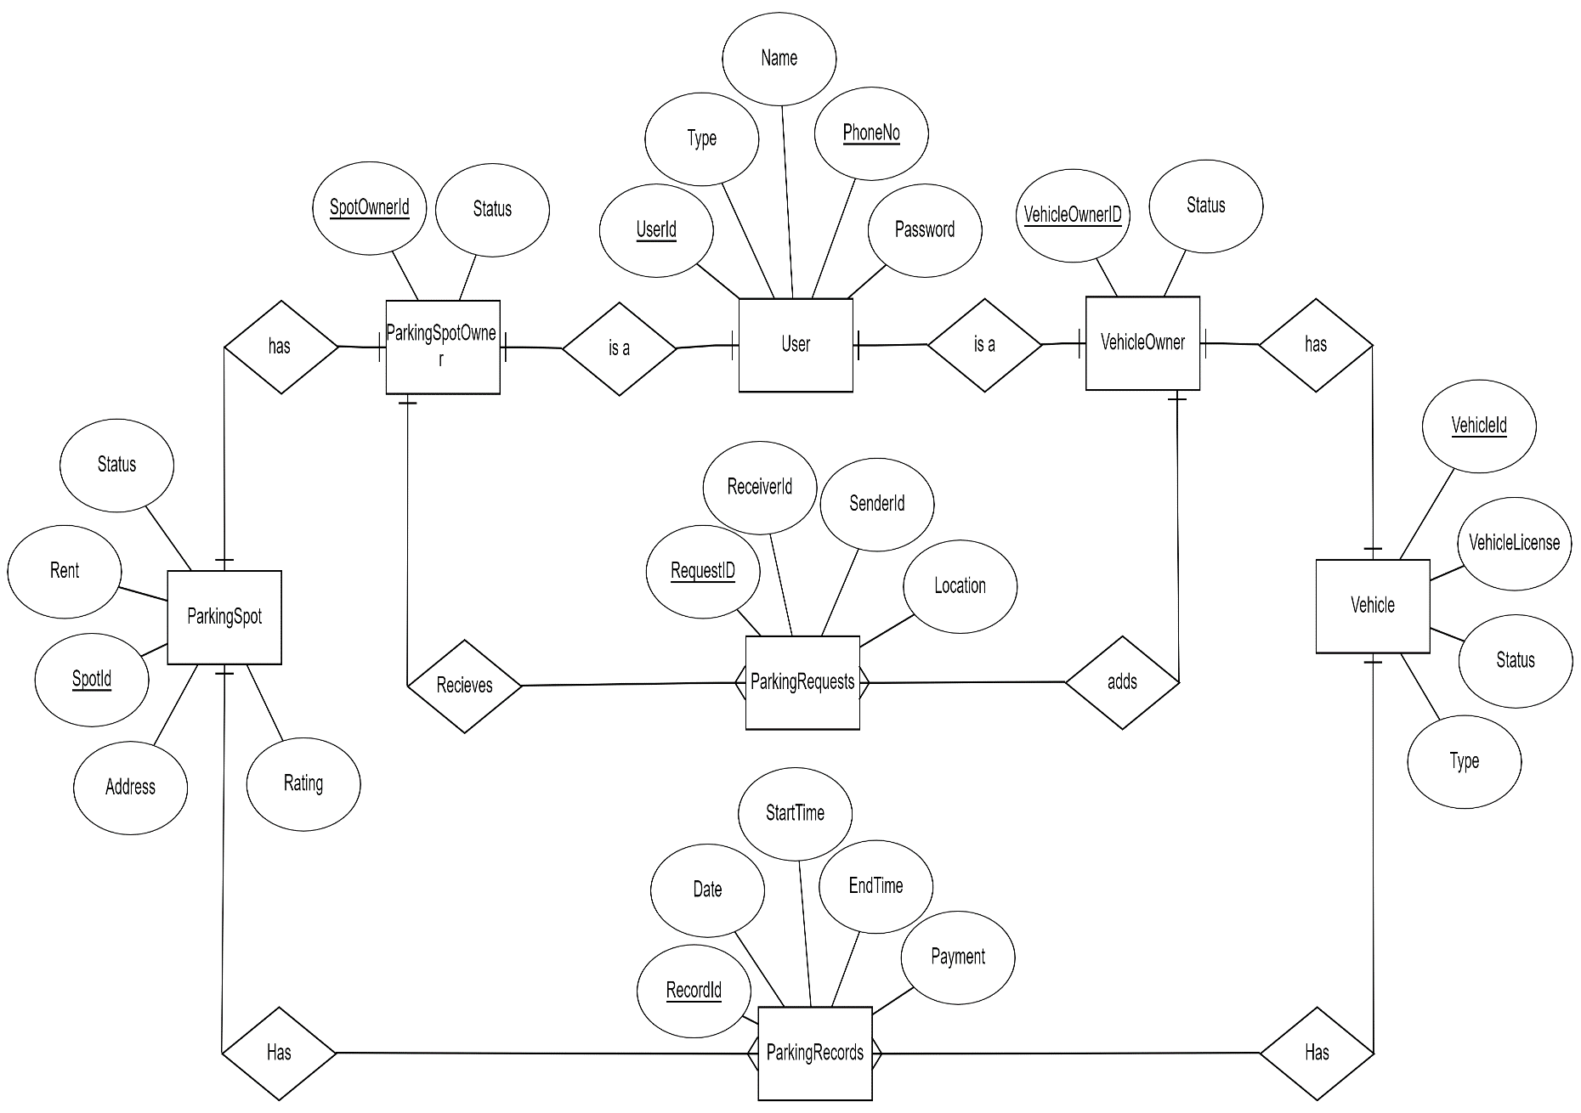

Figure 1: E-R Diagram of Parking Spot Finder