**Welcome to ATM Java project below are the artifacts for the project**

**Initial Project Run**

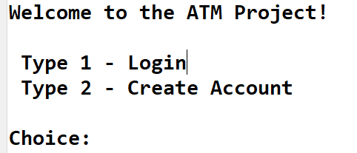

**Case 1: Login with wrong account number**

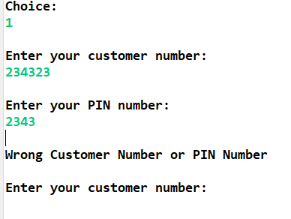

**Case 2: Entering wrong character**

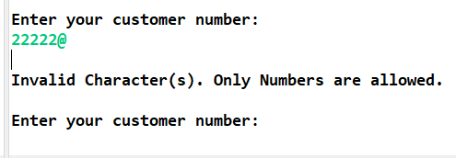

**Case 3: entering first customer credentials**

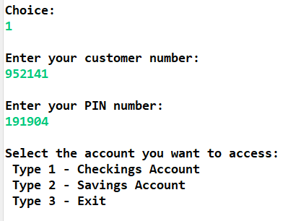

**Case 4: first customer checking account**

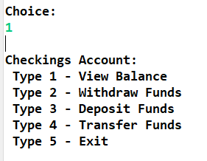

**Case 5: 1st customer account balance**

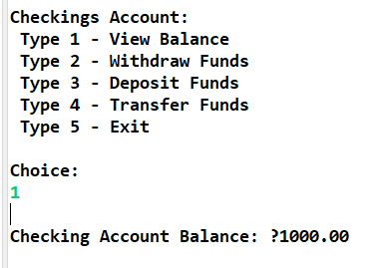

**Case 6: 1st customer Transfer Funds**

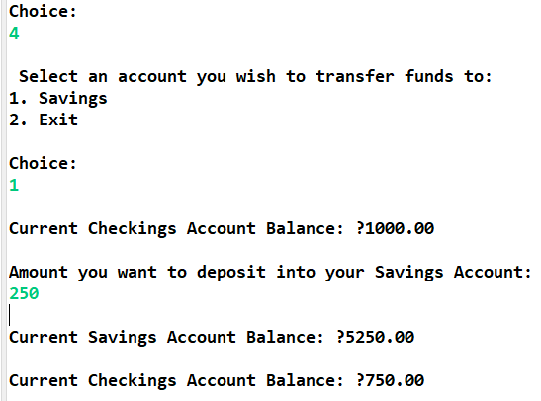

**Case 7:  1st customer check- Withdraw Funds**

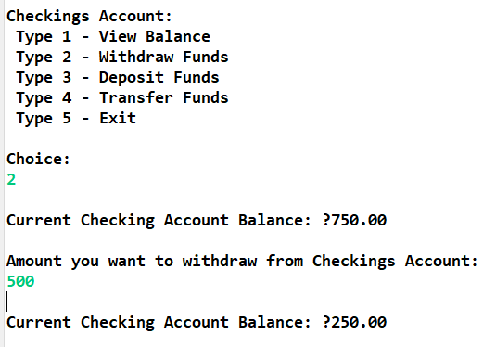

**Case 8 1st customer check Deposit Funds**

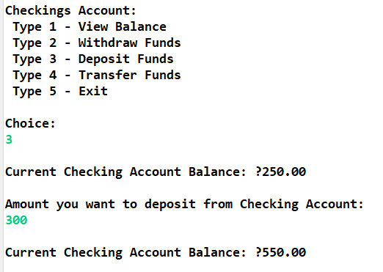

**Case 9: 1st customer check - Exit**

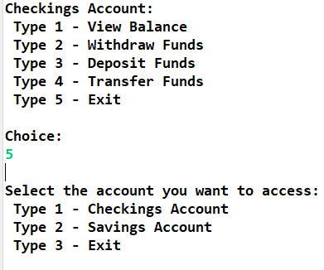

**Case 10: 1st customer saving acc view balance**

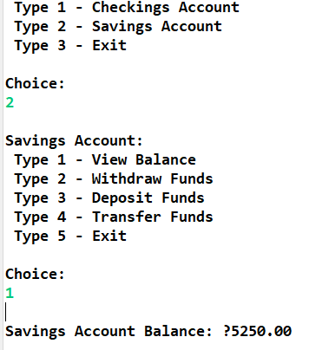

**Case 11: 1st customer saving acc withdrawfunds**

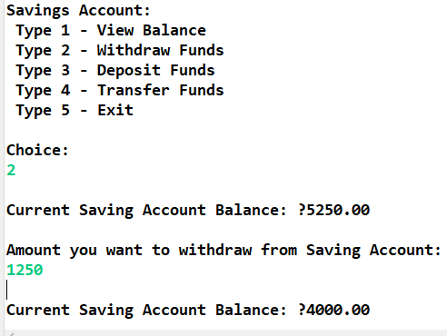

**Case 12: 1st customer saving accDeposit Funds**

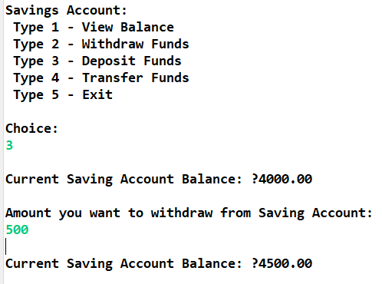

**Case 13: 1st customer saving acc Transfer Funds**

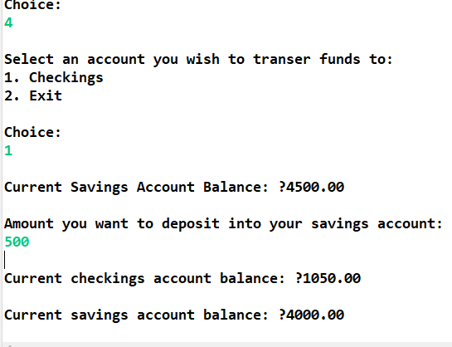

**Case 14: 1st customer saving acc exit**

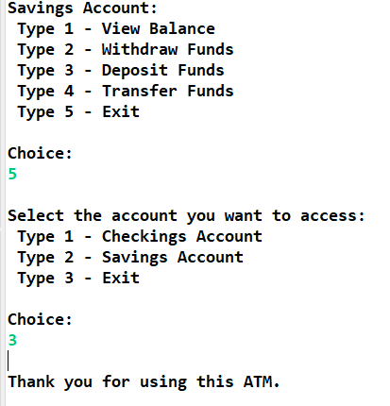

* **14 for 2nd customer**
* **Case 15: Login with wrong account number**
* 
* **Case 16: Entering wrong character**
* 
* **Case 17: entering 2nd customer credentials**
* 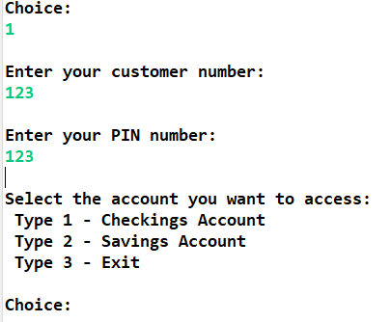
* **Case 18: second customer checking account**
* 
* **Case 19: 2nd customer account balance**
* 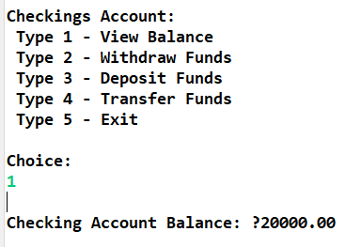
* **Case 20: 2nd customer Transfer Funds**
* 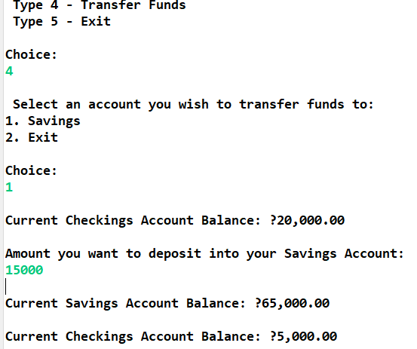
* **Case 21:  2nd customer check- Withdraw Funds**
* 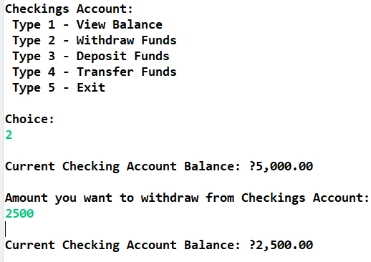
* **Case 22 2nd customer check Deposit Funds**
* 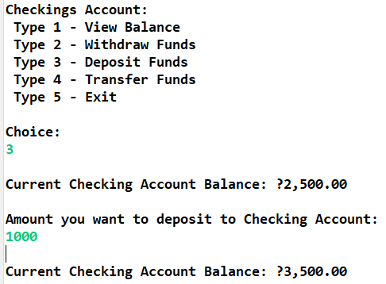
* **Case 23: 2nd customer check - Exit**
* 
* **Case 24: 2nd customer saving acc view balance**
* 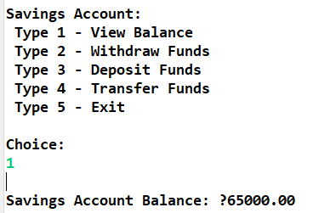
* **Case 25: 2nd customer saving acc withdrawfunds**
* 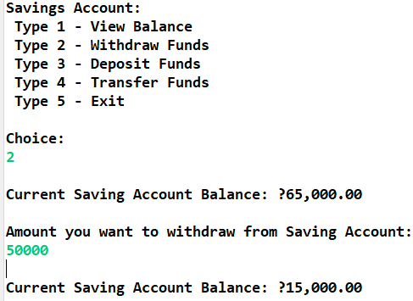
* **Case 26: 2nd customer saving accDeposit Funds**
* 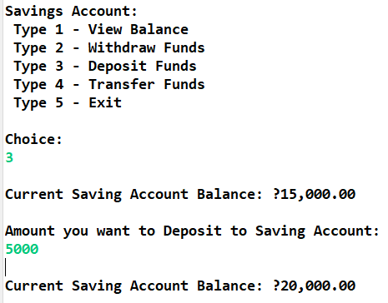
* **Case 27: 2nd customer saving acc Transfer Funds**
* 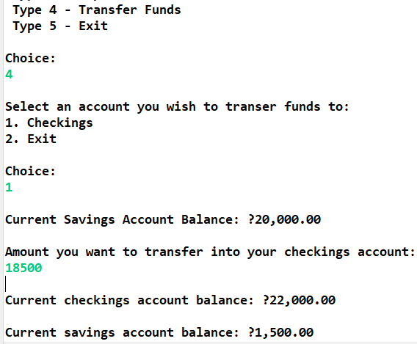
* **Case 28: 2nd customer saving acc exit**
* 

**Case 29: 2 - Create Account**

**Case 29: Login with wrong account number**

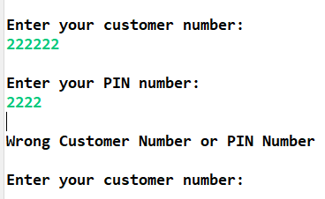

**Case 2: Entering wrong character**



**Case 3: entering new customer credentials**

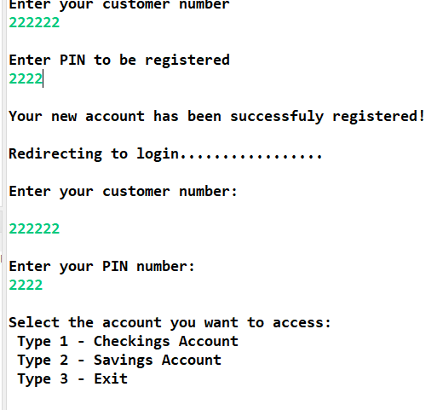

**Case 4: new customer checking account**



**Case 5: new customer account balance**

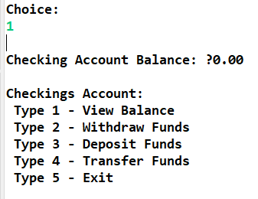

**Case 6: new customer Transfer Funds**

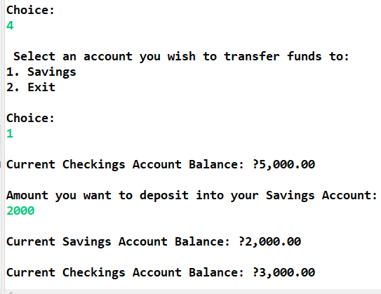

**Case 7:  new customer check- Withdraw Funds**

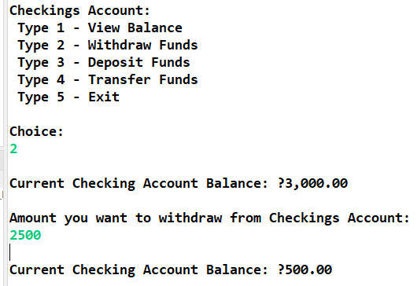

**Case 8 new customer check Deposit Funds**

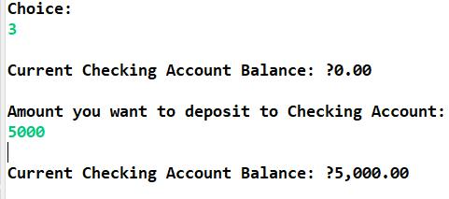

**Case 9: new customer check - Exit**



**Case 10: new customer saving acc view balance**

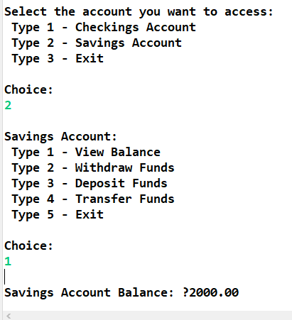

**Case 11: new customer saving acc withdrawfunds**

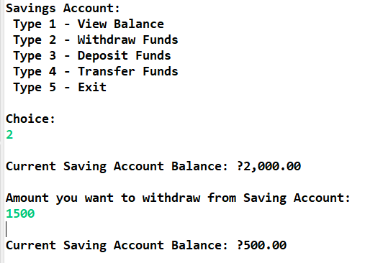

**Case 12: new customer saving accDeposit Funds**

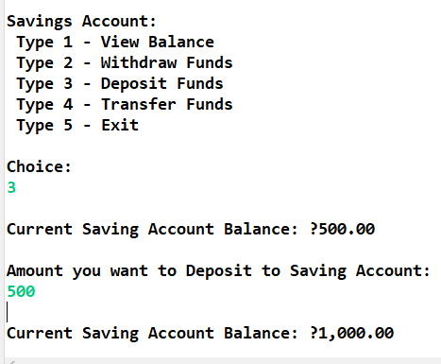

**Case 13: new customer saving acc Transfer Funds**

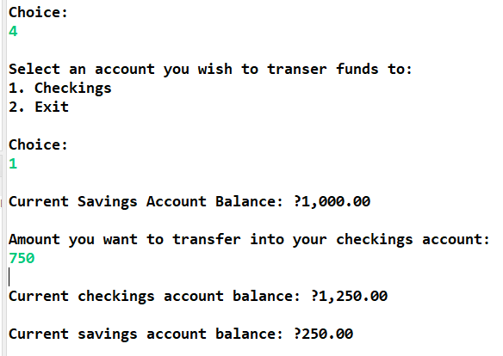

**Case 14: new customer saving acc exit**

