Northstar Delivery Office
PROJECT METHOD PLAYBOOK
LEAN PORTFOLIO
Lean Portfolio Decisions | synthetic baseline
edition
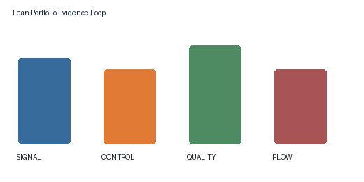
Figure 1

Contents
A. Overview
B. Core Concept
C. Process in Detail
D. Fit Check
E. Strengths and Risks
F. Learning Checklist

A. Overview

Value Stream Scope

Experiment Design
Lean Portfolio teams align work to lean portfolio decisions goals and record evidence before advancing the work item.
· Review the signal before changing the plan
· Keep ownership visible across handoffs
Stage | Evidence | Owner
Frame | Baseline | Lead
Test | Outcome | Team
Learn | Decision | Sponsor
Operations Excellence Series 3
M7 B New Style / Internal Playbook

B. Core Concept

C. Process in Detail

D. Fit Check

E. Strengths and Risks

Portfolio Advantages

Decision Rights
The Lean Portfolio method uses portfolio advantages to make the next decision observable and reversible.
Teams capture context, compare evidence, and assign a named owner for the next review.
Operations Excellence Series 4
M7 B New Style / Internal Playbook
Lean Portfolio records a measurable result for flow evidence and preserves the decision context.
Check | Threshold
Trace | Evidence linked
Review | Owner assigned
Close | Action recorded
Figure 2
Operations Excellence Series 5
M7 B New Style / Internal Playbook
A closeout record states what changed, who accepted the evidence, and what remains open in Lean Portfolio.
Operations Excellence Series 6

F. Learning Checklist

Appendix 1 — Figure Index
Structure inside images may be lost in transcription.
AI-generated figure id | AI-generated source page | AI-generated hash prefix | AI-generated caption | AI-generated transcribed text | AI-generated source part hashes
m7_b_new_style-p001-006 | 1 | e74d45d27667 | [missing enrichment result] | [none] | e74d45d2766738b8561bef2df4f841ebfd8d64c205d14457492d14f951521246
m7_b_new_style-p005-006 | 5 | e74d45d27667 | [missing enrichment result] | [none] | e74d45d2766738b8561bef2df4f841ebfd8d64c205d14457492d14f951521246

Appendix 2 — Source Map
m7_b_new_style-p003-002: source number 1; title Value Stream Scope; target A. Overview
m7_b_new_style-p003-003: source number 1.1; title Experiment Design; target A. Overview
m7_b_new_style-p004-002: source number 2; title Portfolio Advantages; target E. Strengths and Risks
m7_b_new_style-p004-003: source number 2.1; title Decision Rights; target E. Strengths and Risks
m7_b_new_style-p005-002: source number 3; title Flow Evidence; target unmapped
m7_b_new_style-p005-003: source number 3.1; title Assurance Measures; target unmapped
m7_b_new_style-p006-002: source number 4; title Learning Review; target unmapped

Appendix 3 — Unplaced Content

