MindX360 LMS PLATFORM
PROJECT MANAGEMENT METHODOLOGY
KANBAN
Professional Methodology & Learning Document

Contents
A. Overview
B. Core Concept
C. Process in Detail
D. Fit Check
E. Strengths and Risks
F. Learning Checklist

A. Overview

Abstract
Kanban is a visual, flow-based approach to managing work that focuses on making work visible, limiting work in progress, and continuously improving the movement of tasks through a defined workflow. It allows teams to manage work based on current priorities and capacity rather than relying on fixed phases or iterations.
The approach helps teams identify bottlenecks, reduce unnecessary work, improve workflow efficiency, and maintain a steady flow of delivery. Kanban can be applied to different types of projects and operational work, particularly where priorities and workloads may change over time.
This document provides a structured understanding of Kanban, covering its core concepts, workflow, practical application, appropriate use cases, advantages, and limitations from a project-management perspective.

Scope
This document provides a practical overview of the Kanban methodology, covering its core principles, visual workflow, work-in-progress management, flow of work, and continuous improvement. It explains how Kanban can be applied to organize and manage work, identify bottlenecks, respond to changing priorities, and improve delivery efficiency. The document also covers appropriate use cases, advantages, and limitations of Kanban within a project-management environment.

Introduction

Background
Kanban originated as a method for managing production flow and was later adapted for knowledge work and project environments. It focuses on the continuous movement of work through a defined workflow rather than requiring work to follow fixed iterations or sequential phases. Its emphasis on visualizing work, limiting work in progress, and improving flow provides teams with greater visibility and control over how work moves through the process.

Purpose
The purpose of this document is to establish a clear and consistent understanding of Kanban, including its core principles, workflow, methods for managing work in progress, and techniques for improving flow. It also explains how Kanban can be applied in project-management environments and the conditions in which it may be appropriate.

Intended Audience
This document is intended for project management learners, Project Managers, Business Analysts, team members, and other professionals involved in managing or delivering work through continuous-flow processes.

B. Core Concept

Kanban Methodology
Kanban is a visual, flow-based method for managing work in which tasks are represented and tracked as work items as they move through a defined workflow. The core idea is to make work visible, control the amount of work being handled at each stage, and improve the flow of tasks from initiation to completion. A typical Kanban system uses a board with workflow stages such as To Do, In Progress, Review, and Done, although teams can define stages according to their specific process.
Kanban does not require work to be divided into fixed iterations or predefined time periods. Instead, work items are pulled through the workflow as capacity becomes available. Work-in-Progress (WIP) limits help prevent excessive multitasking and expose bottlenecks. By observing how work moves through the system and identifying where tasks accumulate or become delayed, teams can make incremental adjustments to improve flow and delivery.
Typical Kanban Board Structure
Workflow Stage | Purpose
To Do | Work that has been identified and is ready to be started
In Progress | Work currently being actively handled
Review | Work awaiting review, validation, or approval
Done | Work that has met the defined completion criteria
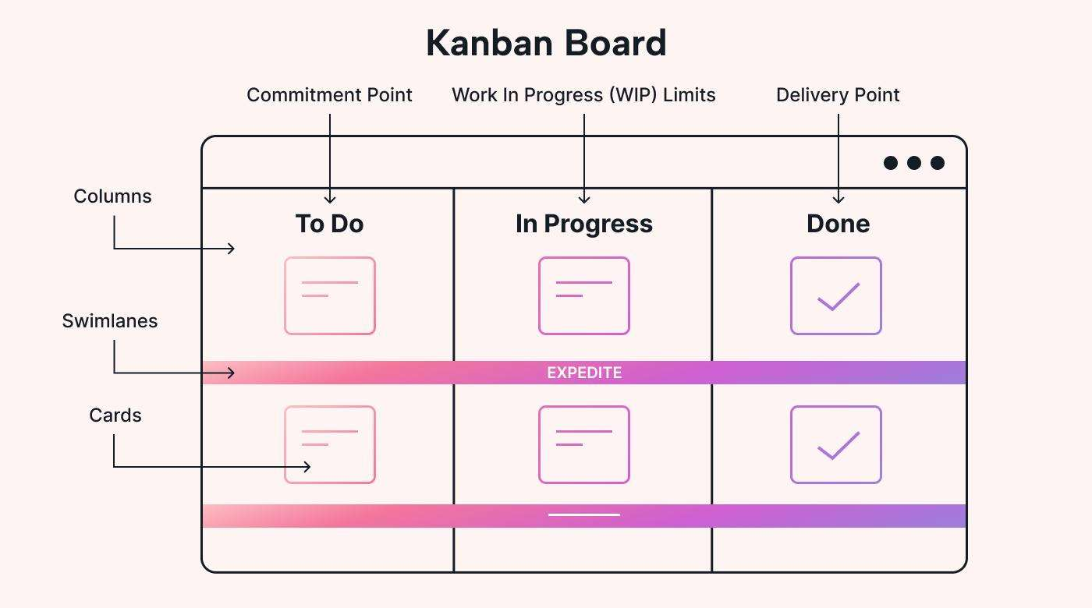
Figure 1
AI-generated description: A diagram illustrating the elements and layout of a Kanban board with labels for columns, swimlanes, cards, and workflow points.

C. Process in Detail

Detailed Kanban Process Explanation

Visualizing Work
The first step in a Kanban system is to make work visible by representing tasks as work items on a Kanban board. The board is divided into workflow stages that reflect how work moves through the process, such as To Do, In Progress, Review, and Done. Each work item is moved across the board as its status changes, giving the team a clear view of what work is waiting, currently being handled, or completed.

Defining the Workflow
The workflow defines the stages a work item must pass through from initiation to completion. Teams establish these stages according to their actual working process and define clear criteria for when work can move between stages. A clearly defined workflow creates consistency, makes delays easier to identify, and provides a common understanding of how work should progress.

Managing Work in Progress
Work-in-Progress (WIP) limits control the amount of work that can be handled simultaneously within a workflow stage. By limiting active work, teams can reduce excessive multitasking, prevent tasks from accumulating at bottlenecks, and encourage completion before starting additional work. WIP limits can be adjusted based on team capacity and observed workflow performance.
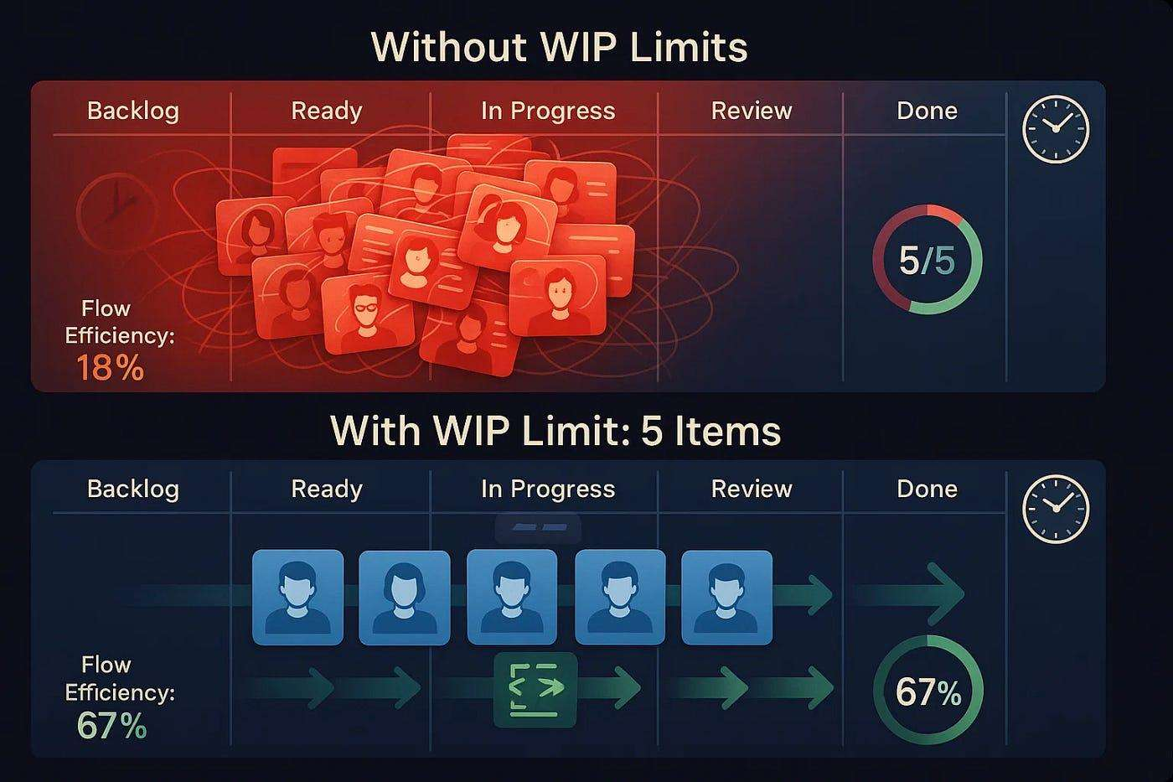
Figure 2
AI-generated description: A diagram comparing Kanban workflow performance without WIP limits versus with a WIP limit of five items, showing an increase in flow efficiency.

Managing Flow
Flow management focuses on ensuring that work moves through the workflow steadily and efficiently. Teams monitor where tasks become delayed or accumulate and identify constraints affecting their movement. Improvements may involve addressing bottlenecks, balancing workloads, reducing unnecessary handoffs, or adjusting workflow stages and WIP limits.

Continuous Improvement
Kanban encourages teams to regularly evaluate and improve their workflow using observations and performance data. Teams can review delivery patterns, identify recurring problems, and make incremental changes to improve efficiency and predictability without requiring the entire process to be redesigned.

D. Fit Check

When to Use Kanban
Kanban Kanban is well suited to environments where work arrives continuously, priorities change frequently, and teams need flexibility in managing the order and volume of tasks. It is particularly useful when work items vary in size or urgency, when maintaining a steady flow is more important than working within fixed iterations, or when teams need greater visibility into work status and bottlenecks. Kanban can be applied across project, operational, support, maintenance, and service-oriented environments where work can be visualized and moved through defined stages.
Suitability Framework
Project Characteristic | Kanban Suitability
Continuous flow of work | Suitable
Frequently changing priorities | Suitable
Variable task sizes or urgency | Suitable
Need to identify bottlenecks | Suitable
Need for visual work tracking | Suitable
Fixed iterations are mandatory | Less suitable
Workflow cannot be clearly visualized | Less suitable
Example: A customer support team receiving requests throughout the day can use Kanban to move tickets through stages such as To Do, In Progress, Waiting for Customer, Resolved, and Closed while using WIP limits to prevent too many requests from being handled simultaneously.

E. Strengths and Risks

Best Practices
Effective Kanban implementation depends on maintaining a clear and consistently managed workflow. Teams should keep work visible, define workflow stages clearly, and establish appropriate Work-in-Progress (WIP) limits based on their capacity. Work should be pulled into each stage only when capacity is available, helping prevent excessive multitasking and unnecessary accumulation of tasks.
Teams should regularly monitor the flow of work, identify bottlenecks, and address delays as they occur. Performance information and team observations should be used to make incremental improvements to the workflow. For example, if tasks consistently accumulate in the Review stage, the team can investigate the cause and adjust its WIP limits, workflow, or available capacity to improve the movement of work.

Advantages of Kanban
Kanban provides greater visibility and transparency by making work and its current status easy to understand through a visual workflow. Team members can see which tasks are waiting, in progress, blocked, under review, or completed. This creates a shared understanding of the workload and makes it easier to identify where attention is required.
Kanban also supports flexibility and controlled workload management. Teams can respond to changing priorities without waiting for a new iteration or restarting the planning process. Work-in-Progress (WIP) limits help prevent excessive multitasking and highlight areas where work is accumulating, allowing teams to identify bottlenecks and address constraints that may be slowing delivery.
Another advantage is its focus on continuous flow and improvement. By observing how work moves through the workflow, teams can identify delays, recurring problems, and opportunities to improve their process. For example, if tasks regularly accumulate in a review stage, the team can investigate the cause and make changes to improve the movement of work.

Limitations & Challenges
Kanban relies on a clearly defined workflow and consistent management of work, which can become challenging when processes are poorly understood or frequently change without control. Without appropriate Work-in-Progress (WIP) limits, teams may take on too many tasks simultaneously, reducing focus and causing work to accumulate at different stages. Excessive priority changes can also disrupt workflow and make delivery less predictable.
Another challenge is that Kanban requires continuous monitoring and improvement. If teams do not regularly review bottlenecks, delays, and workflow performance, the board may become only a status-tracking tool rather than a mechanism for improving delivery. For example, if a team consistently has a large number of tasks waiting for review but does not address the underlying capacity constraint, the bottleneck will continue to affect overall flow.
Key Challenges
Challenge | Potential Impact
Poorly defined workflow | Inconsistent movement of work
Excessive WIP | Reduced focus and work accumulation
Frequent priority changes | Disrupted flow and reduced predictability
Lack of continuous monitoring | Bottlenecks and delays remain unresolved
Review or approval constraints | Work accumulates at specific stages
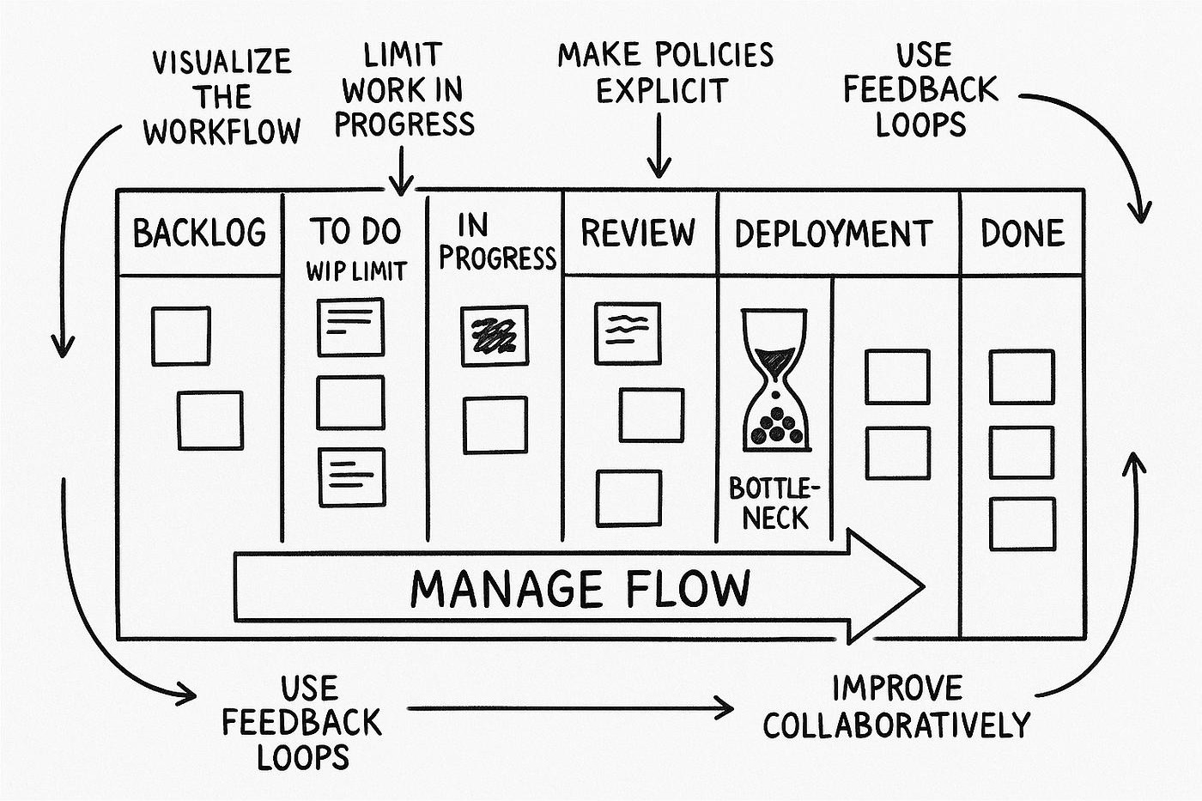
Figure 3
AI-generated description: A hand-drawn diagram illustrating Kanban practices across workflow stages from Backlog to Done.

F. Learning Checklist

Learning Objectives
After completing this document, a learner should be able to:
- Define Kanban and explain its flow-based operating model.
- Explain the purpose and components of a Kanban workflow.
- Describe how Kanban boards are used to visualize work.
- Explain the purpose of Work-in-Progress (WIP) limits.
- Understand how teams identify and manage bottlenecks.
- Explain how flow metrics can be used to monitor and improve delivery.
- Recognize the types of work environments where Kanban can be effectively applied.
- Identify the principal advantages and limitations of the Kanban method.

Appendix 1 — Figure Index
Structure inside images may be lost in transcription.
AI-generated figure id | AI-generated source page | AI-generated hash prefix | AI-generated caption | AI-generated transcribed text | AI-generated source part hashes
kanban-p004-016 | 4 | 871f41caa636 | A diagram illustrating the elements and layout of a Kanban board with labels for columns, swimlanes, cards, and workflow points. | Kanban Board | Commitment Point | Work In Progress (WIP) Limits | Delivery Point | Columns | To Do | In Progress | Done | Swimlanes | EXPEDITE | Cards | 871f41caa636ea40bfd2c2d7c5f09a9d2221fb6a40e89717b1cc6eca33e5de07
kanban-p005-008 | 5 | a8cae953c2e9 | A diagram comparing Kanban workflow performance without WIP limits versus with a WIP limit of five items, showing an increase in flow efficiency. | Without WIP Limits | Backlog | Ready | In Progress | Review | Done | Flow | Efficiency: | 18% | 5/5 | With WIP Limit: 5 Items | Backlog | Ready | In Progress | Review | Done | Flow | Efficiency: | 67% | 67% | a8cae953c2e9caa8f32cb563f89f95b53106189412c9eaa453772e6df1610454
kanban-p007-008 | 7 | 692d7cf00e68 | A hand-drawn diagram illustrating Kanban practices across workflow stages from Backlog to Done. | VISUALIZE THE WORKFLOW | LIMIT WORK IN PROGRESS | MAKE POLICIES EXPLICIT | USE FEEDBACK LOOPS | BACKLOG | TO DO | WIP LIMIT | IN PROGRESS | REVIEW | DEPLOYMENT | DONE | BOTTLE-NECK | MANAGE FLOW | USE FEEDBACK LOOPS | IMPROVE COLLABORATIVELY | c3067df9e4b95d5fc7eafc292d6488f70fe5579704b9991b4ed7002ecfc9b4a0, 381d6aa609619f79b0b4dd35d1ff3b4f01f107c0deacc1661ad5681c672df46a

Appendix 2 — Source Map
kanban-p003-001: source number 1; title Abstract; target A. Overview
kanban-p003-005: source number 2; title Scope; target A. Overview
kanban-p003-007: source number 3; title Introduction; target A. Overview
kanban-p003-008: source number 3.1; title Background; target A. Overview
kanban-p003-010: source number 3.2; title Purpose; target A. Overview
kanban-p003-012: source number 3.3; title Intended Audience; target A. Overview
kanban-p004-001: source number 4; title Learning Objectives; target F. Learning Checklist
kanban-p004-011: source number 5; title Kanban Methodology; target B. Core Concept
kanban-p005-001: source number 6; title Detailed Kanban Process Explanation; target C. Process in Detail
kanban-p005-002: source number 6.1; title Visualizing Work; target C. Process in Detail
kanban-p005-004: source number 6.2; title Defining the Workflow; target C. Process in Detail
kanban-p005-006: source number 6.3; title Managing Work in Progress; target C. Process in Detail
kanban-p005-009: source number 6.4; title Managing Flow; target C. Process in Detail
kanban-p005-011: source number 6.5; title Continuous Improvement; target C. Process in Detail
kanban-p006-001: source number 7; title When to Use Kanban; target D. Fit Check
kanban-p006-006: source number 8; title Best Practices; target E. Strengths and Risks
kanban-p006-009: source number 9; title Advantages of Kanban; target E. Strengths and Risks
kanban-p007-003: source number 10; title Limitations & Challenges; target E. Strengths and Risks

Appendix 3 — Unplaced Content

