MindX360 LMS PLATFORM
PROJECT MANAGEMENT METHODOLOGY
WATERFALL
Professional Methodology & Learning Document

Figure 1
AI-generated description: A long-exposure photograph of Skógafoss waterfall cascading down lush green mossy cliffs into a misty pool surrounded by dark pebbled ground.

Contents
A. Overview
B. Core Concept
C. Process in Detail
D. Fit Check
E. Strengths and Risks
F. Learning Checklist

A. Overview

Abstract
Waterfall is a structured, sequential approach to project delivery in which work is organized into defined phases and progresses through a planned order. A typical lifecycle moves from requirements to design, development, testing, deployment and maintenance. The output of an earlier phase provides the basis for the next phase.
The approach is strongest when requirements are sufficiently clear and stable, the intended outcome is understood, and upfront planning, documentation and formal approvals provide value. Its principal weakness is reduced flexibility: significant changes discovered later can require rework across downstream activities and may affect schedule, cost and scope.

Scope
This document provides a practical overview of the Waterfall project management methodology, covering its core principles, sequential lifecycle, key phases, activities, outputs, advantages, limitations and appropriate use cases. It also explains best practices, common pitfalls and key considerations for managing projects in a predictive delivery environment. The document is intended to provide a structured understanding of how Waterfall can be applied throughout the project lifecycle, from requirements definition through deployment and maintenance.

Introduction

Background
Waterfall represents a traditional predictive way of organizing project work. Rather than continuously redefining the product during delivery, the project establishes a defined direction early and moves through planned stages.

Purpose
The purpose of this document is to establish a clear, consistent understanding of Waterfall: what it is, how its lifecycle operates, what project-management disciplines support it, and the conditions under which it is an appropriate choice.

Scope
The document covers the methodology at a practical project level. It addresses lifecycle phases, phase outputs, decision considerations, benefits, limitations, selection criteria, best practices and common pitfalls. It does not prescribe a single organizational governance model or a universal phase-gate standard.

Intended Audience
This document is intended for project and program management learners, Project Managers and PMO professionals, Business Analysts and project stakeholders, and team members working within predictive delivery environments.

B. Core Concept

Waterfall Lifecycle
Phase | Primary Purpose | Typical Output
1. Requirements | Define what the project must deliver | Approved requirements and scope
2. Design | Define how the requirements will be satisfied | Solution design and specifications
3. Development | Build the solution according to the agreed definition | Completed product/build
4. Testing | Verify that the solution works and meets requirements | Test results, defects and verification evidence
5. Deployment | Make the approved solution available in its intended environment | Released solution
6. Maintenance | Address post-release defects, operational needs and approved maintenance changes | Fixes, updates and support
The six phases above are used as the course framework. The source material explicitly notes that organizations may define or name phases differently; the important concept is the sequential organization of work rather than memorizing one universal phase list.

C. Process in Detail

Detailed Phase-by-Phase Explanation
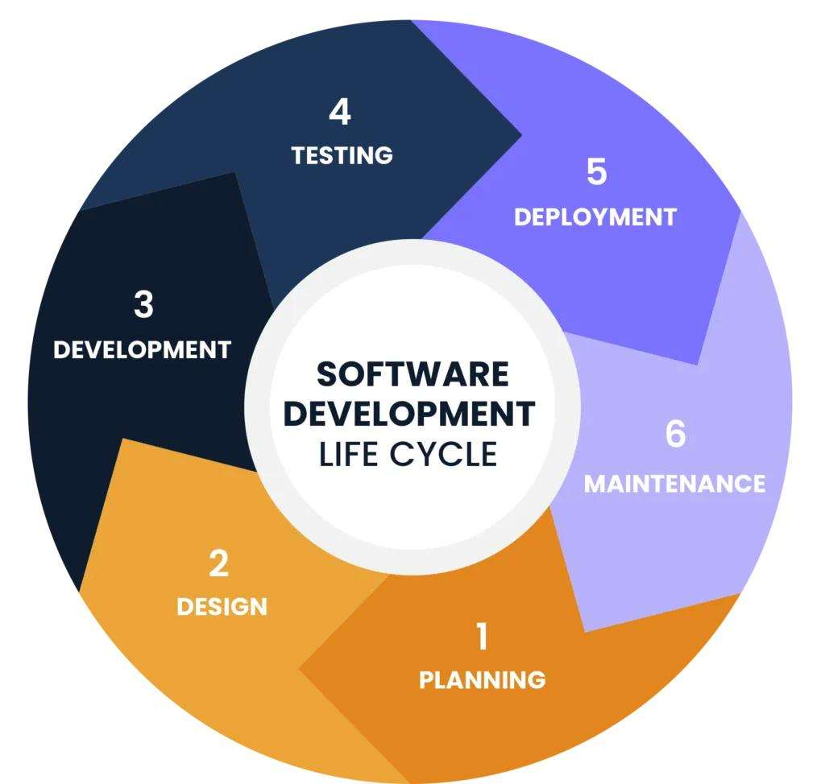
Figure 2
AI-generated description: A circular diagram detailing the six phases of the software development life cycle.

Requirements
The Requirements phase establishes a sufficiently clear definition of the business need, user needs, scope, constraints and expected outcomes. Activities include understanding business and user needs, defining functional requirements, identifying constraints and establishing the project scope and expected outcomes. The primary output is an approved requirements baseline and agreed scope. The quality of this phase strongly influences downstream design, development and testing, so requirements should be understood, documented and agreed before substantial downstream work begins.

Design
The Design phase translates the agreed requirements into a solution that can be built. Activities include defining the solution architecture, database design, interface design, technical specifications and process flows. The primary outputs are the approved design and technical specifications. The design should remain traceable to the requirements it is intended to satisfy, providing a clear foundation for development.
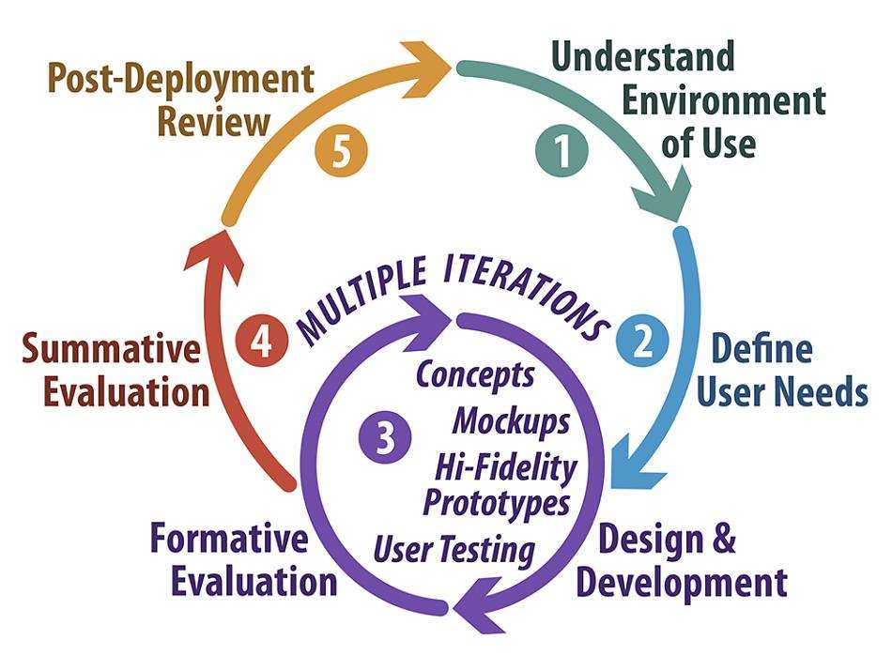
Figure 3
AI-generated description: A circular diagram outlining a five-step design and development process, highlighting an iterative cycle in step three.

Development
The Development phase involves constructing the solution in accordance with the approved requirements and design. Activities include coding, configuration, component creation and other implementation activities required to build the solution. The primary output is the completed build or implemented solution. During this phase, the team should control deviations from the approved baseline and formally surface material changes rather than absorbing them informally.

Testing
The Testing phase determines whether the completed solution works as expected and satisfies the agreed requirements. Activities include functional verification, scenario testing, defect identification and performance checks where applicable. Outputs include test evidence, defect records and a readiness recommendation. Testing is not limited to finding bugs; it also evaluates whether the delivered solution satisfies the agreed requirements and is ready to proceed to deployment.
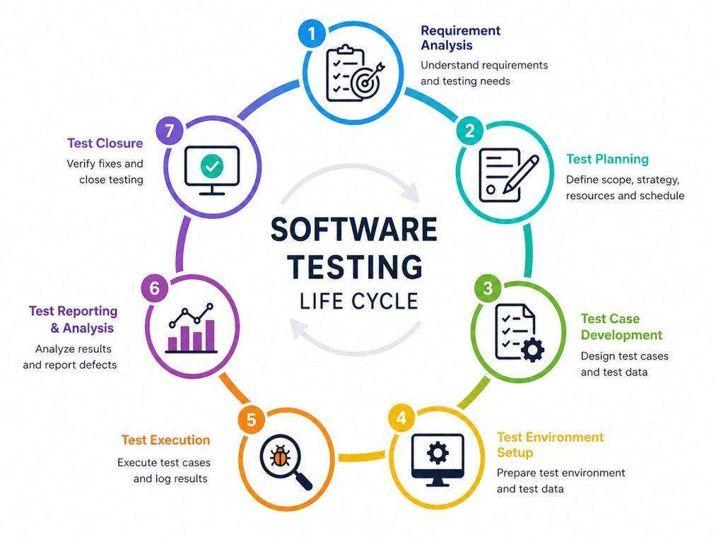
Figure 4
AI-generated description: A circular diagram depicting the seven stages of the software testing life cycle, starting with requirement analysis and ending with test closure.

Deployment
The Deployment phase releases the tested and approved solution into its intended environment. Activities include release preparation, deployment and operational handover. The primary output is the deployed solution. Deployment should occur only after the required testing and approvals have been completed, ensuring that the solution is ready for use in its intended environment.

Maintenance
The Maintenance phase supports the solution after release and addresses issues that arise during operation. Activities include defect fixes, operational support, updates and approved maintenance changes. Outputs include fixes, updates and support outcomes. Maintenance forms part of the lifecycle after deployment and allows the solution to be supported and updated without implying unrestricted addition of new scope.
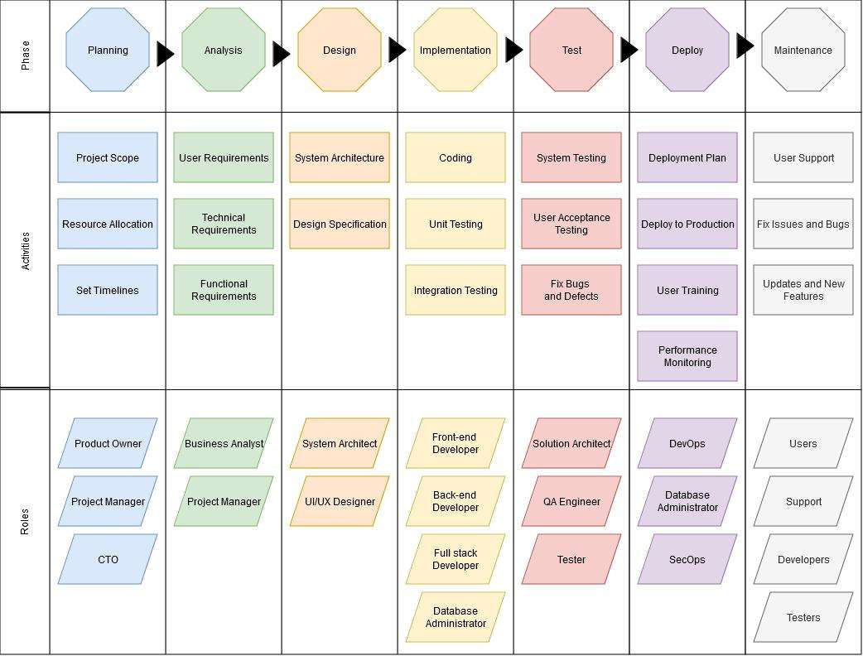
Figure 5
AI-generated description: A matrix diagram illustrating the phases of the software development lifecycle, detailing the associated activities and roles for each phase.

D. Fit Check

When to Use Waterfall
Waterfall is a strong candidate when requirements can be understood and defined upfront, major requirements are unlikely to change materially during delivery, the intended outcome is sufficiently predictable, the work can be planned effectively before execution, formal documentation, reviews or approvals provide meaningful value, and the cost of late change is acceptable relative to the benefits of structured delivery.

Decision Framework
Question | If Yes | If No
Are requirements clear? | Supports Waterfall | Increases uncertainty
Are requirements relatively stable? | Supports sequential planning | Raises rework risk
Is the outcome predictable? | Supports upfront planning | Makes baseline definition harder
Can work be planned effectively upfront? | Supports a predictive lifecycle | Suggests need for learning/adaptation
Are formal phases/documentation/approvals valuable? | Provides additional fit | Reduces the structural advantage

E. Strengths and Risks

Best Practices
Practice | Application
Establish a clear baseline | Define scope, requirements and expected outcomes before substantial downstream work begins.
Validate before progressing | Use structured reviews to confirm that requirements and design are sufficiently complete for the next phase.
Maintain traceability | Ensure important requirements can be connected to design decisions, implementation and verification.
Manage dependencies actively | Identify what each phase requires from preceding work and confirm readiness before transition.
Control change formally | Assess scope, schedule, cost, resources and downstream effects before approving material changes.
Use meaningful phase criteria | Define what 'complete' means for each phase rather than relying only on elapsed time.
Keep stakeholders aligned | Communicate decisions, risks, issues, changes and milestones consistently.
Treat documentation as an operational asset | Keep documentation current enough to support decisions, handover, verification and future maintenance.

Advantages of Waterfall
Advantage | Project Value
Clear structure | The sequence makes the current phase, expected work and next decision point easy to understand.
Documentation | Requirements, specifications, plans and decisions create a durable record of what was agreed.
Predictable planning | Stable requirements and a well-understood outcome support estimation of scope, schedule and budget.
Clear milestones | Phase deliverables and completion criteria provide straightforward progress checkpoints.
Controlled decision-making | Formal review and approval points can help organizations manage commitments and accountability.
These advantages are most meaningful when the project's underlying assumptions remain stable.

Limitations & Challenges
Challenge | Impact
Late or significant requirement change | May require revisions to design, development and testing, increasing rework, time and cost.
Late user feedback | Users may only meaningfully interact with the completed solution relatively late, increasing the risk of discovering expectation gaps.
Downstream dependency | A delay or defect in one phase can affect subsequent activities.
Uncertainty | Projects that do not yet know what the final solution should be can be difficult to define upfront.
False sense of certainty | A detailed initial plan cannot eliminate uncertainty; it can only provide a baseline against which changes are managed.

F. Learning Checklist

Learning Objectives
After completing this document, a learner should be able to:
- Define Waterfall and explain its sequential operating model.
- Describe the purpose and typical outputs of each lifecycle phase.
- Explain how dependencies between phases affect project planning and control.
- Recognize the principal advantages and limitations of the approach.
- Evaluate whether a project has the characteristics needed for effective Waterfall delivery.
- Identify practices that reduce avoidable risk in a predictive project.

Appendix 1 — Figure Index
Structure inside images may be lost in transcription.
AI-generated figure id | AI-generated source page | AI-generated hash prefix | AI-generated caption | AI-generated transcribed text | AI-generated source part hashes
waterfall-p001-005 | 1 | 3805ba5b973d | A long-exposure photograph of Skógafoss waterfall cascading down lush green mossy cliffs into a misty pool surrounded by dark pebbled ground. | [none] | ed8d88c614e835ffaa56938928093eccb11d61f7d407219f0254c9b7c8d12a0e, e6aa97ad0187054d506702971643481b97db8df642331c54a217012d06778471, a5d194f9ecd1acf56523a99a2214450ebef0798c51d0d3b513019c06f3da072e, 2a21e5f00acbbc1fee4eba22916be34cca205e23b70fb119d2db3a89e261ac9b, 1a03fc940d1f998d1512037aa6af2b6d3affb021166a6157cc524d4b01bc968c
waterfall-p008-002 | 8 | f40b8f6d1873 | A circular diagram detailing the six phases of the software development life cycle. | 4 | TESTING | 5 | DEPLOYMENT | 3 | DEVELOPMENT | SOFTWARE | DEVELOPMENT | LIFE CYCLE | 6 | MAINTENANCE | 2 | DESIGN | 1 | PLANNING | f40b8f6d18739ebffdfb70761bf54ec389671dfb929c46040e44cd75974bdfe8
waterfall-p008-007 | 8 | 130bd37d0c5a | A circular diagram outlining a five-step design and development process, highlighting an iterative cycle in step three. | Post-Deployment Review | Understand Environment of Use | 5 | 1 | MULTIPLE ITERATIONS | Summative Evaluation | 4 | 2 | Define User Needs | Concepts | 3 | Mockups | Hi-Fidelity Prototypes | Formative Evaluation | User Testing | Design & Development | 130bd37d0c5a17eeb1d28870620ee9218fabd21d84d6a6248fb0c5277a8bd155
waterfall-p009-005 | 9 | 14574a6e9dc0 | A circular diagram depicting the seven stages of the software testing life cycle, starting with requirement analysis and ending with test closure. | 1 | Requirement Analysis | Understand requirements and testing needs | 2 | Test Planning | Define scope, strategy, resources and schedule | SOFTWARE TESTING LIFE CYCLE | 3 | Test Case Development | Design test cases and test data | 4 | Test Environment Setup | Prepare test environment and test data | 5 | Test Execution | Execute test cases and log results | 6 | Test Reporting & Analysis | Analyze results and report defects | 7 | Test Closure | Verify fixes and close testing | 14574a6e9dc06baeceabc300085ae75b44da8bc11859b35c87de352e8390f0b3
waterfall-p010-001 | 10 | e22cec6dfe7b | A matrix diagram illustrating the phases of the software development lifecycle, detailing the associated activities and roles for each phase. | Phase | Planning | Analysis | Design | Implementation | Test | Deploy | Maintenance | Activities | Project Scope | User Requirements | System Architecture | Coding | System Testing | Deployment Plan | User Support | Resource Allocation | Technical Requirements | Design Specification | Unit Testing | User Acceptance Testing | Deploy to Production | Fix Issues and Bugs | Set Timelines | Functional Requirements | Integration Testing | Fix Bugs and Defects | User Training | Updates and New Features | Performance Monitoring | Roles | Product Owner | Business Analyst | System Architect | Front-end Developer | Solution Architect | DevOps | Users | Project Manager | Project Manager | UI/UX Designer | Back-end Developer | QA Engineer | Database Administrator | Support | CTO | Full stack Developer | Tester | SecOps | Developers | Database Administrator | Testers | e22cec6dfe7b870d0b22d38492242e6d087f507b79cc54f3c2114b3d18e48599

Appendix 2 — Source Map
waterfall-p003-001: source number 1; title Abstract; target A. Overview
waterfall-p004-001: source number 2; title Scope; target A. Overview
waterfall-p005-001: source number 3; title Introduction; target A. Overview
waterfall-p005-002: source number 3.1; title Background; target A. Overview
waterfall-p005-004: source number 3.2; title Purpose; target A. Overview
waterfall-p005-006: source number 3.3; title Scope; target A. Overview
waterfall-p005-008: source number 3.4; title Intended Audience; target A. Overview
waterfall-p006-001: source number 4; title Learning Objectives; target F. Learning Checklist
waterfall-p007-001: source number 5; title Waterfall Lifecycle; target B. Core Concept
waterfall-p008-001: source number 6; title Detailed Phase-by-Phase Explanation; target C. Process in Detail
waterfall-p008-003: source number 6.1; title Requirements; target C. Process in Detail
waterfall-p008-005: source number 6.2; title Design; target C. Process in Detail
waterfall-p009-001: source number 6.3; title Development; target C. Process in Detail
waterfall-p009-003: source number 6.4; title Testing; target C. Process in Detail
waterfall-p009-006: source number 6.5; title Deployment; target C. Process in Detail
waterfall-p009-008: source number 6.6; title Maintenance; target C. Process in Detail
waterfall-p011-001: source number 7; title When to Use Waterfall; target D. Fit Check
waterfall-p011-003: source number 7.1; title Decision Framework; target D. Fit Check
waterfall-p012-001: source number 8; title Best Practices; target E. Strengths and Risks
waterfall-p013-001: source number 9; title Advantages of Waterfall; target E. Strengths and Risks
waterfall-p014-001: source number 10; title Limitations & Challenges; target E. Strengths and Risks

Appendix 3 — Unplaced Content

