Manual
What are the Priority and Severity in Software Testing
- Severity refers to how badly a defect impacts the functionality of the application.
It is technical and typically decided by QA/Testers.
Severity – Levels & Examples
- Critical – App crashes; no workaround
- High – Major functionality broken
- Medium – Partial impact, workaround exists
- Low – Cosmetic/UI issues

- Priority refers to how urgently a defect needs to be fixed.
It is business-driven and usually set by the Product Owner/Manager.
Priority – Levels & Examples
- P1 – High → Fix immediately
- P2 – Medium → Fix soon
- P3 – Low → Fix later / next release

Smoke Testing
Smoke testing also known as Build Verification Testing is a software testing method that is performed at the beginning of the testing process to make sure that the most critical functions of the software applications are working correctly.

Sanity Testing

Sanity testing is a quick, focused test done after developers deliver a new build, mainly to verify that specific bug fixes or small changes are working correctly. It checks only the affected modules rather than the entire application. If the sanity test fails, we reject the build and stop further testing. It is a subset of regression testing.

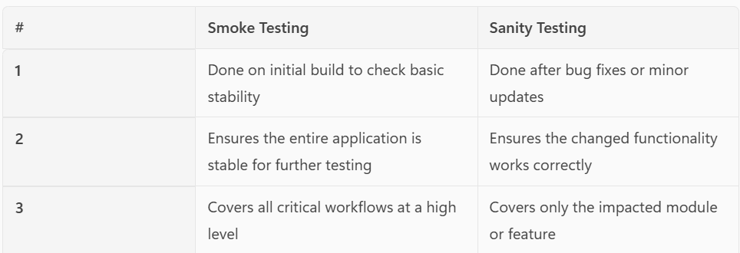

Bug Lifecycle
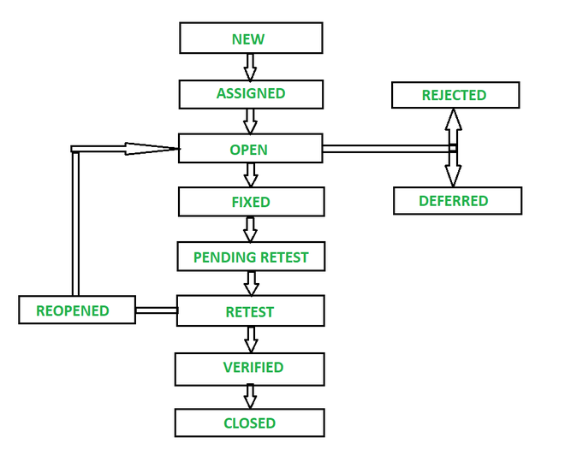

RTM (Requirement Traceability Matrix)
RTM is a document that maps and traces requirements to their corresponding test cases.
It ensures that all requirements are covered, tested, and no functionality is missed.

Verification
Verification is the process of checking whether the requirements, design, and documents are correct before development starts. It is a static activity
This includes reviewing requirements, API contracts, acceptance criteria, and ensuring everything is testable and automatable

Validation
Validation is the process of checking whether the developed application works as expected by executing tests. It is a dynamic activity
This includes running automated tests (UI/API), functional testing, regression, and end-to-end testing.

What are Test Case Design Techniques
a. Equivalence Partitioning
b. Boundary Value Analysis
c. Decision Table Testing
d. State Transition Testing

Equivalence Partitioning
Equivalence Partitioning is a black‑box test design technique where we divide input data into logical groups called partitions and select one representative value from each group to test.
The idea is that all values in the same partition should behave the same way, so we don’t need to test each one. This reduces the number of test cases without losing coverage.
For example, if an age field accepts values from 18 to 60:
Valid partition: 18–60
Invalid partition 1: Less than 18
Invalid partition 2: Greater than 60
I’ll pick one value from each partition (like 30, 15, and 70).

Error Guessing
Error Guessing is a test design technique where test cases are created based on the tester’s experience to guess where defects might occur. It focuses on areas where similar bugs have appeared before or where the system is likely to fail.

Boundary Value Analysis
Boundary Value Analysis is a black-box test design technique where test cases are created based on the boundary values of input ranges. This is because defects commonly occur at the edges of input ranges rather than in the middle.
We test:
Lower Boundary
Upper Boundary
Just Below the Boundary on the Boundary
Just Above the Boundary

Test Plan
Test Plan is basically the blueprint for how testing will be carried out in a project. It outlines the overall approach, objectives, scope, and the resources needed for testing. In simple terms, it tells the team what will be tested, how it will be tested, who will test it, and when the testing will happen.
I usually start with the purpose and objectives, followed by defining the scope — what are in scope and what are out scope. Then I describe the test strategy, which explains the types of testing we’ll perform, like functional, integration, regression, or system testing. I also include details about the test environment, required data, tools, and the roles and responsibilities within the QA team.
A good Test Plan also includes entry and exit criteria, risks with mitigation strategies, and a high-level schedule. Overall, it ensures everyone is aligned, reduces ambiguity, and helps deliver a clear, structured, and efficient testing process

Entry Criteria
Entry Criteria are the conditions that must be fulfilled before we start testing. This usually includes having finalized and approved requirements, a fully configured and stable test environment, and a build that has passed smoke testing. Test cases and test data must be prepared, reviewed, and available. All required access, user roles, and tools should also be in place. These conditions ensure that the QA team starts testing smoothly without blockers

Exit Criteria
Exit Criteria are the conditions that must be met before we can conclude testing. This includes: all planned test cases executed, all critical and high-severity defects fixed and verified, acceptable low-severity defects approved by the business, required test coverage achieved, and all deliverables like defect reports and the final test summary completed

Test Strategy
A Test Strategy is a high-level document that defines the overall approach for testing. It sets the standards and guidelines that the QA team follows to ensure consistency and quality.
It typically outlines the types of testing we will perform — like functional, integration, system, regression, and non-functional testing
The Test Strategy also defines the environment setup, test data approach, automation strategy, defect management process, tools to be used, and how test reporting and communication will happen. It includes entry and exit criteria, risk management, and mitigation plans.

Automation Strategy
Automation Strategy defines what to automate, how to automate it, and when automation should be implemented. It focuses on selecting stable, repeatable, high-value test scenarios like regression, smoke, and API tests. It outlines the tools and frameworks to use, the architecture such as POM or data-driven design, and how automation will integrate into CI/CD pipelines
