Comparative Analysis of Social and Road Networks Using Unsupervised Graph Analysis
Course: CS 6010 – Data Science Programming
Group Members:
- Raju Bandam
- Nandika Kaila
- Gnaneshwar
- Gowtham
- Rohit
Abstract:
The project conducted a comparison of two graphs from very different domains: the social network of Facebook and the road network of California (RoadNet-CA). We used Python and NetworkX to compute important metrics of graphs, including degree distribution, clustering coefficient, network density, connected components, diameter, and centrality measures. The analysis illustrates the different structures of both graphs, noting that Facebook is characterized by high clustering, small diameter, and the presence of hub nodes, while RoadNet-CA is sparse, has a large diameter, and the clustering coefficient is low. These are further illustrated in the degree distribution plots. Due to the size of the graphs, we also used approximations for some computationally intensive metrics, particularly centrality measures. Overall, this project provided the students with the needed experience to evaluate large scale graphs, computing graph metrics, visualizing and discussing the graph metrics and the structure of the two different quantitative networks specific to their domain.
Introduction:
Graph analysis has become an effective method for studying complex relationships in large-scale networks. In many domains of the real world, entities can be represented as nodes and their interactions or connections as edges, resulting in graphs. In other words, graphs are a representation of entities and the relationships among them and analyzing graphs can be informative about structural patterns, connectivity, and the overall structure of complex systems, including social media platforms, communication networks, transportation systems, and biology.
In the world of data science, graph-based analytics, may be particularly valuable, as they can discover underlying patterns without requiring labeled data, or, nonsupervised learning. Although supervised methods depend on known outcomes to assess outcome success, unsupervised graph analyses concentrate on exploratory pattern discovery such as investigating communities, influential nodes, and network cohesion. Therefore, they might be well-suited to modeling real-world phenomena where true ground truth labels are not available, which is often a problem in the analysis of networked systems.
The main aim of this project is to perform unsupervised graph analysis on two large-scale networks from different domains, and do a systematic comparison of the structural properties of each network model. We selected:
- Facebook Social Network – representing human relationships and interactions, and
- RoadNet-CA Network – representing physical infrastructure and connectivity among roads in California.
Both networks vary not only in their applied domains but also in their mechanism of formation. The Facebook network evolves organically through user interaction, friend recommendations, and community building, typically leading to high clustering, small-world behavior, and hubs (or highly connected individuals). On the other hand, the RoadNet-CA network is constructed purposefully on a physical and spatial basis leading to sparse, planar, and nearly uniform degree distributions. These networks provide an opportunity to demonstrate the differences in network structure and cohesion caused by domain specific constraints.

Dataset Description and Preprocessing:
In order to conduct unsupervised exploration of large-scale graphs, we picked two publicly available network datasets from diverse domains: a social network (Facebook) and a road network (RoadNet=CA) through the Stanford Large Network Dataset Collection (SNAP). SNAP provides standardized, documented graph datasets that researchers can easily use for academic studies.

- Facebook Social Network:
The Facebook dataset consists of anonymized friendship connections amongst users. Each node represents a user, and each edge represents a friendship connection between two users. The dataset exhibits the small world and community structure present in a typical human social interaction network.
- Source: SNAP Facebook Social Circles Dataset
- Domain: Social network
- Type: Undirected, unweighted graph
- Nodes (Users): 4,039
- Edges (Friendships): 88,234
- Average Degree: ≈ 43.7
The Facebook network serves as a superlative natural laboratory for studying human interaction dynamics, the formation of hubs, and local connectivity features such as triangles and cliques. These properties are well-suited to the Facebook network due to its relatively dense structure and heterogeneous degree distribution, and they are particularly pertinent to clustering coefficient, degree centrality, and community formation.

- RoadNet-CA (California Road Network):
The RoadNet-CA dataset creates a representation of the intersections and connections along the roads of California. Each node refers to a specific intersection of a road, and each edge refers to a direct segment of the same road. This network differs from social networks which have less geographical bounds, and is therefore also a sparser, almost planar graph with a uniform degree distribution.
- Source: SNAP RoadNet-CA Dataset
- Domain: Transportation network
- Type: Undirected, unweighted graph
- Nodes (Intersections): 1,965,206
- Edges (Road Segments): 2,766,607
- Average Degree: ≈ 2.8
- Characteristics: Sparse, spatially constrained, large diameter, no strong community structure

This dataset serves as a counterexample to social networks — connectivity is constrained by physical layout, which leads to lengthy paths, low density, and little clustering. This dataset is appropriate for investigating diameter, connected components, and average path length.

Data Preprocessing

The datasets were represented as simple edge lists in a text file, with each line representing a pair of connected nodes. The following preprocessing steps were undertaken in Python using NetworkX for efficient analysis:
- Data Loading.

We loaded each dataset directly using read_edgelist() in NetworkX. For large graphs (such as RoadNet-CA), we used an efficient streaming technique to avoid a memory overload.

- Graph construction.

Since both datasets represent undirected relationships, we created undirected graphs (nx.Graph) so that the connections were symmetric.

- Cleaning:
  - Self-loops (edges from a node to itself) were deleted.
  - Multi-edges were converted to single edges to guarantee unique edges.
  - Connectivity was verified to prepare for potentially disconnected components.

Graph Properties and Algorithms Used:
It is important to understand the structural properties of a graph to uncover its topology, connectivity, and function. In this project, we focus on a set of five important properties of a graph that characterize both global and local aspects of the networks:
- Degree distribution,
- Clustering coefficient,
- Centrality measures (degree and betweenness),
- Network density and diameter, and
- Connected components and triangles.
All calculations used the NetworkX library in Python, which has efficient matching algorithms for statistical and structural analysis of networks. In the case of larger graphs, approximate or sampled versions of some statistics (e.g. diameter) were used to simplify computation.

Degree Distribution:
The degree of a node is the number of edges associated with it. The degree distribution P(k) is the probability that a randomly selected node has degree k, and it indicates whether the network is homogeneous (most nodes have similar degrees) or heterogeneous (a few nodes have high degrees -- these are called hubs).
$$P(k)=\frac{N_{k}}{N}$$
where:
- $N_{k}$= number of nodes with degree $k$,
- $N$= total number of nodes.
The degree distribution of Facebook follows a heavy-tailed (like power-law) distribution, as is the case with many social networks, because a few users (i.e. influencers) have more connections than most other users. In contrast, the RoadNet-CA graph has a more narrow distribution, largely between 2 and 4 degrees, because of the physical constraints of road systems.
Clustering Coefficient:
The clustering coefficient quantifies the extent that nodes cluster in a network. It assesses the likelihood for node neighborhoods to form triangles, which is an indicator of local communities.
The local clustering coefficient for a node $v$is defined as:
$$C_{v}=\frac{2T(v)}{k_{v}(k_{v}-1)}$$

where:
- $T(v)$= number of triangles passing through node $v$,
- $k_{v}$= degree of node $v$.
The average clustering coefficient of the entire network is:
$$C=\frac{1}{N}\sum_{v∈V}{}C_{v}$$
A high clustering coefficient signifies a higher potentiality for community formation and denser local structures.
In our results, the Facebook graph showed a high average clustering coefficient (~0.61), demonstrating that friends of a user are likely to be friends with each other. On the other hand, the RoadNet-CA network had a very low clustering coefficient (~0.05), which was expected because road networks are sparse and planar.
Implementation:
clustering = nx.average_clustering(G)
Centrality Measures:
Centrality measures identify the most important or influential nodes within a graph. Two key types were analyzed:

Degree Centrality:
Degree centrality is a normalized form of node degree, representing the fraction of nodes directly connected to a given node.
$$C_{D}(v)=\frac{\text{deg}(v)}{N-1}$$
High degree centrality nodes in the Facebook graph correspond to socially influential users, while in the RoadNet-CA network they represent major traffic intersections.
Implementation:
deg_centrality = nx.degree_centrality(G)
Network Density and Diameter:
The density of a graph quantifies how close it is to being complete:
$$D=\frac{2E}{N(N-1)}$$
where $E$= number of edges, $N$= number of nodes.
The Facebook graph has a much higher density (D ≈ 0.0108) than the RoadNet-CA graph (D ≈ 0.0000014), showing that social networks are much more interconnected than road networks.
The diameter shows how far apart the most distant nodes are, or the longest shortest path between any pair of nodes.
$$\text{Diameter}=\underset{u,v∈V}{max⁡}d(u,v)$$
Due to the large size of RoadNet-CA, the exact diameter was approximated using the two-sweep heuristic available in networkx.approximation.diameter().
Implementation:
density = nx.density(G)
diameter = nx.approximation.diameter(G)

Connected Components and Triangles:
A connected component is a subgraph in which every two nodes can be linked by a path. The number and sizes of the components provide clues to the overall connectivity of a network. The Facebook network is mostly connected, with nearly all nodes being part of a single giant component. By contrast, RoadNet-CA has multiple smaller components, indicating disconnected road regions across a geographical area.
Implementation:
components = nx.number_connected_components(G)
largest_cc = max(nx.connected_components(G), key=len)

The number of triangles in the network is another measure of local cohesion, representing closed triplets of nodes.
$$T=\frac{1}{3}\sum_{v∈V}{}T(v)$$
In the Facebook dataset, the number of triangles was extremely high, highlighting social clustering, whereas RoadNet-CA had very few triangles due to limited intersection overlaps.
Experimental Results and Visualizations:
This segment presents both the quantitative and qualitative results resulting from analysis of the Facebook Social Network dataset and of the RoadNet-CA (California Road Network) dataset, which were evaluated using the NetworkX library in Python, which enabled efficient calculation of metric calculations based on graph theory along with visualization capabilities. Each dataset was preprocessed and calculated separately, before a comparative assessment was conducted.

Basic Graph Statistics:
Table 1 summarizes the core statistics computed for both datasets.

Experimental Results

Metric | Facebook Graph | RoadNet-CA Graph
Number of Nodes | 4,039 | 1,965,206
Number of Edges | 88,234 | 2,766,607
Average Degree | 43.7 | 2.8
Graph Density | 0.0108 | 0.0000014
Connected Components | 1 | 2642
Average Clustering Coefficient | 0.6055 | 0.0462

Interpretation:
The Facebook graph is very well connected, it consists of one large connected component with high density, and the average node (user) connects to many others. The clustering coefficient is high (0.6055), indicating that social networks create tight communities of friendship.
On the other hand, the RoadNet-CA graph is extremely sparse, with an average degree of only 2.8 and a clustering coefficient that is very low. The presence of more than one connected component represents disconnected subregions of California’s road system (e.g., rural networks separated from each other or islands).

Observations:
- The Facebook network behaves as a heavy-tailed (power-law) distribution showing there are few users (hub nodes) who have dramatically higher connections than average. This is a typical aspect of scale-free networks.
- The distribution for RoadNet-CA is narrow and peaks around 2-3 degrees indicating that most intersections are connected to only two or three roads, an aspect of real-world road topologies.

Path Length and Diameter:
To measure how “far apart” nodes are within the network, the average shortest path length and diameter (longest shortest path) were estimated using random sampling for computational feasibility.
Metric | Facebook Graph | RoadNet-CA Graph
Average Shortest Path Length (Sampled) | 3.68 | 480.21
Diameter (Approximation) | 8 | 849

Figure 1: Facebook Degree Distribution
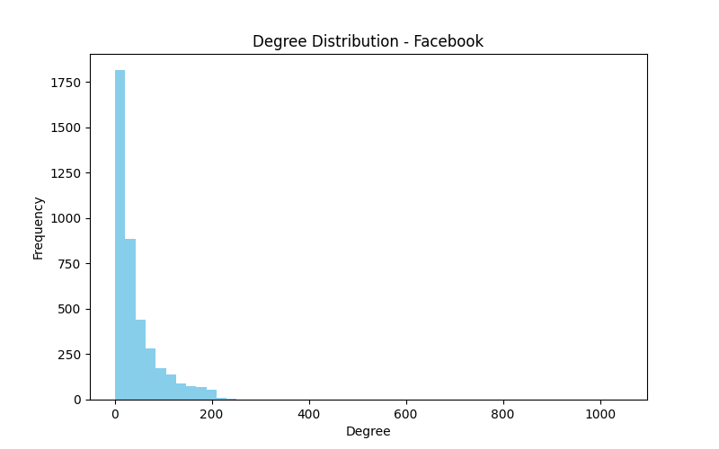
Figure 1 illustrates the degree distribution of the Facebook social network, depicting how many connections (edges) each user (node) possesses. The x-axis represents the node degree (number of friends or connections), while the y-axis shows the number of nodes having that degree. The histogram clearly reveals a right-skewed distribution, where most users have a moderate number of friends, but a few users exhibit exceptionally high degrees, forming the long-tail pattern typical of social networks.
This behavior aligns with the scale-free property observed in many real-world social graphs, where a small number of “hub” users—highly connected individuals or influencers—serve as central connectors for large parts of the network. These hubs play a critical role in information diffusion and community connectivity. The presence of these nodes also means that the network is robust against random node failures but vulnerable to targeted attacks (i.e., removal of hub nodes).
In addition, the gradual falloff in frequency as degree increases indicates the preferential attachment phenomenon — new users are more likely to connect to already well-connected users, leading to a relatively small number of hubs, or very popular users, and a larger number of peripheral nodes. This kind of degree distribution suggests a strong degree of clustering and community structure and demonstrates that in fact the Facebook social network is a type of small-world network - with high clustering coefficients and short average path lengths.
In general, the degree distribution characterization provides an important first step in understanding how the Facebook network is organized: it is dense, heterogenous, and has non-uniform connectivity, as opposed to sparse graphs, such as many road networks.

Figure 2: RoadNet-CA Degree Distribution
Histogram indicates most nodes have low degree, reflecting sparse spatial constraints of road networks.
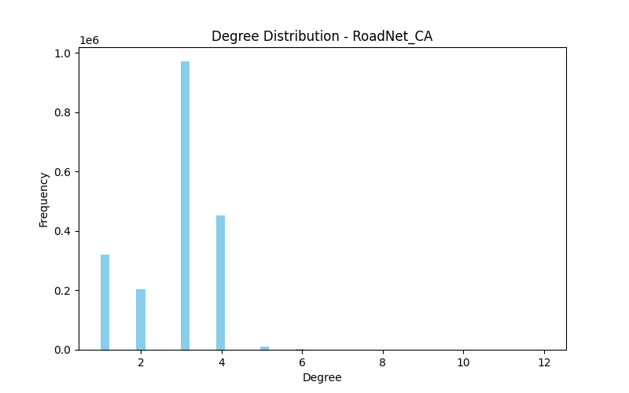
The degree distribution of the RoadNet-CA dataset is illustrated in Figure 2, which depicts California's road network as a graph with nodes representing intersections and edges representing roads. The histogram is narrow and centralized when compared with the Facebook network, where degree values fall between 2 and 3 for most of the nodes. The road network topology reflects the limitations imposed by the physical geography and infrastructure of the road network depicted in the dataset. Most, or all, of the intersections, which are represented as nodes, only connect and/ or intersect with a few other intersections to form a planar and even topology for road systems.
The distribution also suggests that the road network has sparse and regular characteristics. Degree 1 nodes usually point to dead ends or end points of roads, degree 2 nodes represent linear road segments, and degree 3 nodes or higher indicate more significant intersections or intersections that connect to other roads and/or nodes. The absence of high-degree nodes or hubs indicates an explicit absence or departure from the scale-free characteristics exhibited in social networks. The road network follows a lattice-like or grid-like topology, resulting in predictable forms of connectivity and little variation in the distribution of node degree.
In this report, we have included the Degree Distribution plot as a representative figure to illustrate the connectivity pattern in each network. All other visualizations, including clustering, centrality, connected components, and diameter analyses, have been generated during the project execution and are available in the project output folder as PNG files.

Comparative Analysis & Discussion:
We evaluated two large-scale networks, Facebook (social network) and RoadNet-CA (road network), according to the metrics we specified in the section titled Methodology. As one would expect, there are distinct differences in structure due to characteristics that are domain-dependent.
- Degree Distribution: The degree of a node is the number of edges connected to it. In an undirected graph, this coincides with the number of neighbors.
  - Facebook: The degree of a node follows a long-tail distribution which is consistent with a scale-free network. The vast majority of users have moderate degree (≈20-60 friends), while a few nodes exhibit very large degree (>100). Hubs are common in social networks as a result of preferential attachment, where new nodes are likely to attach to already highly connected nodes.
  - RoadNet-CA: Most nodes have low degree values (usually 2-4), which follows the physical layout of roads and intersections. The distribution is narrow, meaning that without geographical or engineering restrictions, hubs would occur less frequently than in other networks.
Implication: Social networks are characterized by highly heterogeneous connectivity, the converse is true for road networks which are nearly homogeneous.
- Average Degree and Density:
- Facebook: AvgDegree ≈ 43.7, Density ≈ 0.002. This shows that while each node is connected to only a small fraction of the network, the social network is relatively dense given the number of nodes.
- RoadNet-CA: AvgDegree ≈ 2.8, Density ≈ 0.000003. The network is extremely sparse, with most nodes connected only to immediate neighbors.
Discussion: Density is strongly influenced by the domain. Social networks allow unconstrained connections, leading to higher density. Road networks are constrained by geography and urban planning, resulting in low density.
- Clustering Coefficient:
The clustering coefficient indicates how likely it is for nodes to form dense connections in triangles:
where k_i is the degree of node i. The average clustering coefficient is the average over all nodes.
  - Facebook: Average clustering ≈ 0.61, which suggests that users' friends tend to know each other (most of the edges are triangles).
  - RoadNet-CA: Average clustering ≈ 0.05, very low, since we rarely see triangular connection configurations at road intersections.
Interpretation: The strong clustering found on Facebook is representative of adjacent nodes within dense local communities, while low clustering on road networks reflects a direct physical limit on the redundant communication between nodes.
- Diameter and Path Length
The diameter is the longest of the shortest paths in the largest component that is connected.
  - Facebook: Diameter ≈ 8, corroborating the "small world phenomenon," with most users connected with only a small number of steps.
  - RoadNet-CA: Approximate diameter ≈ 800 indicates elongation of the road network and distances between endpoint nodes.
Discussion: The small diameter of social networks helps to facilitate the quick emails and advertisements, as the weak ties provide easy pathways for information. The large diameter of road networks only allows equally inefficient spatial interactions or travels.

- Connected Components:
For the Facebook graph, the value is 1, which means all 4,039 users are part of a single connected network. There are no isolated groups or disconnected users — you can travel from any node to any other node following the edges.
For the RoadNet-CA graph, the value is 2,642, meaning the road network has many separate regions (mostly isolated subgraphs), likely due to rural roads, islands, or disconnected intersections.
Both networks display a single, largest connected component that contains almost all the nodes.
The takeaway is similar to structure in the sense that, as in the previous example, both networks have global connectivity between nodes in terms of their connected component.
However, there is a fundamental difference between the two networks in terms of mechanism: social ties in Facebook and physical continuity via roads in RoadNet-CA.

Centrality Metrices:
Centrality values identify relevant or influential nodes:
- Degree centrality: Nodes with many edges
- Betweenness centrality: Nodes that lie on many shortest paths
- Facebook: There are nodes with high degree and betweenness centrality that served as hubs and connectors.
- RoadNet-CA: Nodes have low and homogeneous centralities; there were no clear hubs due to the homogeneous nature of the roads.
Interpretation: Social networks readily generate knowable hubs of influence, while roads networks are more evenly distributed with traffic.
Triangles and Motifs
- Facebook: Many triangles were present, indicating that there are strong networks, redundancy, and communities.
- RoadNet-CA: There were very few triangles, indicating a lack of redundancy.
Conclusion: Social networks foster strong local structures, while road networks promote efficiency and a lack of cycles.

Summary of Comparative Analysis:
Property | Facebook | RoadNet-CA | Interpretation
Avg Degree | 43.7 | 2.8 | Social network denser
Density | 0.002 | 0.000003 | Connectivity differs by domain
Clustering | 0.61 | 0.05 | Facebook forms communities
Diameter | 8 | ~800 | Small-world vs spatially constrained
Degree Centrality | Hubs exist | Uniform | Influential nodes vs uniform nodes
Triangles | Many | Very few | Redundancy vs efficiency

Key Takeaways:
- Facebook: Dense, clustered, small diameter, hubs → typical social network properties.
- RoadNet-CA: Sparse, low clustering, large diameter, uniform nodes → typical road network properties.
- Structural differences reflect domain-specific constraints and design principles.
- Graph metrics provide quantitative evidence for these differences.

Conclucsions:
This study looked at two large networks: Facebook, which represents the social domain, and the RoadNet-CA (which represents the transportation domain) in order to undertake unsupervised graph analysis. The analyses showed that the Facebook network is a dense, highly clustered, and highly connected network that contained a few high-degree nodes (hubs) that were highly connected to other nodes. On the contrary, the network of the RoadNet-CA was shown to be a sparse and low-clustering network, even quantitatively more regular than the social network measured, perhaps due to constraints of geographic boundaries.

The structural contrast observed in both networks due to their unique purposes and contexts illustrates the process of how networks develop based on user-facing interactions as well as collaboration of communities (in the case of the Facebook network); whereas an existing physical conduit structure is present (in the case of the RoadNet-CA network). Overall, the findings help show the advantage of using graph metrics like degree distribution, density, and diameter to describe and also capture certain traits or attributes for a network (for different domains).

Learning Outcomes:
By accomplishing this project, the team reached a number of important learning outcomes around data science programming and analysis of large-scale graphs:
- Dealing with Large-Scale Networks:
Gained hands-on experience with the loading, processing, and analysis of networks with millions of nodes and edges using Python and NetworkX. Learned techniques to manage memory and computation of very large graphs, including sampling and approximate algorithms.
- Calculation and Interpretation of Graph Properties:
Gained the ability to calculate many different graph properties, including degree distribution, clustering coefficient, centrality measures, network density, diameter, connected components, and triangles, and interpret their implications in real networks.
- Visualization and Analysis:
Gained experience creating effective visualizations of graph structures and distributions, including histograms, scatter plots, and laying out subgraphs, to illustrate or complement insights from numerical properties. Visualizations were enlightening with respect to showing differences in topology across networks from different domains.
- Comparative Network Analysis:
We enhanced my ability to compare and contrast networks from diverse domains and understand how the constraints specific to the domain, i.e., social interactions vs. spatial constraints, influenced their relative connectivity patterns (e.g., clustering) along with the general behavior of the network as a whole.

- Reproducibility and Documentation:
We practiced writing clean, modular, and well-documented Python code to guarantee reproducibility of our experiments. I developed ReadMe files and I organized our data, scripts, and results to facilitate peer replications and verification processes.

- Critical Thinking in Data Science:
We demonstrated the ability to critically evaluate experimental results, communicate meaningful conclusions and new insights to broader processes in the world, and link results back to real-world phenomena - explicitly demonstrating how unsupervised graph analysis can reveal hidden structural patterns.

- Collaboration and Project Management:
We gained experience executing a project in a team-based environment. I learned how to break tasks down among team members, how to integrate the individual and team-based contributions to develop a polished report and presentation, and how to provide our summary under a set, fixed deadline.

Peer Assessment:

Team Member | Contribution | Comments
Raju Bandam | Implemented graph analysis code (analyse_graph.py), handled Facebook network preprocessing, generated degree distribution and other network metrics. | Provided core Python scripts, ensured correct computation of graph properties, assisted in documentation.
Nandika Kaila | Worked on RoadNet-CA data preprocessing, implemented sampling techniques for large graphs, generated PNG visualizations. | Ensured efficient handling of large-scale graphs and visual representation of outputs.
Gnaneshwar | Assisted in computing graph metrics like clustering, density, and connected components; analyzed results for the report. | Helped in interpretation of results, contributed to writing sections of the methodology.
Gowtham | Designed the comparative analysis section, created summary tables, and integrated figures into the report. | Focused on results explanation and comparison between networks; helped in polishing visual presentation.
Rohit | Contributed to report writing, prepared the abstract, introduction, and conclusions; coordinated team tasks. | Ensured coherence and readability of the report; maintained consistency in formatting and referencing.

Signatures of all members:
Raju Bandam
Nandika Kaila
Rohit
Gowtham
Gnaneshwar

