Table of Contents
1. Problem Overview and Solution 2
Problem Statement 2
Data Set 2
Solution 2
Clustering 2
Why Clustering 2
Procedure to parse the data 2
Implementation 3
Procedure to prepare the input (sparse matrix) for kmeans algorithm 3
Implementation: 3
Used Libraries 3
Results 3
Observations 3
Conclusion 3
2. Problem Statement 4
Solution 4
EigenVector Centrality 4
Procedure for creating whole user connected graph 4
Procedure for creating user connected graph for single cluster 4
Used Libraries 5
Implementation 5
Results 5
Graphs 5
Observations 6
Difference between Eigenvector, degree, closeness centralities 7

1. Problem Overview and Solution

Problem Statement
Recommend the repositories to the users who have the same interest

Data Set
The dataset is in the form of JSON dumps of GitHub activity of various repositories and users. Please find the sample files here

Solution
The solution attempts to cluster the repositories based on description and the language using kmeans algorithm

Clustering

Why Clustering
Organizing data into clusters shows internal structure of the data like common interests.

Procedure to parse the data
- parse the github json data and insert into the repository table
- delete the repositories based on the following conditions (outlier removal)
  - delete from repository where length(description)<5;
  - delete from repository where description like '%my first%' ;
  - delete from repository where length(description) < 30 and description like '%test%';
  - delete from repository where description like '%first%' and length(description) < 50;
  - delete from repository where name like '%demo%';
  - delete from repository where name like '%sample%' and length(description) <50 ;
  - delete from repository where description like '%sample app%' and length(description) <50 ;
- retrieve the repository description from the repository table and clean the data.
    - split the description into words using the following characters ( _-/,)
    - remove the special characters in the words
    - remove the stop words like the, a, an, the etc..
    - do the stemming, used the nltk python library
- insert all these words into the keywords table
- select distinct words and count of these words from keywords table and insert into clean_keywords table

Implementation
The python implementation for the above algorithm can be found here

Procedure to prepare the input (sparse matrix) for kmeans algorithm
- calculate the term frequency and document frequency of each and every word
- prepare the sparse matrix with the size of number of repositories and number of words
- Iterate over the repositories,
get the words with document frequency> 5 and language
calculate the TFIDF using tf*log(N/df) formula
tf- term frequency (word appeared in one repository)
df – document frequency
N- Number of repositories
make an entry in the sparse matrix(repoidIndex, wordIndex) with the TFIDF value

run the kmeans algorithm

Implementation:
The python implementation for the above algorithm can be found here

Used Libraries
Scipy for clustering and sparse matrix
Numpy for manipulating the data
Nltk for stemming

Results
Find the clustering results here

Observations
1. People used Javascript, Coffescript, Ruby, Objective-C, Haxe languages for developing the chrome extension. Mostly used language is JavaScript
2. People used Php, python, Java, Shell, Ruby for developing OpenShift applications
3. Some graphs of the clusters are not connected (checked the connectivity of the cluster by creating the graph with repository owners)

Conclusion
Based on observation 3, we can recommend the users (who are not connected in the graph) in the cluster to follow the repositories/owners of the repositories to know more about their interest
Find the cluster connectivity graph here

2. Problem Statement
Find the influential(important) actors in github social network
Influential actor is the user who can increase the popularity of repository either by watching or following the repository

Solution
and finds the important actors in repository clusters using eigenvector centrality

Centrality
One important feature of networks is the relative centrality of individuals in them. Centrality is a structural characteristic of individuals in the network, meaning a centrality score tells you something about how that individual fits within the network overall. Individuals with high centrality scores are often more likely to be leaders, key conduits of information, and be more likely to be early adopters of anything that spreads in a network.

EigenVector Centrality
Eigenvector centrality is a measure of the influence of a node in a network. It assigns relative scores to all nodes in the network based on the concept that connections to high-scoring nodes contribute more to the score of the node in question than equal connections to low-scoring nodes. Google's PageRank is a variant of the Eigenvector centrality measure.
Eigenvector centrality is calculated by assessing how well connected an individual is to the parts of the network with the greatest connectivity. Individuals with high eigenvector scores have many connections, and their connections have many connections, and their connections have many connections … out to the end of the network.
High eigenvector centrality individuals are leaders of the network. They are often important members with many connections to other high-profile individuals.

Closeness centrality:
It is defined as the inverse of farness, which in turn, is the sum of distances to all other nodes.
This measure expresses the average social distance from each individual to every other individual in the network
High closeness centrality individuals tend to be important influencers within their local network community. They may often not be important members to the entire network of a corporation or profession, but they are often respected locally and they occupy short paths for information spread within their network community.

Degree centrality:
Degree is the simplest of the node centrality measures by using the local structure around nodes only.
An individual with high degree centrality maintains numerous contacts with other network individuals. Individuals have higher centrality to the extent they can gain access to and/or influence over others.

Procedure for creating whole user connected graph
- Take the cluster of similar repositories (read from file), find the owners of it.
- Add these owners to the unExploredQueue.
- loop unExploredQueue until empty
- add the user to the explored map if the user is not explored
- find the following, followers for the user
- add these nodes to the graph
- create incoming edges for user, followers. ex: if user1 has followers user2, user3 then the edges (user2, user1) (user2, user1) will be added to the graph
- create outgoing edges for user, following. ex: user1 follows user2, user3 then the edges (user1, user2) (user1, user3) will be added to the graph
- loop ends when the unExploredQueue is empty
- find the eigenvalue vector of the created user connected graph using python networkx library

Procedure for creating user connected graph for single cluster
Take the cluster of similar repositories (read from file), find the owners of it and add to the userSet
For every user,
- Take the cluster of similar repositories (read from file), find the owners of it and add to the userSet
- for every user in userSet, find the following users of the user add to the clusteredUserSet
- for every user in clusteredUserSet,
- retrieve the following users and add to the followinglist
- check the followuser in followinglist is present in clusteredUserSet if present then create an outgoing edge (followuser, user) and add to the graph

Used Libraries
networkx for calculating the centrality
matplotlib for plotting the graphs

Implementation
The python implementation for the above algorithm can be found here

Results
The centrality results are available here

Graphs
Whole User Connected Graph(first 20 important users)
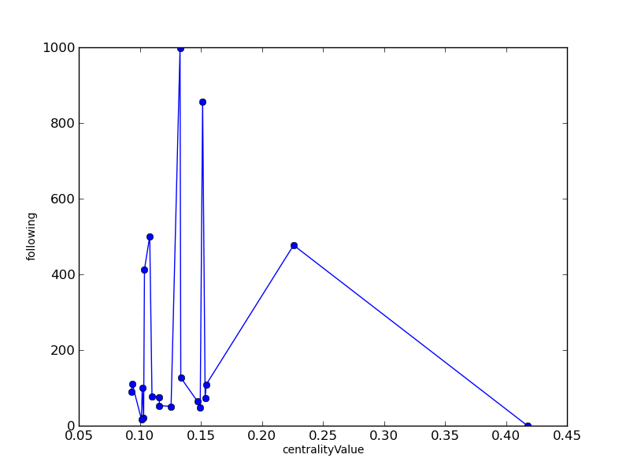Illustration 1: Eigenvector centrality graph

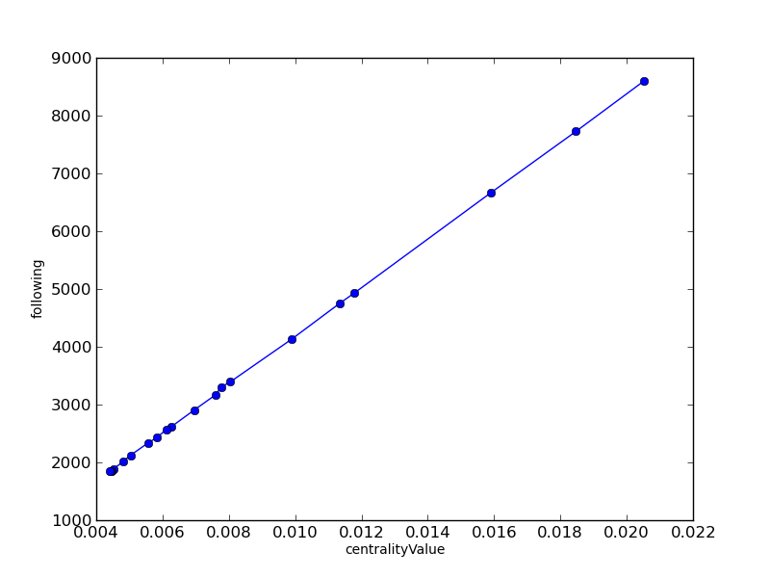Illustration 2: Degree Centrality graph

Observations
1. Eigenvector centrality value is high for some of the actors even though number of followers are less, means these actors are highly influential
Actor | centrality value | followers
hcilab | 0.226 | 477
tblobaum | 0.154 | 109
Marak | 0.151 | 856
2. Degree centrality value depends upon the number of users

User Connected graph for single cluster
Eigenvector results:
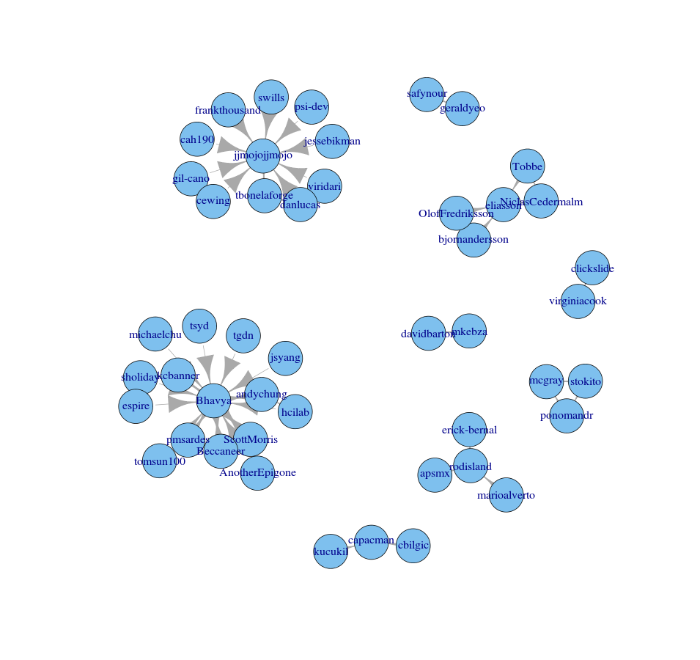Illustration 3: User connected graph for single cluster
Bhavya 0.423877693459
sholiday 0.414392259826
espire 0.359763442462
AnotherEpigone 0.293498581479
ScottMorris 0.259991241366
hcilab 0.259991241366
Beccaneer 0.181917170697

Closeness centrality results
Bhavya 0.108695652174
sholiday 0.096837944664
espire 0.088768115942
hcilab 0.0782608695652
AnotherEpigone 0.0782608695652
tgdn 0.0711462450593
tomsun100 0.0711462450593

Degree centrality results
Bhavya 0.304347826087
jjmojojjmojo 0.217391304348
eliasson 0.0869565217391
rodisland 0.0652173913043
tbonelaforge 0.0434782608696
ScottMorris 0.0434782608696
mcgray 0.0434782608696

