### A PRELIMINARY REPORT

**ON**

Generative AI in Architectural Design and Enhancing Sheer Walls & Slabs

SUBMITTED TO THE SAVITRIBAI PHULE PUNE UNIVERSITY, PUNE IN THE PARTIAL FULFILLMENT OF THE REQUIREMENTS

FOR THE AWARD OF THE DEGREE OF

### BACHELOR OF ENGINEERING (ARTIFICIAL INTELLIGENCE AND DATA SCIENCE) SUBMITTED BY

STUDENT NAME EXAM SEAT NO:

**SHUBHAM TIWARI BEAD21233**

### SHRIYASH SHITOLE BEAD21247 KRITHIK JOSHI BEAD21262



**DEPARTMENT OF ARTIFICIAL INTELLIGENCE AND DATA SCIENCE DR. D.Y.PATIL INSTITUTE OF ENGINEERING, MANAGEMENT & RESEARCH**

### AKURDI, PUNE 411044

**SAVITRIBAI PHULE PUNE UNIVERSITY 2024 -2025**



# CERTIFICATE

This is to certify that the project report entitles

### “Generative AI in Architectural Designing and Enhancing Sheer Walls & Slabs”

Submitted by

STUDENT NAME EXAM SEAT NO

**SHUBHAM TIWARI BEAD21233**

### SHRIYASH SHITOLE BEAD21247 KRITHIK JOSHI BEAD21262

is a bonafide student of this institute and the work has been carried out by him/her under the supervision of **Mrs.Kalyani Kute** and it is approved for the partial fulfillment of the requirement of Savitribai Phule Pune University, for the award of the degree of **Bachelor of Engineering** (Artificial Intelligence and Data Science).

### Mrs. Kalyani Kute Dr Suvarna Patil

Guide H.OD

Department of AI&DS Department of AI&DS

### Dr. Anupama V. Patil

Principal,

Dr.D.Y.Patil Institute of Engineering,Management & Research Akurdi Pune – 41

Place : Pune Date :

# ACKNOWLEDGEMENT

It gives us great pleasure in presenting the preliminary project report on ‘End to end Implementation using MLOps Tool MLflows and DVC’.

I would like to take this opportunity to thank my internal guide **Mrs.** **Kalyani Kute** for giving me all the help and guidance I needed. I am really grateful to them for their kind support. Their valuable suggestions were very helpful.

I am also grateful to **Dr Suvarna Patil**, Head of Computer Engineering Department, Dr. D. Y. Patil Institute of Engineering, Management & Research for his indispensable support, suggestions.

In the end our special thanks to **Mrs.** **Sneha Kanawade** for providing various resources such as laboratory with all needed software platforms, continuous guidance, for Our Project.

Name of Student Sign

**SHUBHAM TIWARI**

**SHRIYASH SHITOLE**

**KRITHIK JOSHI**

(BE Artificial Intelligence and Data Science)

# ABSTRACT

This system provides a new way of analyzing and designing structures for beam and slab systems used in shear walls by use of deep learning. Manual design methods are quite tedious and unproductive in many cases. A better approach therefore is to employ deep neural networks as tools for developing high-dimensional image features that enable optimized designs. In addition, the system can infer new layout schemes by combining two different aspects of fused building space and element attributes, thus demonstrating performance comparable to experienced engineers but vastly improving design efficiency. Furthermore, there will be an additional module concerned with assessing the environmental impact of the designed structures such as their carbon footprint i.e. incorporate a system that considers sustainable materials first during design.

The system provides a comprehensive overview of the advancements in generative artificial intelligence (AI) as a tool for building structural design. It highlights how generative AI can learn from existing data to create new design ideas by analyzing complex structural drawings and integrating various types of knowledge. The paper reviews recent research and applications of generative AI, focusing on data representation, the construction of intelligent generation algorithms, evaluation methods, and the integration of generation with optimization. It emphasizes the significant progress made in this field and outlines the key challenges and future prospects for the application of generative AI in building structural design.

**Keywords**:- Beam and Slab Design, Intelligent Structural Design, Deep Neural Network, Reinforced Concrete Shear Wall, Structural Optimization, Environmental Impact, Interactive 3D Visualization.

## TABLE OF CONTENTS

LIST OF ABBREVATIONS i

LIST OF FIGURES ii

LIST OF TABLES iii

**CHAPTER TITLE PAGE NO.**

|  |  |  |  |
| --- | --- | --- | --- |
| Sr.No. | Title of Chapter | | Page No. |
| 01 | **Introduction** | | 10 |
| 1.1 | Overview | | 10 |
| 1.2 | Motivation | | 10 |
| 1.3 | Problem Definition and Objectives | | 10 |
| 1.4 | Project Scope & Limitations | | 10 |
| 1.5 | Methodologies of Problem solving | |  |
| 02 | **Literature Survey** | | 12 |
| 03 | **Software Requirements Specification** | | 15 |
| 3.1 | Assumptions and Dependencies | | 15 |
| 3.2 | Functional Requirements | | 15 |
|  | 3.2.1 | System Feature 1(Functional Requirement) |  |
|  | 3.2.2 | System Feature2 (Functional Requirement) |  |
|  |  | …… |  |
|  |  | …… |  |
| 3.3 | External Interface Requirements (If Any) | |  |
|  | 3.3.1 | User Interfaces |  |
|  | 3.3.2 | Hardware Interfaces |  |
|  | 3.3.3 | Software Interfaces |  |
|  | 3.3.4 | Communication Interfaces |  |
| 3.4 | Nonfunctional Requirements | | 17 |
|  | 3.4.1 | Performance Requirements |  |
|  | 3.4.2 | Safety Requirements |  |
|  | 3.4.3 | Security Requirements |  |
|  | 3.4.4 | Software Quality Attributes |  |
| 3.5 | **System Requirements** | | 19 |
|  | 3.3.1 | Database Requirements |  |
|  | 3.3.2 | Software Requirements(Platform Choice) |  |
|  | 5.3.3 | Hardware Requirements |  |
| 3.6 | **Analysis Models: SDLC Model to be applied** | | 20 |
| 3.7 | **System Implementation Plan** | | 21 |
| 04 | **System Design** | | 23 |
| 4.1 | System Architecture | |  |
| 4.2 | Data Flow Diagrams | |  |

|  |  |  |
| --- | --- | --- |
| 4.3 | Entity Relationship Diagrams |  |
| 4.4 | UML Diagrams |  |
| 05 | **Other Specification** | 29 |
| 5.1 | Advantages |  |
| 5.2 | Limitations |  |
| 5.3 | Applications |  |
| 06 | **Conclusions & Future Work** 30 | |
|  | **Appendix A:**  Problem statement feasibility assessment using, satisfiability analysis and NP Hard,NP-Complete or P type using modern algebra and relevant mathematical models.  **Appendix B:**  Details of the papers/Copyright. Summary of the Paper/copyright in not more than 3-4 lines. Here you should write the seed idea of the papers/ copyright you had referred for preparation of this project report in the following format.  Example:  Thomas Noltey, Hans Hanssony, Lucia Lo Belloz,”Communication Buses for Automotive Applications” In *Proceedings of the* 3rd *Information Survivability Workshop (ISW-2007)*, Boston, Massachusetts, USA, October 2007. IEEE Computer Society.  **Appendix C:** Plagiarism Report | |
|  | References |  |

# LIST OF ABBREVATIONS

|  |  |
| --- | --- |
| **ABBREVIATION** | **ILUSTRATION** |
| **HTTP** | Hyper Text Transfer Protocol |
| **MQTT** | Message Query Telemetry Transport |

**LIST OF FIGURES**

|  |  |  |
| --- | --- | --- |
| **FIGURE** | **ILLUSTRATION** | **PAGE NO.** |
| 1 | WATERFALL MODEL | 21 |
| 2  3 | TIMELINE CHART  SYSTEM ARCHITECTURE | 23  24 |
| 4 | DFD LEVEL – 0 | 25 |
| 5 | DFD LEVEL – 1 | 25 |
| 6  7 | DFD LEVEL – 2  ER DIAGRAM | 26  26 |
| 8 | USE CASE DIAGRAM | 27 |
| 9 | SEQUENCE DIAGRAM | 28 |
| 10 | COLLABORATIVE DIAGRAM | 28 |
| 11 | DEPLOYMENT DIAGRAM | 29 |
| 12 | COMPONENT DIAGRAM | 29 |
| 13 | CLASS DIAGRAM | 30 |
| 14 | STATE CHART DIAGRAM | 30 |
| 15 | ACTIVITY DIAGRAM | 31 |

# LIST OF TABLES

|  |  |  |
| --- | --- | --- |
| **TABLE** | **ILLUSTRATION** | **PAGE NO.** |
| 4.1 | Project Plan | 29 |

1. **INTRODUCTION**

### OVERVIEW

The document explores the significant role of generative AI in building structural design, highlighting its capabilities in effectively representing data features related to topology and geometry, which enhance the design generation process. It reviews advancements in generative algorithms, particularly those leveraging deep learning, and emphasizes the importance of objective evaluation methods for AI-generated designs, addressing challenges such as consistency and the need for differentiable loss functions. Additionally, the integration of generative AI with optimization techniques is discussed, pointing out the necessity for further research to improve their coordination. Ultimately, the paper underscores the transformative potential of generative AI to enhance the efficiency and accuracy of structural design while calling for continued innovation to address existing challenges.

### MOTIVATION

* The increasing demand, for buildings necessitates. Precise structural planning.
* Traditional design techniques are time consuming and struggle to meet the challenges posed by needs.
* By utilizing AI and deep learning we can revolutionize the design phase through automation and optimization.
* AI powered methods have the potential to address the drawbacks of approaches offering solutions, for intricate structural designs

### PROBLEM STATEMENT AND OBJECTIVE Problem Statement:

* + - Effective methods for encoding complex data features in building design are lacking. MLflows facilitates the efficient deployment, management and tracking of models.
    - Current evaluation criteria for AI-generated designs are often inconsistent and inadequate.
    - The integration of generative AI with optimization techniques is insufficient, hindering design specification compliance.
    - There is a need for advanced algorithms and larger datasets to improve building structural design outcomes.

### Objectives:

* Automate the layout design process for beams and slabs.
* Enhance design efficiency and accuracy.
* Generate new structural designs that adhere to existing engineering standards.
* Compare the performance of AI-generated designs with those created by professional engineers.

### PROJECT SCOPE

**Project Scope:**

The project scope encompasses the exploration and development of generative AI technologies specifically tailored for building structural design. It aims to investigate various data representation techniques that effectively capture the essential features of structural components, including topology, geometry, and mechanical properties. By focusing on multimodal data integration, the project seeks to enhance the understanding and representation of design information, facilitating the generation of innovative and efficient structural designs.

Additionally, the project will address the evaluation methods for AI-generated designs, aiming to establish consistent and objective criteria that ensure the feasibility and safety of the generated structures. This includes developing differentiable loss functions for training generative models and implementing robust testing protocols to assess design performance against empirical rules and economic indicators. The goal is to create a comprehensive framework that guides the optimization of generative algorithms and improves the overall quality of design outputs.

Finally, the project will explore the integration of generative AI with advanced optimization techniques to ensure that the designs meet specific project requirements and constraints. By leveraging cutting-edge algorithms and expanding the availability of open-source datasets, the project aims to push the boundaries of automation in structural design. Ultimately, the scope includes not only the technical advancements in generative AI but also the practical implications for the construction industry, enhancing efficiency, accuracy, and cost-effectiveness in building projects.

# LITERATURE SURVEY

|  |  |  |  |  |
| --- | --- | --- | --- | --- |
| **Sr. No** | **Paper Title** | **Journal Name** | **Authors &**  **Publication Date** | **Methodology** |
| 1 | AI-  Optimized DevOps for Streamlined Cloud CI/CD. | IEEE | Kunal pahwa, Neha Agarwal 16 Feb 2019 | Random Forest, AdaBoost, Logistic Regression, Decision Trees, Naïve Bayes, and Convolutional Neural Networks (CNNs) |
| 2 | On Continuous Integration / Continuous Delivery for Automated Deployment of Machine Learning Models using MLOps. | IEEE | S. Naveen Balaji, P. Victer Paul, R. Saravanan .  2018 | CNN with Recursive Feature Elimination (RFE), comparison of SVM, Random Forest, KNN, Logistic Regression, and Naïve Bayes classifiers. |
| 3 | Automating the Training and Deployment of Models inMLOps by Integrating Systems with Machine Learning. | ACM | Gozde Sismanoglu,  Mehmet Ali Onde,  Furkan Kocer,  Ozgur Koray Sahingoz.  2018 | Combines machine learning models like Random Forest and XGBoost. Deploys them using a cloud- based CI/CD pipeline, ensuring scalability and real- time monitoring for clinical use. |
| 4 | A  Comparati ve Study of Machine Learning Algorithms for | IEEE | Penglei Gao , Rui Zhang , Xi Yang.  18 August 2020 | Develops interpretable models such as LIME or SHAP to ensure transparency in Chest cancer diagnosis. Implements a CI/CD pipeline that focuses on deploying models with explainability features |

|  |  |  |  |  |
| --- | --- | --- | --- | --- |
|  | Detecting Chest Cancer. |  |  |  |
| 5 | Chest Cancer Detection using Machine Learning Way and blockchain for security. | Science Gate | Xiongwen Pang, Yanqiang Zhou, Pan Wang, Weiwei Lin, Victor Chang.  2018 | Explores the use of blockchain to ensure data security and traceability within CI/CD pipelines. The research focuses on maintaining patient privacy during model deployment in healthcare. |
| 6 | Chest Cancer Detection Using Machine Learning Algorithms  . | IEEE | Shom Prasad Das, Sudarsan Padhy.  March 2017 | Investigates the deployment of Chest cancer detection models on edge devices using a CI/CD pipeline. Emphasizes low-latency model inference for real-time diagnosis in remote clinics. |
| 7 | Brea Chest Cancer Detection using Machine Learning Technique s. | ACM | Özgür İcan, Taha Buğra Çelik.  October 15,  2017 | Utilizes pre-trained models through transfer learning techniques for Chest cancer detection. Deploys these models using a CI/CD pipeline to ensure seamless updates and model improvements.  . |
| 8 | Integrating CI/CD  Pipelines for Efficient Deployme nt of Chest Cancer Prediction Models | ACM | Ehsan Hoseinzade, Saman Haratizadeh.  20 March 2019 | Proposes a deep learning model using CNNs for Chest cancer diagnosis. Incorporates a CI/CD pipeline to automate the training, testing, and deployment process, ensuring rapid iterations and updates. |

|  |  |  |  |  |
| --- | --- | --- | --- | --- |
| 9 | Leveraging CI/CD  Pipelines for Real- time Chest Cancer Diagnostic s Using Machine Learning forecasting and performan ce analysis | IEEE | Mujibur Rahman Majumder, Imran Hossain, Mohammad Kamrul Hasan.  9 February, 2019 | Proposes a federated learning approach where multiple hospitals train models locally without sharing patient data. Implements a CI/CD pipeline to aggregate and deploy the global model. |
| 10 | Automatin g Chest Cancer Detection: A CI/CD  Approach for Scalable Model Deployme nt | IEEE | Saloni Mohan, Sahitya Mullapudi, Sudheer Sammeta, Parag Vijayvergia, David C. Anastasiu.  2019 | Automates the hyperparameter tuning process using grid search and random search techniques. Integrates CI/CD pipelines to continuously train, validate, and deploy optimized models for better clinical outcomes. |

1. **SOFTWARE REQUIREMENT SPECIFICATION**

### INTRODUCTION

* + 1. **PROJECT SCOPE**
* Develop techniques to effectively capture building structure features for innovative design generation.
* Establish consistent criteria for assessing the feasibility and safety of AI-generated designs.
* Integrate generative AI with advanced optimization methods to enhance design outcomes and automation.

### USE CLASSES AND CHARACTERISTICS

Our system is divided into two class/modules:

1. user
2. system

### ASSUMPTIONS AND DEPENDENCIES

1. User must have the knowledge of web based application.
2. User must have the knowledge of English.
3. User must have all required software to run the application.

### MATHEMATICAL MODELING

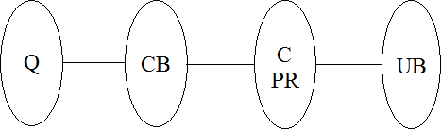

**Figure 1 : Caption of Figure**

Where,

Q = take attributes

CB = preprocess

C= apply deep learning algorithm PR= Preprocess request evaluation

UB = predict outcome

### THEORY

1. Let S be as system which input image

S = {In, P, Op,}

1. Identify Input In as

In = {Q}

Where,

Q = User entered input image(dataset)

1. Identify Process P as

P = {CB, C, PR}

Where,

CB = preprocess C = apply LSTM

PR = Preprocess request

1. Identify Output Op as

Op = {UB}

Where,

UB = predict outcome

=Failures and Success conditions.

### Failures:

1. Huge database can lead to more time consumption to get the information.
2. Hardware failure.
3. Software failure.

### Success:

1.Search the required information from available in Datasets. 2.User gets result very fast according to their needs.

### Time Complexity:

The time complexity of the project varies, with data preprocessing and ingestion at O(n)O(n)O(n), model training depending on the algorithm (e.g., O(n⋅d)O(n \cdot d)O(n⋅d) for linear models or O(n⋅d⋅l)O(n \cdot d \cdot l)O(n⋅d⋅l) for neural networks). MLflow and DVC add minimal overhead for versioning and experiment tracking, approximately O(k)O(k)O(k) and O(v⋅n)O(v \cdot n)O(v⋅n) respectively, where kkk is the number of models/experiments and vvv is the number of data versions.

### Space Complexity:

The space complexity depends on the dataset size, model complexity, and storage of multiple model/data versions, typically proportional to the size of the data O(n)O(n)O(n) and number of versions O(v⋅n)O(v \cdot n)O(v⋅n).

Check No. of patterns available in the datasets= n

If (n>1) then retrieving of information can be time consuming. So the time complexity of this algorithm is O.

### FUNCTIONAL REQUIRMENTS

* **Data Ingestion and Preprocessing**: The system must automatically handle data collection, cleaning, and feature engineering for breast cancer detection.
* **Model Training and Optimization**: It should support the training, tuning, and validation of machine learning models using scalable resources.
* **Version Control for Data and Models**: Implement DVC for managing multiple versions of datasets and MLflow for tracking models and experiments.
* **Model Deployment**: Seamless deployment of trained models into clinical environments for real-time breast cancer detection.
* **Monitoring and Continuous Integration**: Enable continuous monitoring of model performance and integration of new data to ensure model accuracy and reliability over time.

### EXTERNAL INTERFACE REQUIREMENTS

* + 1. **USER INTERFACES**

The requirements section of hardware includes minimum of 180 GB hard disk and 4 GB RAM with 2 GHz or higher speed. The primary requirements include a memory of 4GB for the Android Application development and MySQL.

### HARDWARE INTERFACES

As this is an online application for product management we are not enabling or installing any hardware components for user interface.

It’s not an embedded system

* Processor - Pentium IV 2.4 GHZ
* Speed - 1.5 Ghz and Above
* RAM - 4 GB (min)
* Hard Disk - 220 GB
* Key Board - Standard Windows Keyboard
* Mouse - Two or Three Button Mouse

### SOFTWARE INTERFACES

This is the software configuration in which the project was shaped. The programming language used, tools used, etc are described here.

* Operating System : Windows
* Front End : html,css,boostrap,javascript
* Tool : DVC,MLflows,VS code
* Database : MySQL

### COMMUNICATION INTERFACES

* User can access the web application from remote location.
* Standard internet connection is required.
* TCP/UDP connection will be required.

### NON-FUNCTIONAL REQUIREMENTS

* + 1. **PERFORMANCE REQUIREMENTS**

### High Speed:

System should process requested task in parallel for various action to give quick response. Then system must wait for process completion.

### Accuracy:

System should correctly execute process, display the result accurately. System output should be in user required format.

### SAFETY REQUIREMENTS

The data safety must be ensured by arranging for a secure and reliable transmission media. The source and destination information must be entered correctly to avoid any misuse or malfunctioning. Password generated by user is consisting of characters, special character & number so that password is difficult to hack. So, that user account is safe.

### SECURITY REQUIREMENTS

Secure access of confidential data (user’s details).

* Information security means protecting information and information systems from unauthorized access, use, disclosure, disruption, modification or destruction.
* User password must be stored in encrypted form for the security reason
* All the user details shall be accessible to only high authority persons.
* Access will be controlled with usernames and passwords.

### SOFTWARE QUALITY ASSURANCE

* Availability [related to Reliability]
* Modifiability [includes portability, reusability, scalability]
* Performance
* Security
* Testability
* Usability[includes self-adaptability and user adaptability]

### SYSTEM REQUIREMENTS

* + 1. **DATABASE REQUIREMENTS**

MySQL : MySQL is an open-source relational database management system (RDBMS). Its name is a combination of "My", the name of co-founder Michael Widenius's daughter, and "SQL", the abbreviation for Structured Query Language.

MySQL is free and open-source software under the terms of the GNU General Public License, and is also available under a variety of proprietary licenses. MySQL was owned and sponsored by the Swedish company MySQL AB, which was bought by Sun Microsystems (now Oracle Corporation). In 2010, when Oracle acquired Sun, Widenius forked the open-source MySQL project to create MariaDB.

MySQL is a component of the LAMP web application software stack (and others), which is an acronym for Linux, Apache, MySQL, Perl/PHP/Python. MySQL is used by many database-driven web applications, including Drupal, Joomla, phpBB, and WordPress. MySQL is also used by many popular websites, including Facebook, Flickr, MediaWiki, Twitter, and YouTube.

* + 1. **SOFTWARE REQUIREMENTS** Operating system : Windows 7 and above. Coding Language : Python,

IDE : Sublimetext3 Pycharm

### HARDWARE REQUIREMENTS

System : Intel I3 Processor and above.

Hard Disk : 200 GB.

Monitor : 15 VGA Color.

Ram : 4 GB.

### ANALYSIS MODELS : SDLC MODEL TO BE APPLIED

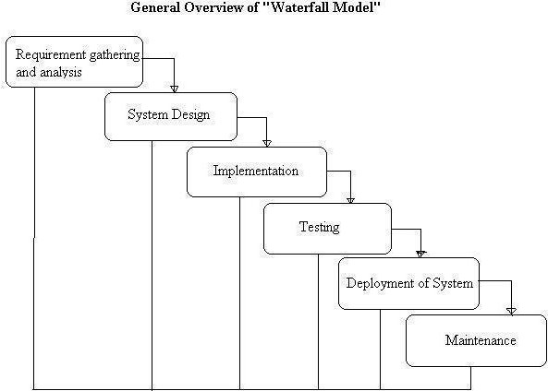

**Figure 1 : Caption of Figure**

### SYSTEM IMPLEMENTION PLAN

1. **Requirement gathering and analysis:**

In this step of waterfall we identify what are various requirements are need for our project such are software and hardware required, database, and interfaces.

### System Design:

In this system design phase we design the system which is easily understood for end user i.e. user friendly.

We design some UML diagrams and data flow diagram to understand the system flow and system module and sequence of execution.

### Implementation:

In implementation phase of our project we have implemented various module required of successfully getting expected outcome at the different module levels.

With inputs from system design, the system is first developed in small programs called units, which are integrated in the next phase. Each unit is developed and tested for its functionality which is referred to as Unit Testing.

### Testing:

The different test cases are performed to test whether the project module are giving expected outcome in assumed time.

All the units developed in the implementation phase are integrated into a system after testing of each unit. Post integration the entire system is tested for any faults and failures.

### Deployment of System:

Once the functional and nonfunctional testing is done, the product is deployed in the customer environment or released into the market.

### Maintenance:

There are some issues which come up in the client environment. To fix those issues patches are released. Also to enhance the product some better versions are released. Maintenance is done to deliver these changes in the customer environment.

All these phases are cascaded to each other in which progress is seen as flowing steadily downwards like a waterfall through the phases. The next phase is started only after the defined set of goals are achieved for previous phase and it is signed off, so the name "Waterfall Model". In this model phases do not overlap.

# 4. SYSTEM DESIGN

### SYSTEM ARCHITECTURE:

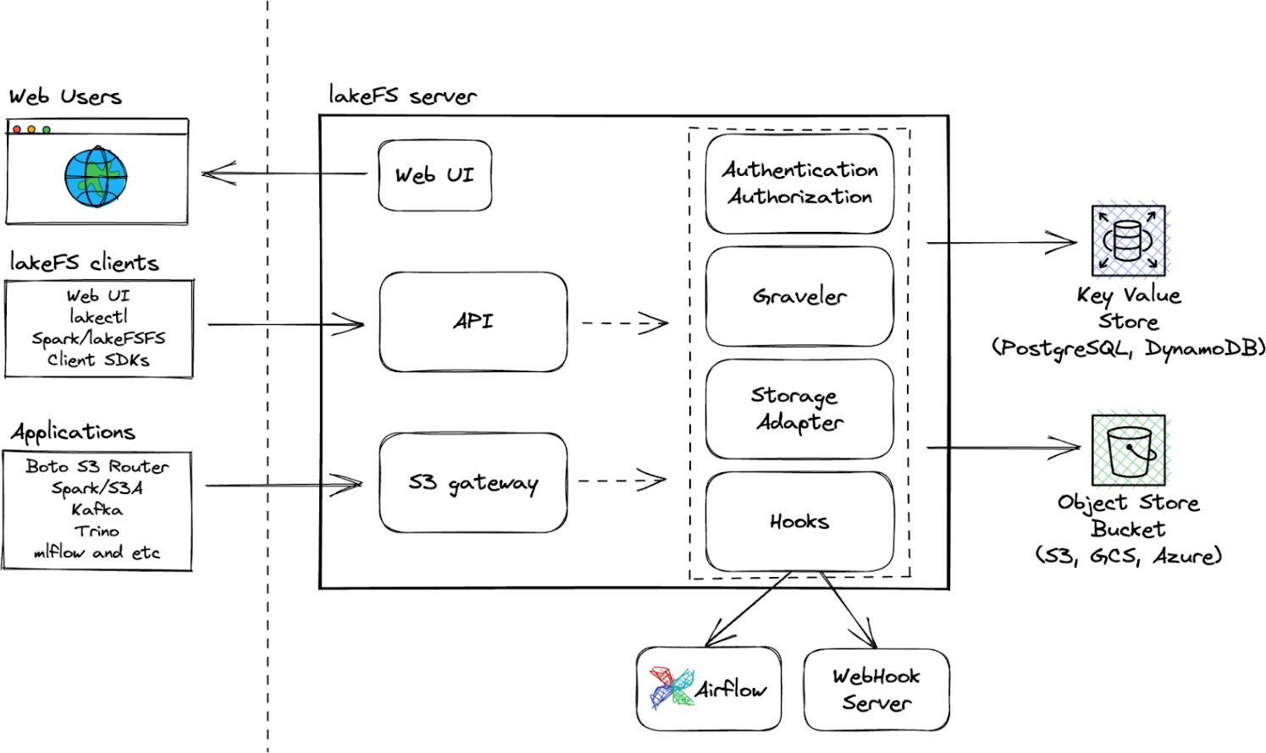

**Figure 1 : Caption of Figure**

### DATA FLOW DIAGRAMS DFD level 0

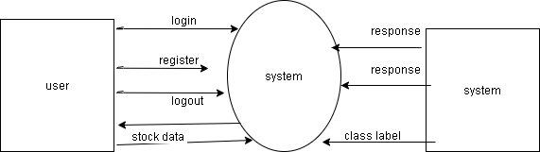

**Figure 1 : Caption of Figure**

### DFD level 1

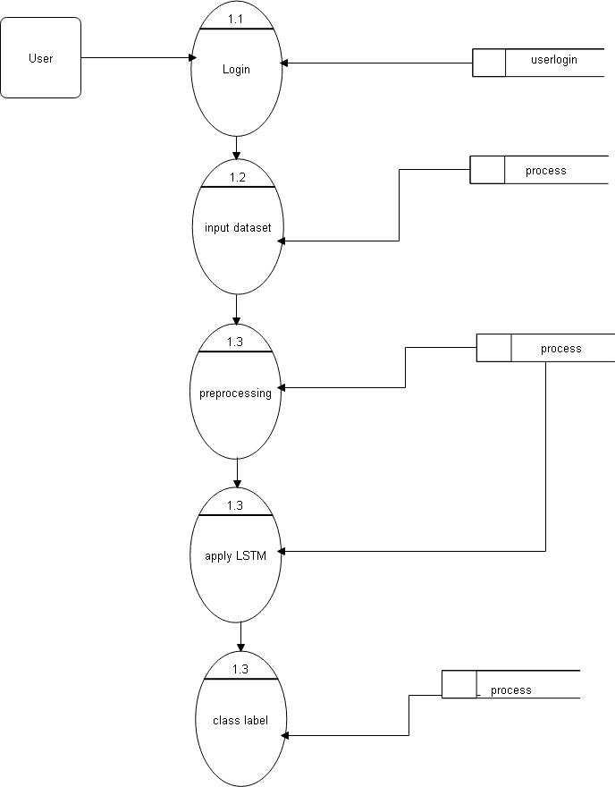

**Figure 1 : Caption of Figure**

### DFD level 2

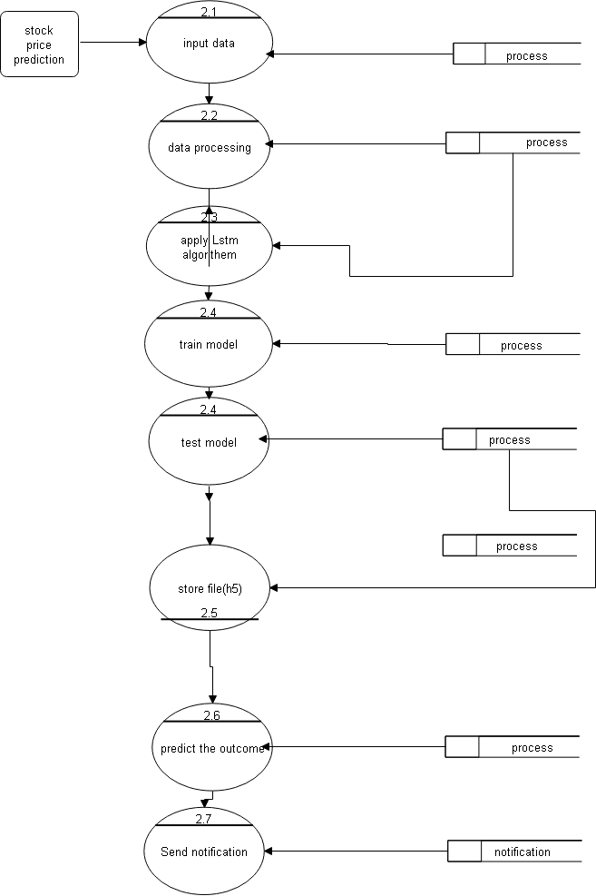

**Figure 1 : Caption of Figure**

### ENTITY RELATIONSHIP DIAGRAMS

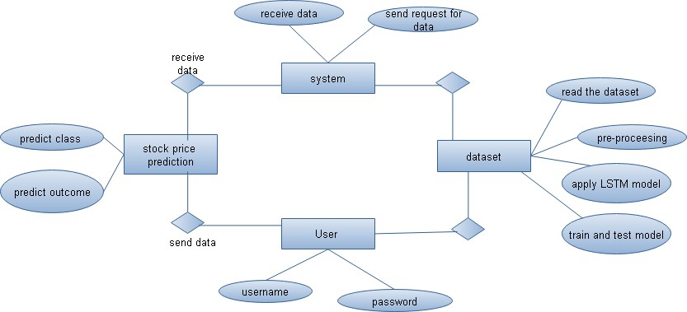

**Figure 1 : Caption of Figure**

### UML DIAGRAM

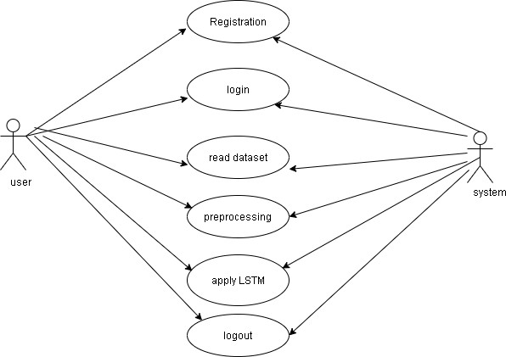

**SEQUENCE DIAGRAM**

### Figure 1 : Caption of Figure

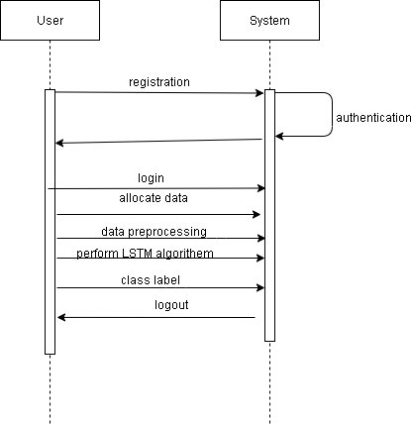

**ACTIVITY DIAGRAM**

### Figure 1 : Caption of Figure

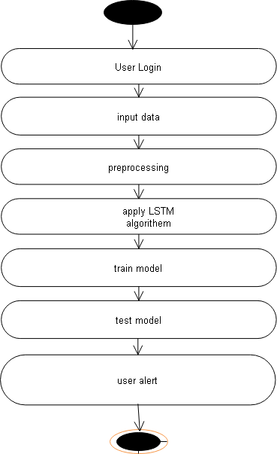

**Figure 1 : Caption of Figure**

### ADVANTAGES

* + - Predict Chest cancer.

# OTHER SPECIFICATION

## 5.

* + The system aids in early identification of whether a tumor is benign or malignant, improving the chances of successful treatment and better patient outcomes.
  + By leveraging advanced machine learning algorithms like XGBoost, the model offers high accuracy, sensitivity, and specificity, leading to more reliable diagnoses.
  + By detecting Chest cancer early and providing accurate classifications, the system helps reduce the need for unnecessary tests and treatments, lowering overall healthcare costs.
  + The system automates the analysis of diagnostic data, saving time for clinicians by providing rapid and accurate results without manual interpretation.

### LIMITATIONS

1. The accuracy of the model heavily relies on the quality and quantity of available diagnostic data. Incomplete or inconsistent data could lead to inaccurate predictions.
2. The system requires regular updates to maintain accuracy, security, and reliability, which could be resource-intensive over time.
3. The use of patient data requires stringent adherence to privacy regulations, and any breach or misuse of data could lead to legal complications.
4. The model may require significant computational resources for processing large datasets, which could be a constraint in resource-limited healthcare settings.

**CONCLUSION**:

# CONCLUSION & FUTURE WORK

MLOps is a paradigm that addresses the challenges of automating and operationalizing machine learning products, and provides a holistic understanding of MLOps, including its principles, components, roles, and architecture. The text concludes that MLOps is an interdisciplinary group process that requires the interplay of different roles, including business stakeholders, solution architects, data engineers, data scientists, ML engineers, and DevOps engineers.

### FUTURE SCOPE:

* + Future iterations can integrate the model with other diagnostic tools such as imaging technologies (e.g., mammograms, ultrasounds) to provide a more comprehensive Chest cancer detection system.
  + Incorporating real-time data analysis will allow the system to process and provide predictions instantly, improving the efficiency of clinical workflows.
  + The model can contribute to further research in cancer detection by identifying trends, patterns, and correlations within patient data that could lead to breakthroughs in understanding cancer development.

### REFERENCES:

1. Seyyid Ahmed Medjahed, Tamazouzt Ait Saadi, Abdelkader benyettou, “Chest Cancer Diagnosis by using k-Nearest Neighbor with Different Distances and Classification Rules”, International Journal of Computer Applications, Volume 62 - No. 1, January 2013
2. Walberg WH, Mangasarian OL, “Multi-surface method of pattern separation for medical diagnosis applied to Chest cytology”, Proc Natl Acad Sci U S A, 1990, 87(23):9193-6, Doi: 10.1073/pnas.87.23.9193
3. B. Fu, P. Liu, J. Lin, L. Deng, K. Hu, and H. Zheng, "Predicting Invasive Disease-Free Survival for Early-Stage Chest Cancer Patients Using Follow-Up Clinical Data,", IEEE Transactions on Biomedical Engineering, vol. 66, no. 7, pp. 2053-2064, July 2019.doi: 10.1109/TBME.2018.2882867
4. Mariam Amrane, Saliha Oukid, Ikram Gagaoua, and Tolga Ensari, "Chest cancer classification using machine learning", Electric Electronics, Computer Science, Biomedical Engineerings, Meeting, 2018
5. Mirsadeghi, L., Haji Hosseini, R., Banaei- Moghaddam, A.M, “EARN: an ensemble machine learning algorithm to predict driver genes in metastatic Chest cancer”, BMC Med Genomics 14, 122, 2021, https://doi.org/10.1186/s12920-021- 00974-3
6. Mohammed Amine Naji, Sanaa El Filali, Kawtar Aarika, EL Habib Benlahmar, Rachida Ait Abdelouhahid, Olivier Debauche, “Machine Learning Algorithms for Chest Cancer Prediction and Diagnosis”, Procedia Computer Science, Volume 191, 2021, Pages 487-492, ISSN 1877-0509, https://doi.org/10.1016/j.procs.2021.07.062.