# Assignment 1 Create a new directory and write a terraform code which

# would create Ec2 instance and use Existing Security Group and Key.

#

provider "aws" {

region = "ap-south-1"

}

resource "aws_instance" "web1" {

ami = "ami-013e83f579886baeb"

instance_type = "t2.micro"

key_name = "web1keypair"

vpc_security_group_ids = ["sg-0d4573c8fdc06ec95"]

tags = {

Name = "Server-1"

}

}

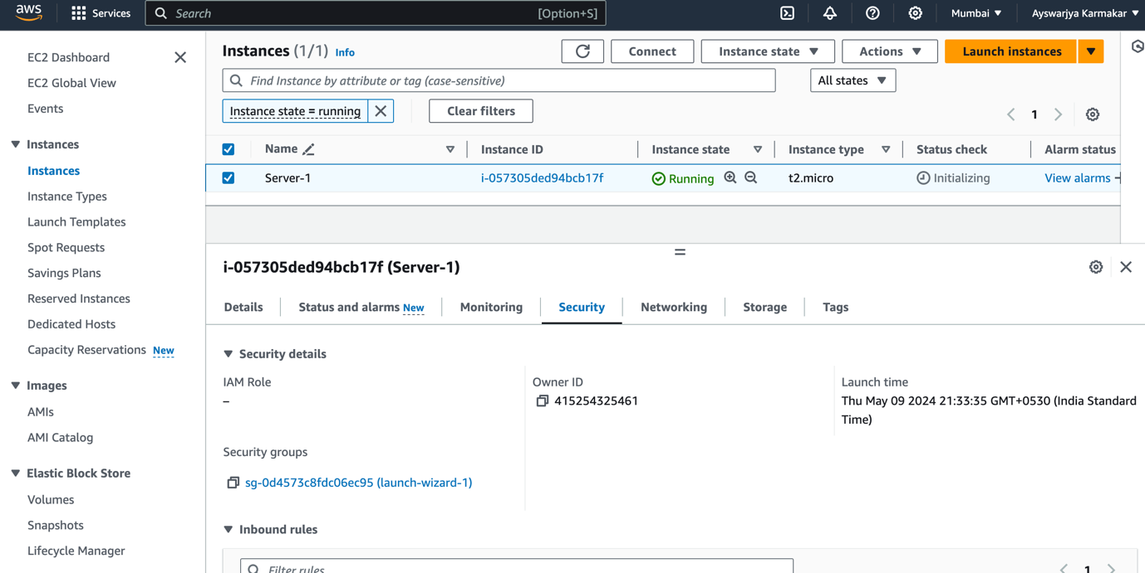

# Assignment 2 Create a new directory and write a terraform code

# which would create Security Group and new Key and create Ec2

# instance and use newly created Security Group and Key.The security

# group should allow incoming traffic on port 22 (SSH) and port 80 (HTTP).

provider "aws" {

region = "ap-south-1"

}

resource "aws_instance" "web2" {

ami = "ami-013e83f579886baeb"

instance_type = "t2.micro"

key_name = aws_key_pair.key_pair.key_name

vpc_security_group_ids = [aws_security_group.server2_sg.id]

tags = {

Name = "Server-2"

}

}

#Create security group

resource "aws_security_group" "server2_sg" {

name = "server2_sg"

description = "Allow inbound ports 22, 80"

vpc_id = "vpc-0019a55ca82b2fc1d"

#Allow incoming TCP requests on port 22 from any IP

ingress {

description = "Allow SSH Traffic"

from_port = 22

to_port = 22

protocol = "tcp"

cidr_blocks = ["0.0.0.0/0"]

}

#Allow incoming TCP requests on port 80 from any IP

ingress {

description = "Allow HTTP Traffic"

from_port = 80

to_port = 80

protocol = "tcp"

cidr_blocks = ["0.0.0.0/0"]

}

}

# Generates a secure private key and encodes it as PEM

resource "tls_private_key" "key_pair" {

algorithm = "RSA"

rsa_bits = 4096

}

# Create the Key Pair

resource "aws_key_pair" "key_pair" {

key_name = "ec2-key-pair"

public_key = tls_private_key.key_pair.public_key_openssh

}

# Save file

resource "local_file" "ssh_key" {

filename = "${aws_key_pair.key_pair.key_name}.pem"

content = tls_private_key.key_pair.private_key_pem

}

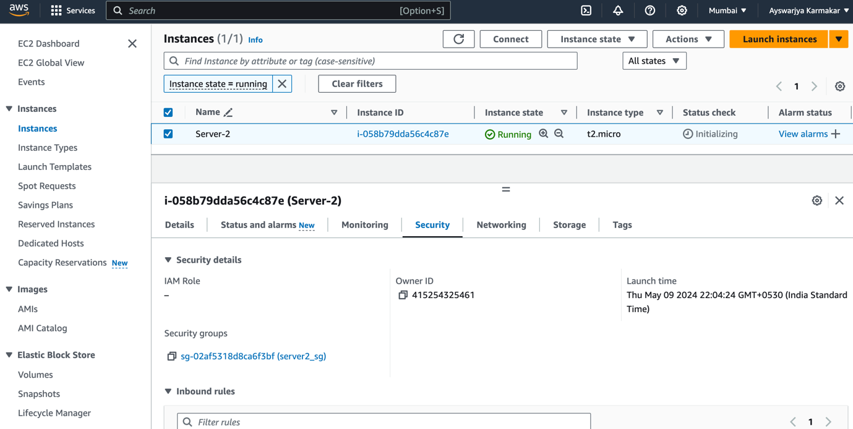

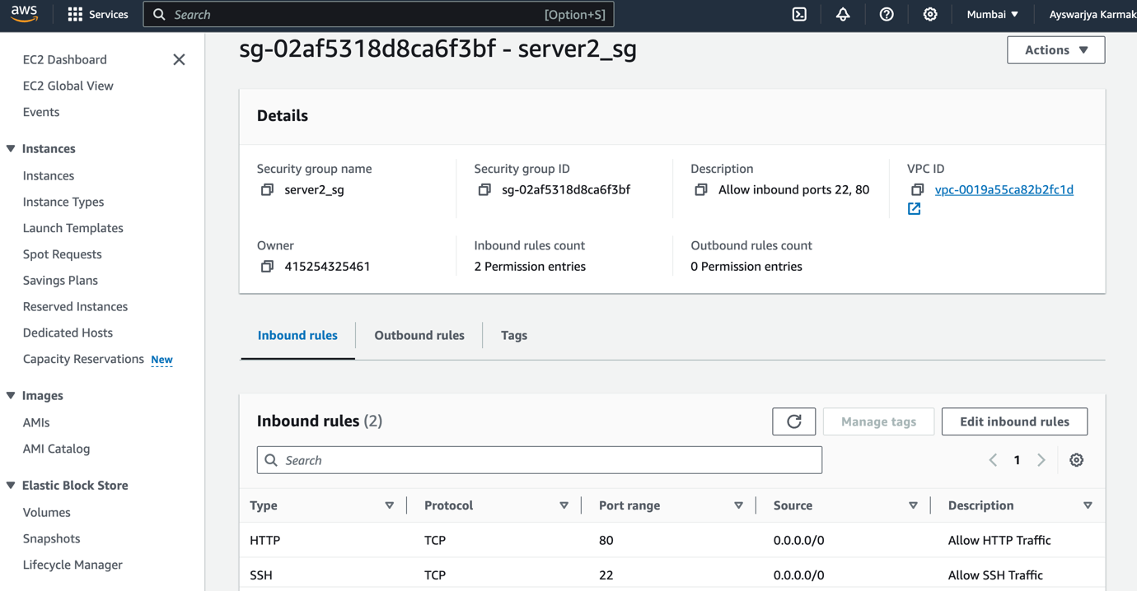

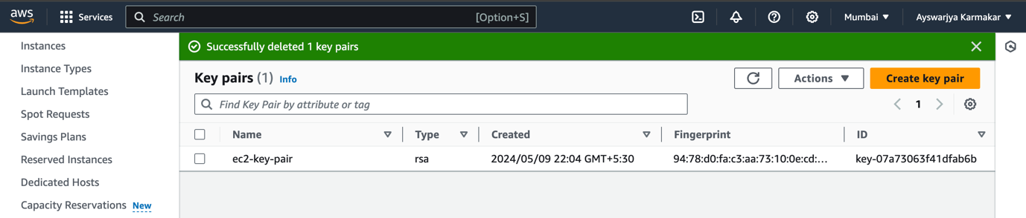

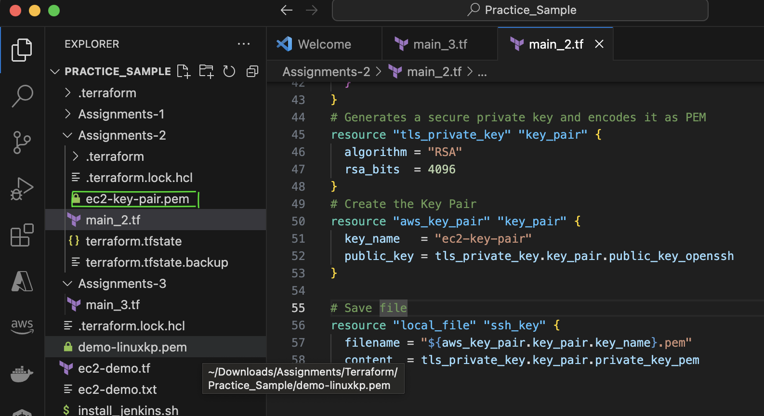

# Assignment 3 Write a terraform code would create following resources

# keypair (Public key– ON AWS – Private -key – Local) Display a pvt key

# on Console Create a Security group must open 80 Port Create a Ec2 instance

# Ubuntu using the same Key & SecurityGroup which you created above.

# You must install/Start apache2 in EC2 instance :

# $ apt-get update

# $ apt-get install apache2 -y

# $ systemctl start apache2

provider "aws" {

region = "ap-south-1"

}

# Generates a secure private key and encodes it as PEM

resource "tls_private_key" "key_pair" {

algorithm = "RSA"

rsa_bits = 4096

}

# Create the Key Pair

resource "aws_key_pair" "key_pair" {

key_name = "ubuntu-key-pair"

public_key = tls_private_key.key_pair.public_key_openssh

}

# Save file

resource "local_file" "ssh_key" {

filename = "${aws_key_pair.key_pair.key_name}.pem"

content = tls_private_key.key_pair.private_key_pem

}

output "keypair" {

value = file(tls_private_key.key_pair.private_key_pem)

#sensitive = true

}

output "keypair1" {

value = "${aws_key_pair.key_pair.key_name}.pem"

}

#Create security group

resource "aws_security_group" "server3_sg" {

name = "server3_sg"

description = "Allow inbound ports 80"

vpc_id = "vpc-0019a55ca82b2fc1d"

#Allow incoming TCP requests on port 80 from any IP

ingress {

description = "Allow HTTP Traffic"

from_port = 80

to_port = 80

protocol = "tcp"

cidr_blocks = ["0.0.0.0/0"]

}

#Allow incoming TCP requests on port 22 from any IP

ingress {

description = "Allow SSH Traffic"

from_port = 22

to_port = 22

protocol = "tcp"

cidr_blocks = ["0.0.0.0/0"]

}

egress {

from_port = 0

to_port = 0

protocol = "-1"

cidr_blocks = ["0.0.0.0/0"]

}

}

resource "aws_instance" "web2" {

ami = "ami-0f58b397bc5c1f2e8"

instance_type = "t2.micro"

key_name = aws_key_pair.key_pair.key_name

vpc_security_group_ids = [aws_security_group.server3_sg.id]

tags = {

Name = "Server-3"

}

connection {

type = "ssh"

user = "ubuntu"

private_key = file("./${aws_key_pair.key_pair.key_name}.pem")

host = self.public_ip

}

provisioner "file" {

source = "./index.html"

destination = "/tmp/index.html"

}

provisioner "remote-exec" {

inline = [

"sudo apt-get update",

"sudo apt-get install apache2 -y",

"sudo cp -r /tmp/index.html /var/www/html/",

"sudo systemctl start apache2",

]

}

}

<html>

<body style="background-color: rgb(0, 255, 8);">

<h1> Welcome to UBUNTU Server Ayswarjya </h1>

<p>{tdevs}-Learning terraform is easy</p>

</body>

</html>

