Prepared BY: ramesh kalla

Address/Location: brandix apparel india

Version: v1

OWNER: Amulya PANDIRI

Surplus Destruction process



Version History

|  |  |  |  |  |  |
| --- | --- | --- | --- | --- | --- |
| Version # | Date | Remarks | Prepared by | Verified by | Approved by |
| V1 | 2015-05-25 |  | RAMESHK | AMULYAP |  |
|  |  |  |  |  |  |
|  |  |  |  |  |  |

Table of content:

1. About Surplus Destruction Process
2. Scope of Surplus Destruction Process
3. Process Flow
4. Flow Chart

## **About Surplus Process**

Definition of SURPLUS: The amount that remains when use or need is satisfied.

In the apparel business, The Surplus program receives the items from the production floor and the other departments.

Whole lot of goods inspected undergone the destruction process.

**Path:** Reports > Packing > Advice of Dispatch - Surplus

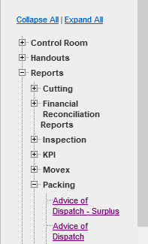

1. Provide necessary details in below, once user went to the mentioned path.

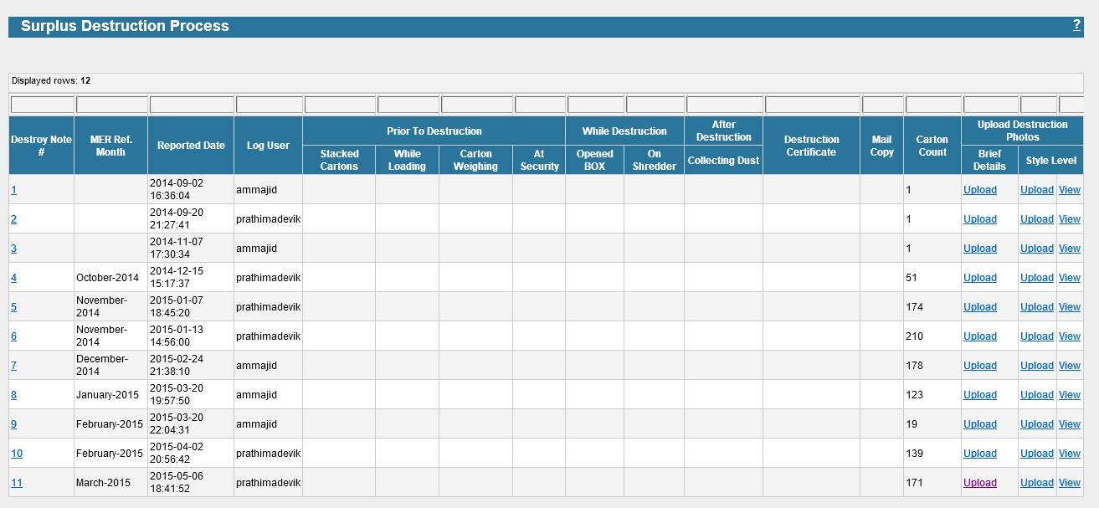

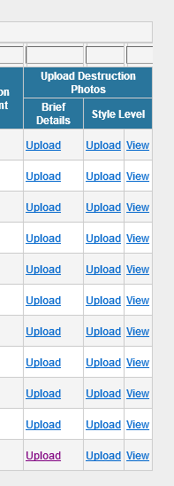

1. After the default page, by selecting the Upload link under the brief details, then the below details can be entered.

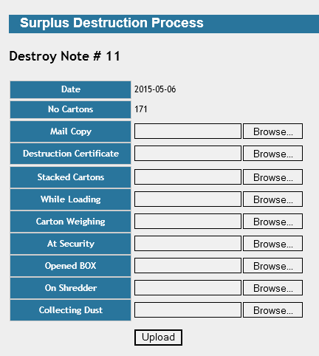

1. Click on Brow button to locate and select the appropriate file to be upload.

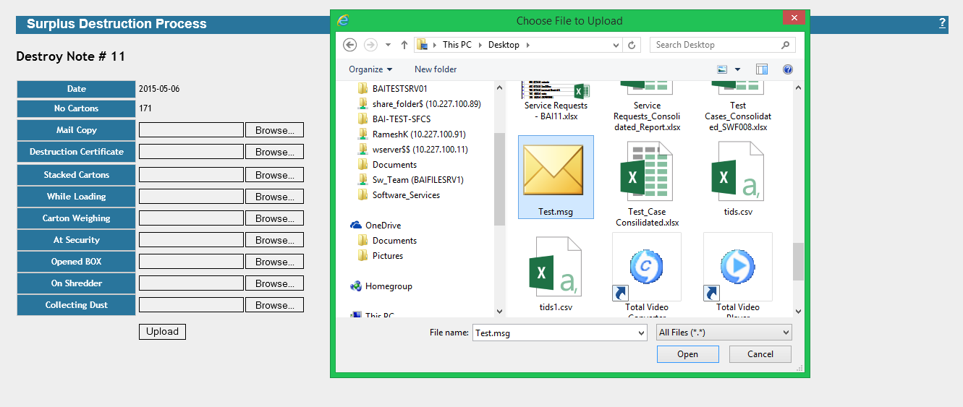

1. Then click on upload button to upload the selected files.

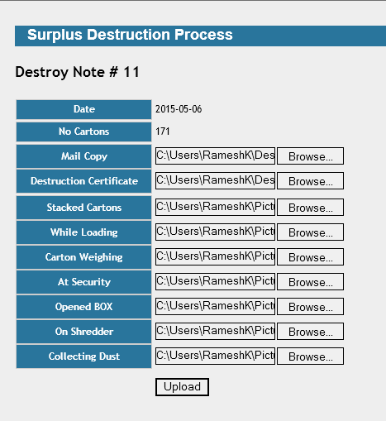

## **Destruction Photo Upload Process**

In this process, Team will upload the respective photos to respective fields.( In Brief for entire Cut to Ship Month )

Then the view will be.

Uploaded View:

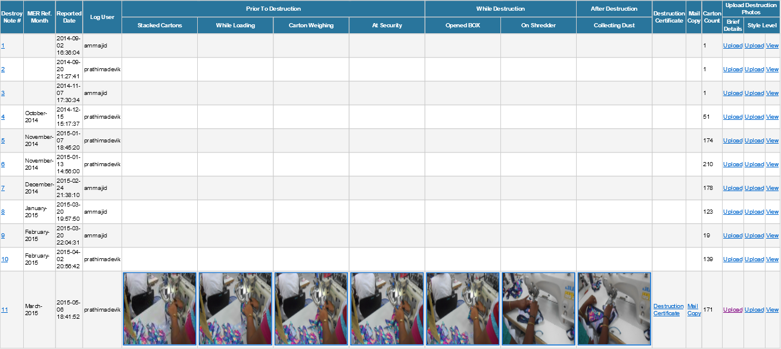

c

b

a

1. After uploading, by selecting the Destroy Note #, then below details can be view.

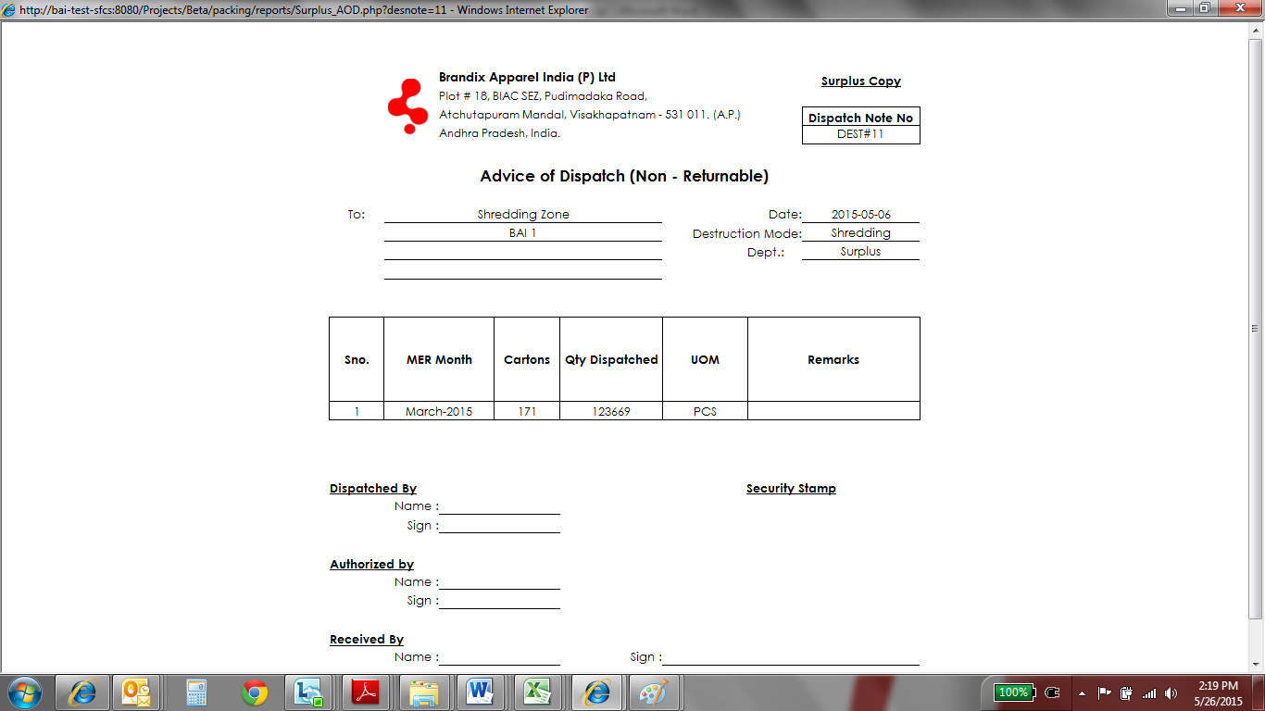

1. After uploading, by selecting the Destruction Certificate the below details can be view.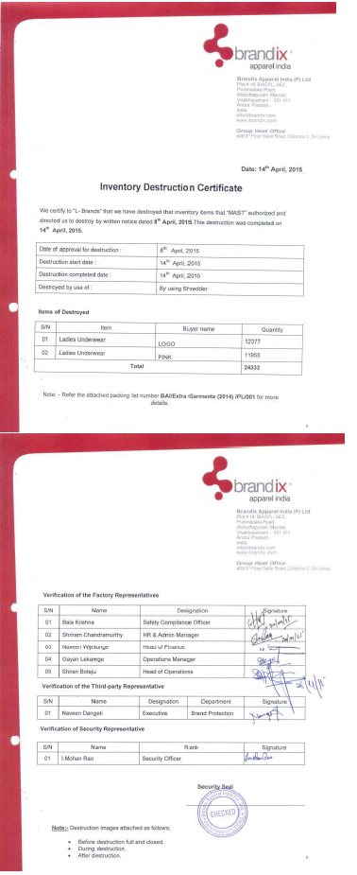
2. After uploading, by selecting the Carton # the below details can be entered.

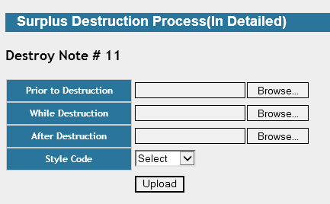

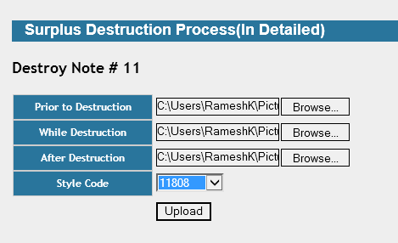

In this process, Team will upload the respective photos to respective fields.( In detail for style level in that particular Cut to Ship Month )

Then the view will be.

Uploaded View:

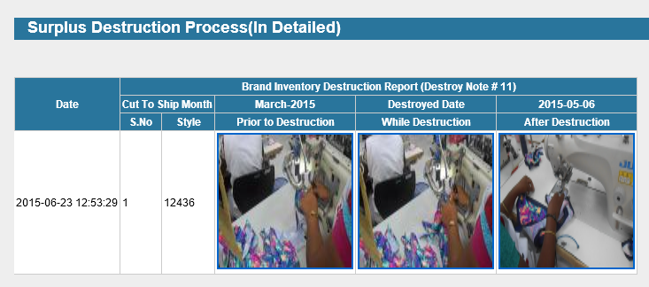

## **Process Flow Chart**



## **Process Flow Chart**

