Quality rejection reversal report

Prepared BY: BHARGAV GEDALA

Address/Location: brandix apparel india

Version: v1

OWNER:



Version History

|  |  |  |  |  |  |
| --- | --- | --- | --- | --- | --- |
| Version # | Date | Remarks | Prepared by | Verified by | Approved by |
| V1 | 2013-01-13 |  | BHARGAV |  |  |
|  |  |  |  |  |  |

TABLE OF CONTENTS:

1. About Quality Rejection Reversal Report.
2. Scope of Quality Rejection Reversal Report.
3. Database Requirements.
4. Database Design.
5. Quality Rejection Reversal Report Format.
6. Flow Chart.

About Quality Rejection Reversal Report

In this report users can see the total number of rejections for particular schedule then he removes the data from table.

Scope of Quality Rejection Reversal Report

In this report will display the total rejections for those particular schedules.

Database Requirement

To show the packing LIST report, we used the below tables from respective databases.

1. Bai_pro3

Database Design

**Database:**

1. Bai_pro3

**Tables:**

1. Bai_qms_db
2. Bai_qms_db_deleted

**Structure:**

|  |  |  |
| --- | --- | --- |
| Table Name | Field Name | Purpose to use |
|
| Bai_qms_db | qms_tid | It is a primary key |
| Bai_qms_db | Qms_style | To display the Qms_style of the product |
| Bai_qms_db | Qms_schedule | To display the qms_schedule of the product |
| Bai_qms_db | Qms_color | To display the qms_color code of the product |
| Bai_qms_db | Date | To display the date |
| Bai_qms_db | Qms_Size | To display the qms_size of the product |
| Bai_qms_db | Qms_qty | To display the qms_qty of the product |
| Bai_qms_db_deleted | Qms_tid | It is a primary key using this we are inserting the data in to this table |

Quality Rejection Reversal Report Format

1. **Quality Rejection Reversal report form:**

In this interface user can provide the schedule no. we can also provide the intelligence of the form. So user can understand he provide schedule is not in the data. Now user can provide schedule no then he search the data from the database. Then he get the result. We will provide the control access to the user wants to delete the row and also we are maintaining log to deleted records.

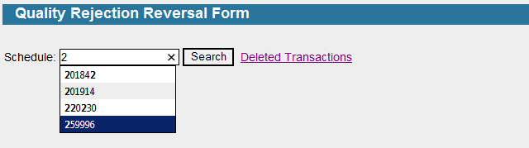

1. **Rejection Deleted log:**

In this interface we will display the total rejection log.

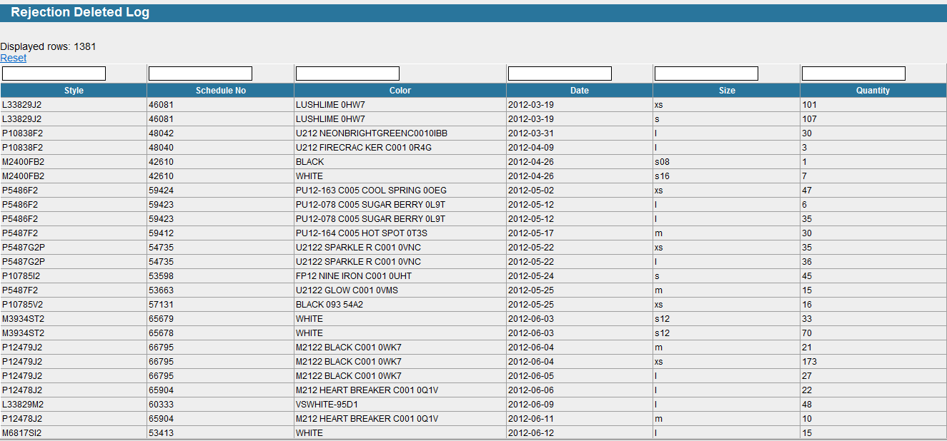

Flow Chart

