Code Repository Tool(Version Managemenet):-

----------------------------

To develope app. we write different

types of files in projects (like java,

xml,jsp etc..). All these files are

stored finally in a central server

ie Code Repository. It maintains the

details of code. like

> How many times code is modified?

> Who modified what code(+/-

added/removed)

> Changes done on what date and time?

Maintaining these details is known as

Version Management/Version Control.

*)In developement mostly used tool is

GIT(gitHub).

*)It maintains two level repository

process for cross verify and commit.

*)For this we need to create an account

in github.com(using email id and

verify email after creation).

*)It maintains staging area to select

/verify/comment the file while adding

to local repository.

*)Git Process:-

Git Repository Types:-

Public : Free for every one

Private : Paid version.

<https://github.com/>

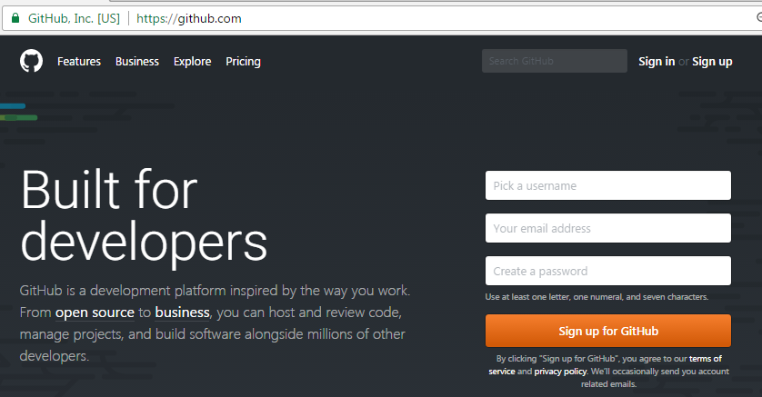

Goto email account and click on verify link.

Click on signin

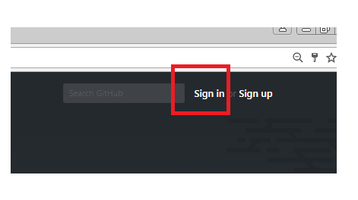

Enter un,pwd

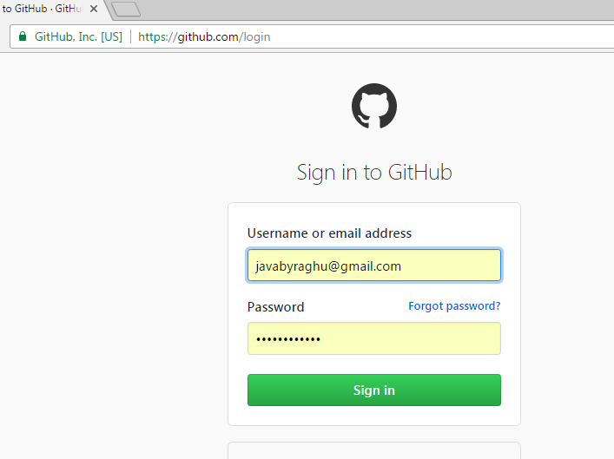

Click on new Repository

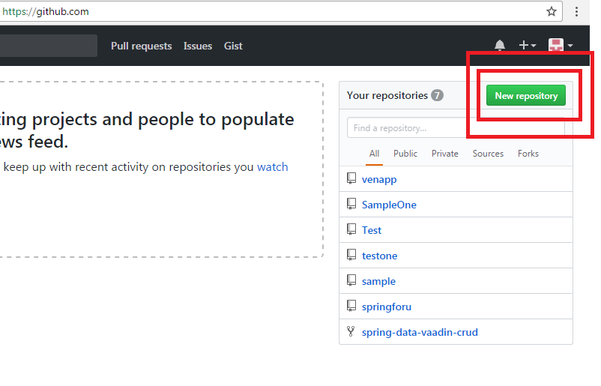

Provide Repository Details

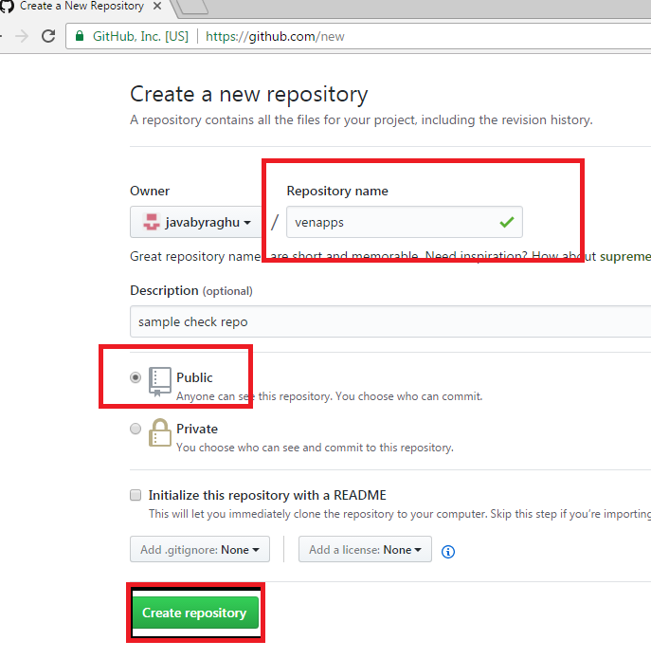

On click create repository

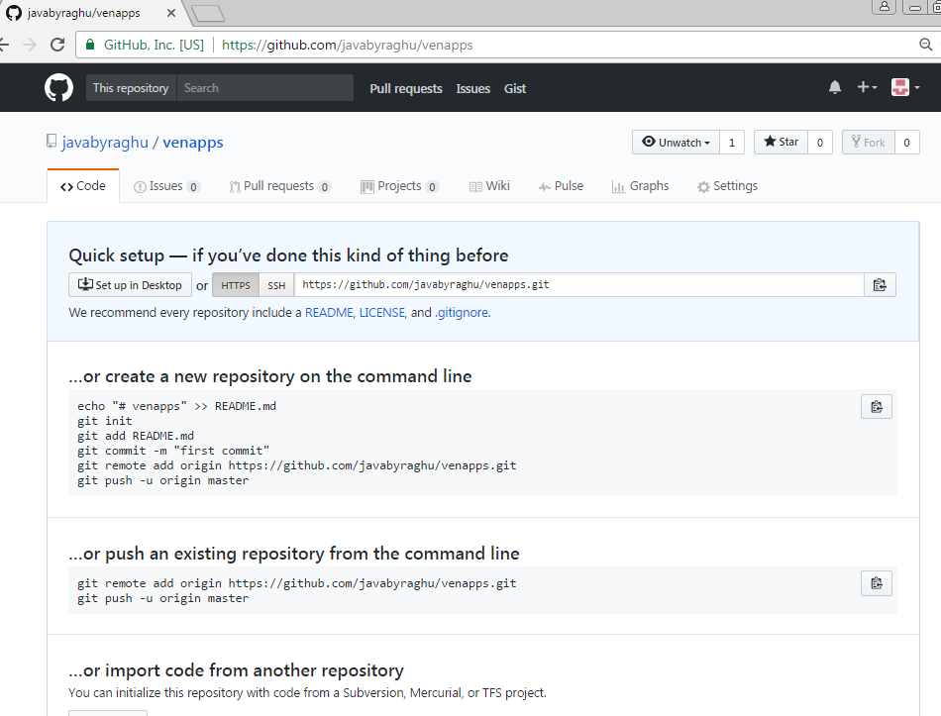

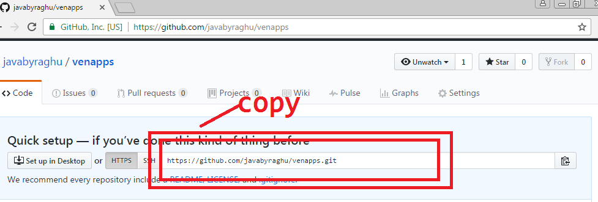

Ex : (Repository Link)

<https://github.com/javabyraghu/venapps.git>

Got Eclipse:

* Create A new Java Project **(project name and repository name**

**Should be same )**

* Add Git Views

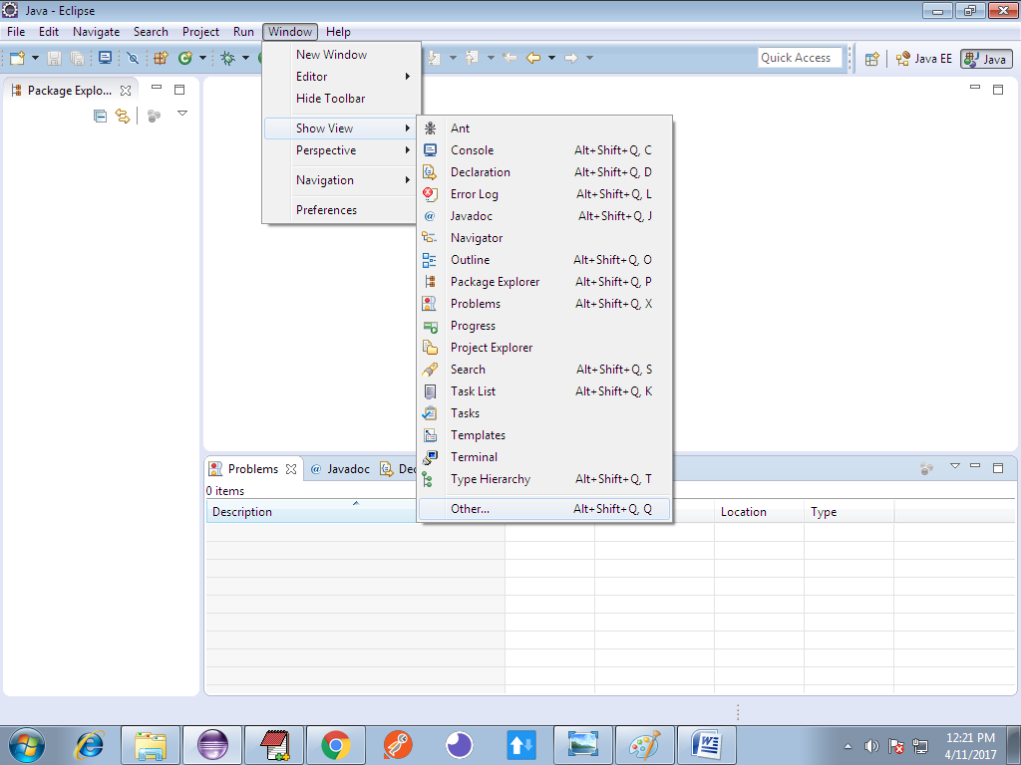

Serach with Git, select Git Repository, Staging

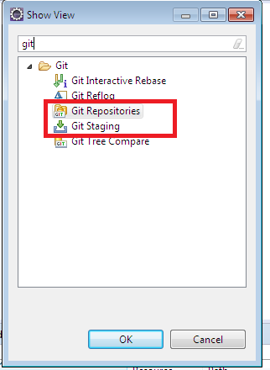

Observer options like

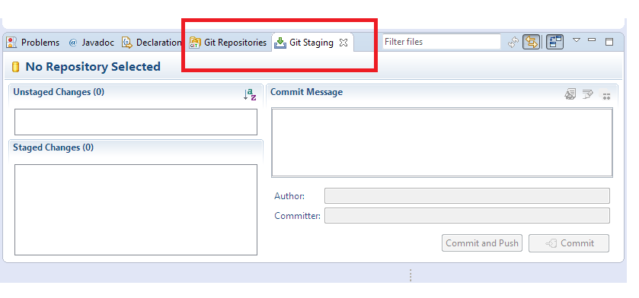

After writing of some code ex: Employee.java

>right click on project > tem > share project

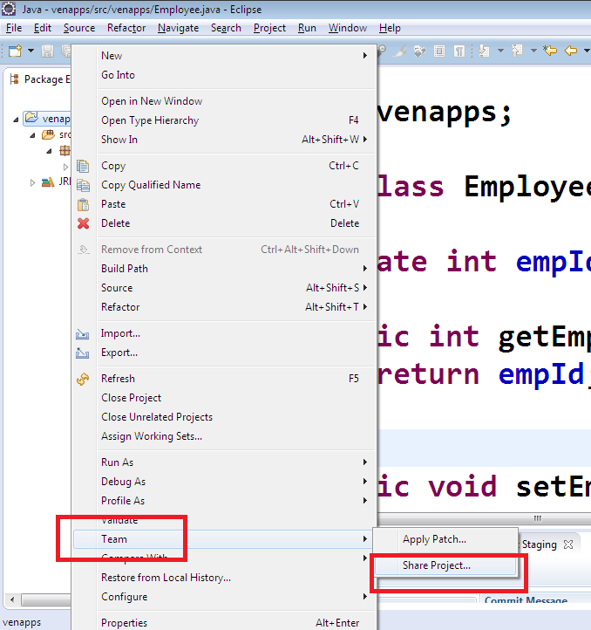looks as below:

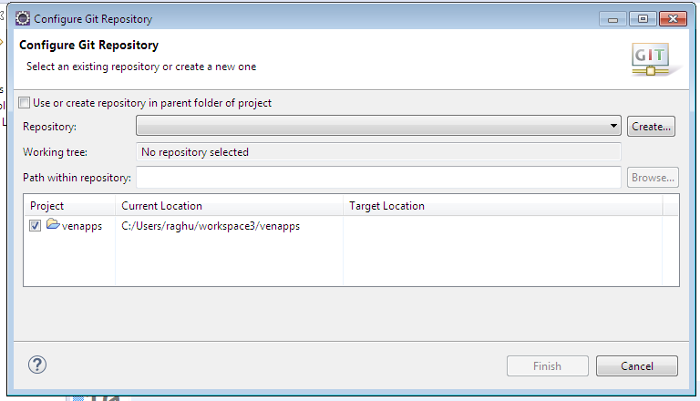

Click on check box:

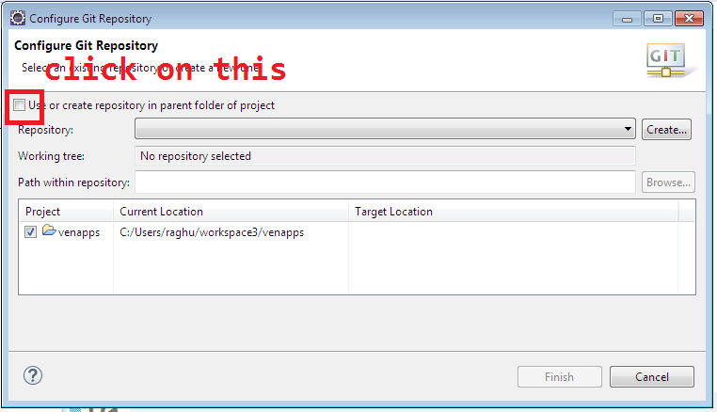looks as below:

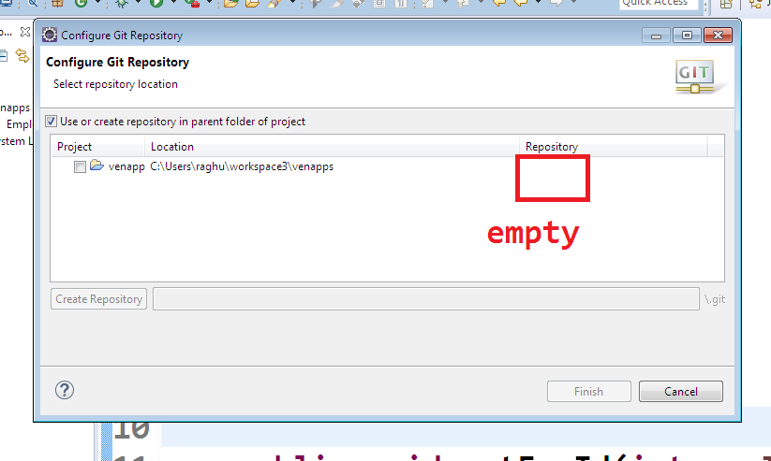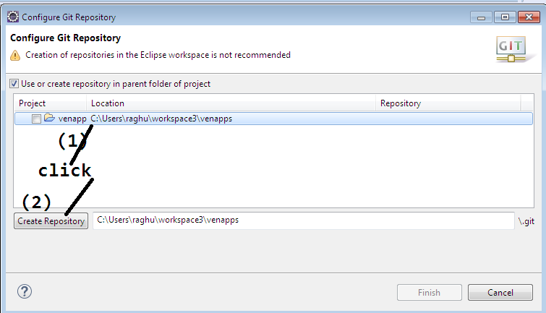then observe repository name:

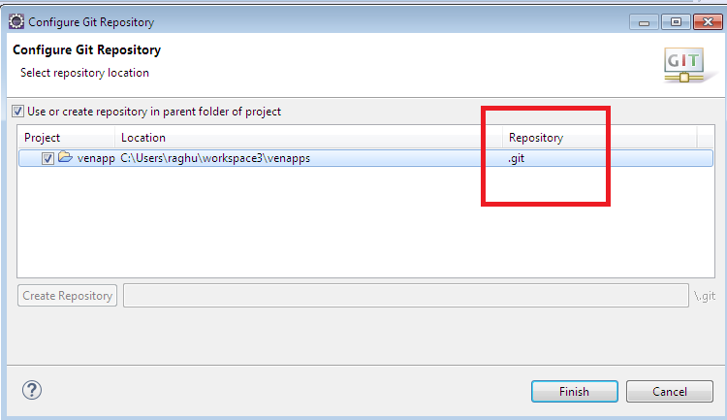click on finish.

By this we created local and remote repositories.

Now link local and remote, using firsh commit and push.

Come to git repositoes

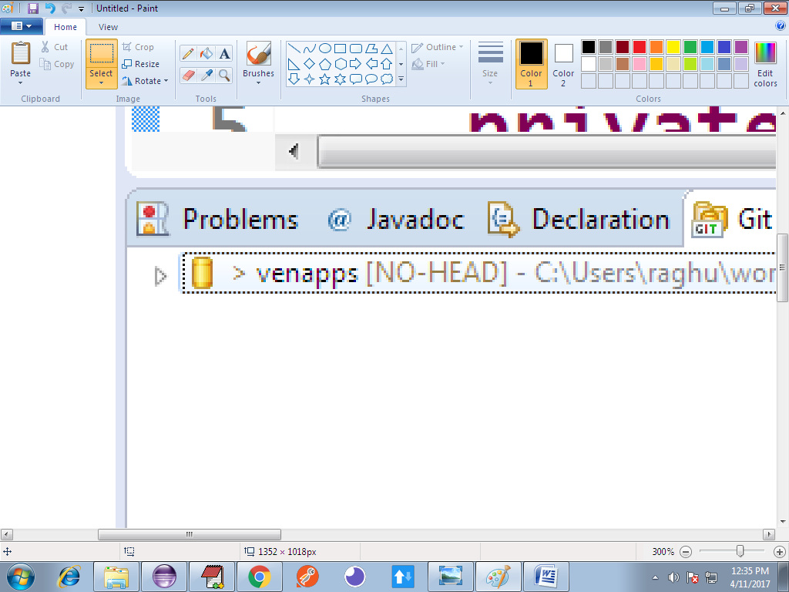

In staging are:

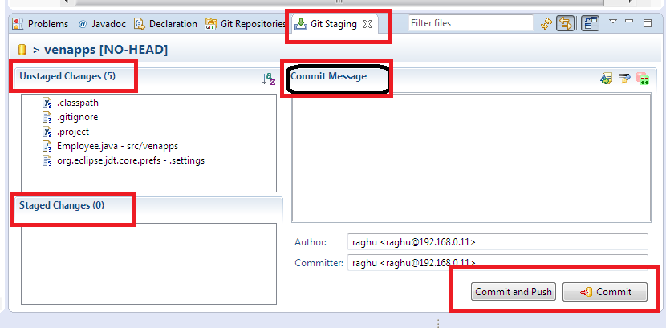

1)Unstaged changes : files which are not ready to send to local

2)staged chages: file which needs to move to local/remote

3)commit message: what is the purpose specify here as message for sending of this code.

4) click commit/ commit & push to send the code.

*)Click on a file in unstage drag and drop into stage.

Click and Drag:

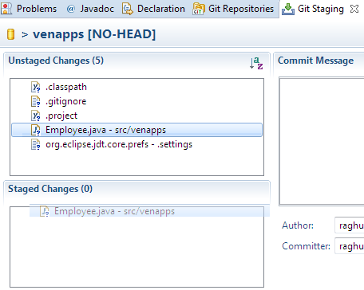

After drop

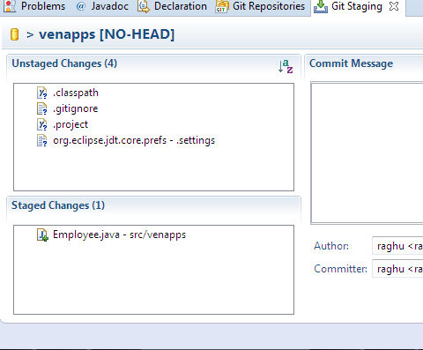

Enter commit message

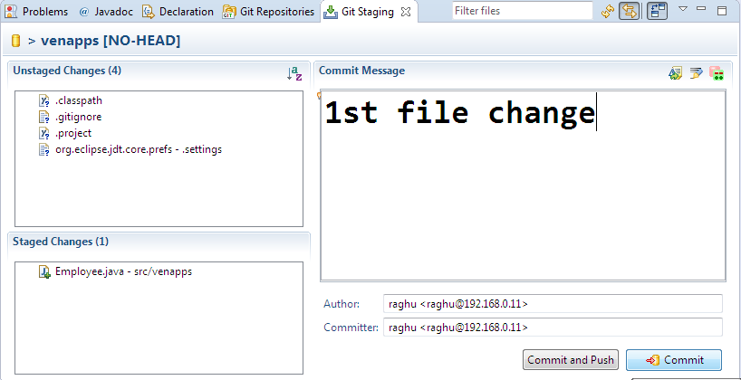

And click on commit

In GitRepository , right click on projectName>choose Push Branch master

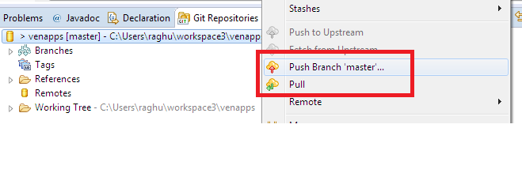

After Push option one screen looks below, there enter URI

(Repository link)

Ex: <https://github.com/javabyraghu/venapps.git>

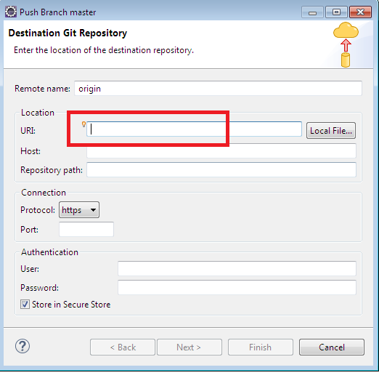

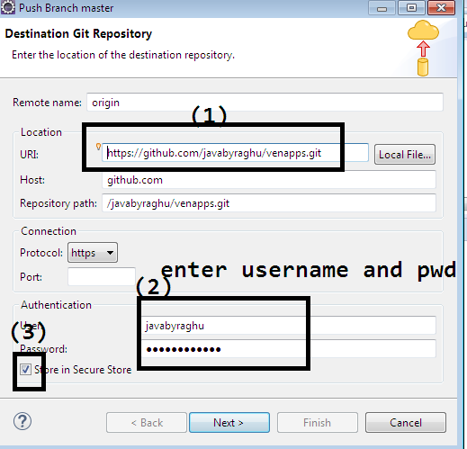

Click on next>next>finish

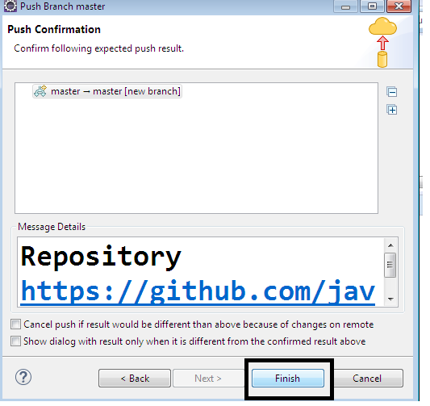

Shows as below:

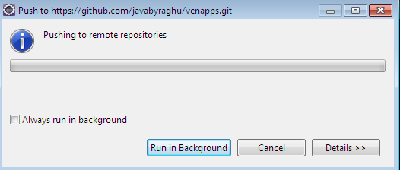

On success:

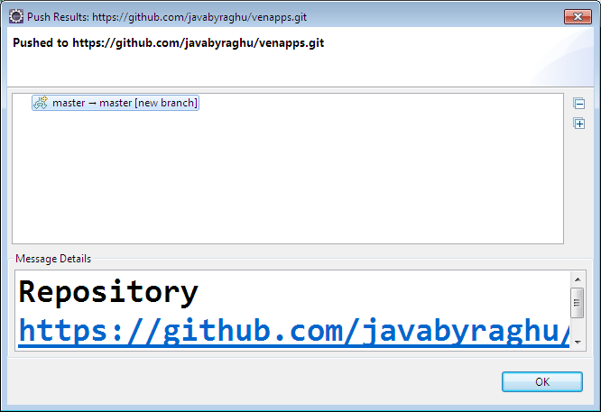

Come back to browser and refresh:

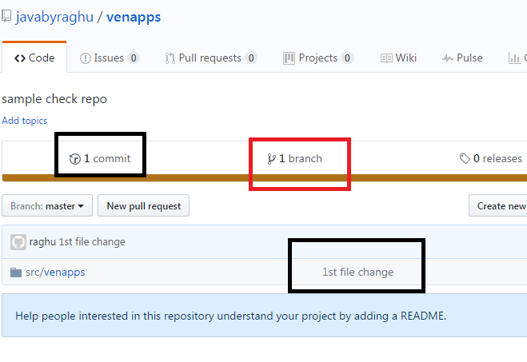

Click on src/venapp>Employee.java

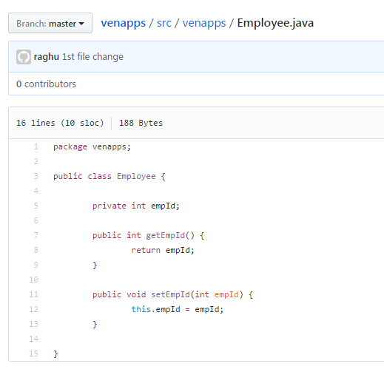

Right click on project: pull and then rebase for other update:

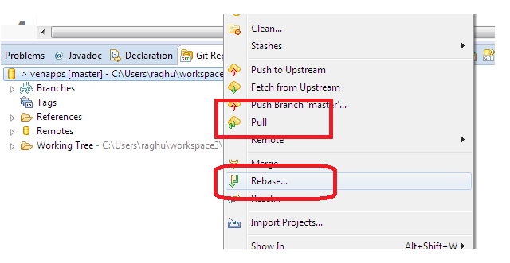

***)After Ading file to staging ,double click on that to comapre with

Old one (previous one)looks as :

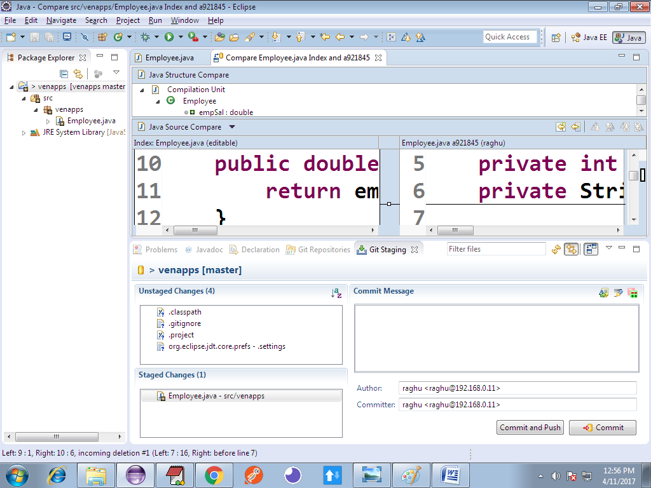

To see history:

Right click on File (ex: Employee.java)> Team>Showin History

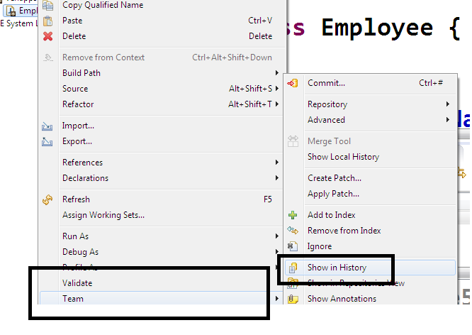

View history:

