A PROJECT WORK

ON

**Online Application System**

**Course Code:** IT – 604

**Course Title:** Web Technology-1 Lab



**Institute of Information Technology**

Jahangirnagar University

Savar, Dhaka – 1342

**Submitted By:** **Project Adviser:**

Mahfujur Rahman Shamim Al Mamun

Class Roll:865 Assistant Professor

Eaxm Roll:110384 Institute of Information Technology,

Jahangirnagar University,Savar,Dhaka

Project Overview:

This project is entitled as “ONLINE ADMISSION APPLICATION”. It helps us making an application management system in an university, college to manage student application in an available time. This Application system helps the organizer to manage the application system so easily.

Our Task:

1.Admin set the seat plan

2.Admin create the pdf format of seat plan

3.Student see the seat plan

Admin panel: Seat plan update and set

Step1: At first admin see the all information of students that is serialNo,mobile_no,tx_id, number_found,merit_position unitwise. For example we select A unit using dropdownlist.

Given below a screenshoot and code for this option:

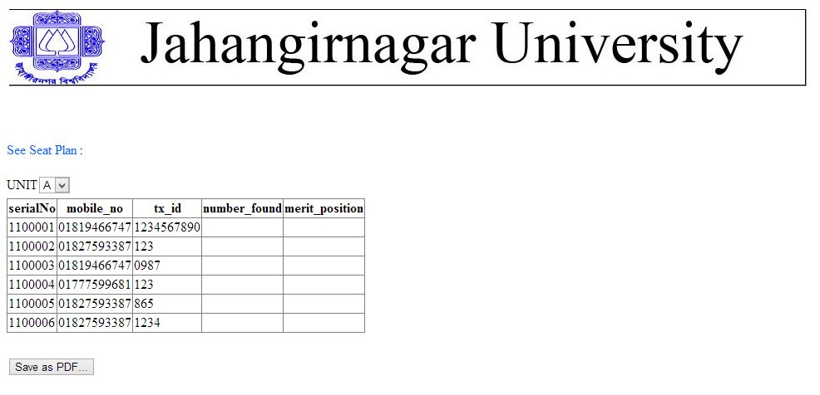

Code for unit selection:

using System;

using System.Collections.Generic;

using System.Linq;

using System.Web;

using System.Web.UI;

using System.Web.UI.WebControls;

using MySql.Data.MySqlClient;

using System.Configuration;

using iTextSharp.text;

using iTextSharp.text.pdf;

using System.IO;

namespace Online_Admission_Test

{

public partial class seatplan : System.Web.UI.Page

{

MySqlConnection con = new MySqlConnection(ConfigurationManager.ConnectionStrings["admissionConnectionString"].ConnectionString);

string constring = ConfigurationManager.ConnectionStrings["admissionConnectionString"].ConnectionString;

protected void Page_Load(object sender, EventArgs e)

{

//for datagridview 1

con.Open();

SqlDataSource dataSource = new SqlDataSource("MySql.Data.MySqlClient", constring, "SELECT * FROM apply"+DropDownList1.SelectedValue.ToLower()+"");

GridView3.DataSource = dataSource;

GridView3.DataBind();

con.Close();

}

Step 2: Here we use Gridview and sqldatasource for showing room information and total seat.Here we configuration default sqldatasouce and showing all room and seat information.

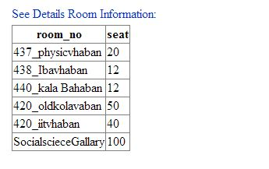

Step 3: Here admin set the room no against every roll no.Before setting admin see that figure.

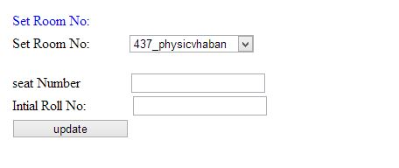

Here admin set the room number,seat number,initial roll number.

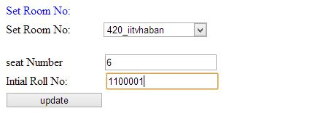

Code for update button:

protected void updateB_Click(object sender, EventArgs e)

{

//int dif = Convert.ToInt32( endRollNo.Text) - Convert.ToInt32(intialRollNo.Text);

//UPDATE `admission`.`applya` SET `number_found` = '437' WHERE `applya`.`serialNo` =1100000;

int dif = Convert.ToInt32(seatTB.Text);

con.Open();

for (int i = 0; i <= dif; i++)

{

MySqlCommand cmdo = new MySqlCommand("Update apply" + DropDownList1.SelectedValue.ToLower() + " set number_found='" + roomNoDDL.SelectedValue + "' where serialNo='" + (Convert.ToInt32(intialRollNo.Text) + i) + "'", con);

cmdo.ExecuteNonQuery();

// GridView1.DataBind();

}

con.Close(); Response.Redirect("seatplan.aspx");}

Step 4: After clicking update button admin see the seat number against every roll unit based.

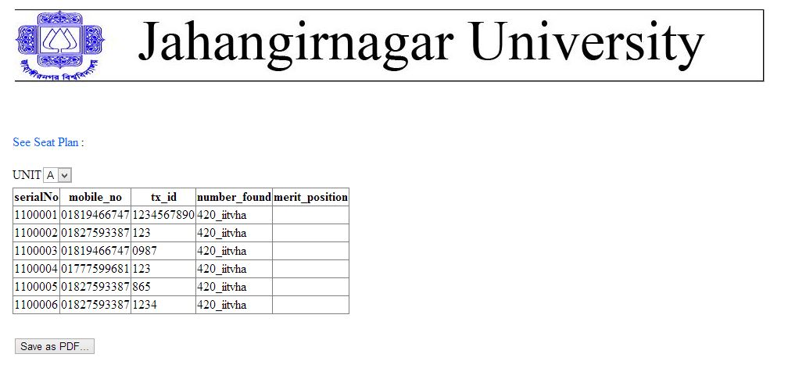

Step 5: When admin click save as PDF button he will see the pdf file which contains Serial ,mobile, transaction Id, seat Information etc.

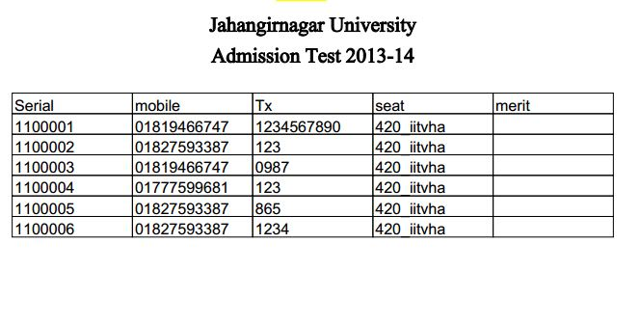

Code for save as PDF button:

protected void Button1_Click(object sender, EventArgs e)

{

Document document = new Document(PageSize.A4, 5, 5, 15, 15);

PdfWriter.GetInstance(document, new FileStream(HttpContext.Current.Server.MapPath("~/PDFs/doc.pdf"), FileMode.Create));

document.Open();

PdfPTable table = new PdfPTable(5);

PdfPCell cell = new PdfPCell();

//for font

string fontpath = Server.MapPath("~/font/") + "times.ttf";

BaseFont basefont = BaseFont.CreateFont(fontpath, BaseFont.IDENTITY_H, true);

//for end of font

//set font size

Font font16 = new iTextSharp.text.Font(basefont, 16, iTextSharp.text.Font.NORMAL, iTextSharp.text.BaseColor.BLACK);

Font font16bold = new iTextSharp.text.Font(basefont, 16, iTextSharp.text.Font.BOLD, iTextSharp.text.BaseColor.BLACK);

Font font14bold = new iTextSharp.text.Font(basefont, 14, iTextSharp.text.Font.BOLD, iTextSharp.text.BaseColor.BLACK);

//for image

iTextSharp.text.Image gif = iTextSharp.text.Image.GetInstance(Server.MapPath("~/img/") + "julogo.GIF");

gif.ScaleToFit(50f, 50f);

gif.Alignment = iTextSharp.text.Image.TEXTWRAP | iTextSharp.text.Image.ALIGN_CENTER;

gif.IndentationRight = 9f;

gif.SpacingAfter = 9f;

gif.Border = Rectangle.BOX;

gif.BorderColor = iTextSharp.text.BaseColor.YELLOW;

gif.BorderWidth = 5f;

document.Add(gif);

//end of image

Paragraph p1 = new Paragraph("Jahangirnagar University\nAdmission Test 2013-14\n\n", font16bold);

p1.Alignment = iTextSharp.text.Image.ALIGN_CENTER;

document.Add(p1);

//cell.Padding = 9f;

cell.Phrase = new Phrase("Serial");

table.AddCell(cell);

cell.Phrase = new Phrase("mobile");

table.AddCell(cell);

cell.Phrase = new Phrase("Tx");

table.AddCell(cell);

cell.Phrase = new Phrase("seat");

table.AddCell(cell);

cell.Phrase = new Phrase("merit");

table.AddCell(cell);

con.Open();

MySqlCommand cmd = new MySqlCommand("SELECT * FROM `applya` inner join dbbl where applya.mobile_no = dbbl.mobile_no and applya.tx_id = dbbl.tx_id ", con);

MySqlDataReader reader = cmd.ExecuteReader();

while (reader.Read())

{

cell.Phrase = new Phrase(reader.GetString(0).ToString());

table.AddCell(cell);

cell.Phrase = new Phrase(reader.GetString(1).ToString());

table.AddCell(cell);

cell.Phrase = new Phrase(reader.GetString(2).ToString());

table.AddCell(cell);

cell.Phrase = new Phrase(reader.GetString(3).ToString());

table.AddCell(cell);

cell.Phrase = new Phrase(reader.GetString(4).ToString());

table.AddCell(cell);

}

reader.Close();

con.Close();

document.Add(table);

document.Close();

Response.Redirect("~/PDFs/doc.pdf");

}

}

}

Database Information:

Here we use My sql database.

Requirement: Xamp server,mysqlconnector.msi for mysqlconnection,itextsharp.dll for pdf.

Database Name:admission.sql

Code for connection:

MySqlConnection con = new MySqlConnection(ConfigurationManager.ConnectionStrings["admissionConnectionString"].ConnectionString);

string constring = ConfigurationManager.ConnectionStrings["admissionConnectionString"].ConnectionString;

Web.config

<?xml version="1.0"?>

<configuration>

<connectionStrings>

<add name="admissionConnectionString" connectionString="server=localhost;User Id=root;database=admission"

providerName="MySql.Data.MySqlClient" />

</connectionStrings>

<system.web>

<compilation debug="true" targetFramework="4.0" />

</system.web>

</configuration>

Student Panel:

Step 1: Student login his page and then see his all information

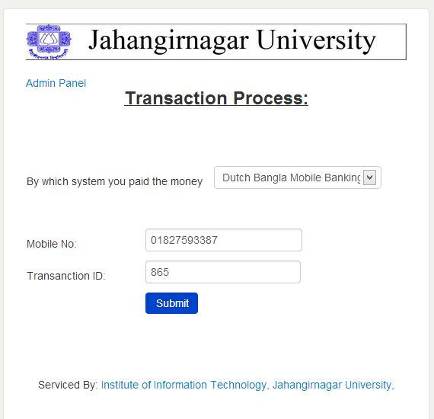

Code for login:

using System;

using System.Collections.Generic;

using System.Linq;

using System.Web;

using System.Web.UI;

using System.Web.UI.WebControls;

using MySql.Data.MySqlClient;

using System.Configuration;

namespace Online_Admission_Test

{

public partial class Default : System.Web.UI.Page

{

MySqlConnection con = new MySqlConnection(ConfigurationManager.ConnectionStrings["admissionConnectionString"].ConnectionString);

protected void Page_Load(object sender, EventArgs e)

{

}

protected void systemDDL_SelectedIndexChanged(object sender, EventArgs e)

{

if (systemDDL.SelectedIndex == 0)

{

teletalkPanel.Visible = true;

DBBLPanel.Visible = false;

}

else {

teletalkPanel.Visible = false ;

DBBLPanel.Visible = true;

}

}

protected void submitDBBL_Click(object sender, EventArgs e)

{

try

{

con.Open();

string query = "SELECT * from dbbl where mobile_no='" + mobileNoTB.Text.ToString() + "' and tx_id ='" + txIDTB.Text.ToString() + "'";

MySqlCommand cmd = new MySqlCommand(query, con);

MySqlDataReader reader = cmd.ExecuteReader();

if (reader.Read())

{

//this.Visible = false;

// main c = new main();

Session["mobile"] = reader.GetString(0);

Session["tx_id"] = reader.GetString(1);

// c.Visible = true;

if(reader.GetString(3) == "")

Response.Redirect("general.aspx");

else

Response.Redirect("main.aspx");

}

else

{

wrongLabel.Visible = true;

}

reader.Close(); //close Data Reader

//close Connection

con.Close();

}

catch (Exception ew)

{

wrongLabel.Text = ew.Message.ToString();

}

}

}

Step 2: After login student see his/her own seat plan unit based

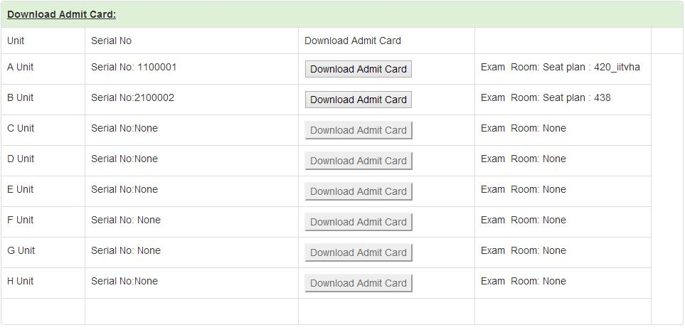

Code for showing seat plan:

protected void Page_Load(object sender, EventArgs e)

{

mobileNoPanel7.Text = Session["mobile"] as string;

tx_idPanel7.Text = Session["tx_id"] as string;

/* hscboardLPanel7.Text = Session["hsc_board"] as string;

hscrollLpanel7.Text = Session["hsc_roll"] as string;

hscpassyearLpane7.Text = Session["hsc_pass_year"] as string;

*/

//admit card choose

admitcardselection("applya", admitcardBA,Aunitserial,AunitExamRoom);

admitcardselection("applyb", admitcardBB,Bunitserial,BunitExamRoom);

admitcardselection("applyc", admitcardBC,Cunitserial,CunitExamRoom);

admitcardselection("applyd", admitcardBD,Dunitserial,DunitExamRoom);

admitcardselection("applye", admitcardBE,Eunitserial,EunitExamRoom);

admitcardselection("applyf", admitcardBF,Funitserial,FunitExamRoom);

admitcardselection("applyg", admitcardBG,Gunitserial,GunitExamRoom);

admitcardselection("applyh", admitcardBH,Hunitserial,HunitExamRoom);

}