Simulation and Scientific Computing 2

Assignment 1: Multigrid Methods

# 

**Team Members :**

**Paras Kumar, Iniyan Kalaimani, Raju Ram**

1) Dirichlet Boundary Conditions:

For this case, number of V-cycle = 15

Following table contains error norm with varying grid size.

| S No | Grid Size (h) | Error Norm |
| --- | --- | --- |
| 1 | 0.125 | 0.0281737 |
| 2 | 0.0625 | 0.00664675 |
| 3 | 0.03125 | 0.00161231 |
| 4 | 0.015625 | 0.000396936 |
| 5 | 0.0078125 | 9.84684e-05 |
| 6 | 0.00390625 | 2.45215e-05 |

Following graph contains error norm with varying grid size.

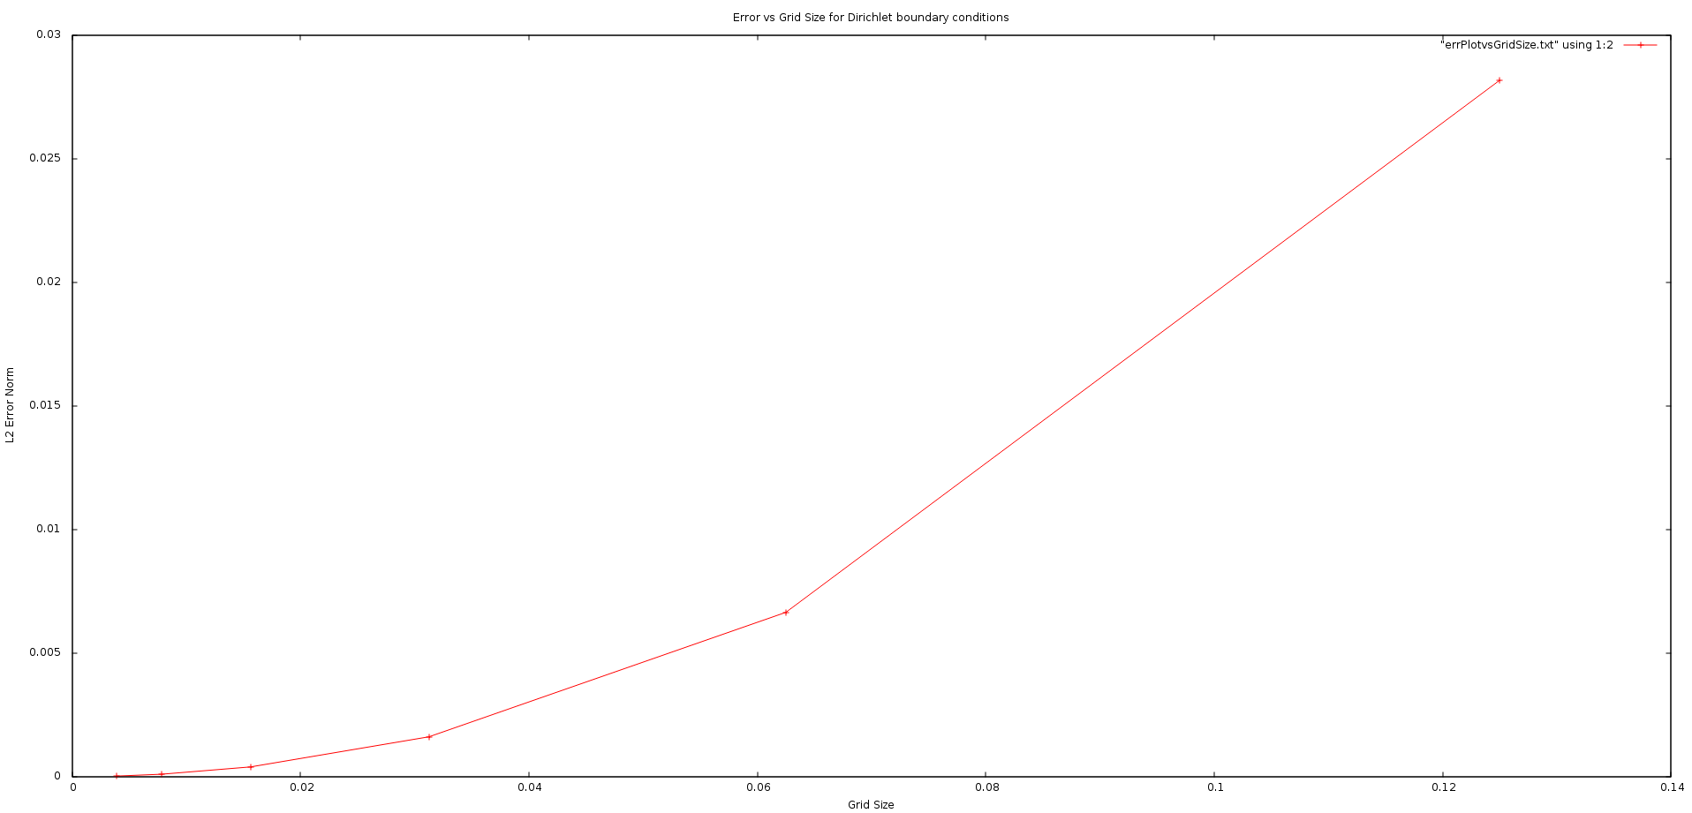

Computed solution for Dirichlet bc for level = 5, number of V-cycle =15.

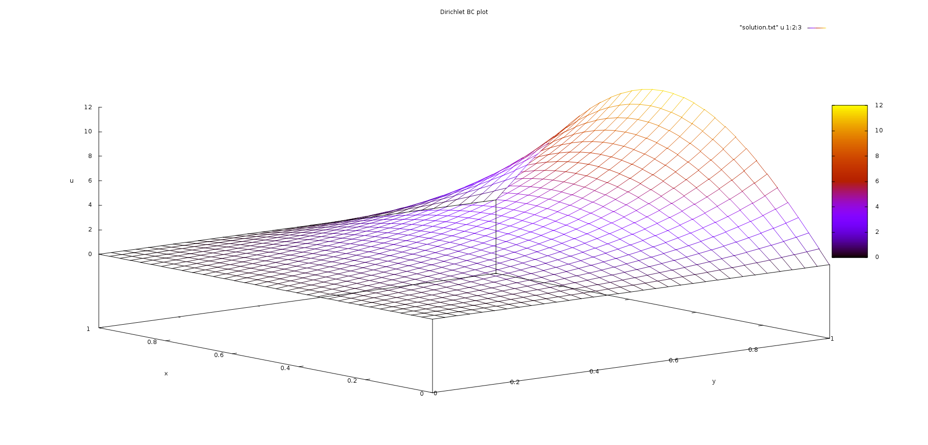

2) Neumann Boundary Conditions:

For this case, number of V-cycle = 50

| S No | Grid Size (h) | Error Norm |
| --- | --- | --- |
| 1 | 0.125 | 0.259294 |
| 2 | 0.0625 | 0.215424 |
| 3 | 0.03125 | 0.197853 |
| 4 | 0.015625 | 0.189904 |
| 5 | 0.0078125 | 0.184646 |
| 6 | 0.00390625 | 0.173314 |

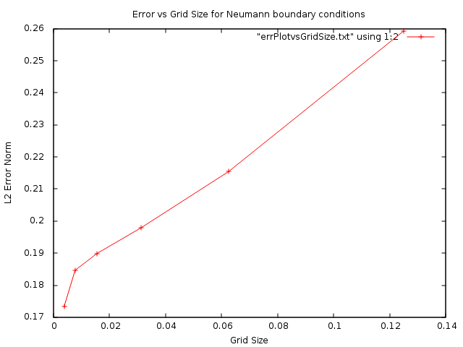

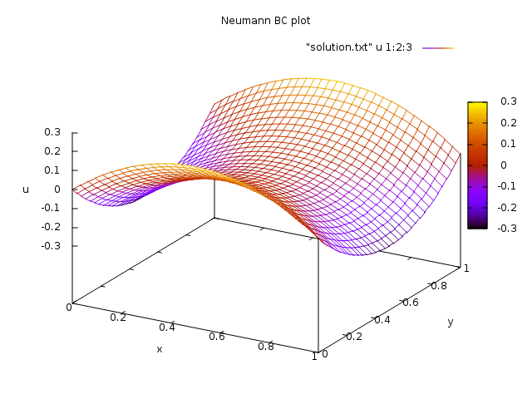

Computed solution for Neumann bc for level = 5, number of V-cycle =50.