Simulation and Scientific Computing 2

Assignment 1: Multigrid Methods

# 

**Team Members :**

**Paras Kumar, Iniyan Kalaimani, Raju Ram**

1) Dirichlet Boundary Conditions:

Following table contains error norm with varying grid size.

| S No | Grid Size (h) | Error Norm |
| --- | --- | --- |
| 1 | 0.125 | 0.0281737 |
| 2 | 0.0625 | 0.00664675 |
| 3 | 0.03125 | 0.00161231 |
| 4 | 0.015625 | 0.000396936 |
| 5 | 0.0078125 | 9.84684e-05 |
| 6 | 0.00390625 | 2.45215e-05 |

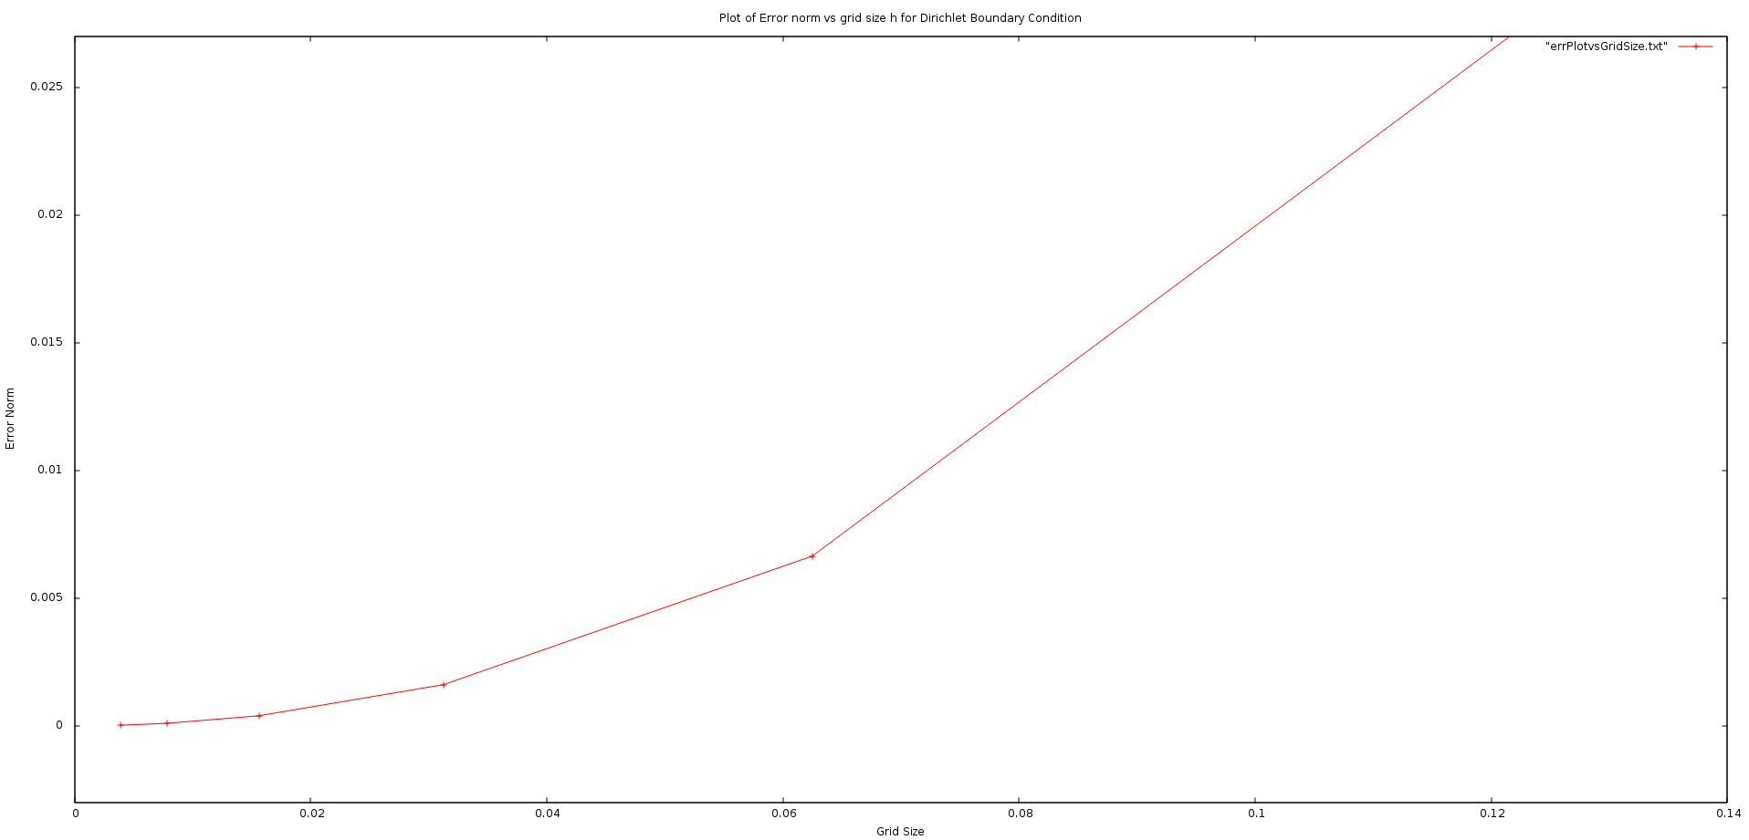

Following graph contains error norm with varying grid size.

Computed solution for Dirichlet boundary conditions for total number of level 5.

