PRODUCT DOCUMENTATION
MotionMirror
Full-person video replacement: product, architecture and delivery plan
Replace a selected dancer in a source video with the user’s own appearance while preserving the original choreography, timing, scene and audio — with architecture for the UI, backend, AI worker and model layers.
Item | Detail
Product | MotionMirror (provisional name)
Document | Product documentation: objectives, problem, solution, features, modules, architecture and operation
Version | 1.0 — draft for review
Date | November 6, 2026
Derived from | Master development prompt for the full-person video replacement application, Revision 3 (2026-11-06)
Audience | Product, engineering, ML, platform, security and stakeholders

About this document
This document describes the intended product and design. Quality, hardware requirements and benchmarks are stated as targets or planning candidates until measured on real hardware; nothing here claims that real GPU validation has already been performed.

Contents
1. Executive summary
2. Product vision and goals
3. Problem statement
4. Solution overview
5. Users and journeys
6. Features
7. Scope
8. Modules
9. Architecture
10. How it works end to end
11. Training track and model deployment
12. Security and privacy
13. Environments and hardware tiers
14. Deployment and operations
15. Quality, testing and acceptance
16. Delivery roadmap
17. Risks, assumptions and limitations
18. Documentation and handoff
Figures: 1 System architecture · 2 UI architecture · 3 Backend architecture · 4 Job dispatch sequence · 5 Job state machine · 6 AI worker architecture · 7 Model architecture · 8 Training and deployment lifecycle

1. Executive summary
MotionMirror (provisional name) is a private video-editing application. A user uploads a source dance video, selects the dancer they want to replace, and uploads photographs of themselves. The application then generates an edited video in which the user’s entire appearance — face, hair, visible body, clothing and footwear — replaces the selected dancer, while the original choreography, timing, camera movement, scene and audio are preserved as far as the selected model and compositing pipeline allow.
The product is built on an existing pretrained video model, Wan2.2-Animate-14B in replacement mode, which is treated as a baseline to be validated in a feasibility phase rather than a fixed mandate. It is an application-development effort, not a foundation-model research project. A separate, operator-run training track adds LoRA adapter fine-tuning on open or consented data, with an evaluation gate and a controlled path to production.
This document describes what the product is meant to achieve, the problem it addresses, the solution and its features, the modules that make it up, and how it works end to end, including architecture diagrams for the UI, backend, AI worker and model layers.
Honesty about quality
Exact anatomy, likeness, foot contact and frame-perfect movement are quality targets, not guarantees. The product distinguishes mock, real and experimental output everywhere, and it never presents mock output as proof of model quality.

At a glance
Aspect | Summary
What it does | Replaces a selected dancer in a source clip (up to 30 seconds) with the user, using the user’s photographs as the target appearance.
Who it is for | Individual creators using a private application; operators who run and deploy it; ML engineers who customize the model.
Core model | Wan2.2-Animate-14B replacement mode (pinned revision), validated first by a CLI spike on a CUDA GPU.
Architecture | Next.js web UI, Spring Boot API (system of record), PostgreSQL with transactional outbox, RabbitMQ dispatch, Redis cache and rate limits, Keycloak OIDC, private S3-compatible storage, Python GPU worker.
Environments | Apple Silicon Mac for daily development with a mock worker; Linux with NVIDIA GPU for real inference, authoritative evaluation and real training; ordinary Linux host for web and control plane.
Delivery model | Phased: feasibility spikes, local foundation, real short preview, full MVP, deployment, training track, adapter deployment.
Status of claims | Hardware requirements, benchmarks and quality are reported only when measured. Items that need a GPU are marked pending GPU validation until verified.

2. Product vision and goals

2.1 Vision
Let anyone place themselves into a dance performance as if they had performed it, with a privacy-respecting workflow that is simple for the user, honest about what the AI did, and reliable enough to run long GPU jobs without losing work.

2.2 What we are going to achieve
# | Objective | Meaning
O1 | Whole-person replacement | Replace the selected dancer’s face, hair, body appearance, clothing and footwear with the user’s appearance, not only the face.
O2 | Preserve the performance | Keep source choreography, timing, camera movement, scene and original audio as far as the model and compositing allow.
O3 | Precise selection | Let the user pick exactly one dancer, preview the mask and pose, and correct them before spending GPU time.
O4 | Honest, auditable output | Record which reference images were actually used, the effective settings, model and adapter revisions, and checksums for every run.
O5 | Durable processing | Run long GPU jobs through a database-backed state machine with leases, retries, cancellation and recovery that converges to a single accepted output.
O6 | Private by default | OIDC identity, ownership checks, quarantined uploads, short-lived signed URLs, deletion that purges derived data, no training on uploads by default.
O7 | Practical developer workflow | Develop on an Apple Silicon Mac with a mock backend and run real inference on a CUDA worker, switched by an explicit profile rather than code edits.
O8 | Customizable model | Support presets in the application and an operator-run LoRA adapter track with evaluation, staging, promotion and rollback.

2.3 Success criteria
The MVP is accepted only when a real user can complete the journey on a real GPU and the evidence is recorded:
- A supported continuous-shot source of up to 30 seconds produces a decodable MP4 of the expected duration with aligned original audio when present.
- The replacement is generated by the configured real model; mock output cannot satisfy the gate.
- Reference usage and effective prompts and settings are accurately disclosed and recorded.
- Worker restart, expired lease, cancellation and retry never produce conflicting successful outputs or cross-user access.
- RabbitMQ dispatches jobs through the outbox, and Redis caches and rate-limits with tested failure behavior.
- OIDC works for browsers and workers, and private media does not leak through caches, logs, broker payloads or unscoped signed access.
- If no GPU is available, the gate is marked pending GPU validation, not complete.

2.4 Non-goals
- Training a foundation model from scratch.
- Simultaneous multi-person replacement, automatic multi-shot re-identification, 4K output, real-time streaming, billing, mobile apps, Kubernetes and multi-region infrastructure (all deferred).
- Per-user identity training at upload time and genuine multi-view identity conditioning (research extensions, deferred).
- Bundling celebrity videos or scraped photographs as test data. The illustrative example of replacing a famous performer in a clip is not a data source; fixtures must be user-supplied or appropriately licensed.

3. Problem statement

3.1 The problem
People want to see themselves performing a dance they admire, but doing so convincingly is difficult. Swapping only a face leaves the original body, hair and outfit visible. Doing a full replacement by hand means frame-by-frame masking and compositing, and it still has to follow the original motion, camera and timing. Generative video models can now animate a person from a reference image, but turning such a model into a dependable product raises further problems.

3.2 Sub-problems the product must solve
Area | Problem | How the product responds
Identifying the target | A clip may contain several people; the model needs the exact dancer to replace. | Selection frames with points, box or paint; mask propagation; mask and pose preview with corrections stored as new selection revisions.
Describing the new appearance | A face close-up cannot specify an outfit. An image list is not a reconstructed 3D person. | One clear full-body primary reference plus optional supplementary views. The UI states which image was actually consumed.
Temporal consistency | Models generate short segments; a 30-second clip cannot be treated as one unrestricted tensor sequence. | Segment-by-segment generation using the runtime’s verified continuation mechanism, careful frame accounting, and no unconditional crossfades.
Visual boundaries | Tight silhouettes clip hair and limbs; occluders and shadows complicate compositing. | Edit region may exceed the original silhouette; soft-edge compositing; documented limits behind occluders.
Audio and timing | Variable frame rate and rotation metadata break sync. | Timestamp-based resampling, rational time bases, original audio restored aligned to the trim, output probed before success.
Long, costly GPU jobs | Jobs can outlive timeouts, workers can die, messages can be redelivered. | Outbox, leases, fencing tokens, heartbeats, manual acknowledgements, reconciler, and one real job per GPU.
Privacy and consent | Photos of people and their likeness are sensitive. | OIDC ownership, quarantine, signed URLs, consent confirmation, AI-edited labelling, deletion that purges derived artifacts, no default training on uploads.
Hardware reality | The developer machine is an Apple Silicon Mac without CUDA. | Explicit device profiles, mock worker for daily work, remote CUDA worker for real output, and no equivalence claims for Mac runs.
Customization | A baseline model may not meet quality needs for specific styles. | Presets in the app and an operator-run LoRA track with a strict evaluation gate.

3.3 Problem statement
Problem statement
How can a user replace one selected dancer in a source video of up to 30 seconds with their own full appearance, using only photographs of themselves, while preserving the original performance, timing, scene and audio — delivered as a private, durable, auditable application whose output honestly reflects what the AI model actually did and does not depend on hardware the developer does not have?

3.4 Constraints and known limits of the model
- Baseline Wan-Animate workflows centre on one character image. A batch or list argument is not evidence of multi-view identity fusion, so extra views are stored but marked as supplementary unless a real multi-view path consumes them.
- Negative prompts only affect output when the selected guidance path uses them. The product never accepts a negative prompt, runs with guidance disabled and claims it was applied.
- Replacement pose retargeting may be disabled by default. It is not silently enabled and is treated as experimental until verified.
- Memory requirements, LoRAs and optimization flags from similarly named Wan T2V or I2V models are not assumed to apply to Animate.
- Dependency and model licences differ; the repository’s licence is not assumed to cover every auxiliary tool.

4. Solution overview

4.1 Concept
MotionMirror combines a guided editing workflow with a model-backed generation pipeline. The user prepares inputs in a web interface; a Spring Boot API owns identity, ownership and job state; a RabbitMQ-dispatched Python worker performs preprocessing, generation, compositing and encoding on a GPU; and results come back through authorized, short-lived download links.

4.2 Three asset roles
The schema, API and UI keep three kinds of media strictly separate:
Role | What it is | Used for
Driving video | The source dance clip. | Motion, scene and timing.
Source selection frames | Exact frames and annotations that identify the original dancer. | Choosing and tracking the person to replace.
Target appearance references | Photographs of the replacement person and outfit; one primary full-body image plus optional views. | Defining who and what the output should look like.

4.3 Design principles
- Verify the model first. A CLI spike on real hardware precedes tight coupling to any runtime. Negative results are recorded.
- Spring Boot is the authority. Users, projects, assets, jobs, retries, leases and canonical status live in PostgreSQL behind the API. The web UI and Python worker never mutate that state independently.
- RabbitMQ transports, PostgreSQL decides. Delivery is at-least-once; correctness comes from the outbox, leases and fencing rather than a claim of exactly-once.
- Redis is only a performance layer. It is never the sole authority for authorization, jobs or idempotency.
- Mock is labelled mock. Mock output carries conspicuous “MOCK / NO AI REPLACEMENT” labelling and cannot satisfy any acceptance gate.
- Private by default. Buckets are private, uploads are quarantined, URLs are short-lived, and uploads are never used for training unless the user opts in.
- Split by hardware tier. The same repository and configuration run on a Mac for development and on a CUDA server for real work; the device is chosen by profile.

4.4 Solution at a glance
Need | Solution component
Guided editing workflow | Next.js App Router web app with upload, trim, selection, reference gallery, preview and correction, settings, job monitor and result viewer.
Authoritative business logic | Spring Boot modular monolith with identity, projects, assets, selections, jobs, presets, model registry and worker integration modules.
Reliable asynchronous work | PostgreSQL transactional outbox, RabbitMQ capability-routed queues, fenced leases, heartbeats, reconciler.
Real video replacement | Python ML worker with a pluggable backend interface: mock backend, Wan-Animate backend, optional experimental MPS backend.
Model customization | Versioned presets plus an operator-run LoRA training track, evaluation gate and adapter registry with staging, promotion and rollback.
Security and privacy | Keycloak OIDC, separate browser and worker security chains, quarantined uploads, signed URLs, audit events, scanning and signed releases.
Operations | Docker Compose profiles, Caddy, Runpod reference deployment, OpenTelemetry, Prometheus, Grafana, CI/CD with SBOM and image signing.

5. Users and journeys

5.1 Personas
Persona | Goals | Main touchpoints
Creator (end user) | Produce a believable video of themselves replacing a dancer, with minimal effort and clear feedback. | Web UI: projects, upload, selection, references, settings, jobs, results.
Operator / admin | Deploy, monitor and recover the system; control model configuration and adapters; manage cost. | Runbooks, dashboards, admin API for adapters and presets, audit events.
ML / MLOps engineer | Validate the model, build datasets, train and evaluate adapters, promote safely. | Training track commands, dataset registry, evaluation manifests, model registry.
Developer | Run the full stack quickly on a Mac and test changes without a GPU. | Mock mode, native hot reload, make targets, remote CUDA worker option.

5.2 Primary user journey
- Sign in through the OIDC login flow and land on the project list.
- Create a project and upload the source clip; the server validates and probes it and shows duration errors or a trim control for clips over the limit.
- Scrub the source frames and select the dancer with points, a box or paint.
- Add references: upload photographs, label views, and choose one clear full-body primary image.
- Review preprocessing: inspect the mask and pose preview, and correct problem frames with positive or negative points; corrections create a new selection revision.
- Configure generation: choose a preset, set positive and negative prompts, seed and permitted advanced options.
- Run a short preview of three to five seconds, check likeness, outfit, motion and edges.
- Run the full accepted clip and follow real stages and segment or frame counts, with cancellation and retry available.
- Review and download the result with synchronized source versus output playback, the settings manifest and the list of references actually used; delete assets when finished.

6. Features
Priorities follow the tiers used to plan delivery. P0 is the core flow, P1 is the hardening gate, and P2 is deferred.

6.1 Feature catalogue
ID | Feature | Description | Tier
F1 | Authentication and projects | OIDC login, server-side sessions, project list and lifecycle, stable issuer-plus-subject identity. | P0
F2 | Source video upload | Direct signed upload, quarantine, probing and decode checks, duration and size limits, trim or clear error for clips over 30 seconds. | P0
F3 | Dancer selection | Frame scrubber and canvas with points, box and paint; mask propagation across frames; coordinate mapping to model space. | P0
F4 | Mask and pose preview | Review before generation; positive and negative corrections; re-propagation; cache recompute for affected artifacts. | P0
F5 | Reference gallery | JPEG, PNG and WebP references; view labels; one primary full-body image; transparent disclosure of which images were consumed. | P0
F6 | Generation settings | Presets, positive and negative prompts, seed, limited advanced panel; incompatible combinations rejected or adjusted transparently. | P0
F7 | Preview and full generation | Short real preview, then full accepted clip using segment continuation, compositing and original audio. | P0
F8 | Job control | Real stages and counts, cancellation, failure explanation, retry, event history. No fabricated percentages or ETAs. | P0
F9 | Results | Synchronized source versus output playback, MP4 download, settings manifest, job history, deletion controls. | P0
F10 | Mock and real modes | Clearly labelled mock backend for development and tests; real GPU mode; experimental mode distinguished. | P0
F11 | Durable job orchestration | Outbox, RabbitMQ dispatch, fenced leases, heartbeats, retries, reconciler. | P0
F12 | Rate limits and caching | Redis cache-aside for bounded metadata; atomic rate limits; PostgreSQL-backed hard quotas. | P0
F13 | Preset and adapter management | Versioned presets; admin registration, staging, promotion and rollback of trained adapters with audit events. | P0 (training track)
F14 | Observability | Traces, metrics, structured logs, dashboards and alerts across API, outbox, queue, worker and storage. | P1
F15 | Security hardening | ClamAV scanning, Cosign-signed images, SBOM, Semgrep, Gitleaks, Trivy, k6 control-plane tests, backup and restore drills. | P1
F16 | Later enhancements | Multi-person replacement, automatic multi-shot re-identification, multi-view conditioning, per-user identity training, 4K, streaming, billing, mobile apps. | P2

6.2 Feature highlights

Honest generation controls
The interface shows effective settings, not just requested ones. If a preset uses a trained adapter, the adapter name, revision and evaluation status are visible and the preset is labelled experimental until promoted. Supplementary photos that were stored but not consumed by the model are never shown as applied.

Recoverable long-running work
Jobs survive API restarts, worker termination, expired signed URLs and broker reconnects. Late workers cannot overwrite newer attempts because completions carry a fencing token, and outputs are attached only after the result file has been probed and uploaded.

Developer-friendly hardware split
A single select_device() function reads an explicit profile (cuda, mps or cpu), fails fast on an unsupported choice and never silently moves a CUDA-only path to another device. make doctor reports chip, memory, container architecture, MPS availability and FFmpeg codecs.

7. Scope

7.1 MVP boundaries
- Source clips up to 30 seconds; real-model validation starts with a 3–5 second preview and then the full clip.
- One selected person per job; other people may appear but are not edit targets.
- Continuous single-shot clips first. Cuts are detected; multi-shot input requires explicit reselection per shot or is rejected with an actionable explanation. Tracking never silently crosses unrelated shots.
- MP4 and MOV inputs that FFmpeg can decode, with configurable byte, duration, dimension and decoded-frame limits.
- JPEG, PNG and WebP references with orientation and colour normalized.
- Mask preview and correction, positive and negative prompts, supported presets, seed and a limited advanced panel.
- Downloadable MP4 output, original versus output comparison, processing metadata and job history.
- Real OIDC, ownership checks, RabbitMQ dispatch and Redis in the first complete application slice.
- Both a labelled mock mode and a genuine GPU mode. The Mac path is never required to produce real output.

7.2 Training track scope
Operator-run LoRA fine-tuning of the pinned Wan-Animate checkpoint on open or consented datasets, and deployment of the resulting adapter, is a required deliverable that runs independently of the application MVP and must not delay the working preview. It is neither foundation-model training nor per-user identity training, and the documentation never describes one as the other.

7.3 Deferred
- Simultaneous multi-person replacement and automatic multi-shot re-identification.
- Arbitrary multi-view conditioning and new identity training per user.
- 4K output, real-time streaming, billing, mobile apps, Kubernetes and multi-region infrastructure.

8. Modules
The system is organized into five groups of modules. The backend is a modular monolith rather than many microservices; observability and security tooling are development and deployment capabilities, not extra services.

8.1 Web application modules (apps/web)
Module | Responsibility
Sign-in and project list | Starts the OIDC flow through the API, lists projects, applies private no-store behaviour to authenticated responses.
Upload and trim | Requests upload intents, uploads directly to storage with progress, shows validation and trim controls.
Selection canvas | Frame scrubber and annotation canvas (points, box, paint) with a tested mapping between display and model coordinates.
Reference gallery | Uploads reference photos, labels views, designates the primary full-body image, shows which images were used.
Preview and correction | Displays mask and pose previews and sends corrections that create new selection revisions.
Generation settings | Presets, prompts, seed and permitted advanced options, validated with Zod against the shared contract.
Job monitor | Polls status with backoff, shows real stages and counts, cancellation, failure explanation and retry.
Result viewer | Synchronized source and output playback, download, manifest view and deletion controls.
API client layer | Generated, typed OpenAPI client with TanStack Query for caching, cancellation and backoff.

8.2 Backend modules (apps/api)
Module | Responsibility
identity | Stable issuer-plus-subject users, USER and ADMIN roles, Spring Session JDBC sessions, browser and worker security chains.
projects | Project ownership and lifecycle; the anchor for access checks.
assets | Upload intents, server-generated ownership-scoped keys, completion validation, quarantine states, signed download URLs, media metadata.
selections | Versioned subject selections with source revision, frame and timestamp, coordinate mapping and annotations.
jobs | Preprocessing and generation jobs, state machine, attempts, events, idempotency, cancellation, retries and outputs.
presets | Versioned preset and model configuration definitions validated against a shared contract.
model registry | Trained adapters with base revision, hash, rank, licence, datasets and evaluation reference; promotion and rollback.
worker integration | Registration, lease acquisition, heartbeat, progress, completion, failure and artifact-access endpoints for workers.
outbox publisher | Publishes outbox events to RabbitMQ with confirms and mandatory-return handling, recording publication only after confirmed routing.
reconciler | Repairs expired leases and overdue jobs that lack a viable dispatch, without treating ordinary queue wait as loss.
audit | Redacted, bounded audit events for login, admin actions, generation, model configuration and deletion.

8.3 ML worker modules (services/ml-worker)
Module | Responsibility
contracts | Typed Pydantic models for task envelopes, requests, results and capabilities, shared with Spring Boot through a versioned contract.
backends | Backend registry and implementations: mock, Wan-Animate (CUDA) and a possible experimental MPS backend.
preprocessing | Segmentation and mask propagation, body-pose and face-motion extraction, background preparation, with cacheable artifacts.
media | FFmpeg and ffprobe handling, timestamps, rotation, VFR, compositing, joining, audio restoration and output validation.
worker | AMQP consumer, lease client, heartbeat, isolated inference process, cancellation and cleanup.
cli | Inference spike, doctor checks, smoke and benchmark commands.

8.4 Platform modules
Module | Responsibility
Edge | Caddy reverse proxy for same-origin routing and TLS.
Identity provider | Keycloak realm and clients for browser login and worker service accounts, with no embedded secrets.
Messaging | RabbitMQ vhost, durable exchanges, quorum queues, dead-letter queues, scoped producer and consumer identities.
Cache and limits | Redis with key-prefix ACLs, TTL policy, atomic rate limiting and a separate, non-evicting limiter in production.
Storage | Private S3-compatible buckets with quarantine, immutable keys, lifecycle rules and short-lived signed access; MinIO for local use.
Observability | OpenTelemetry, Micrometer, Prometheus and Grafana with dashboards and alert templates.
Delivery and security | CI pipelines, Gitleaks, Semgrep, Trivy, CycloneDX SBOM and Cosign signing; separate GPU acceptance pipeline.

8.5 Training track modules (training/)
Module | Responsibility
Dataset registry | configs/datasets/registry.yaml with sources, licences, commercial_use_ok gate, checksums, reviewer and dates.
Data construction | Clip filtering, mask, pose and face extraction, reference selection from other frames, manifests and person-level splits.
Trainer wrapper | Runs the pinned DiffSynth-Studio (or verified official) trainer under gpu-cuda, mac-mps and cpu-smoke profiles.
Evaluation | Base-versus-adapter generation on a fixed set through the real worker path; produces eval_manifest.json and a contact sheet.
Export and registration | Safetensors export, run manifest and the admin registration, staging, promotion and rollback commands.

9. Architecture

9.1 System architecture
The system has a browser tier, a control plane on an ordinary CPU host, and an AI plane on a GPU host. The control plane owns every business decision; the AI plane receives work over RabbitMQ and reports back to the control plane over authenticated HTTPS.
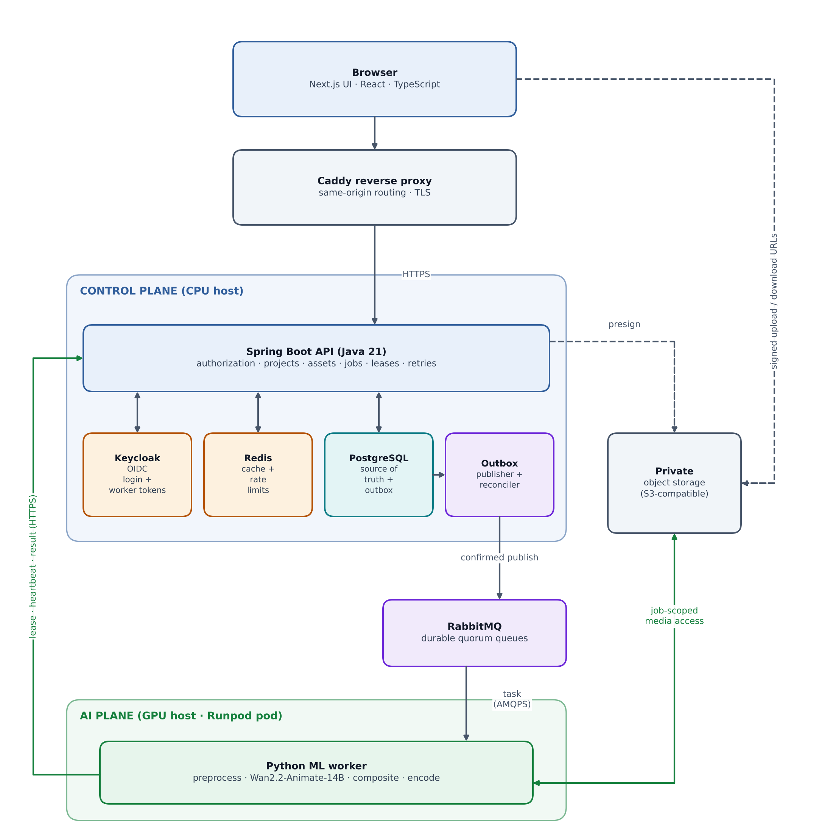
Figure 1. System architecture: browser, control plane, messaging, storage and GPU worker.

Component responsibilities
Component | Role | Authority and boundaries
Next.js web app | Media workflow and responsive UI. | UI only; business authorization is not implemented here.
Caddy | Reverse proxy and TLS. | Same-origin routing for browser traffic.
Spring Boot API | Users, projects, assets, selections, jobs, retries, leases, presets, adapters. | System of record for all business state; issues signed URLs after authorization.
Keycloak (OIDC) | Browser login and worker client-credentials tokens. | No custom JWT issuer or password database in the app.
PostgreSQL | Canonical metadata, attempts, outbox, sessions, audit. | Durable source of truth. No video binaries.
Outbox publisher and reconciler | Reliable dispatch and recovery. | Part of Spring Boot initially; coordinated through the database.
RabbitMQ | Capability-routed task transport with dead-lettering. | Transport only; never the sole record of work.
Redis | Cache-aside metadata, short-lived progress, atomic rate limits. | Never authoritative for authorization, jobs or idempotency.
Object storage | Quarantined uploads, assets, artifacts, results and adapters. | Private; access via short-lived signed URLs or job-scoped credentials.
Python ML worker | Preprocessing, inference, compositing, encoding. | No direct database or cache access; acts only under a fenced lease.

Technology stack
Layer | Tools
Web | Next.js App Router, React, TypeScript (strict), pnpm, Tailwind CSS, shadcn/ui and Radix, React Hook Form, Zod, TanStack Query, generated OpenAPI client.
API | Spring Boot, Java 21, Maven Wrapper, Spring MVC, Bean Validation, Spring Security, springdoc/OpenAPI.
Persistence | PostgreSQL, Spring Data JPA, explicit SQL where concurrency needs it, HikariCP, Flyway.
Messaging and cache | RabbitMQ with Spring AMQP and aio-pika; Redis with Spring Data Redis and Lettuce.
Identity | Keycloak with Spring Security OAuth2 Login and Resource Server.
ML worker | Python, uv with a lockfile, Pydantic, PyTorch, verified Diffusers or official model runtime, FFmpeg and ffprobe.
Storage and runtime | S3-compatible storage (MinIO locally), Docker multi-stage builds, Docker Compose, Caddy, separate CPU and GPU images.
Observability | OpenTelemetry, Spring Actuator and Micrometer, Prometheus, Grafana, structured logs.
Testing and delivery | JUnit, Testcontainers, pytest, Vitest, Playwright, k6; CI with Ruff, ESLint, Gitleaks, Trivy, Semgrep, CycloneDX, Cosign.
Training | Pinned DiffSynth-Studio (or verified official trainer), PyTorch with CUDA or MPS, safetensors, dataset registry, evaluation scripts.

Versions and model revisions are pinned after the initial compatibility spike, with no production dependency or image left on a floating latest tag. Celery, Kafka, a service mesh and Kubernetes are intentionally excluded from the MVP.

9.2 UI architecture
The web application is a Next.js App Router project that walks the user through the editing workflow. It is deliberately a thin client: it validates input for convenience, but Spring Boot repeats every authoritative check.
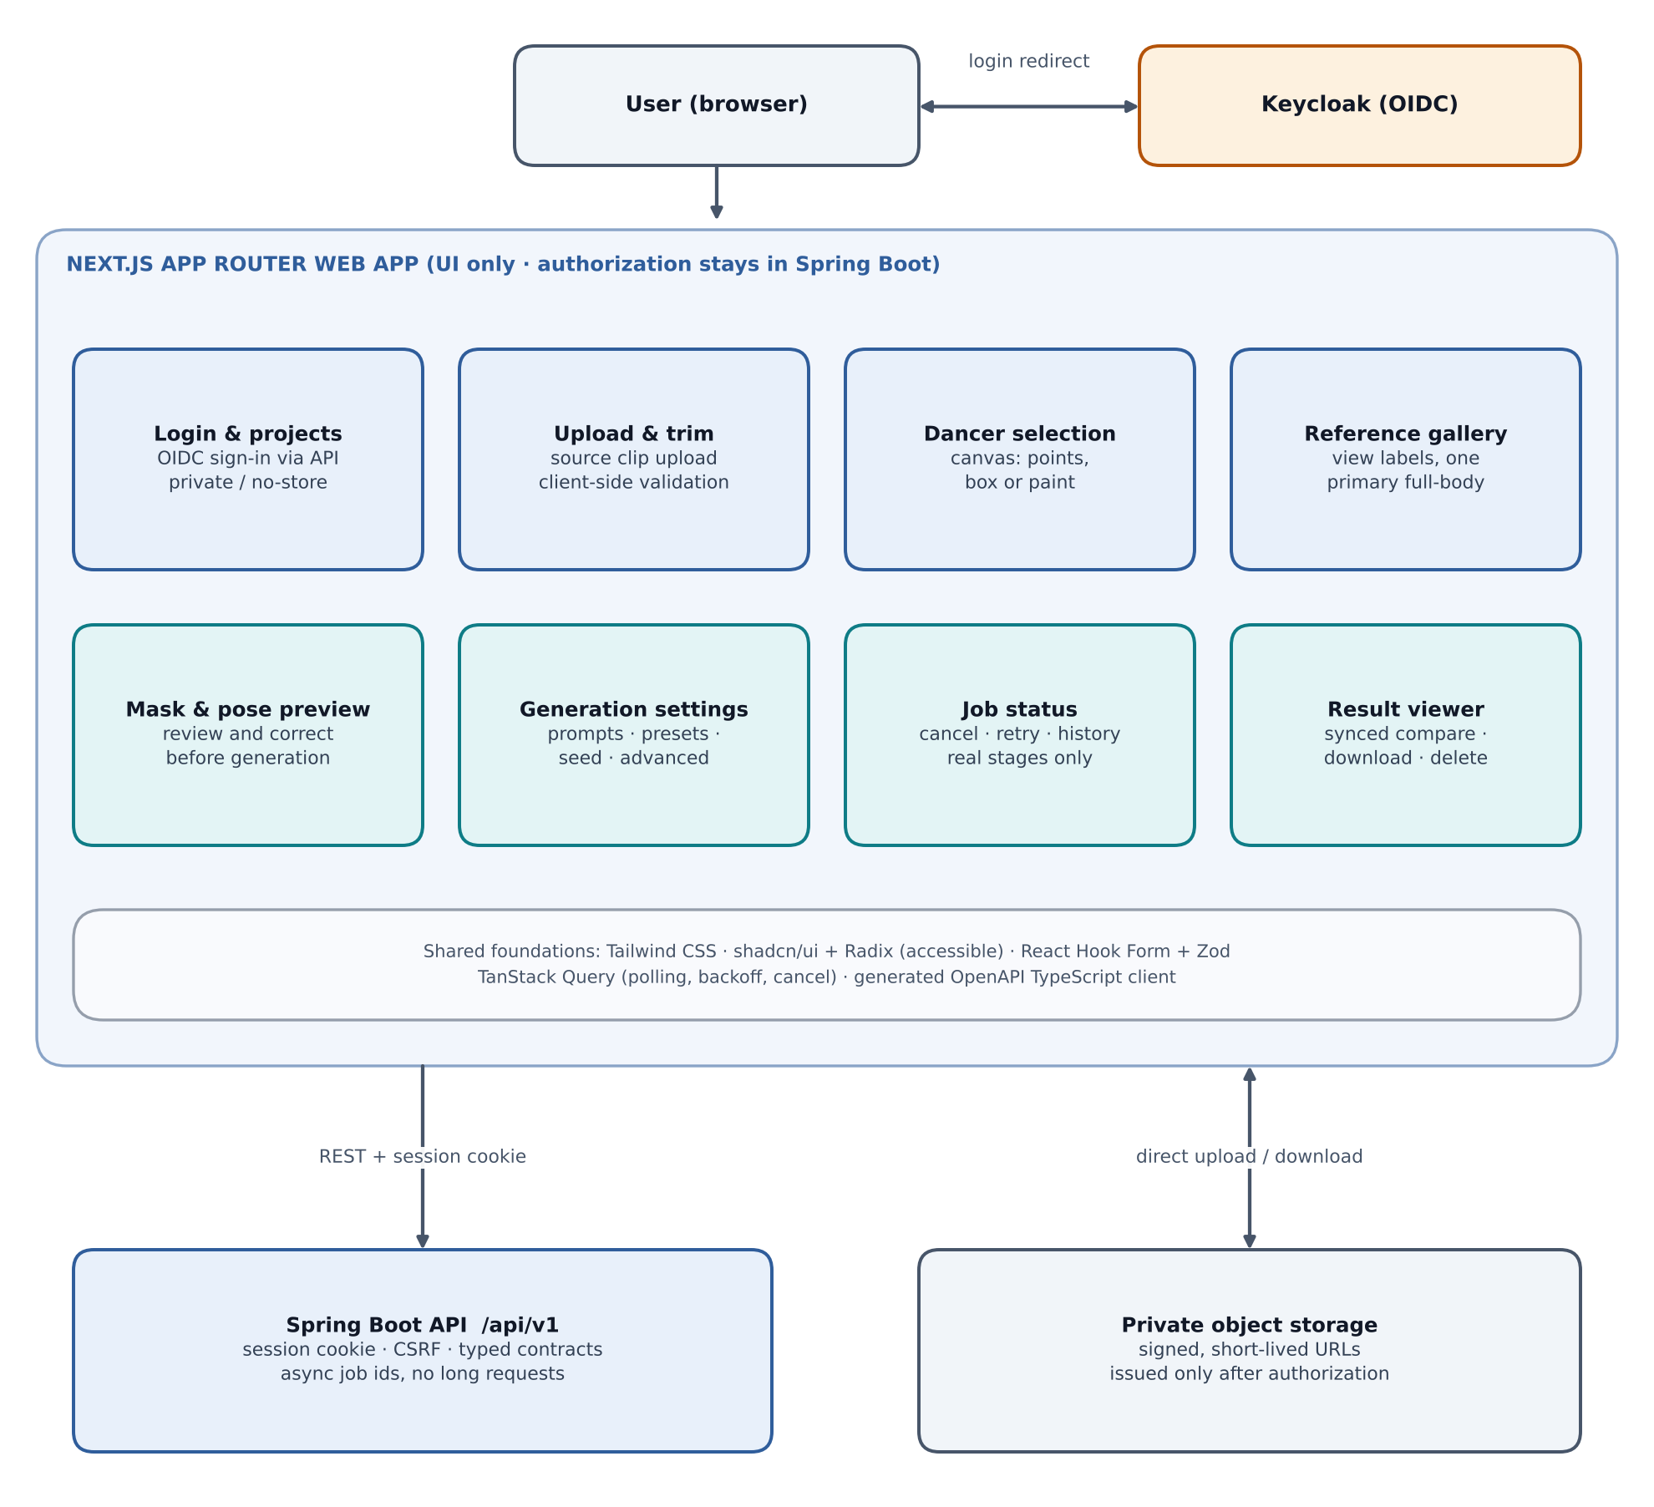
Figure 2. UI architecture: workflow screens, shared foundations and connections to the API and storage.
- Workflow screens: sign-in and projects, upload and trim, dancer selection, reference gallery, mask and pose preview, generation settings, job status and history, and result viewer.
- Shared foundations: Tailwind CSS with accessible shadcn/ui and Radix components, React Hook Form with Zod, TanStack Query for polling, backoff and cancellation, and a typed client generated from OpenAPI.
- Two network paths: REST calls to the API using a server-side session cookie, and direct uploads or downloads to object storage using signed URLs issued by the API.
- Security behaviour: sensitive responses use private or no-store caching, a tested content security policy and anti-framing headers, CORS limited to configured origins, and no unsafe rendering of filenames, prompts or model metadata.
- Status communication: MVP polling with backoff, showing real stage names and available frame or segment counts. Estimates are labelled and never fabricated; mock, real and experimental runs are visibly distinct.
- Accessibility: form labels, keyboard actions, loading, empty and error states, cancellation feedback and responsive layouts. Raw model internals sit in an expandable details panel.

9.3 Backend architecture
The backend is a Spring Boot modular monolith. Browser requests and worker requests pass through separate security chains. PostgreSQL holds canonical state and the transactional outbox, Redis supplies caching and rate limiting, RabbitMQ transports tasks, and object storage holds media.
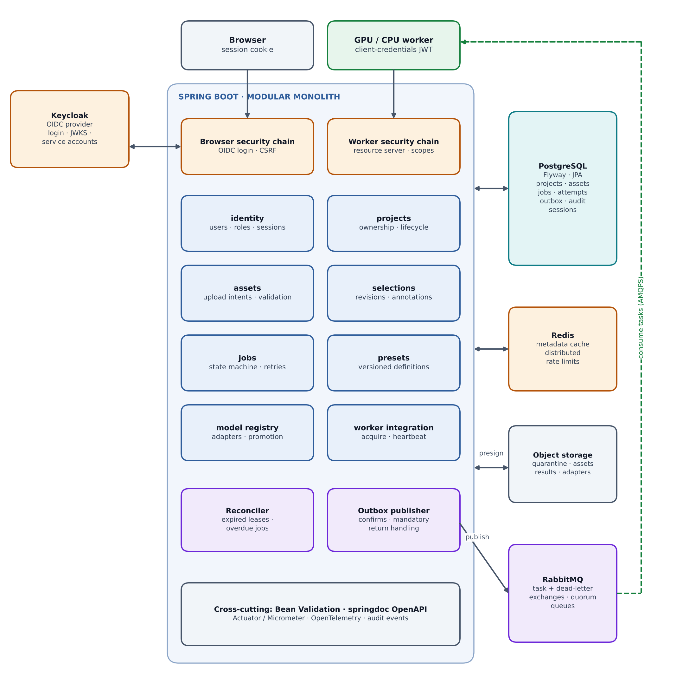
Figure 3. Backend architecture: security chains, modules, outbox publisher and data services.

Security chains
- Browser chain: Spring Security OAuth2 Login with the Authorization Code flow, state and nonce validation and PKCE where supported, server-side sessions through Spring Session JDBC, secure HttpOnly cookies and CSRF protection on cookie-authenticated mutations.
- Worker chain: OIDC client-credentials service accounts validated by Spring Security Resource Server for issuer, audience, algorithm, expiry and narrow scopes. Artifact access additionally requires a current worker-bound attempt and lease.

Data model
Table (suggested) | Purpose
users | Keyed by stable OIDC issuer plus subject; never by mutable email.
projects | Owner and lifecycle status.
assets | Role, owner and project, immutable object key, checksum, size, validation status and media metadata.
appearance_profiles, reference_images | Target references with view label and primary designation.
subject_selections | Source revision, frame and timestamp, coordinate mapping, annotations and version.
preprocessing_artifacts | Cache key, configuration and artifact references.
generation_jobs | Kind, state, requested and effective settings, idempotency key, cancellation flag, timestamps.
job_attempts | Worker, lease token and generation, expiry, heartbeat, stage, timings and failure details.
job_events | Ordered diagnostic history.
outputs | Artifact references and reproducibility metadata.
model_configs / presets | Immutable, versioned definitions.
model_adapters, adapter_promotions | Adapter id, base model and revision, artifact key, hash, rank, scale, licence, datasets, trained_on, evaluation reference, lifecycle state; promotion history for rollback.
outbox_events, worker_deliveries | Event id, schema version, job and dispatch generation, payload, publication state; durable delivery and deduplication records.
audit_events | Authorization, admin, generation and deletion actions with redacted, bounded metadata.

JSONB holds evolving annotations and generation settings; relational structure, foreign keys, indexes and unique idempotency constraints hold everything else. Schema changes use Flyway migrations, never automatic destructive generation.

API surface
Group | Endpoints
Authentication | /api/v1/auth/*
Projects and assets | /api/v1/projects, /api/v1/projects/{id}/assets/upload-intents, /api/v1/assets/{id}/complete, /api/v1/assets/{id}/download-url
References and selections | /api/v1/projects/{id}/appearance-profiles, /api/v1/projects/{id}/subject-selections
Jobs | /api/v1/projects/{id}/preprocessing-jobs, /api/v1/projects/{id}/generation-jobs, /api/v1/jobs/{id}, /events, /cancel, /retry
Models and presets | /api/v1/models/capabilities, /api/v1/presets
Admin (adapters) | /api/v1/admin/adapters, /{id}/stage, /{id}/promote, /api/v1/admin/presets/{id}/rollback
Worker (internal) | /internal/v1/workers/register, /internal/v1/jobs/{id}/acquire, /heartbeat, /progress, /complete, /fail, /artifact-access, /internal/v1/adapters/{id}/artifact-access

Endpoints return asynchronous job identifiers instead of holding browser requests open for GPU work, and use pagination, structured errors, request identifiers and optimistic version checks.

Job dispatch and execution flow
A job and its dispatch event are written in a single PostgreSQL transaction. The outbox publisher then sends the task to RabbitMQ with publisher confirms; the worker receives it, acquires a fenced lease from the API, performs the work, and acknowledges only after the outcome is durably recorded.
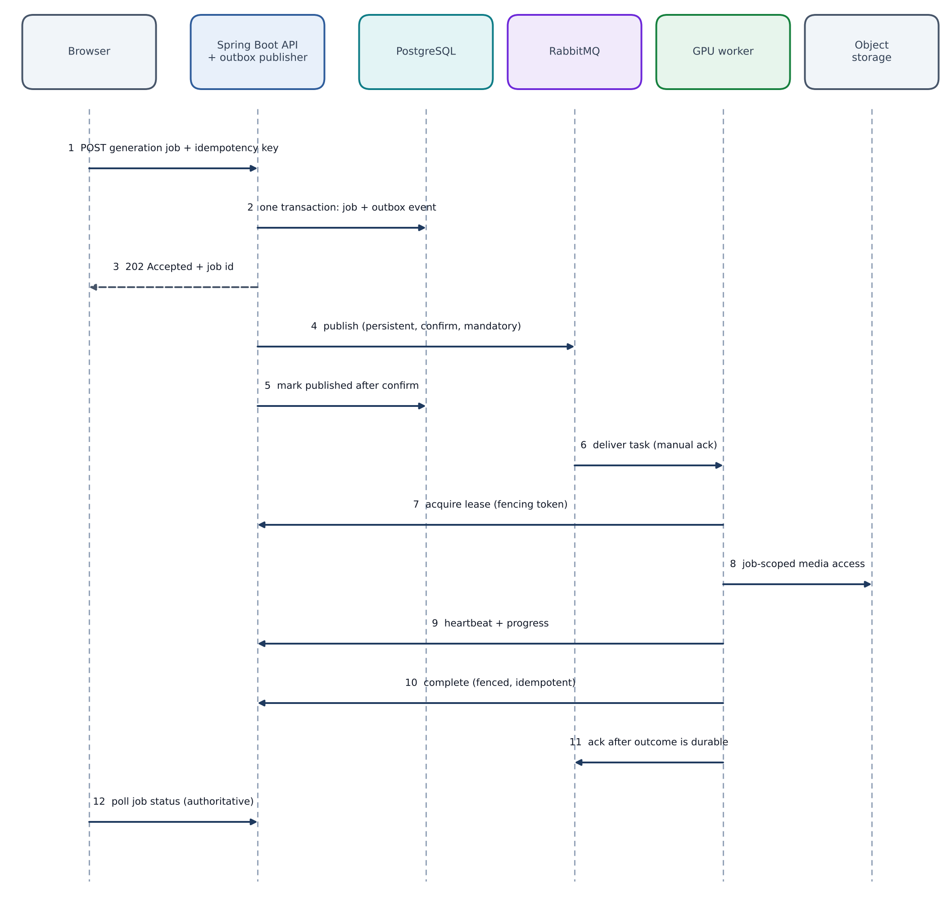
Figure 4. Job dispatch sequence from browser request to fenced completion.

Job states
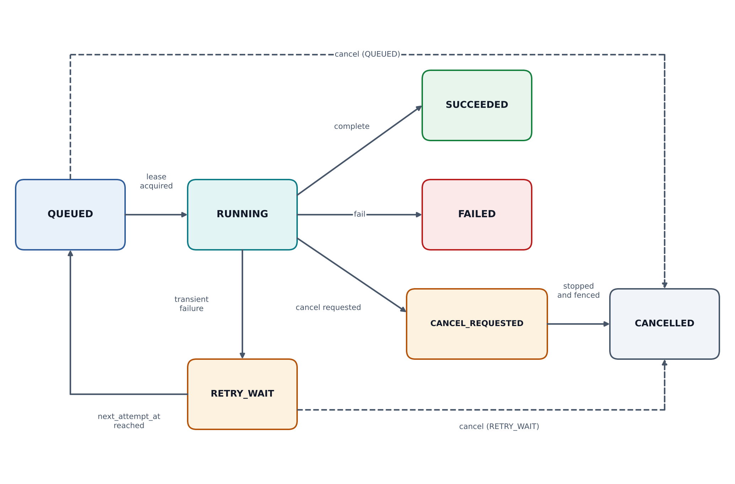
Figure 5. Job state machine including retry and cancellation paths.
Stages within a running attempt are tracked separately: validate, decode, segment, extract_motion, prepare_reference, generate, composite, encode, upload and verify. Preprocessing, preview and full generation are distinct job kinds with immutable configuration snapshots.

Reliability rules
- Outbox: no locks are held during broker I/O. A crash after publish but before recording publication may produce duplicates, so the design is at-least-once and does not claim exactly-once.
- Topology: durable task and dead-letter exchanges and separate capability-routed queues such as motionmirror.preprocess.v1 and motionmirror.generate.wan-animate.v1; mock jobs use a distinct mock queue. Quorum queues are used where supported.
- Message envelope: schema_version, event_id, job_id, dispatch_generation, task_type, backend_id, config_revision, created_at and bounded trace context. No media bytes, secrets, signed URLs, full prompts or executable arguments are ever published.
- Leases and fencing: a monotonically increasing fencing token, bounded expiry and heartbeats that continue while the model runs. A late worker with an expired lease cannot overwrite a newer attempt or attach its output.
- Acknowledgement: manual ack with prefetch one per GPU consumer, sent only after the outcome is recorded. The broker acknowledgement deadline must exceed the maximum attempt duration plus margin, and this is verified rather than assumed.
- Retries and DLQ: Spring Boot owns retry policy with persisted next_attempt_at; poison messages go to a dead-letter queue and operators replay through an audited action that creates a fresh authorized dispatch.
- Cancellation: stops at safe boundaries or terminates the isolated process after a timeout; late completion is fenced and abandoned artifacts are cleaned.
- Concurrency and cost limits: one real generation per GPU initially, per-user queue limits, maximum job runtime, and hard quotas enforced transactionally in PostgreSQL so a Redis restart cannot reset the spending boundary.

Redis usage
Redis holds cache-aside metadata such as versioned presets, model capabilities and authorized project summaries, with TTLs, jitter, schema-versioned keys and stampede control. It also provides atomic distributed rate limits and short-lived progress snapshots. Ownership checks are always performed authoritatively before cached private data is returned. If the cache is down, reads fall back to PostgreSQL with bounded load; if limiting is unavailable, new expensive submissions are rejected with a retriable error while cancellation, result reads and worker heartbeats continue.

9.4 AI architecture
The AI plane is a Python worker. A lightweight control loop receives RabbitMQ tasks, manages the lease and heartbeat, and delegates the heavy work to an isolated inference process so that heartbeats and cancellation stay responsive.
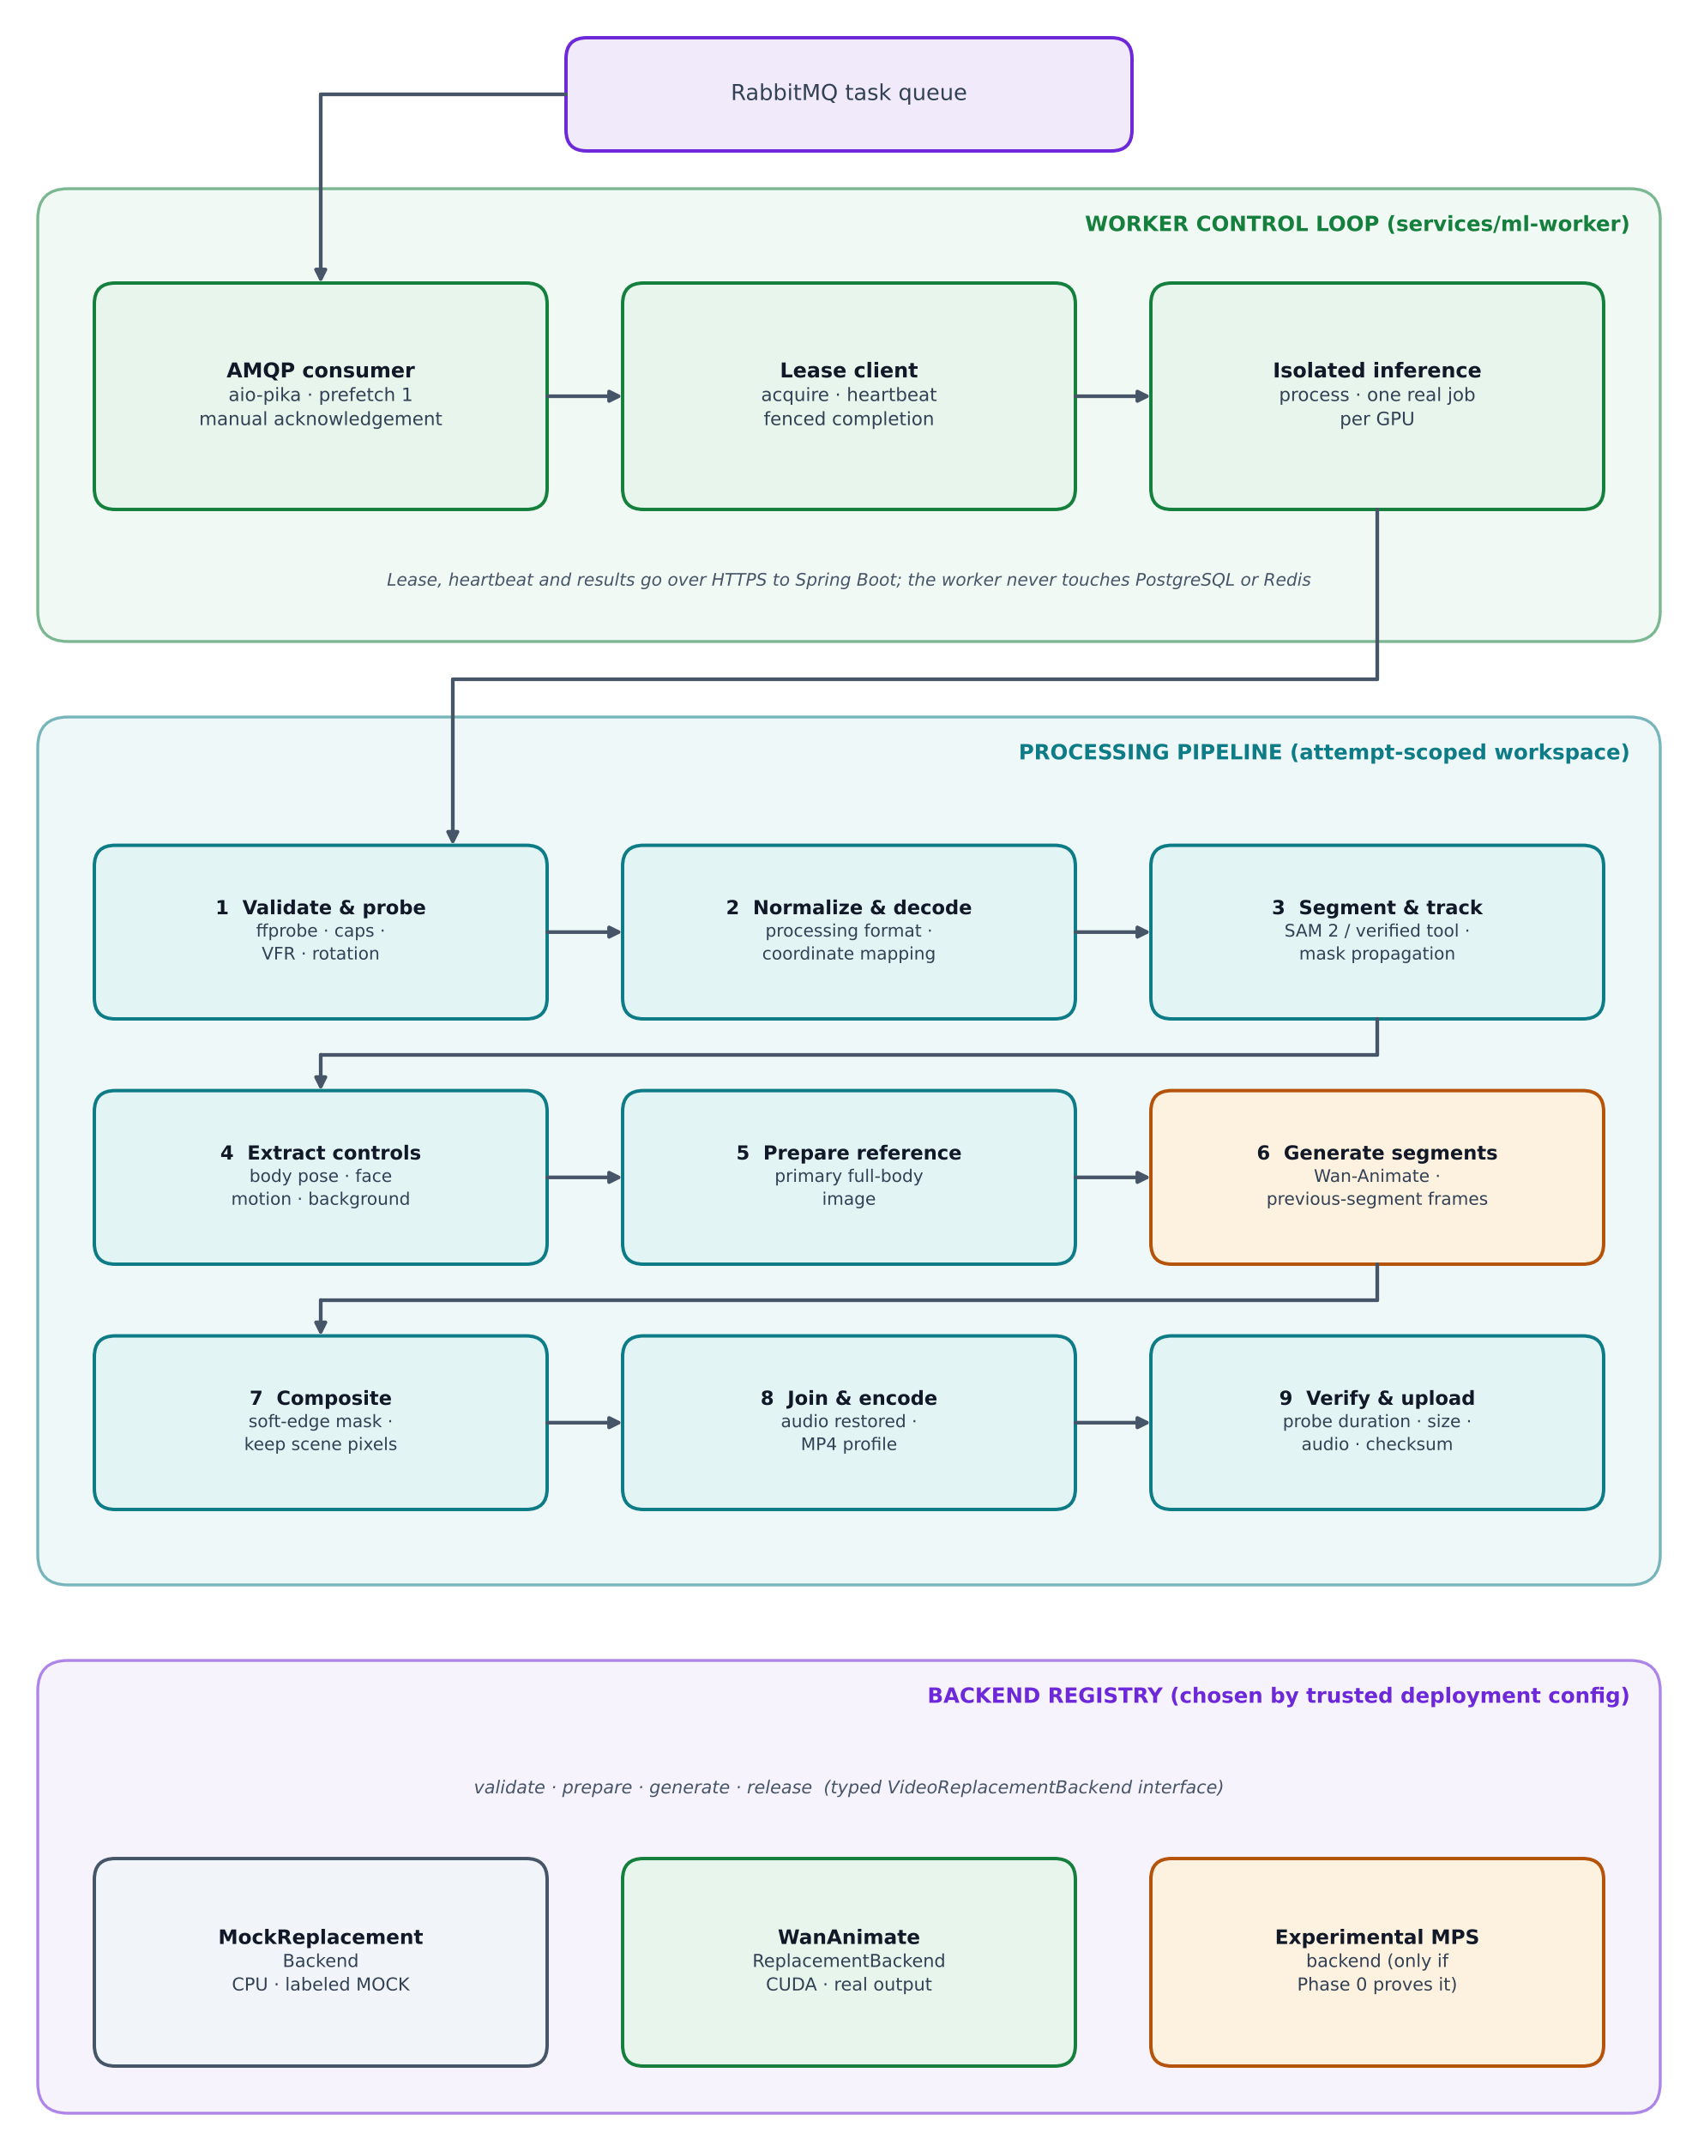
Figure 6. AI worker architecture: control loop, processing pipeline and backend registry.

Processing pipeline
Step | What happens
1. Validate and probe | Inspect actual content rather than filename or MIME; record dimensions, rotation, rational time base, timestamps, duration and audio streams.
2. Normalize and decode | Convert to a documented processing format, preserve aspect ratio with previewable padding or cropping, and keep the mapping from display coordinates to model coordinates.
3. Segment and track | Segment the selected person from the user’s points, box or paint and propagate masks using the verified preprocessing pipeline or SAM 2; corrections become a new selection revision.
4. Extract controls | Extract synchronized body-pose and face-motion controls and the masked background required by the backend.
5. Prepare reference | Prepare the primary full-body image; other references are recorded as supplementary unless a real multi-view path consumes them.
6. Generate segments | Generate short segments using the model’s supported continuation mechanism with documented segment lengths and boundary-frame accounting.
7. Composite | Blend the generated region over the original with the validated mask and soft edges, without clipping generated hair or limbs to the tight original silhouette.
8. Join and encode | Join segments with correct timestamp and frame accounting, avoid unconditional crossfades, restore aligned original audio and encode a broadly playable MP4.
9. Verify and upload | Probe duration, dimensions and audio, upload to attempt-specific keys and report completion; only then is the job marked successful.

Temporal consistency and caching
- Processing FPS, input FPS and output FPS are kept separate; downsampled motion controls use timestamp-based resampling, and a higher export FPS is not claimed to add detail.
- Output duration targets the selected source duration within one output frame on the supported continuous-shot path.
- Preprocessing results are cached by source checksum, selection revision, configuration and tool or model revision. Changing the target photo or prompt does not regenerate masks.
- Temporary files are isolated per attempt and cleaned on success, cancellation and failure.

Backends
Backend | Device | Purpose and limits
MockReplacementBackend | CPU | Deterministic fixture processing with conspicuous “MOCK / NO AI REPLACEMENT” labelling. Imports no CUDA modules and downloads no heavy weights.
WanAnimateReplacementBackend | CUDA | Real inference using the pinned runtime. The only backend that can satisfy the MVP acceptance gate.
Experimental MPS backend | Apple Silicon | Registered only if the Phase 0 spike shows it works; labelled experimental and never used for acceptance.

9.5 Model architecture
The generation model is Wan2.2-Animate-14B in replacement mode, used as pretrained software. The worker feeds it control inputs derived from the driving video and a reference image of the user, optionally with a trusted LoRA adapter, and receives generated frames for the replacement region.
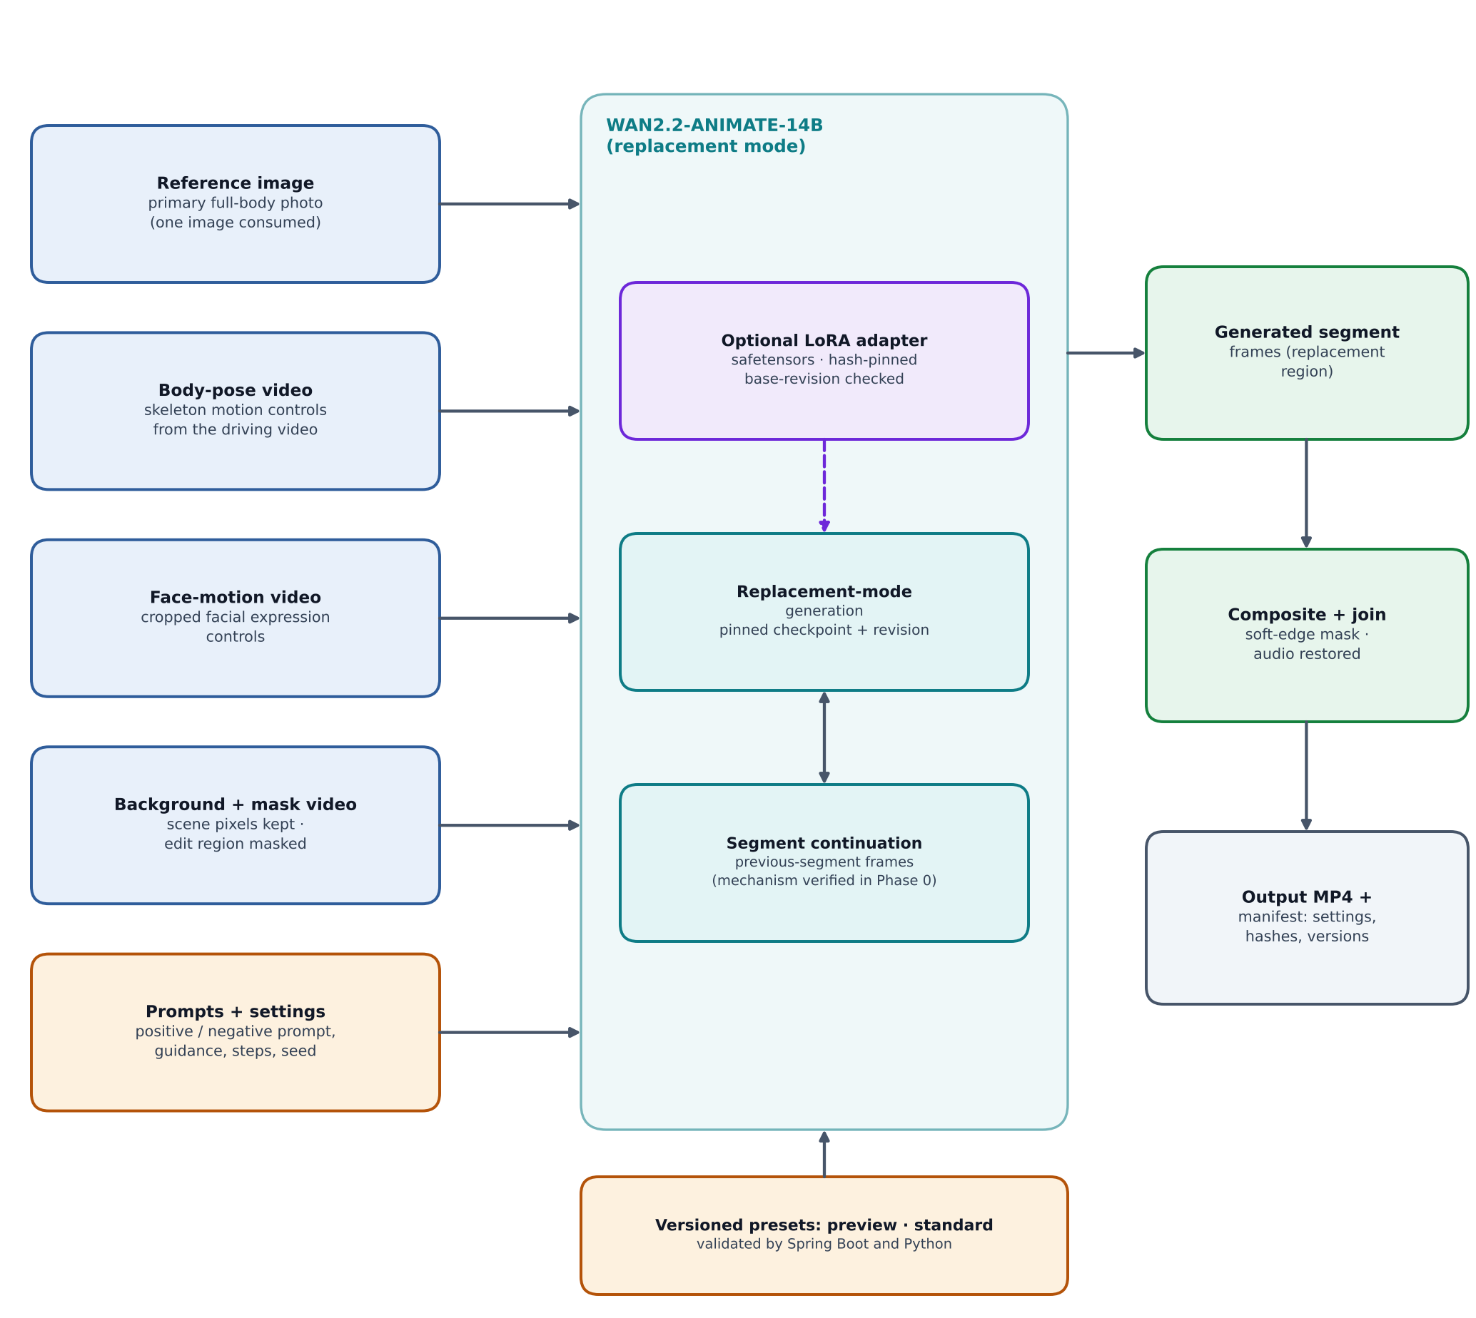
Figure 7. Model architecture: conditioning inputs, Wan2.2-Animate-14B and output assembly.

Model inputs
Input | Source | Notes
Reference image | User’s primary full-body photo. | Baseline workflows use one image; other views are stored but not claimed as used.
Body-pose controls | Extracted from the driving video. | Synchronized with the face controls and the background video.
Face-motion controls | Extracted from the driving video. | Cropped facial expression controls.
Background and mask video | Source frames with the selected person masked. | Mask polarity, resolution divisibility and normalization are verified for the pinned runtime.
Prompts and settings | User settings and presets. | Negative prompts only apply if the guidance path uses them; effective settings are recorded.

Backend interface and configuration
A narrow typed VideoReplacementBackend interface exposes capabilities, validate, prepare, generate and release. A backend registry configured by trusted deployment settings selects the implementation, so adding a backend does not require rewriting the UI or job system. Capabilities describe prompt and guidance modes, reference support, precisions, dimension and frame constraints, continuation modes, adapter compatibility, device_type, loaded adapter revisions and experimental flags, and are kept separate from worker readiness and measured hardware suitability.
Versioned presets such as preview and standard define validated defaults for resolution, frame-rate policy, inference steps, guidance, seed, segment length, continuation frames, mask expansion and feathering and audio retention. Configuration is validated in both Spring Boot and Python against a shared contract, unknown options are rejected, and each run persists requested and effective settings, model revision, adapter hashes, runtime versions and input and output checksums.

Model integrity rules
- Public requests can never specify filesystem paths, Python modules, shell arguments, remote model code or checkpoint URLs.
- Model revisions and images are pinned; safetensors are preferred; arbitrary remote model code is disabled by default.
- Adapters are loaded only if explicitly configured, hash-verified and compatible with the pinned base revision. Without a verified compatible path, the capability is reported as unsupported rather than shown as a nonfunctional toggle.
- A runtime out-of-memory error is surfaced separately; quality is never silently lowered.

9.6 Deployment architecture
One concrete reference path is delivered: a Runpod GPU pod running the prebuilt worker image, plus an ordinary Linux CPU host for the web, API and Caddy, with managed PostgreSQL, RabbitMQ and Redis, a production OIDC provider and private S3-compatible storage. Provider-neutral worker Docker artifacts keep other GPU providers possible.
Environment | Hardware and OS | Used for
Developer workstation | Apple Silicon Mac (M1-class, macOS, arm64) | Daily development of web, API, broker, cache, identity, storage, mock worker and tests; dataset preparation; training smoke tests; optional experimental native runs.
Production GPU server | Linux x86_64 with NVIDIA GPU (CUDA) | Real Wan-Animate inference, authoritative evaluation and real LoRA training.
Production CPU host | Ordinary Linux host | Web, API, Caddy, identity and control-plane services.
CI | Linux CPU runners | Lint, unit and Testcontainers integration tests, scans and image builds.

Persistent model caches are kept separate from disposable attempt workspaces. GPU workers need no public inbound port; broker consumers connect outbound. The worker needs access to RabbitMQ over AMQPS, the OIDC token endpoint and API over HTTPS, and the object store, but not PostgreSQL or Redis.

10. How it works end to end
The following walkthrough connects the modules above for a single real generation.

10.1 Prepare inputs
- The user signs in. The browser is redirected through the OIDC Authorization Code flow; Spring Boot creates a server-side session and the user is identified by issuer plus subject.
- The user creates a project. The API records the owner and lifecycle state.
- The user uploads the source clip. The API issues a server-generated, ownership-scoped upload intent; the browser uploads directly to storage, and completion validates existence, size, checksum and decode. The asset stays quarantined until validation and any configured scanning succeed.
- The user selects the dancer on a frame. The API stores a selection revision containing source revision, frame index, timestamp and annotations.
- The user uploads reference photos, labels the views and picks the primary full-body image.

10.2 Preprocess and review
- A preprocessing job is created with an immutable configuration snapshot and queued through the outbox to the preprocessing queue.
- The worker acquires a lease, segments and propagates the mask, and extracts pose, face and background controls. Results are cached by checksum, selection revision, configuration and tool revision.
- The browser shows the mask and pose preview. If the user corrects points, a new selection revision is created and only affected artifacts are recomputed.

10.3 Generate
- The user submits a preview or full generation job with an idempotency key. The API validates settings against the shared contract and stores requested and effective settings.
- The job row and an outbox event are committed in one transaction; the API returns a job identifier immediately.
- The publisher sends the task to the Wan-Animate queue with confirms. A worker with the real backend loaded receives it, validates the envelope and acquires a fenced lease.
- The worker obtains job-scoped storage access, runs the generation pipeline segment by segment with continuation, composites against the original, joins segments, restores aligned audio and encodes MP4.
- While it runs, heartbeats and stage progress are reported to the API. The browser polls for real stages and counts.
- The worker probes the output, uploads it under an attempt-specific key and calls the fenced completion endpoint. The API attaches the output and records settings, versions and checksums; the worker then acknowledges the message.

10.4 Review and clean up
- The user opens the result viewer with synchronized source and output playback, downloads the MP4 through a fresh signed URL and inspects the manifest showing which references were consumed.
- On deletion, the API revokes access, cancels and fences pending work, purges cache entries and removes originals, masks, derived images, outputs and failed-attempt artifacts.

10.5 When things go wrong
Situation | Behaviour
Worker crashes mid-job | Lease expires; the reconciler or a retry issues a new dispatch generation; the stale worker is fenced out.
Duplicate delivery | The acquire call identifies a duplicate or obsolete dispatch and the worker acknowledges without executing.
Cancel requested | Job enters CANCEL_REQUESTED; the worker stops at a safe point or its process is terminated after a timeout; late completion is rejected.
Transient infrastructure error | Spring Boot persists next_attempt_at and republishes through the outbox within the attempt limit.
Poison message | Rejected to a dead-letter queue with a redacted operational error; an operator can replay through an audited action.
CUDA out of memory | Reported as its own failure category; no silent quality reduction, and a supported fallback is proposed or recorded.
Redis outage | Metadata reads fall back to PostgreSQL; new expensive submissions are rejected with a retriable error; heartbeats and cancellations continue.
Expired signed URL | Refreshed through the API rather than stored in job payloads.

11. Training track and model deployment
The training track lets operators fine-tune the pinned Wan-Animate checkpoint with a LoRA adapter on open or consented data, evaluate it, and deploy it to production through the model registry. It is a required deliverable that runs independently of the application MVP; it must not delay the working preview and it must not be faked.

11.1 Three levels of customization
Level | What it is | Status
1. Application settings | Prompts, presets, masks, primary reference, seeds and runtime settings. | Required in the application MVP.
2. Adapter fine-tuning | Operator-run LoRA (or similar) fine-tune of the pinned Wan-Animate checkpoint on open or consented data, evaluated then deployed through the model registry. | Required training track.
3. Research extensions | Per-user identity training at upload time and genuine multi-view identity conditioning. | Deferred; experimental and off by default if ever pursued.

11.2 Verify the training path first
Before relying on training, the exact pinned trainer commit is checked, not a README summary. As of the brief’s date, DiffSynth-Studio lists inference, full-training and LoRA-training examples for Wan2.2-Animate-14B, taking inputs for reference image, pose video, face video, inpaint video and mask video. The checks cover the current state, dataset format, licence, dependency pins and which devices (CUDA, MPS, CPU) the trainer really runs on, plus whether exported adapters load in the production inference runtime. Official Wan guidance advises against using LoRAs trained for other Wan2.2 models with Animate, so training is done on the Animate-14B base. If no verified path exists, the gap is documented rather than shipping a trainer that does not train.

11.3 Training profiles
Profile | Where | Purpose
gpu-cuda | Linux with NVIDIA GPU, local or rented | Real LoRA training on Animate-14B; the only profile whose adapters can be promoted without a Mac-specific caveat.
mac-mps | Apple Silicon, native uv environment | Dataset building and validation, preprocessing, training-code smoke tests and small runs. A real 14B run only if Phase 0 proves it and measurements are recorded.
cpu-smoke | CI | Tiny synthetic fixtures that prove pipeline wiring; never a quality signal.

- All profiles share one configuration schema and one command set. PyTorch MPS covers a single device only, so there is no multi-GPU Mac training.
- An adapter is valid only for the base model identifier and revision it was trained against. Every manifest records trained_on (device, OS, PyTorch version, dtype).
- Because numerics differ across devices, every adapter must pass the evaluation gate on a production-class CUDA worker before promotion, wherever it was trained.
- Training dependencies live in their own lockfile and image and never appear in the inference worker image.
- No minimum memory figure is published until measured; peak memory, step time and disk use are recorded per profile.

11.4 Datasets
No open dataset supplies paired person-replacement ground truth. Open human-video data supports self-supervised reconstruction-style training and evaluation. The candidates below are starting points; each licence, availability and checksum must be verified from its primary source, with a verified fallback recorded.
Candidate | Intended use | Notes to verify
TikTok dance dataset (Jafarian and Park, 2021) | Single-person dance videos; closest to product input. | About 340 short clips, limited diversity, research-oriented terms.
UBC-Fashion (Zablotskaia et al., 2019) | Full-outfit appearance and clothing transfer. | About 500 to 600 mostly standing subjects, research-oriented terms.
HumanVid (Wang et al., 2024) | Larger-scale human video with camera-motion variety. | Roughly 20,000 1080p clips reported; real-world part must be fetched from Pexels under its terms, synthetic part from 3D avatars.
SA-V, AIST++, DeepFashion, VITON-HD, CelebV-HQ, HyperMotionX | Segmentation evaluation, dance motion, garment references, face motion, complex-motion benchmark. | Licences and availability unverified; confirm before use.
Permissively licensed stock footage | Scene and motion diversity. | Check each clip’s licence and whether building a dataset is allowed.
Your own consented captures | Recommended source for production customization. | Written likeness release; multiple outfits, full-body views and varied poses; never taken from user uploads by default.

Registry rules
- configs/datasets/registry.yaml records id, version, primary and fallback URLs, access method, licence, commercial_use_ok, attribution, consent notes, size, checksum manifest, retrieval date and reviewer.
- commercial_use_ok defaults to false. Production-intended training is blocked until a human licence review is recorded; research-only data may only produce clearly labelled research adapters that are never promoted.
- Datasets are fetched only on explicit command, resumably, with disk checks and checksums, and are never fetched during bootstrap, tests or API startup, redistributed or committed to Git.
- Removing a dataset from the registry (for example after a takedown) invalidates adapters trained on it until reviewed. Likeness data needs a consent basis, and training on user uploads requires explicit opt-in recorded in a ledger.

11.5 Building training data
Replacement training is self-supervised from single-person videos:
- Filter clips: single continuous shot, one dominant person, mostly full body visible, minimum resolution and duration, adequate pose and face confidence; record every rejection reason.
- Segment and track the person using the same preprocessing as inference so training and serving distributions match.
- Extract controls: body pose, face motion and the masked background video.
- Choose the reference from a different frame of the same person, with varied crop and colour augmentation so the model cannot copy the target frame.
- Use the original clip as the target and store everything in the manifest and layout the trainer expects.
This supervises same-person reconstruction only. Cross-identity quality is not directly supervised, so it is judged through the evaluation gate. Manifests require person-level and source-clip-level splits, near-duplicate detection across splits, a fixed evaluation set covering spins, back views, occlusion and fast footwork, and a dataset card.

11.6 Evaluation gate
Before promotion, base-versus-adapter generation runs on a fixed evaluation set with fixed seeds through the real worker path on a production-class CUDA worker. The run saves eval_manifest.json (input and output hashes, settings, hardware, timings) and a contact sheet, applies the human quality checklist and includes a regression set of ordinary cases to confirm the adapter does not make the baseline worse. Automated metrics may supplement the review but are not proof of identity. A model card lists data sources, licences, known failures and intended use.

11.7 From trained adapter to production
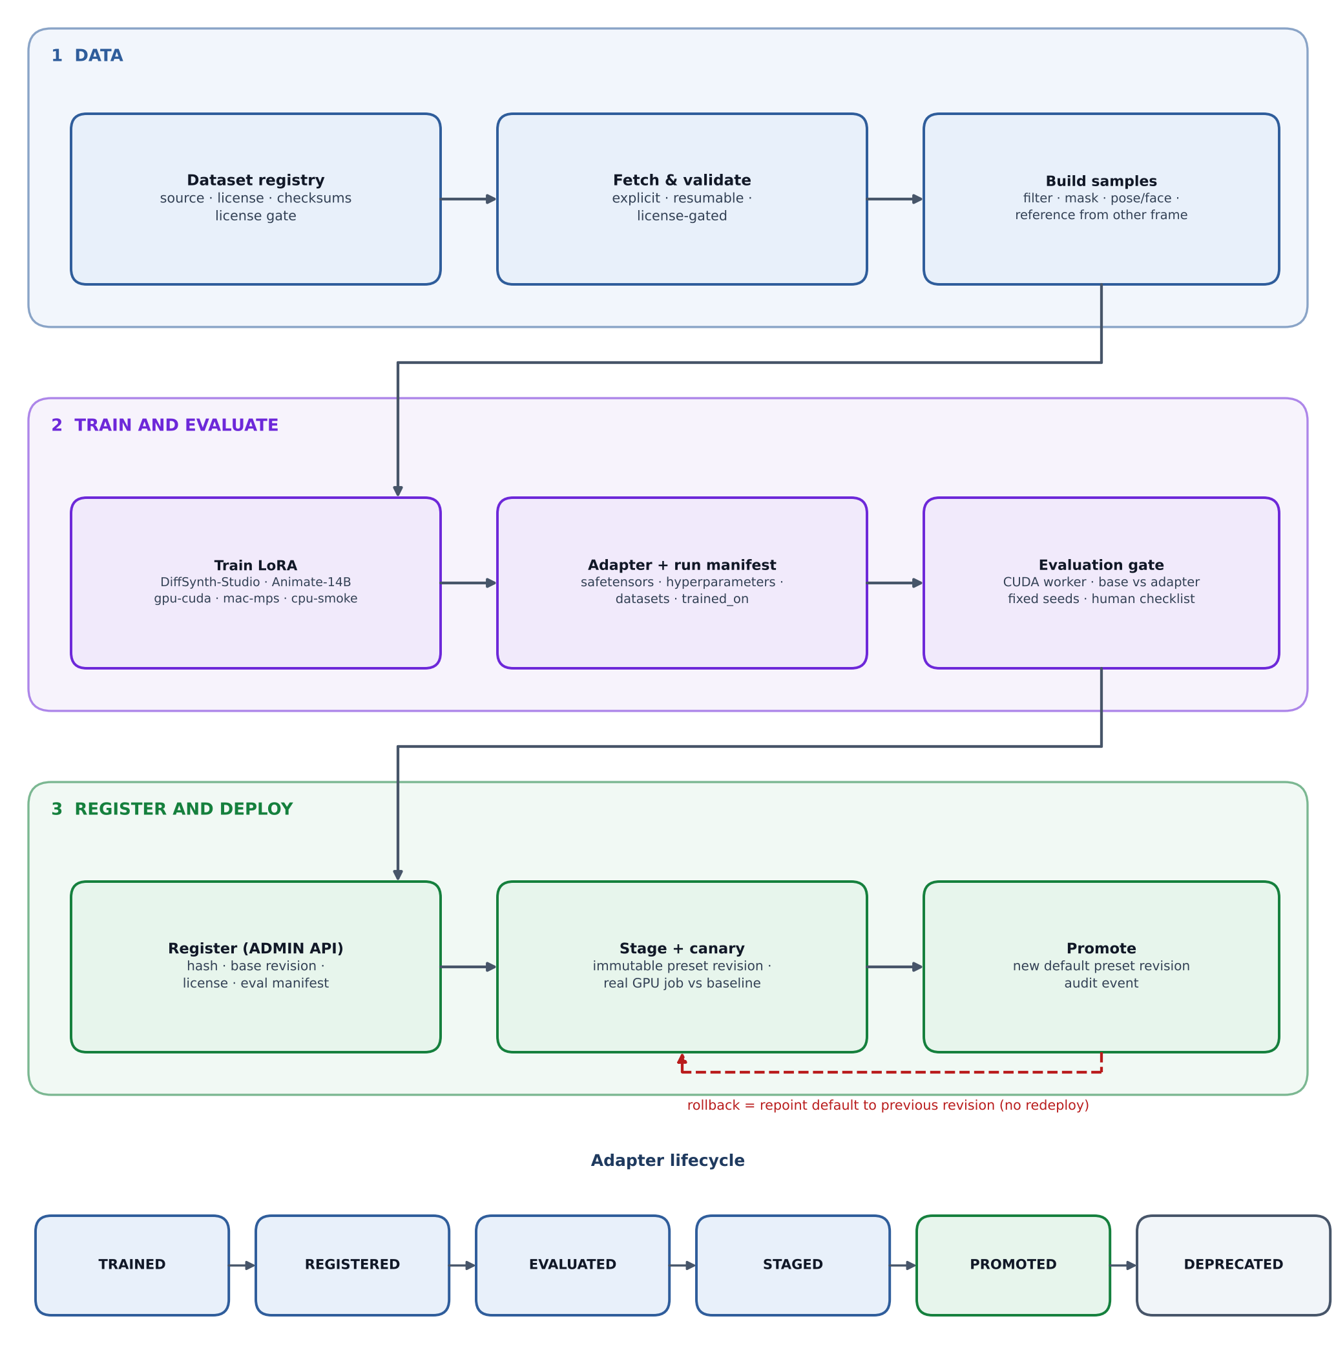
Figure 8. Training track: data, training and evaluation, then registration and deployment with an adapter lifecycle.
- Package: export safetensors with the training and evaluation manifests. Pickle and user-uploaded checkpoints are never loaded.
- Upload: place the artifact under an immutable key in the private model bucket.
- Register: an ADMIN calls the registration endpoint; Spring Boot records hash, base model and revision, target modules, rank, scale, licence, dataset versions, trained_on and the evaluation manifest, and rejects base-revision mismatches, unreviewed production licences and missing evaluations.
- Stage: create an immutable preset revision referencing the adapter, visible only to administrators or a canary group; Redis entries are invalidated by revision.
- Distribute: workers fetch the adapter through worker-scoped artifact access into the persistent cache, verify the hash, load it only after the runtime capability check, and advertise the loaded adapter revisions.
- Canary: run a real GPU job against the staged preset, compare with the baseline and review the output.
- Promote: create a new preset revision that becomes the default. In-flight jobs keep their immutable snapshot, the adapter hash is recorded in every output manifest, and an audit event is written.
- Roll back: repoint the default preset to the previous revision without redeploying, and test that stale caches and workers with the old adapter converge.
Failure cases — hash mismatch, base-revision mismatch, worker cache miss and out-of-memory with the adapter loaded — are documented alongside the full path.

12. Security and privacy
A compact threat model covers the browser and API, identity provider, object storage, RabbitMQ, Redis, GPU workers, third-party model artifacts, CI and deployment administrators. Applicable OWASP ASVS controls serve as a review baseline; passing a checklist or scanner is never presented as certification.

12.1 Controls by area
Area | Controls
Browser identity | Keycloak OIDC with Spring Security OAuth2 Login; Authorization Code flow with state, nonce and PKCE where supported; server-side sessions with Secure, HttpOnly cookies, idle and absolute expiry and rotation on login; CSRF protection; exact redirect and origin allowlists; MFA for production administrators.
Authorization | USER and ADMIN roles plus ownership checks at service and data-access boundaries; tests for guessed UUIDs, nested asset references, downloads, retries, cache hits and cross-project reference reuse; admin access to private media is exceptional and audited.
Web hardening | Private or no-store caching for sensitive responses, CSP compatible with Next.js, anti-framing, MIME-sniffing protection, restrictive referrer policy, HSTS after TLS works, CORS limited to configured origins with no wildcard-with-credentials.
Worker identity | Separate client-credentials service accounts validated for issuer, audience, algorithm, expiry and scope; artifact access requires a current worker-bound lease; per-worker credentials that can be rotated.
Network and secrets | TLS with certificate and hostname verification for API, OIDC, storage, AMQPS and deployed Redis and PostgreSQL; no public exposure of Redis, PostgreSQL, RabbitMQ management, Actuator, Grafana or GPU health endpoints; secret manager or mounted files; distinct broker and Redis identities scoped to required permissions.
Uploads and media | Private encrypted buckets; uploads quarantined until size, checksum, real media type and bounded decode succeed; ClamAV in the public profile; presigned POST policies or a verified bounded mechanism; raster-only references; FFmpeg run with argument arrays in an isolated process with network protocols disabled; resource caps on pixels, frames, duration and scratch disk.
Outputs | Output validated before success; workers get attempt-specific access only; short-lived signed URLs not logged; fresh URL issuance blocked after revocation or deletion; optional download proxying for strict privacy.
Supply chain | Pinned model revisions and image digests; safetensors preferred; no arbitrary remote model code; multi-stage, non-root, capability-dropped containers; Gitleaks, Semgrep, Trivy, CycloneDX SBOM and Cosign signing; high or critical findings need a fix or an expiring documented exception.
Messaging and cache | Scoped broker producer, consumer, provisioning and monitoring identities; negative permission tests; Redis key-prefix ACLs and TLS; separate non-evicting instance for rate-limit state in production.

12.2 Privacy and data lifecycle
- Credentials, signed URLs, private photos, raw prompts and face data are kept out of routine logs, traces and metric labels. EXIF is stripped while orientation is preserved.
- Users confirm permission for uploaded likeness and media, and results are identified as AI-edited in the product.
- Uploads are never used for training by default. Biometric embeddings are not retained unless a documented feature requires them.
- Deletion revokes access, cancels and fences pending work, purges cache entries and removes originals, derived images and masks, outputs and failed-attempt artifacts. Backups are encrypted, restore drills are run, and deletion tombstones prevent deleted data reappearing after restore.
- Redacted structured audit events cover login, admin changes, permissions, generation, model configuration and deletion, with restricted access and retention.

13. Environments and hardware tiers
Training can run on a Mac or a GPU server, but production inference runs only on GPU servers. The same repository, configuration schema and commands work in both places, with the device chosen by an explicit profile.

13.1 Hardware tiers and what may be claimed
Tier | Real Wan-Animate-14B inference | Preprocessing | Adapter training | May satisfy acceptance
cuda (Linux + NVIDIA) | Supported target | Supported target | Supported target, subject to Phase 0 | Yes, once measured
mps (Apple Silicon native) | Not assumed feasible; optional experimental spike | Only where Phase 0 verifies the tool; expect slow runs | Smoke tests and small runs; real 14B only if proven and measured | No
coreml | Not a target for the 14B model | Optional, small models converted and parity-tested | None | No
cpu | Mock backend only | Tiny fixtures only | Tiny smoke fixtures only | No

- Linux containers on macOS cannot use the Apple GPU. Anything needing MPS or MLX runs as a native host process managed by uv; the container path on a Mac is CPU or mock plus a remote GPU worker.
- Images built on Apple Silicon are arm64, whereas GPU workers need linux/amd64. Worker images are built in CI or with an explicit multi-platform build, and an arm64 image is never deployed to a GPU host.
- Apple Silicon or Core ML runs are never described as equivalent to the CUDA path. Every manifest records device_type, framework versions and dtype, and measurements decide any claim.

13.2 Running on an Apple Silicon Mac
Mode | Description
Mock worker in a container (default) | Real broker, cache and storage integration with mock inference; make up-mock or make up-mac.
Native worker on MPS or CPU | make worker-native-mac for preprocessing experiments and device tests; registers as an experimental backend with device_type=mps; CUDA-only packages are not installed.
Remote CUDA worker | Recommended way to get real output from a Mac: a cloud-hosted development control plane, or a local control plane exposed over a private overlay network such as WireGuard or Tailscale, carrying AMQPS, HTTPS and storage traffic.

make doctor reports chip, unified memory, free disk, container runtime and architecture, emulation use, MPS availability and FFmpeg codecs, and fails when a service silently falls back to emulation. Lite and full Compose profiles keep smaller Macs usable.

13.3 Key commands
Group | Commands
Environment | make doctor, make bootstrap, make up-mock, make up-mac, make up-gpu, make down, make logs
Testing | make test, make test-integration, make test-e2e, make test-security, make test-failure-recovery
Models and GPU | make models-download, make smoke-gpu, make benchmark-gpu, make worker-native-mac, make build-worker-amd64
Observability | make observability-up
Training and adapters | make datasets-fetch, make datasets-validate, make train-smoke, make train-lora, make eval-adapter, make adapter-register, make adapter-promote, make adapter-rollback

Shutdown is separate from an explicitly named destructive reset. Model and dataset downloads are explicit, resumable and revision-pinned, and never happen during bootstrap, tests or API startup. make train-lora refuses to start without a confirmation flag, a duration estimate and a disk and memory check.

14. Deployment and operations

14.1 Reference cloud deployment
- Prepare accounts, container registry, database and bucket, RabbitMQ and Redis services, OIDC provider, hostnames, TLS certificates, scoped credentials and model-hub access.
- Choose a proposed GPU profile using a sizing worksheet, treated as a planning candidate until measured, in a region with compatible GPU and persistent storage.
- Deploy the CPU web and API tier with production configuration, migrations, identity clients, health checks and reverse proxy; configure the broker vhost, topology, limits and TLS, Redis ACLs and eviction policy, private networking and backups; run a secret and permissions check before exposure.
- Build and push the worker image for linux/amd64, verify its architecture, and keep weights out of ordinary image layers unless explicitly decided otherwise.
- Mount a persistent model cache and a separate disposable workspace; download and verify model and adapter artifacts with integrity checks.
- Start the worker with its OIDC and broker credentials; verify registration, queue consumption, lease acquisition, heartbeat and fenced completion.
- Run a short real-generation smoke job, verify the output, then run a 30-second acceptance run.
- Monitor and operate, then tear down using exact instructions that identify what is deleted and what remains billable.

14.2 Observability
- OpenTelemetry instruments API requests, outbox publication, message receipt, lease acquisition, preprocessing, inference, encoding and upload, with bounded trace context carried over HTTP and AMQP.
- Logs carry event, job, attempt and trace identifiers but never raw photos, tokens or prompts; job and user identifiers are not used as unbounded metric labels.
- Dashboards and alerts cover outbox oldest age, queue depth and age, redeliveries and dead letters, expired leases, Redis hits, misses, timeouts and evictions, submission rejections, GPU memory and usage, stage timings and output failures. Thresholds are provisional and refined from measured baselines.
- Readiness distinguishes service alive, dependencies usable, model installed and model ready. Liveness does not restart healthy processes merely because a dependency is briefly down.

14.3 CI/CD and release
- CI runs lint, type checks and builds for web, API and worker; real PostgreSQL, RabbitMQ and Redis integration tests; local OIDC end-to-end tests; security scans; image builds; SBOM generation; and release image signing.
- GPU acceptance is a separately triggered pipeline with explicit spend authorization. Images are published by immutable digest with release, model and configuration metadata.
- Schema and message changes remain backward compatible for rolling updates and unknown message versions are rejected. Flyway down-migrations are never run automatically.
- A deployment smoke script, rollback runbook and bounded k6 control-plane test using mock jobs validate backpressure and user quotas without GPU spend.

14.4 Cost control
Concurrency starts at one real generation per GPU with maximum clip length and runtime, queue limits, documented idle shutdown and budget alerts where available. Paid GPU resources are not left running after a test without the user’s authorization, and the cost model is a worksheet rather than a price promise:
Cost worksheet
Estimated job cost = GPU hourly rate × billed GPU seconds ÷ 3600 + attributable CPU, storage, request and egress costs.
Account for idle allocation and cold model loading; link and date any pricing reference.

15. Quality, testing and acceptance

15.1 Test layers
Layer | Coverage
API and persistence | OIDC, session and CSRF checks, ownership, asset lifecycle, validation, migrations and error contracts using Testcontainers with real PostgreSQL, RabbitMQ and Redis.
Job reliability | Atomic lease acquisition, idempotency, expiry, fencing, cancellation and completion races, retry limits, outbox rollback, publish-before-mark crash, broker outage, duplicate delivery, completion-before-ack, poison messages and long-timeout behaviour.
Redis | Hit, miss and expiry, invalidation, cross-user isolation, stampede limits, noeviction errors, limiter failure and continued heartbeat and cancel during outage.
Security | Invalid issuer, audience and expiry, worker artifact scoping, cookie flags, CSRF and CORS failures, quarantined and oversized uploads, path and command injection, signed-download authorization.
Media (Python) | Timestamps, rotation, mask resizing and polarity, VFR handling, audio sync, output probing and cleanup.
Frontend | Selection coordinate mapping and key user journeys; Playwright end-to-end mock flow including upload, preview, generation, cancel and retry, download and reload persistence.
Training and Apple Silicon | Dataset registry and licence gate, manifest schema and split-leakage checks, cpu-smoke and mac-mps smoke runs, adapter registration failures, promotion and rollback, no silent device fallback, arm64 and amd64 image checks.
GPU validation | Manually triggered: real model load, preprocessing, a short replacement and a full-duration run, with a manifest of hashes, revisions, hardware, timings, memory and a reviewable contact sheet.

Mock mode is a test aid and never proof of actual model quality. Fixtures have documented origin and licence.

15.2 Visual quality checklist
Quality is judged through a repeatable human checklist on fixed comparable cases. Automated pose similarity, background difference or temporal metrics can supplement the review but are not proof of exact identity.
- Likeness and outfit continuity
- Body-motion alignment, spins and back views
- Hands, feet and foot contact
- Occlusion handling and mask edges
- Flicker, boundary transitions and background changes
- Audio sync

15.3 Acceptance gates

MVP gate
- A real user can create a project, select a dancer, correct masks, choose a reference and submit a job.
- A supported clip of up to 30 seconds yields a decodable MP4 of the expected duration with aligned audio, generated by the real model.
- Reference usage and effective settings are disclosed and recorded.
- Restart, expired lease, cancellation and retry produce no conflicting outputs or cross-user access.
- RabbitMQ dispatches through the outbox and Redis genuinely caches and rate-limits.
- OIDC works for browsers and workers; private media does not leak.
- A fresh developer can follow the local guide, and an operator has a complete deployment and teardown guide.
- Remaining limitations and unexecuted environment-dependent checks are explicitly listed.

Training track gate
- The dataset registry lists each dataset with a verified source, licence review status and checksums, and the licence gate demonstrably blocks unreviewed data.
- A reproducible pipeline builds samples from at least one licensed dataset with person-level splits.
- mac-mps and gpu-cuda share a configuration schema and each has a recorded smoke result; unsupported items are documented.
- A real LoRA run on Animate-14B on CUDA produces a safetensors adapter and run manifest, or the exact verified gap is documented. A mock trainer cannot satisfy this gate.
- The adapter passes the evaluation gate on a production-class CUDA worker and is registered, staged, promoted and rolled back through the API with audit events.

16. Delivery roadmap
Phases proceed in order using small working vertical slices. Phase 0 spikes start in parallel with Phase 1, and the Phase 5 training track can proceed in parallel with Phases 2 to 4 once Phase 0 has verified it.
Phase | Deliverable | Exit evidence
0. Feasibility | Model and runtime capability report, CUDA CLI spike, dependency matrix, Apple Silicon spike, training-path spike, dataset spike, hardware tier report. | Verified source and API contracts; real smoke evidence on CUDA when available; recorded results, including negative ones.
1. Local foundation | Monorepo, PostgreSQL with outbox, RabbitMQ, Redis, Keycloak, storage, mock worker, project, upload and result UI. | Authenticated mock flow through real broker and cache, persistence and duplicate-delivery tests; Compose services run natively on arm64.
2. Real short preview | Selection, motion and mask preprocessing, corrections, target image, real backend. | Reviewable short replacement and an actual settings and benchmark manifest.
3. Full MVP | Up to 30 seconds with continuation, composition and audio, retries, cancel and history. | Full-duration real acceptance run and recovery tests.
4. Deployment | Signed images and SBOM, CPU hosting, managed broker, cache and database, OIDC, private storage, Runpod worker, telemetry. | Authorized deployment smoke, security and recovery evidence; complete runbooks.
5. Training track | Dataset registry and tools, data pipeline, gpu-cuda and mac-mps profiles, run manifests, evaluation gate. | Dataset validation tests, smoke runs, a real GPU LoRA run or a documented verified gap, an evaluation manifest.
6. Customization and adapter deployment | Versioned presets, adapter registry, staging, promotion and rollback, base-versus-adapter comparison. | Registration and compatibility tests, a staged canary on a real GPU, a tested rollback.

Work is labelled P0, P1 or P2 in docs/IMPLEMENTATION_STATUS.md. P0 covers the core flow, P1 the hardening gate (deep observability, Cosign, SBOM, k6, ClamAV, restore drills, alerts) and P2 the deferred list. The training track must not delay the working preview, yet it is not optional polish.

17. Risks, assumptions and limitations

17.1 Risks and mitigations
Risk | Impact | Mitigation
Wan-Animate does not meet quality or memory expectations on available GPUs | Product value and cost | Phase 0 CLI spike on real hardware; benchmark exact presets; compare alternatives only if a real limitation blocks the MVP.
Segment continuation introduces identity or motion discontinuities | Visible seams in long clips | Use native previous-segment conditioning; careful frame accounting; no naive concatenation claims; human checklist review.
Single-reference conditioning limits likeness and outfit fidelity | User disappointment | Require a clear full-body primary reference; disclose which images were used; multi-view stays a research extension.
Apple Silicon cannot run the 14B model | Developer workflow | Mock worker for daily work; remote CUDA worker for real output; record the Mac spike result honestly.
At-least-once delivery causes duplicate compute | Wasted GPU spend | Fenced leases, idempotent completion, one job per GPU, deduplication; duplicates are documented as possible.
Misuse of likeness or uploaded media | Privacy and ethics | Consent confirmation, AI-edited labelling, ownership checks, deletion, no default training on uploads.
Dataset licensing and takedown | Legal exposure for adapters | Registry licence gate, human review, research-only labelling, adapter invalidation on takedown.
Dependency and supply-chain compromise | Security | Pinned versions and digests, safetensors, scanners, SBOM, signed images, no arbitrary remote code.
Broker acknowledgement deadlines shorter than long GPU attempts | Redelivery during healthy work | Verify provider settings; test long mock attempts; otherwise use a designed durable handoff alternative.

17.2 Assumptions
- Wan2.2-Animate-14B replacement mode is a candidate baseline to be validated in Phase 0, not a guaranteed fit.
- Tool versions, model revisions and licences will be selected from official sources at implementation time and pinned.
- Any GPU sizing (for example a 48 or 80 GB-class rental) is a planning candidate until measurements exist.
- Cloud provider details, including Runpod behaviour, will be verified at implementation time.
- MotionMirror is a provisional name.

17.3 Known limitations
- Exact anatomy, likeness, foot contact and frame-perfect movement are targets, not guarantees; spins, back views, hands, feet and occluded regions are the hardest cases.
- One selected person per job; multi-shot clips require reselection or are rejected.
- Retargeting to the user’s body proportions is experimental and off by default.
- Mac and Core ML runs cannot satisfy acceptance and are not equivalent to CUDA output.
- A single-node local broker is not highly available; production replication requirements are documented separately.

18. Documentation and handoff
Documentation must contain real commands that match the implemented scripts, explain every environment variable and configuration file, and include expected verification output and recovery steps.

18.1 Planned documents
Area | Documents
Overview | README.md, docs/IMPLEMENTATION_STATUS.md, docs/architecture/OVERVIEW.md, docs/STACK.md
Platform and security | docs/MESSAGING.md, docs/REDIS.md, docs/SECURITY.md, docs/OBSERVABILITY.md, docs/CI_CD.md, docs/API.md
Environments | docs/PREREQUISITES.md, docs/LOCAL_DEVELOPMENT.md, docs/MAC_APPLE_SILICON.md, docs/DEPENDENCY_MATRIX.md
Model | docs/MODEL_CAPABILITIES.md, docs/MODEL_SETUP.md, docs/MODEL_CUSTOMIZATION.md, docs/MODEL_DEPLOYMENT.md
Training | docs/DATASETS.md, docs/TRAINING.md, docs/BENCHMARKS.md
Operations | docs/runbooks/CLOUD_GPU_DEPLOYMENT.md, docs/runbooks/OPERATIONS.md, docs/TROUBLESHOOTING.md, docs/TESTING.md

18.2 Handoff expectations
At handoff the team reports what was built, the commands actually executed and their outcomes, remaining limitations, exactly how to run the app, and whether real GPU and cloud validation were performed. Model reuse and inference, adapter fine-tuning and foundation-model training are never conflated.

18.3 Glossary
Term | Meaning
Driving video | The source clip supplying motion, scene and timing.
Replacement mode | Wan-Animate mode that replaces a person in a source video with a character from a reference image.
LoRA / adapter | A small set of additional weights fine-tuned on top of the base model, stored as safetensors.
Outbox | A table written in the same transaction as the job so events are reliably published to the broker.
Lease and fencing token | A time-limited right to execute a job attempt, with a monotonically increasing token that lets the API reject stale workers.
DLQ | Dead-letter queue holding messages that cannot be processed.
OIDC | OpenID Connect, the standard identity protocol used through Keycloak.
Quarantine | State of an uploaded asset until validation and scanning succeed.
MPS | Apple’s Metal Performance Shaders backend for PyTorch on Apple Silicon.
Evaluation gate | Required base-versus-adapter comparison on CUDA before an adapter can be promoted.
Pending GPU validation | Status for acceptance items that need a GPU that was not available.

18.4 Primary references
These are starting points to verify against the exact pinned versions during implementation.
Topic | Reference
Wan2.2 repository and Animate preprocessing | github.com/Wan-Video/Wan2.2
Wan2.2-Animate-14B model card | huggingface.co/Wan-AI/Wan2.2-Animate-14B
Wan-Animate paper | arxiv.org/abs/2509.14055
SAM 2 | github.com/facebookresearch/sam2
DiffSynth-Studio (training and inference examples) | github.com/modelscope/DiffSynth-Studio
HumanVid dataset | humanvid.github.io and arxiv.org/abs/2407.17438
Spring Security OAuth2 | docs.spring.io/spring-security/reference/servlet/oauth2/index.html
Keycloak OIDC | keycloak.org/securing-apps/oidc-layers
RabbitMQ confirms, consumers and reliability | rabbitmq.com/docs/confirms, /consumers, /reliability
Redis security | redis.io/docs/latest/operate/oss_and_stack/management/security/
OWASP file-upload guidance | cheatsheetseries.owasp.org (File Upload Cheat Sheet)
PyTorch MPS backend | pytorch.org/docs/stable/notes/mps.html
Docker multi-platform builds | docs.docker.com/build/building/multi-platform/
Runpod documentation | docs.runpod.io

