Data Storytelling Plan: Netflix Top 10 Analysis
Gyan Kannur DSC 640
Audience
The primary audience for this data story is Netflix content strategy managers and mid-level managers. They are familiar with the platform’s performance metrics but may not work directly with raw data. Because they have moderate data literacy, the visuals will balance clarity with analytical depth—simple enough for quick interpretation but detailed enough to inform decisions about content investment. This audience cares about trends, cross-country variations, and how viewership aligns with strategic priorities like global reach, retention, and catalog planning.
Some of the responsibilities of these roles include:
- Viewership trends over time both domestic and global
- Differences between English vs. Non-English titles
- Identify themes and patterns to realign strategy expansion.
- How content drives retention and catalog strength
Purpose
The purpose of the story is to highlight global and regional viewership patterns and recommend where Netflix should prioritize content acquisition and marketing. The call to action is to encourage leadership to increase investment in titles and genres showing consistent cross-country traction, while reevaluating markets where catalog breadth is high but viewership concentration is low. By the end, the audience should understand which titles and regions drive engagement and where strategic adjustments could increase viewership efficiency.
The story aims to show that Non-English TV content is driving disproportionately high sustained engagement globally as seen in high cumulative weeks in the Top 10 and large hour volumes in the first 91 days. Meanwhile, English-language films have strong early spikes but weaker longevity. It is also important to note that TV has longer viewership than Films.
What You Want the Audience to Walk Away With
Managers should clearly understand which content categories sustain engagement, where the strongest geographic momentum is emerging, and where investment gaps exist. The audience should leave knowing that expanding non-English TV production and improving English-film retention strategies will produce higher global viewership stability.
Your Call to Action
- Increase investment in high-performing Non-English TV categories—especially in regions showing long Top-10 staying power (e.g., Latin America, Asia). At the same time, evaluate and adjust English film development to improve retention and long-term views.
- Reallocate 7–10% of the upcoming content budget to high-performing international originals and incrementally increase regional marketing for titles with proven cross-border uptake. Pilot the approach in three markets (e.g., Mexico, South Korea, Spain) and measure MAPE/RMSE on predicted vs actual weekly hours to evaluate success. These are some of the ideal regression evaluation metrics for these usecases.
- Seek approval to expand regional production partnerships in Latin America and APAC to accelerate growth where view engagement is sustained.

Medium
- I am planning to use infographics and a pdf version of my python assignment with boxplot visuals and other visuals not in power-bi.
- It allows for sequencing (storytelling flow), pairing visuals with short explanations, and highlighting the call to action in a simple way.
Design Choices
- Color/Charting: Blue visuals for most of the plots with pie chart and scatter plot for titles to show insights on correlation.
- Text: Short, high-impact labels were used—this audience prefers skimmable insights rather than long explanations.
- Alignment: As country names are large in number, added a chart bottom to accommodate the cum weeks trend country wise.

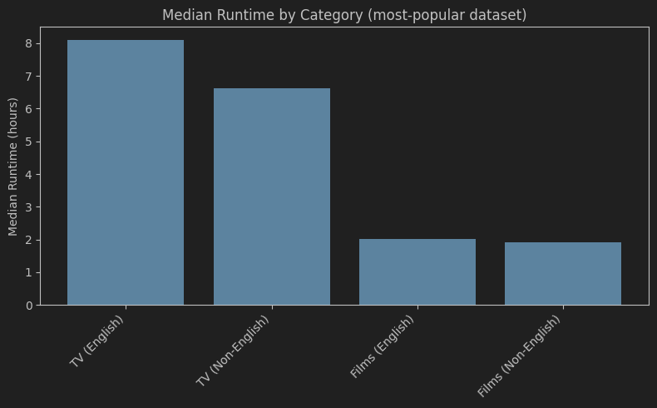

Ethical Considerations
Changes made to the data
No new columns were added, these were used within python to create visuals. Any data cleaning prerequisites were handled appropriately and the notebook is included. These changes did not alter the underlying values but reorganized them for analysis.
Legal or regulatory guidelines
The datasets come from Netflix’s publicly released Top-10 reporting, so there are no direct privacy concerns. Since all data is aggregated at the title/country level with no individual user information, major privacy frameworks like GDPR/CCPA are not triggered.
Risks in transformations or visualizations
- Aggregations can unintentionally hide variation—for example, summing view-hours across countries may exaggerate the popularity of globally distributed titles.
- Visual emphasis (e.g., scaling, color choices) could also create misleading impressions about differences that are relatively small.
Data sourcing and credibility
The datasets are taken directly from Netflix’s official public reporting portal, which is considered the authoritative source for viewership hours and ranking methodology. The data has already undergone Netflix’s internal validation before publication.
Ethical acquisition of data
No personally identifiable information is present, and data was not scraped or collected covertly—only official, publicly available files were used—so the acquisition is ethically sound.
Other considerations
- Ensure representation and avoid cultural stereotyping when promoting or commissioning international content.
- Respect user privacy by using aggregated, anonymized viewership metrics only.
- Monitor regional fairness: avoid over-indexing on markets that might crowd out emerging creators or minority-language content.

