Kaggle Competition: A Reflective Analysis

Gyan Kannur
Department of Data Science, Bellevue University
DSC680: Applied Data Science
Xu Ashton
July 2026

Abstract
This paper reflects on my experience adapting a GPU-dependent machine learning notebook—originally built for Kaggle’s Predicting Student Health Risk competition (Playground Series, Season 6, Episode 7)—to run on local and cloud CPU-based systems. The process uncovered critical lessons about portability, environment dependencies, and the often-overlooked coupling between hardware assumptions and model configuration.

Introduction
The "Predicting Student Health Risk" notebook was originally created for the Kaggle Playground Series — Season 6, Episode 7 competition. The goal of this competition is to predict student health risk, classifying individuals into one of three categories — at-risk, unhealthy, or fit — based on a synthetically generated dataset. The competition uses balanced accuracy as its primary evaluation metric.
While preparing this notebook for reuse outside its original Kaggle-hosted environment, a series of environment-dependency issues were encountered that offer a useful case study in the gap between code that works and code that is portable.
The Problem: Environment-Specific Dependencies
The notebook was originally authored for Kaggle's hosted GPU runtime, which introduced three categories of hard dependencies that prevented execution in any other environment. Table 1 summarizes these dependency categories.

Table 1
Environment Dependency Categories Preventing Notebook Portability
Category | Issue | Specific Example
Data Paths | Absolute paths to Kaggle-internal locations | /kaggle/input/ paths that do not exist on any other machine
GPU Library Imports | Unconditional import of GPU-only libraries | cupy would cause an immediate ImportError without CUDA
Model Configuration | Hardcoded device settings in model parameters | CatBoost and XGBoost explicitly requested GPU execution (task_type: GPU, device: cuda)
Note. GPU = graphics processing unit; CUDA = Compute Unified Device Architecture; cupy = a GPU-accelerated array library.

Beyond these structural issues, the notebook's training configuration was tuned for GPU throughput: 12,000 boosting iterations with a 1,000-round early-stopping window across five cross-validation folds on approximately 690,000 training rows. This configuration made the notebook computationally impractical on standard CPUs.
The Solution: Two Distinct Types of Fixes
Resolving the portability issues required two distinct categories of intervention, each addressing a different dimension of the dependency problem.
Restoring Portability
The first category of fixes addressed environment-specific path and dependency issues. Data were relocated from Kaggle-internal paths to a local data/ directory. The configuration class was repointed to use relative paths. A requirements.txt file was populated to allow the execution environment to be reproduced with a single installation command.
Enabling Execution Without a GPU
The second category of fixes modified the code to permit CPU-only execution. The cupy import that caused immediate failure on non-GPU systems was removed. A GPU memory-cleanup routine dependent on cupy was eliminated. The boosting libraries' device settings were switched from cuda to CPU, with corresponding changes applied to both CatBoost and XGBoost model configurations.
Performance Implications and Trade-Offs
Once CPU-only execution was in place, a second issue emerged: training was slow. Investigation traced this to hyperparameters that had been optimized for Kaggle's GPU environment. The combination of 12,000 boosting iterations, a 1,000-round early-stopping window, five-fold cross-validation, and approximately 690,000 training rows represented a substantially different computational budget on a standard CPU than the parameters were designed for, even with all twelve available cores in use.
Open Questions and Deliberate Decisions
This performance gap was documented as an open item rather than resolved outright. Narrowing the iteration budget trades off against model quality in ways that deserve deliberate consideration, not a default reduction. This reflects a key insight for machine learning engineering: environment design and hyperparameter configuration are coupled decisions, not independent choices. The original GPU-tuned notebook subsequently ran successfully end-to-end on Kaggle itself, confirming that the parameters were never wrong — only environment-specific.
Key Lessons Learned
Hardware Assumptions as Explicit Dependencies
Hardware assumptions — such as GPU availability and absolute file paths — should be treated as explicit, documented dependencies rather than implicit ones. Training speed and model quality are not inherent properties of code alone; they are a function of the code-environment combination. When porting code, the task is not merely to replicate logic but to re-negotiate the computational contract between the code and its runtime. A model that is optimal on a high-performance GPU may be impractical on a CPU without adjusting hyperparameters or early-stopping criteria.

Kaggle Badge
My work on Kaggle extends beyond this project. As of July 2026, I’ve earned several badges, including the below
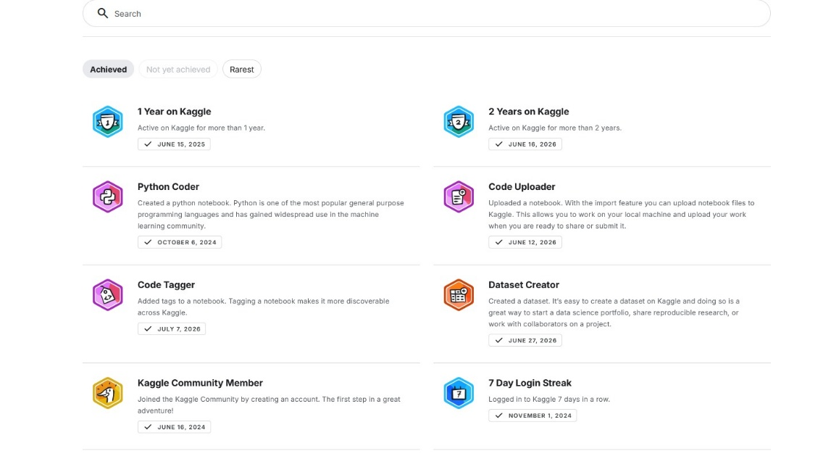
Figure 1. Kaggle achievement badges earned as of July 2026, including the Code Tagger badge (July 7, 2026).
You can explore more on my Kaggle Profile https://www.kaggle.com/gyanraju/code
Conclusion
This journey taught me that portability in machine learning is not just about fixing paths or managing dependencies. It’s about recognizing the environment as a first-class concern. The most elegant code is brittle if it assumes a specific execution context, and the most well-tuned parameters are useless if they can’t run where they’re needed. By treating hardware assumptions as explicit dependencies, we can build code that travels as well as it performs.

References
Chen, T., & Guestrin, C. (2016). XGBoost: A scalable tree boosting system. Proceedings of the 22nd ACM SIGKDD International Conference on Knowledge Discovery and Data Mining, 785–794. https://doi.org/10.1145/2939672.2939785
Kaggle https://www.kaggle.com/gyanraju/code

