Predicting Diabetes Risk Using Ensemble Machine Learning Methods
Project Milestone 2
Gyan Kannur
Bellevue University
DSC 680
Xu Ashton
June 2026

Abstract
This capstone project evaluates machine learning techniques for predicting diabetes risk using clinical health indicators. A logistic regression baseline from prior research was reproduced and compared against ensemble learning approaches including soft voting, bagging, and stacking. The primary objective was to maximize detection of diabetic patients while maintaining acceptable precision.
Business Problem
The goal of this project is to predict the likelihood of diabetes (Outcome = 1) using patient health indicators such as glucose, BMI, age, and other clinical features.
This model supports the following:
- Early screening and detection of diabetes risk
- Prioritization of patients for clinical follow-up
- Reduction of missed diagnoses (false negatives)
The core objective is to maximize detection of diabetic patients while balancing precision to avoid unnecessary follow-ups.

Background / History
To improve the understanding of risk factors, we predict type 2 diabetes for Pima Indian women utilizing a logistic regression model and decision tree. Our analysis finds five main predictors of type 2 diabetes: glucose, pregnancy, body mass index (BMI), diabetes pedigree function, and age. We further explore a classification tree to complement and validate our analysis. The six-fold classification tree indicates glucose, BMI, and age are important factors, while the ten-node tree implies glucose, BMI, pregnancy, diabetes pedigree function, and age as the significant predictors.

Dataset and Data Preparation
- Total records: 768
- Target variable:
  - Outcome (0 = Non-diabetic, 1 = Diabetic)
- Class distribution:
  - 0: 500
  - 1: 268 (imbalance ~65/35)

Features Used
Feature | Description
Pregnancies | Number of pregnancies
Glucose | Blood glucose level
BloodPressure | Blood pressure
SkinThickness | Skin fold thickness
Insulin | Insulin level
BMI | Body Mass Index
DiabetesPedigreeFunction | Genetic risk
Age | Age
Glucose_Age | Engineered interaction

Correlation Matrix

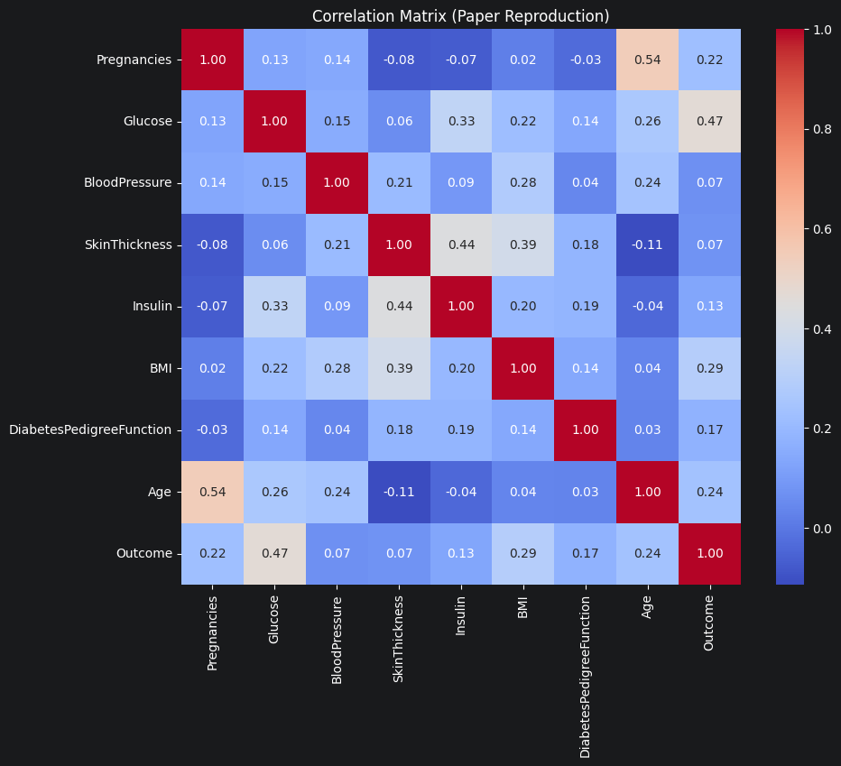

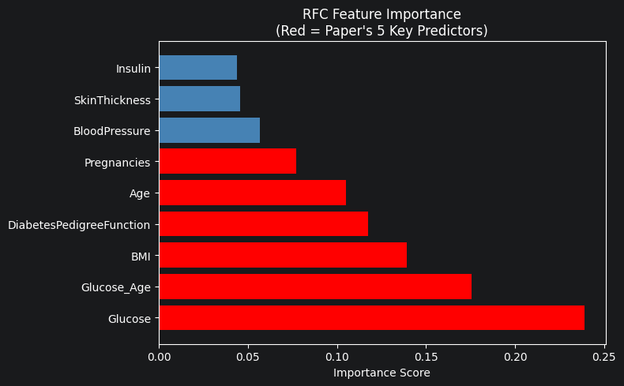

Data Preparation Steps
- Critical Fix (Important Insight)
  - Replaced medically impossible zeros in:
    - Glucose, Insulin, BMI, BloodPressure, SkinThickness
→ with median values
- Feature Engineering
  - Created:
    - Glucose × Age interaction feature
→ Captures nonlinear clinical relationship
- Scaling
  - Applied RobustScaler
→ handles skewed distributions and outliers
- Train–Test Split
- Train: 70%
- Test: 30%
- Stratified split to preserve class balance

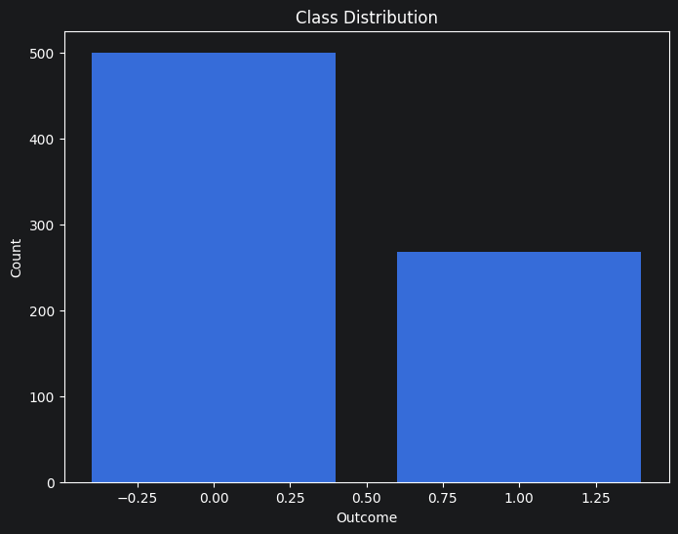

Methods
Baseline Models
- Logistic Regression (paper reproduction)
- Decision Tree (validator)

Ensemble Models
- Soft Voting Ensemble
  - LR, SVM, KNN, NB, MLP, RF, GB
- Bagging Ensemble
  - 200 Decision Trees
- Stacking Ensemble
  - Multiple base models + Logistic Regression meta-model
AUPRC was selected as the primary metric because of class imbalance.

Results and Analysis
Logistic regression achieved approximately 0.717 AUPRC on the test set. Bagging achieved the highest recall at approximately 80.2%, making it most suitable for screening applications. Soft voting achieved the highest AUPRC of 0.735, demonstrating strong ranking capability. Stacking increased complexity without providing meaningful performance gains.
Discussion
The findings indicate that ensemble learning methods can substantially improve identification of diabetic patients. Higher recall is particularly important in healthcare because false negatives may delay diagnosis and treatment.
Assumptions
The model adopts a probability threshold of 0.35 rather than the standard 0.50, reflecting the clinical assumption that missing a diabetic patient (false negative) carries a higher cost than an unnecessary follow-up referral (false positive). All five biological features — Glucose, BMI, BloodPressure, SkinThickness, and Insulin — treat recorded zero values as physiologically implausible missing data, imputed using training-set medians to preserve distributional integrity without leakage.
Limitations
The dataset contains 768 records drawn exclusively from Pima Indian women aged 21 and older, a narrow demographic that limits the model's generalizability to broader or more diverse patient populations without revalidation. At N=538 effective training samples, the dataset falls well below the scale typically required for clinical-grade validation — ensemble methods in particular require sufficient data to reliably estimate diverse error patterns, and the observed performance gains over logistic regression may not hold at larger sample sizes.
Challenges
Exhaustive nested hyperparameter tuning across six base learners within the stacking ensemble was computationally prohibitive on CPU-only hardware, requiring a two-stage approach — HalvingGridSearchCV per base learner followed by frozen estimator stacking — to reduce training time to a feasible range without sacrificing architectural correctness. Ensuring a fully leakage-free preprocessing pipeline required iterative correction across multiple versions, particularly for zero imputation (train medians applied separately to train and test) and the Glucose_Age interaction feature (reordered to compute only after imputation). Calibration of the logistic regression model required method-specific handling — isotonic regression collapsed predicted probabilities below the 0.35 threshold on this sample size, necessitating Platt scaling (sigmoid) as a more stable alternative for parametric models at small N.
Future Uses / Applications
- Clinical screening tools
- Hospital triage systems
- Risk scoring dashboards
- Early detection pipelines
Implementation Plan
The recommended bagging model should be exported and deployed through a Streamlit-based application. Ongoing monitoring should track recall, false negatives, and data drift. Periodic retraining should be performed as new patient data becomes available.
Recommendations:
The stacking ensemble in this study used HalvingGridSearchCV with frozen base learners as a computational compromise; a natural next step is to implement fully nested cross-validation where each base learner's hyperparameter search runs inside the outer stacking CV folds, ideally on GPU-accelerated hardware, to determine whether the architectural advantage of stacking over soft voting is real or an artifact of the constrained tuning budget.
Model comparisons in this study rely on point estimates of AUPRC, Recall, and Precision computed on a single 230-sample holdout; applying McNemar's test on paired holdout predictions and Wilcoxon signed-rank test across stratified CV folds would establish whether the observed performance differences between logistic regression and the ensemble methods are statistically significant or within the margin of sampling noise at this dataset size.
To directly test the generalizability hypothesis, a second dataset with comparable clinical features — Glucose, BMI, BloodPressure, SkinThickness, Insulin, Age, and Pregnancies — drawn from a non-Pima population should be sourced, the model trained on the Pima set applied directly to it without retraining, and the resulting performance degradation quantified; a substantial drop in AUPRC or Recall on the external dataset would constitute empirical evidence that the model has learned a population-specific decision boundary rather than a generalizable clinical signal.
Ethical Considerations
Potential risks include false negatives, demographic bias, and overreliance on automated predictions. The model should be used as a clinical decision-support tool rather than a replacement for healthcare professionals.
Conclusion
Bagging was identified as the preferred deployment model because it improved recall from approximately 70% to 80% while maintaining strong overall performance. The project demonstrates the value of ensemble machine learning methods in healthcare screening applications.

Table 1
Model Performance Comparison
Model | Accuracy | Recall | F1 | AUPRC
Logistic Regression | 0.762 | 0.704 | 0.675 | 0.717
Decision Tree | 0.714 | 0.790 | 0.660 | 0.639
Soft Voting | 0.753 | 0.765 | 0.685 | 0.735
Bagging | 0.749 | 0.802 | 0.691 | 0.711
Stacking | 0.749 | 0.667 | 0.651 | 0.732

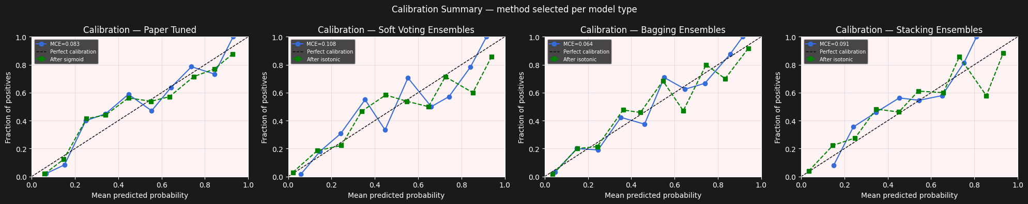

References
Baseline Research Paper using Logistic Regression https://pmc.ncbi.nlm.nih.gov/articles/PMC8306487/#sec2-ijerph-18-07346

