**Steps to Run the Project**

Problem Statement: To Evaluate Expression according to instruction given in input.txt

1. Solution contains ExpressionEvaluator & ExpressionEvaluatorTest.
2. Open the Project in Visual Studio which supports framework 4.6.1
3. Build the Project
4. Run the project :
5. Final output will be displayed on Screen
6. Run test cases to view the test case result.

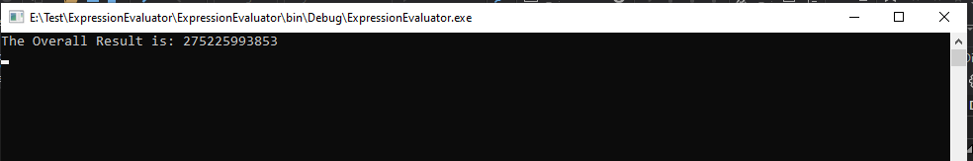

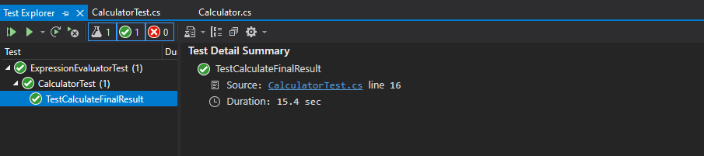

Challenge:

What is the overall result of evaluating the instructions in the input.txt file?

**275225993853**

Further guidance:

- Make sure to document any assumptions that you make:

The format of the file should be correct.

-Provide your answer, along with the code you wrote to get the result –

**275225993853**