In html how many section will be there?

* Head section
* Body section

What is HTML5? 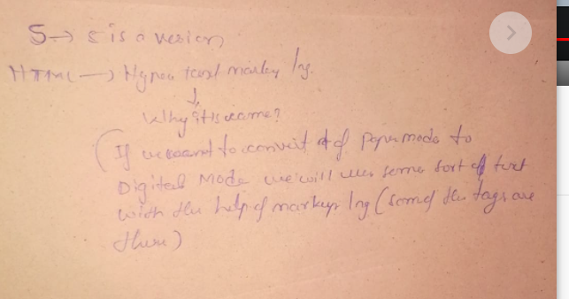

**How many tags are there in HTML5?**

35 tags and autoclosable(<img>, <br>, <hr>, <source>, tags are available in HTML

Ex: <p>/p> : paragraph tags

< - angular tag open and

>angualar tag close

<div></div> : division tag

How many tags are there in HTML?

100+tags

Types of HTML?

1. HTML
2. HTML2
3. HTML4
4. HTML5

**For different tags we have different attributes?**

Yes

What are the types for 100+tags?

1. Inline elements(in same line if content is passing that is called the inline )
2. blockline elements(if it is creating the new line we call it has block line element)

block level elements?

1. What is difference between div tag and span tag?

div tag (div is a block line element)

and span tag

10-02-2022

What is dipspaly :

There are 4 types:

**display flex and display : block and display:inline and display:inline-block**

**display : block** ---(block means whatever block elements are there, display : block means you can convert inline elements to block line elements)

**display:inline**: converting into blocklinr to inline elements

**display:inline-block:**

what block line and inline?

How to create the navigation bar?