1. Command for searching pattern line by line in any document with an example.
Annwer:- we can use grep command for searching line by line in any document
syntax grep “desired text” file name
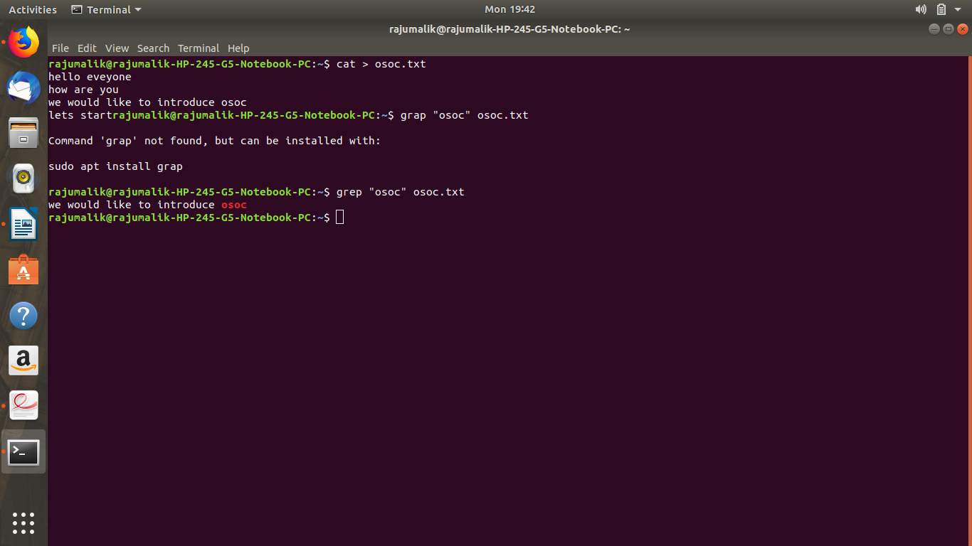
example
example is given in screen shot
2. What all permissions are there in Linux? State all permissions and different way of changing permissions with example
permisions:-
every file has three permision for different users
1. read 2. write 3. execute
1.read
with the help of this permission you can read only the file.
2.write
with the help of this permission you can edit the content of a file.
3.execute
in window the extension of software file is .exe if you want to run on any linux plateform the you have give execute permission . Without execute permission you can not run.
Changing permissions.
We can change permission of a file with the help of chmod command
syntax:- chmod permission desired file name
symbol meaning
 | Symbol
 | No Permission | ---
 | Execute | --x
 | Write | -w-
 | Execute + Write | -wx
 | Read | r--
 | Read + Execute | r-x
 | Read +Write | rw-
 | Read + Write +Execute | rwx
Not g+(desired permission) use give permission
and g-(desired permisssion is used to remove permission)
example shown in screen shot
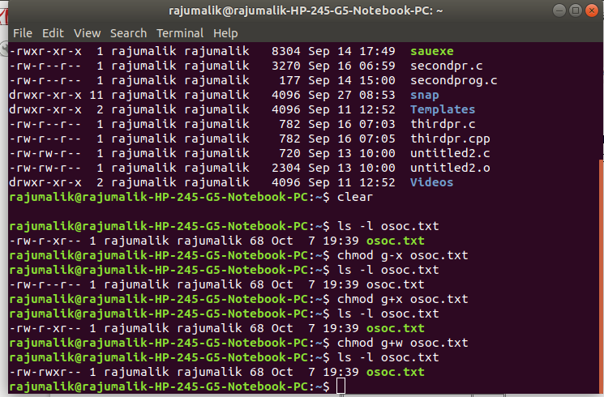
3. Create a folder OSOC and inside that another folder Inductions and now create a file task.txt inside Inductions with some content now copy this file into another folder Workshop in OSOC.
Alogrithm:-
first create a a folder osoc using mkdir command then move into this folder by cd command and again create a folder in nit osoc using mkdir now move to this folder using cd command now create a text file in this folder using cat command
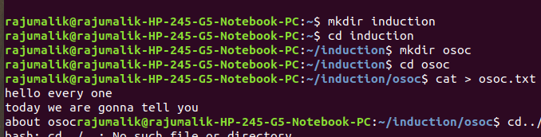

now we have to copy osoc.txt file to workshop in osoc we will use cp command
syntax:- cp (source address/file name) (destination address/file name)
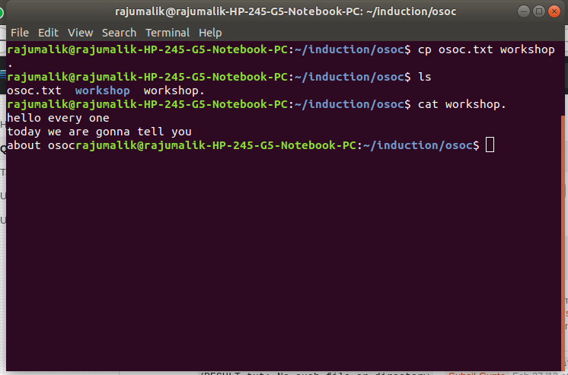

4. I want to check whether my system is connected to any network or not, please suggest appropriate command for this.

Suppose we want to check internet connectivity then we have check it using ping command
syntax ping (website address) i.e ping www.google.com
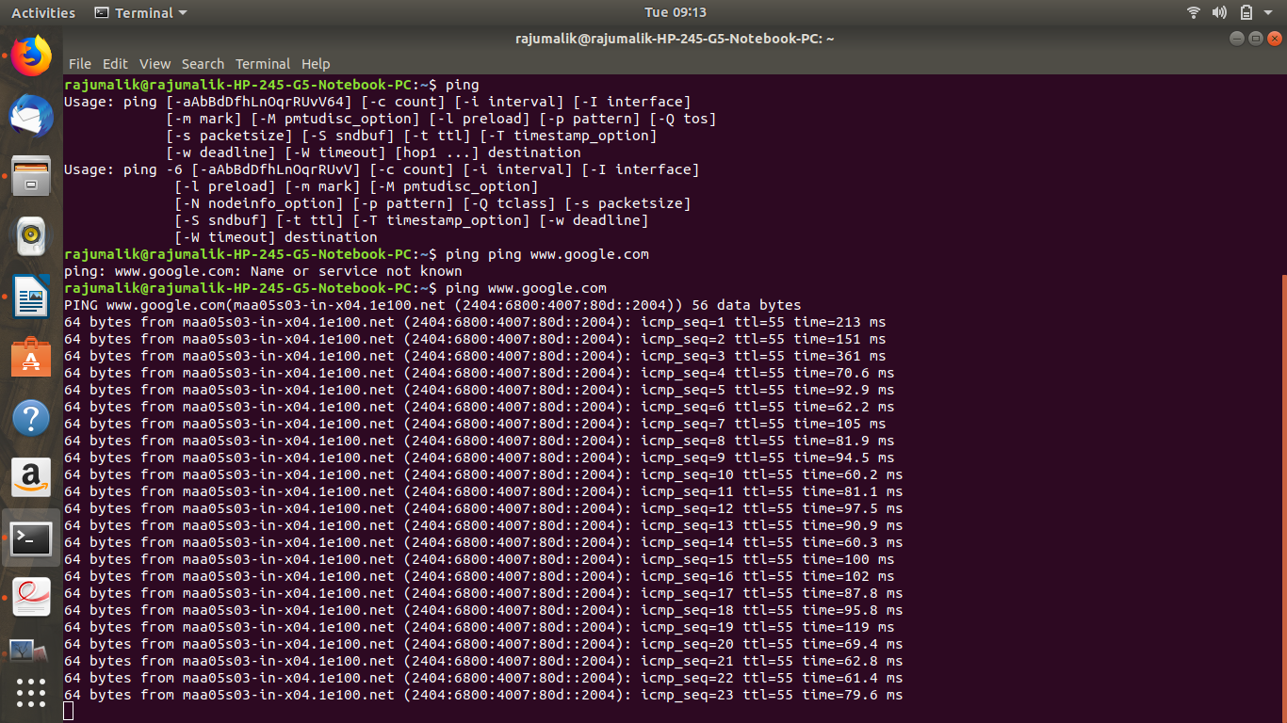
5. I want to change password of another user how will I do that?
Note a normal user can change only the pwd of her/his account but
only super user can change the pwd of any account to change the pwd of another account you have to move to super user
syntax:- passwd userNameHere
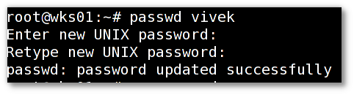
output is like that
7. Using Shell scripting write a program to reverse a string. Input should be taken from user.

#!/ bin / bash
read - p "Enter string:" string
len
= $
{
#string
}
for ((i = $len - 1; i >= 0; i--))
do
reverse = "$reverse${string:$i:1}" done
echo "$reverse"

6. Using shell scripting write program for sort an Array. Input should be taken from user.
echo "Enter number of elements: "
read n
echo "Enter array elements: "
for ((i=0; i<n; i++))
do
read a[$i]
done
for ((i=0; i<n; i++))
do
for ((j=$i; j<n; j++))
do
if [ ${a[$i]} -gt ${a[$j]} ]
then
temp=${a[$i]}
a[$i]=${a[$j]}
a[$i]=$temp
fi
done
done
echo "Array after sorting: "
for ((i=0; i<n; i++))
do
echo ${a[$i]}
8. What is the concept of Branching? How it is useful? Explain with working example.
Using a branch to isolate development work without affecting other branches in the repository. Each repository has one default branch, and can have multiple other branches. we can merge a branch into another branch using a pull request

it is useful because many person can work on like new feature adding to this
finding bug etc.

To create a branch we use git command

9. What is Push, Pull and Commit? Explain with example.
Push:-
The git push command is used to transfer or push the commit, which is made on a local branch in your computer to a remote repository like GitHub. The command used for pushing to GitHub is given below.
git push 'remote_name' 'branch_name'
pull:-
After initializing a pull request, you'll see a review page that shows a high-level overview of the changes between your branch (the compare branch) and the repository's base branch. You can add a summary of the proposed changes, review the changes made by commits, add labels, milestones, and assignees, and @mention individual contributors or teams
Once you've created a pull request, you can push commits from your topic branch to add them to your existing pull request. These commits will appear in chronological order within your pull request and the changes will be visible in the "Files changed" tab.
Other contributors can review your proposed changes, add review comments, contribute to the pull request discussion, and even add commits to the pull request.
Commit:-
The "commit" command is used to save your changes to the local repository.
Note that you have to explicitly tell Git which changes you want to include in a commit before running the "git commit" command. This means that a file won't be automatically included in the next commit just because it was changed. Instead, you need to use the "git add" command to mark the desired changes for inclusion.
Also note that in Git (not like in Subversion), a commit is not automatically transferred to the remote server. Using the "git commit" command only saves a new commit object in the local Git repository. Exchanging commits has to be performed manually and explicitly (with the "git fetch", "git pull", and "git push" commands).

10. Explain how we can restore a file after a commit with an Example.
In case you have accidentally commited a delete on a file and later realized that you need it back.
First find the commit id of the commit that deleted your file.
git log --diff-filter=D --summary
Will give you a sorted summary of commits which deleted files.
Then proceed to restore the file by
git checkout 81eeccf~1 <your-lost-file-name>
(Replace 81eeccf with your own commit id)

13. what is stash stack? How to write working from top of stash stack? (write answer and show screenshot of command on command line)

First of all: let us understand why do we need to use stash?
In order to understand what stash is, we first need to understand the 3-stats. Git has a build in model named 3-states which is the internal git structure for working with local repository.
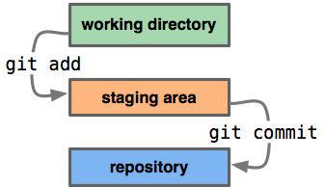
The "problem" with the 3-states is that there is one per repository and not one per branch. So when we switch branches the only thing that is being modified is the head which points to a different commit.
In git a branch is only an alias to a given commit so switching branches as explained before only changes the head while leaving the working directory && stage unchanged and leaving all the modification as is. [Working directory is being updated with the required files which the new branch has but its not part of our explanation.]
So if we add new files, modified some others and now we wish to move to a different branch we will have dirt left out in our working directory and stage area as seen below.
We have some dirty work following us regardless of the branch we are now working on.
Most of the git users use stash in order to gain the ability to work simultaneously on multiple branches. git stash is the basic way to accomplish it since git stash saves our work in a separate zone named stash.

