# ACKNOWLEDGEMENT

We would like to express our deep sense of gratitude towards our respected teachers of Kathmandu Bernhardt College for providing the suitable platform to showcase our skills. Our warm respect goes to the Department of Computer Science and Information Technology for providing this opportunity of undertaking a project and proceeding with it. We would also like to express our heartiest appreciation to our project supervisor Mr. Ram Babu Mahato for his support, and guidance throughout the journey of our project.

We can’t remain idle without giving a lot of thanks to our Head of CSIT Department Mr. Abhimanu Yadav for his tremendous support and attention. Without his support and guidance, it would not have been possible to successfully complete this project.

Sincerely,

Kalpit Pandey

Rajan Neupane

Rajun Pandey

# ABSTRACT

Online book store is a user-friendly online platform that facilitates the buying and selling of books directly between users (customers) and seller. This platform serves as a bridge connecting book enthusiasts who are eager to find new reads and purchase it in a very cost suitable price. In this platform users can easily search for books in a variety of categories and purchase it. This platform aims to promote sustainable reading habits and helps to boost reading habit for more people by offering a cost-effective books. This platform uses front-end web development tools like HTML, CSS, and JavaScript to create an engaging and visually appealing website. On the back-end, this platform will rely on PHP, a Database Management System (DBMS) like MySQL. These tools will manage data processing, handle the database, and ensure smooth, easy and delightful for book enthusiasts.

***Keywords: User-friendly, Sustainable reading, Cost-effective, Front-end, Back-end.***

Table of Contents

ACKNOWLEDGEMENT i

ABSTRACT ii

Chapter 1: Introduction 1

1.1 Introduction 1

1.2 Problems Statement 1

1.3 Aims and Objectives 2

1.4 Scope and Motivation 2

1.5 Application and Feasibility 2

1.6 Development Methodology 2

Chapter 2: Literature Review 4

Chapter 3: Requirement Specification 5

3.1 Functional Requirement 5

3.2 Non-functional Requirement 8

Chapter 4: Analysis 9

4.1 Feasibility analysis 9

4.2Comparison 10

Chapter 5: System Design 11

5.1 User Module 11

5.2 Admin Module 11

5.3 Class Diagram 12

5.4 Sequence Diagram 13

5.5 Activity Diagram 14

5.6 ER Diagram 15

Chapter 6: Implementation and discussion 16

Chapter 7: Conclusion, Limitation and Future 17

Expected Output and Appendices 18

References

Chapter 1: Introduction

# 1.1 Introduction

An ***online book store*** is a virtual store on the Internet where customers can browse the catalog and select books of interest. At checkout time, the items in the e-library will be presented as an order. At that time, more information will be needed to complete the request. Usually, the customer will be asked to fill online form. An e- mail notification is sent to the customer as soon as the order is placed.

This project intends different types of forms with many types of books like story, drama, romance, history, adventures, etc. it can manage studying of books online, customers can choose many types of books categories, etc. Here, the user may select desired book and view its price. The user may even search for specific books on the website. Once the user selects a book, he then has to fill in a form and the book is provided for the user.

# 1.2 Problems Statement

As with most online sites, you need a lot of trust to use online bookstores. The major problem of the online store is that when any sort of network error or power supply cut occurs, then the book starts from the beginning. There is no bookmarks as well. There are no proper application or website to where the students can find study materials for their examination under one roof. Students have to search a lot on the web to get complete study materials.

# 1.3 Aims and Objectives

The objective of this project is to develop an e- book store where books can be studied from the comfort of home through the Internet.

The Objectives are:

* To read and save the details of book and its author’s name.
* To provide an essence of online book store via simple and yet powerful medium.
* View books of all categories.
* Economical, quick and time convenient

# 1.4 Scope and Motivation

Online book store is a convenient way to study books and get updated of new books with the features of cost savings, recommendations and feedback.

The main motive behind the project is to provide facilities that can be available in online bookstore.

Our effort here is to allow people to overcome costly books.

# 1.5 Application and Feasibility

Most of the people, these days are connected with technology and are familiar with it. So, this application is useful to all the website users as they can study all the required books in their devices using this application.

# 1.6 Development Methodology

Our project requirements are well understood and stable. So using waterfall model i.e. the classical model used for system development life cycle to create a system with a linear and sequential approach. We are using the waterfall model for this project because the overall functionality of the system is not subjected to change as time passes and allows us to complete the task at hand in a relatively short amount of time.

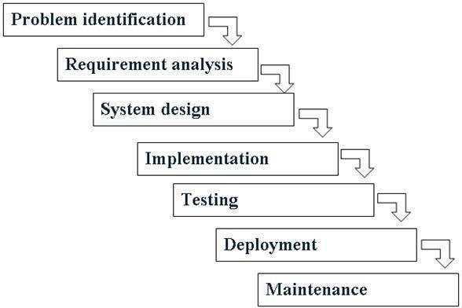

Figure: Waterfall Model

Chapter 2: Literature Review

A lot of websites and applications can be found when we search the google which are developed for learning purposes. But there is ambiguity in choosing the appropriate content in appropriate time. Some websites has been developed which consists of stories, novels, essays etc. Similarly, some personal blogs and websites are developed for studying purpose. Electronic Commerce (e-commerce) applications support the interaction between different parties participating in a commerce transaction via 24 Sep 2017 Shop new, used, rare, and out-of-print books. literature review for online bookstore. prototype provides a guideline in developing a real system of Online Ordering Book based on user's perspective, particularly in the perspective of academic will be handled by the university's book store. However, the ordering is still done manually. Based on literature reviews and web site reviews of other universities. This research was undertaken to provide background for the SCONUL and Jisc eBook Co-Design Project. Since the 1980's, when e-books first The idea of this review paper, begins from writer's disappointment about online bookstore service quality in. Indonesia. Which is, as a consumer in several transactions with the online bookstore. In overall, the writer's did not satisfied towards their services. Lions Villa Probation Hostel Gate Pass Management System at Coimbatore Campus Amrita. The computerized Gate Pass Management System 27 Sep 2017. Also includes introduction to meta-analysis. Relevant to student from any discipline. Includes contributions from both a professor and a librarian.

Chapter 3: Requirement Specification

# 3.1 Functional Requirement

The Function Requirement documents the operations and activities that a system must be able to perform. The functional requirements of this project are defined with the use of Usecase diagrams as follows:

**3.1.1User Registration**

The system shall authenticate the user after registration with valid email and password.

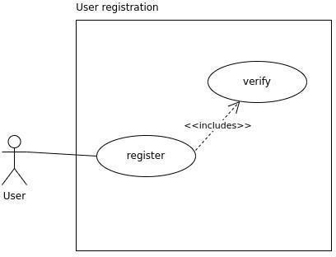

*Figure : Use case for user registration*

**3.1.2Login**

The system shall allow users to login with registered email and password.

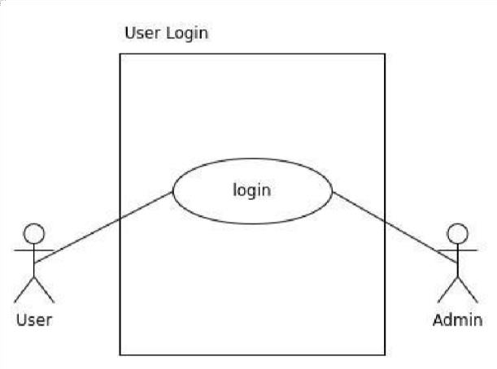

*Figure : Use case for Login*

**3.1.3Placing Order in bookstore**

The system shall allow the Customer to place order based on Category with the help of Website.

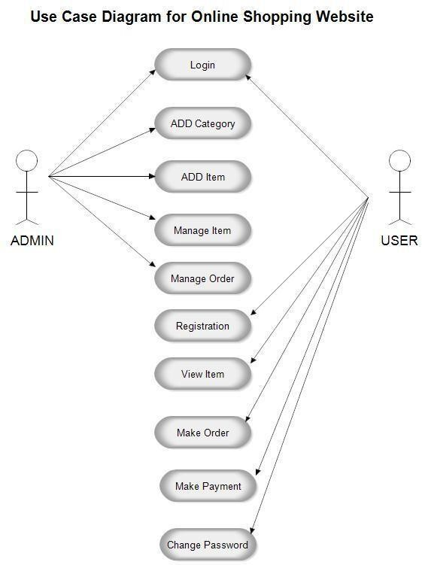

*Figure : Use Case for order System*

# 3.2 Non-functional Requirement

Non-functional requirements are requirements that specify criteria that can be used to judge the operation of a system, rather than specific behaviors. Non-functional requirements for online bookstore:

* **Performance:** Online bookstore should offer fast page loading times and responsive user interactions to ensure a seamless and efficient shopping experience. This includes quick access to product listings, smooth transitions between pages, and minimal wait times during peak traffic periods.
* **Usability**: The user interface of online book store should be intuitive, user-friendly, and visually appealing. Customers should be able to easily browse watch collections, search for specific items, and complete purchases without encountering confusion or frustration.
* **Platform Compatibility**: Online book store must be compatible with various devices and web browsers. It should provide a consistent and optimized shopping experience for users accessing the platform from desktops, laptops, tablets, and mobile phones.
* **Reliability:** The platform should operate reliably with minimal downtime or disruptions. Customers should be able to access and use Online Bookstore without encountering frequent technical issues.
* **Security:** Robust security measures should protect user data and payment information. This includes encryption of sensitive data, secure payment gateways, and compliance with industry standards and data protection regulations to ensure the confidentiality and integrity of customer information.

Chapter 4: Analysis

To understand the nature of the program to build, the analyst must know about the required function, behaviour, performance and interfacing. These requirements are found by interleaving the customer and asking them various questions regarding the needs.

# 4.1 Feasibility analysis

A feasibility study for the Online Bookstore project would assess the viability and potential success of the endeavor. Here are the key components of such a study:

1. **Technical Feasibility:**

This system is technically feasible because we have a suitable server setup using localhost, programming languages like PHP, HTML, CSS, and JS, the necessary programming skills, and access to the required hardware and software resources.

1. **Operational Feasibility:**

This system is feasible in terms of operational feasibility. It will have a cost-free implementation, be accessible to anyone, and require minimal training. These factors contribute to the efficiency and practicability of the system within the current operational framework.

1. **Economic Feasibility:**

This project is economically feasible as it utilizes an open source or free programming language and it is developed as part of an academic qualification for Bachelors of Science in Computer Science and Information Technology (BSe CSIT) from Tribhuvan University, without any costs involved in terms of purchasing components or paying team members.

1. **Schedule Feasibility:**

The system that will be developed is expected to be completed according to the estimated timeline. The various units of the system are planned to be finished within specific periods and will be integrated at defined intervals. Thus, the system is anticipated to be feasible in terms of the schedule factor.

The project's tasks and milestones have been divided as shown in the given Gantt Chart below:

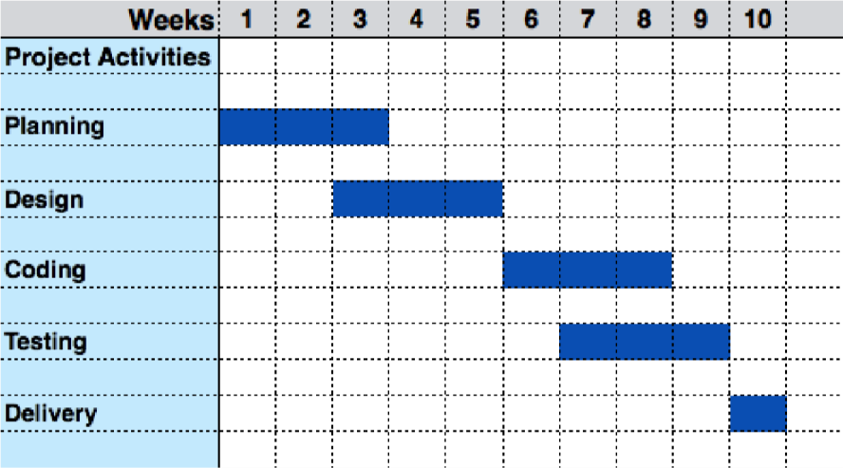

*Figure : GANTT Chart*

The above Gantt chart displays the timeline of the project. The overall project took 10 weeks for completion. The project is divided into 6 activities and time for each activity is shown in the diagram above.

# 4.2Comparison

Our program is similar to expected output since it meets the following output as:

* It is user friendly, easy in user interaction.
* Secure because only allowed one can access, loss of data is eliminated.
* User can read and save the details of book and its author’s name.
* It provides an essence of online book store via simple and yet powerful medium.
* View books of all categories.
* Economical, quick and time convenient.

Chapter 5: System Design

System design represent the overall concept on how the system works. In our system there are two modules. They are system module and admin module.

# 5.1 User Module

* Only register user can login into the application.
* Those users who are not register must register first by filling the necessary attributes such as name, email, password etc. and then the account will be created by providing user name and password.
* User can read the contents of the application such as notes, books, syllabus etc.
* User can watch the videos available in application.
* Interested users can also suggest and provide study materials to admin.

# 5.2 Admin Module

* Admin can upload the study materials such as notes, books, syllabus, old question collection etc.
* Admin can check, verify and post the study materials that are provided by the user.

The overall system can be represented by using following block diagram:

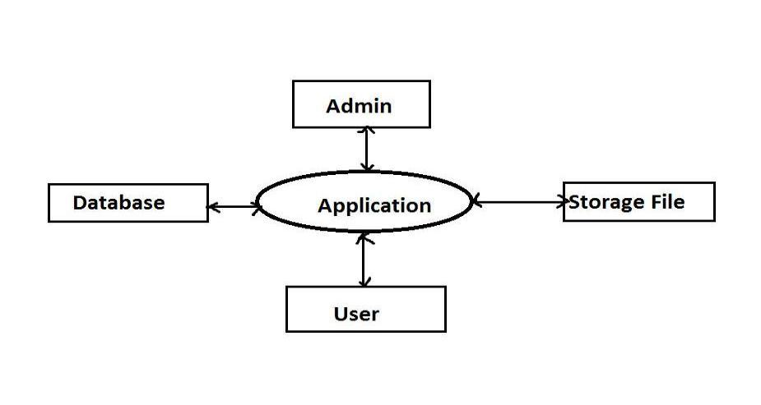

# 5.3 Class Diagram

The Class diagram is a graphical notation used to construct and visualize objectoriented systems. A class diagram in the Unified Modeling Language (UML) is a type of static structure diagram that describes the structure of a system by showing the system’s classes, their attributes, operations (or methods), and the relationships among objects.

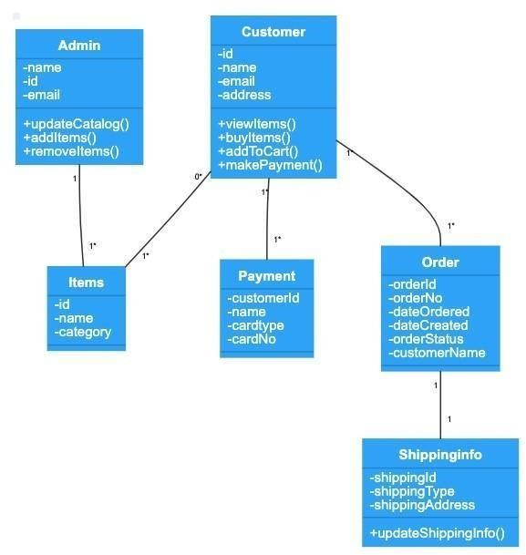

Figure : Class Diagram

# 5.4 Sequence Diagram

Sequence Diagrams are interaction diagrams that detail how operations are carried out. They capture the interaction between objects in the context of a collaboration. Sequence Diagrams are time focus and they show the order of the interaction visually by using the vertical axis of the diagram to represent time, what messages are sent and when.

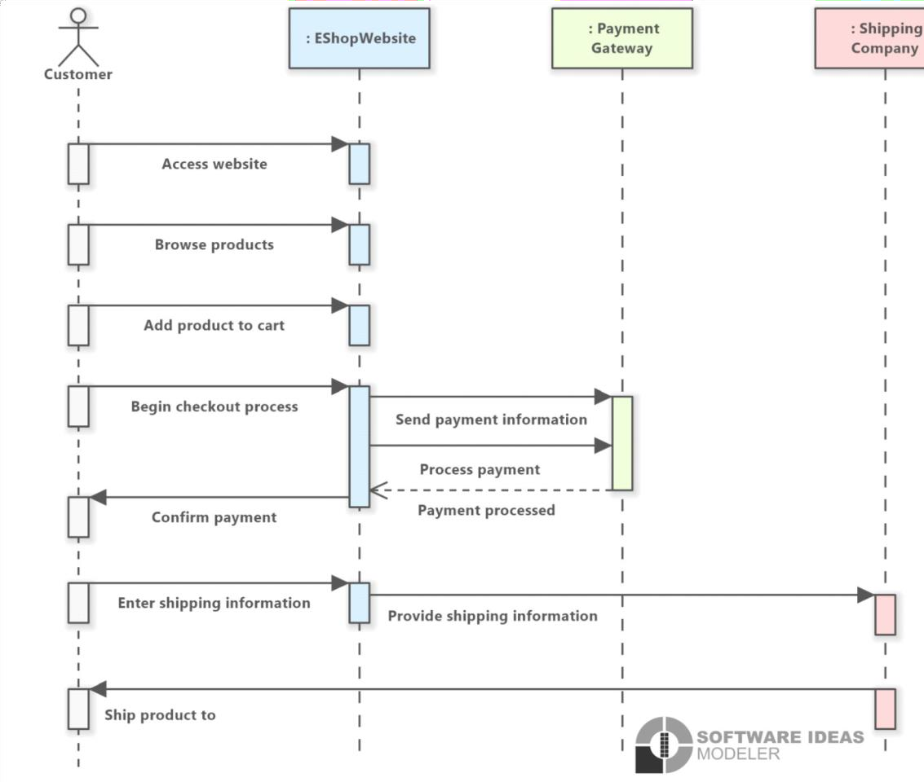

Figure : Sequence Diagram

# 5.5 Activity Diagram

Activity diagram is an important behavioral diagram in UML diagram to describe dynamic aspects of the system. Activity diagram is essentially an advanced version of flowchart that models the flow from one activity to another activity.

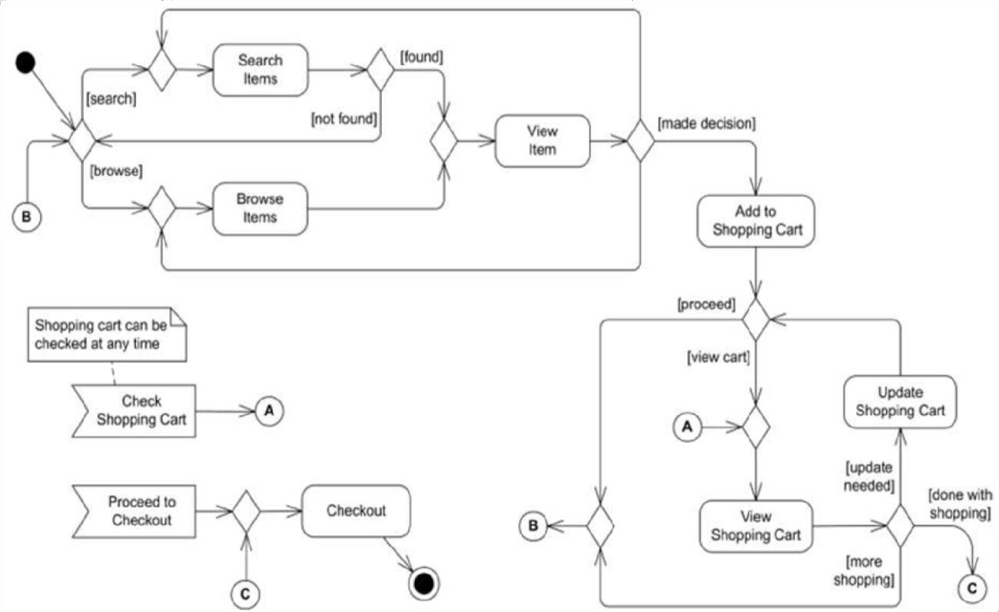

Figure : Activity Diagram

# 5.6 ER Diagram

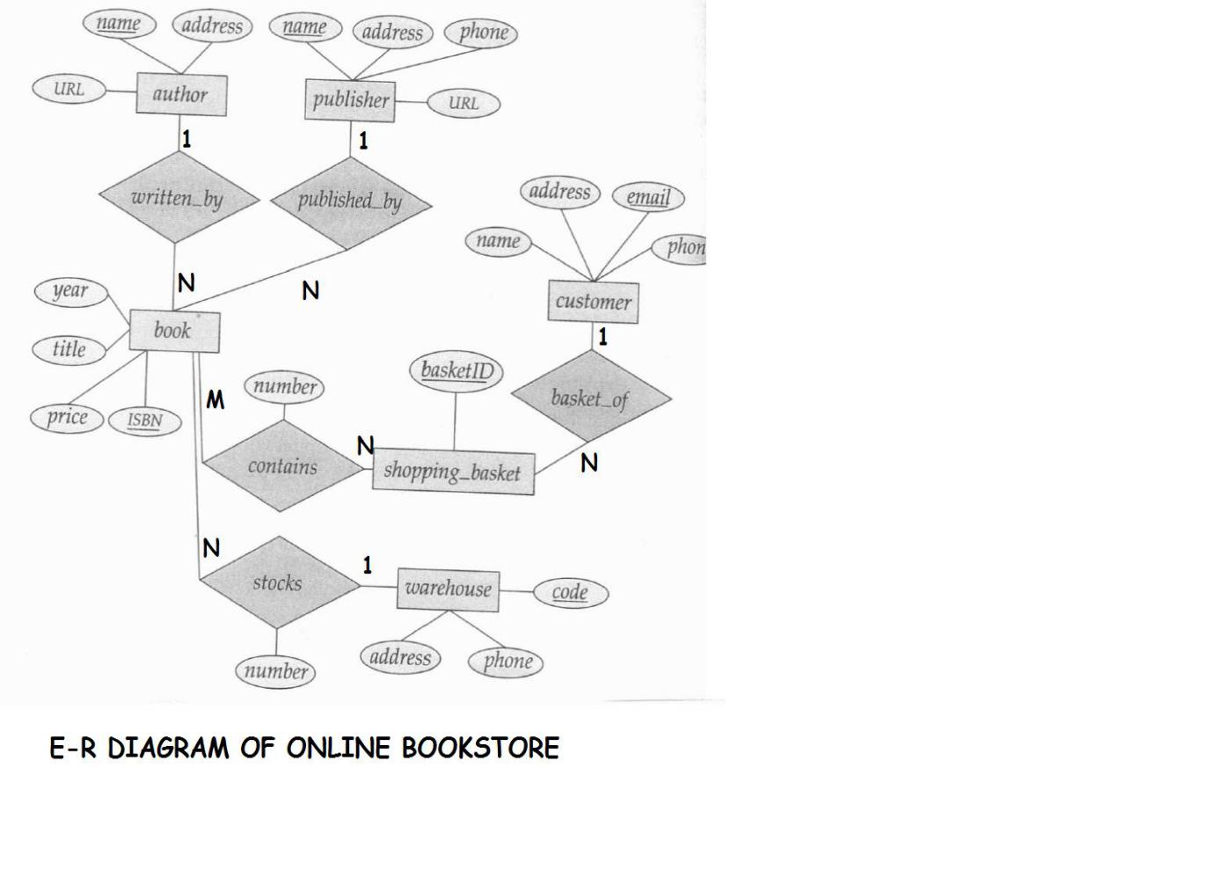

Chapter 6: Implementation and discussion

Till this date all the works has been completed. The front end of application consists of home page which consist of login section with other options like user register and forget password. There are other sub topics like upload file from which users can upload their own books. Logout option from which users can leave the home page. Also from search option user can search their required books. The project requires some serious study of database and how it can be collaborated with PHP. Hence a lot of work has been invested on study of those things. Here in this project main focus is given to things like login, search, upload file, logout and book details. Concept of database and online processing is widely used in this application.

In 1992, Sony launched the Data Discman an electronic book reader that could read e-books that were stored on CDs. One of the electronic publications that could be played on the Data Discman was called The Library of the Future. Early e-books were generally written for specialty areas and a limited audience, meant to be read only by small and devoted interest groups. The scope of the subject matter of these e-books included technical manuals for hardware, manufacturing techniques, and other subjects. In the 1990s, the general availability of the Internet made transferring electronic files much easier, including e-books.

As e-book formats emerged and proliferated, some garnered support from major software companies, such as Adobe with its PDF format that was introduced in 1993.Unlike most other formats, PDF documents are generally tied to a particular dimension and layout, rather than adjusting dynamically to the current page, window, or other size. Different e-reader devices followed different formats, most of them accepting books in only one or a few format, thereby fragmenting the e-book market even more. Due to the exclusiveness and limited readerships of e-books, the fractured market of independent publishers and specialty authors lacked consensus regarding a standard for packaging and selling e-books. [3]

Chapter 7: Conclusion, Limitation and Future

Conclusion:

* “Website design is like a shop Interior. If the shop looks poor or like hundreds of other shops the customer is most likely to skip to the other site”. Hence we have designed the project to provide the user with easy navigation, retrieval of data and necessary feedback as much as possible.
* It is convenient for the customer to view the contents of books. The Online Book Store Application described in this project provides a number of features that are designed to make the customer more comfortable.

The limitations are:

* Cannot be used without internet.
* Users cannot give feedbacks.
* Limited books are only available.
* Error in spelling by the user cannot provide the exact book they want.

The future scope for our project can be:

* Purchase books online
* Publishers insolvency

# Expected Output and Appendices

From our project, we would like to provide a consumers a facility such as:

* To read and save the details of book and its author’s name.
* To make our content more viral.
* To simulate the working of an actual online book store.
* To provide an essence of online book store via simple and yet powerful medium.
* View books of all categories.
* Economical, quick and time convenient.

Landing page



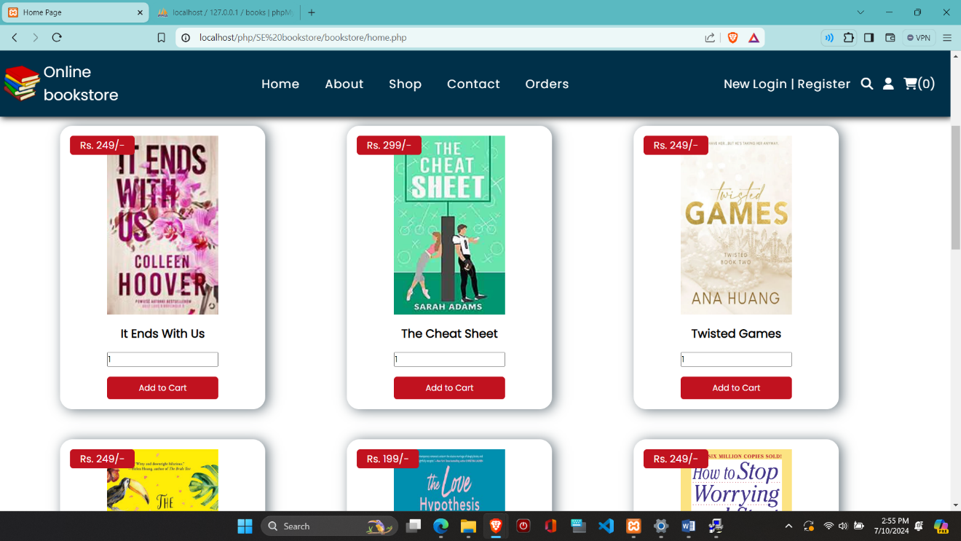

About page

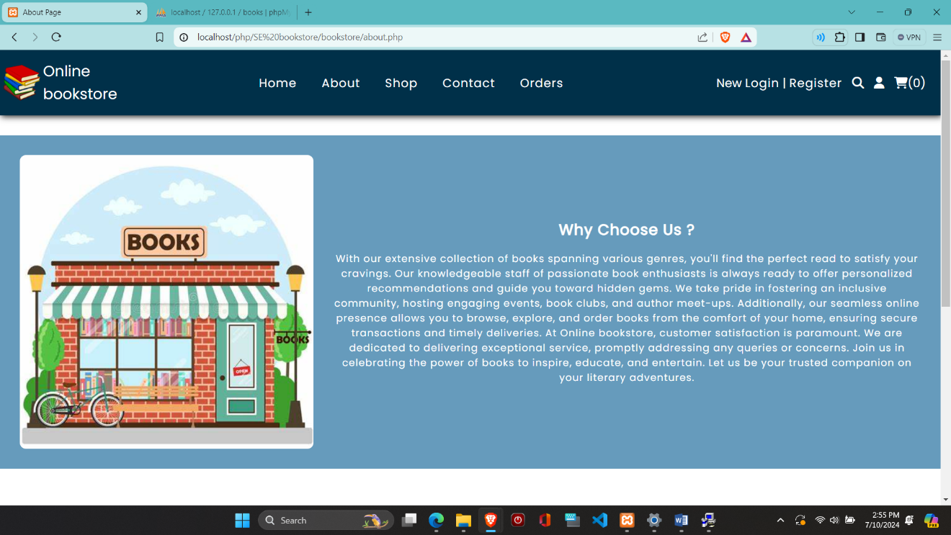

Contact page

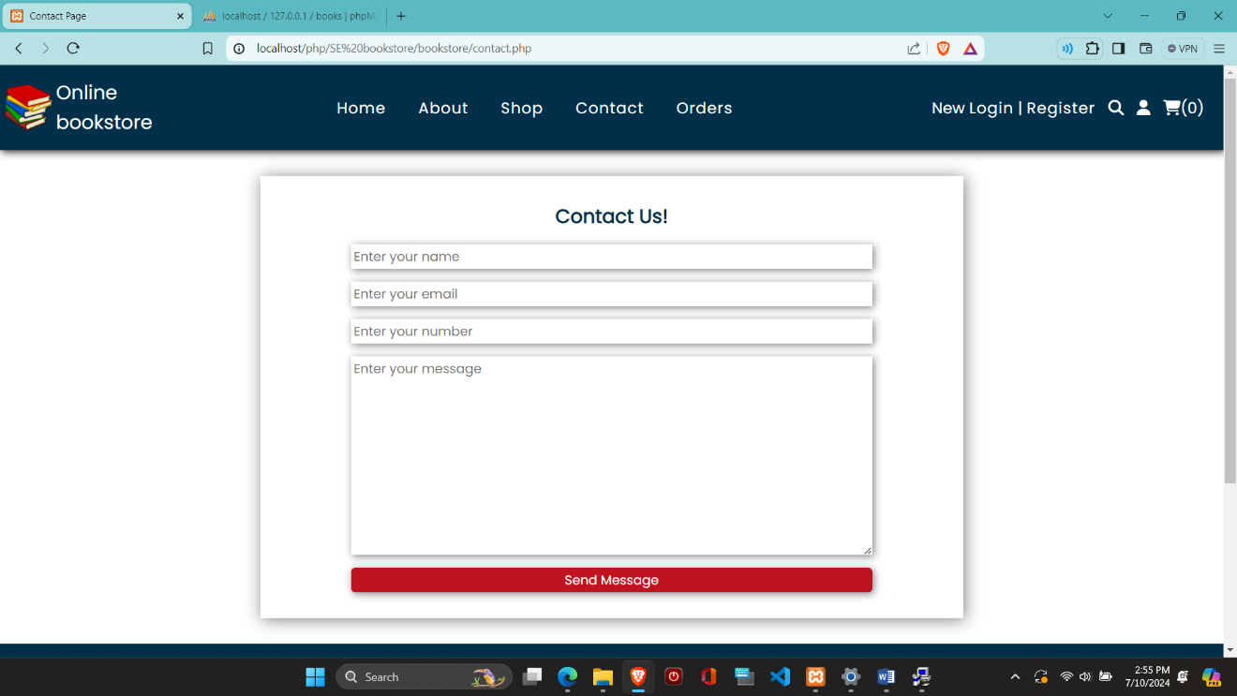

Login form

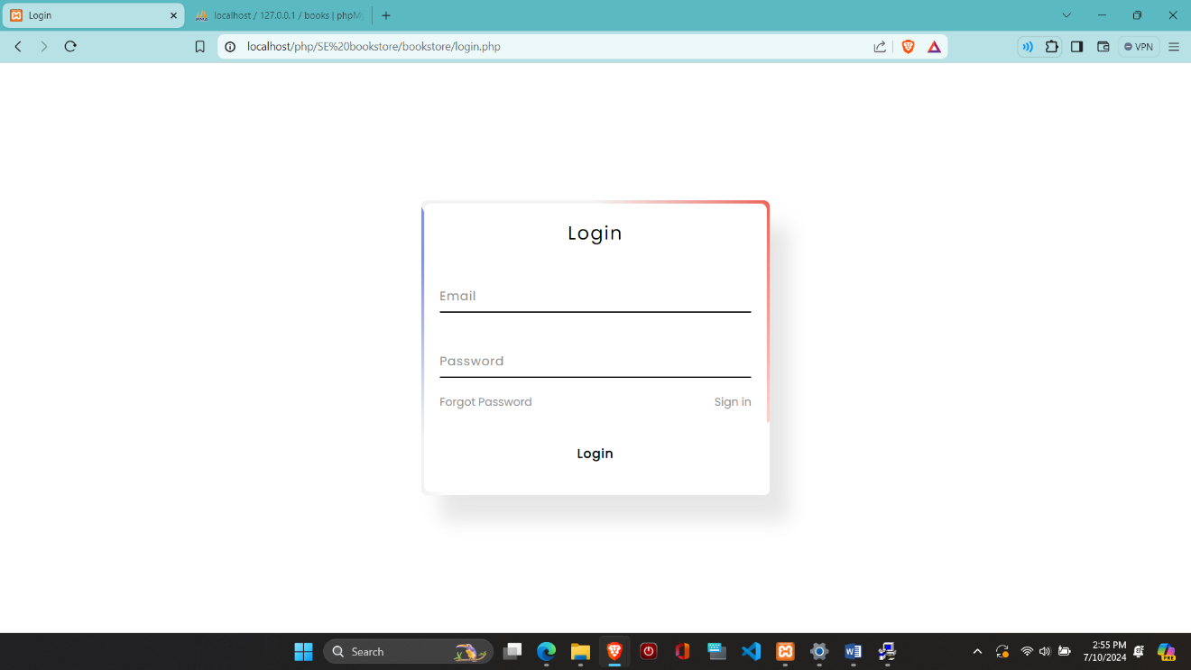

Registration form

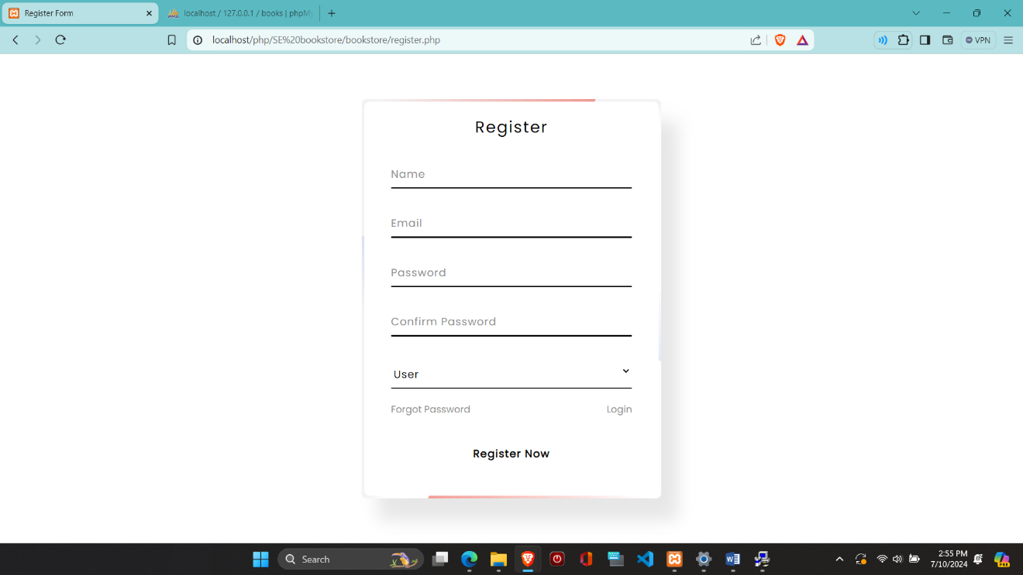

**References**

1. “Engineering paathshala.”
2. E. S. Rn and M. C. Rn, “Literature review,” *International Journal of Nursing Practice*. pp. 89– 98, 2002.
3. “E-Book-Wikipedia.” .
4. Techniques, “Contents 1,” pp. 1–26.