Disk Guard AI Agent
Naga Raju Pitchuka, TCS
May 2026
Table of Contents

Disk Guard AI Agent

A Predictive Multi-AI Architecture for Proactive Disk-Failure Prevention in Production Server Fleets
Author: Naga (TCS) Version: 1.0 Date: May 2026 Status: Working Proof-of-Concept (POC) Repository: https://github.com/rajupitchuka/disk-guard-AIagent

Abstract
Disk-fill incidents are among the most common production failures in enterprise IT. From years supporting infrastructure operations at TCS, I have watched the same pattern play out hundreds of times: a disk fills up, a monitoring tool fires an alert at 85–90% utilization, a ticket lands in the queue, and an on-call engineer logs in to clean up before the volume saturates. Sometimes the engineer wins this race. For anomalous fast-fill scenarios — runaway loggers, retry storms, deploy regressions — the alert fires too late and the host goes down.
The economic cost is significant. Industry surveys put enterprise hourly outage cost above USD 300K [21], [22], and storage-related events account for roughly 10–15% of infrastructure incidents in mid-to-large estates [9]. At the scale of a typical 3,000-server enterprise IT estate, disk-fill incidents alone consume on the order of one engineering FTE per year in routine response time and produce several million dollars per year in associated outage cost. Across the global enterprise IT footprint the aggregate cost runs into the tens of billions of US dollars annually.
This paper describes Disk Guard AI Agent, a working proof of concept I built to address this structurally. Rather than waiting for thresholds, the system continuously forecasts disk saturation using Prophet [1] and classifies anomalous growth using XGBoost [2]. When either forecast or anomaly score crosses a trigger condition, a Claude-powered LangGraph agent [14], [15] grounded in retrieved past-incident records [5] reasons about the situation and produces a structured recommendation: clean, escalate, or wait. A Decision Engine then routes the recommendation to one of three governance bands — auto-remediate, chatbot approval, or ServiceNow ticket only — based on a confidence score that combines LLM self-confidence, ML signal alignment, RAG grounding, and environment risk. Every action is fully audited.
The implementation is end-to-end on a 53-host fleet (3 real Linux containers plus 50 simulated hosts), with full ML cycles completing in approximately 8 seconds. Two reproducible scenarios demonstrate the system in operation: a 16 GB predictive cleanup of routine rotated logs, and a correctly-refused cleanup of an anomalous-growth event in which the agent retrieves a relevant past incident from RAG and files a P2 ServiceNow ticket rather than masking the upstream problem. The contribution is not a new ML algorithm. It is a working composition pattern showing how to combine forecasting, anomaly detection, retrieval-augmented LLM reasoning, and confidence-gated governance into a system that real IT-operations teams can deploy. The pattern generalizes naturally to other infrastructure-operations problems — service uptime, backup verification, storage capacity, network saturation — that share the same predict, reason, decide, act structure.
Index Terms: AIOps, predictive monitoring, agentic AI, retrieval-augmented generation, time-series forecasting, anomaly detection, IT operations, governance AI, large language models, site reliability engineering

1. Introduction
Storage exhaustion is one of the more boring categories of production failure. It is also one of the most common. In the years I have spent supporting infrastructure operations for enterprise customers, disk-fill incidents have been a constant background hum in the on-call rotation. The broader discipline of preventing operational failure has been formalized in the Site Reliability Engineering literature [12], and a fairly active research community has applied machine learning to the problem of failure prediction in cloud and enterprise systems [9], [10], [11]. Despite this, the dominant practical approach in industry remains threshold-based reactive monitoring — and disk-fill incidents keep happening.
The pattern repeats almost without variation. A host’s monitored partition (typically /var/log on a Linux web or app server, or C:\Logs on a Windows IIS server) fills steadily over hours or days. Free space crosses a configured threshold, most often 85% or 90% utilization, and the monitoring agent emits an event. The event lands in a centralized observability platform, an incident ticket is opened, and someone — either an on-call engineer or, in better-instrumented teams, an automated runbook — is dispatched to investigate.
This is reactive by design. Action only begins after a threshold breach. The threshold has to be conservative or the team drowns in false alarms. The response cycle includes human or automation latency. For routine log accumulation it works well enough. For the anomalous cases — a misconfigured logger left enabled in production, an unbounded retry loop, an exception storm triggered by a bad deploy — it does not. In those cases the disk does not fill gradually. It fills in minutes, leaps over the threshold rather than crossing it slowly, and saturates before any responder can react. The result is a production outage that everyone agrees, after the fact, was preventable.
This paper introduces Disk Guard AI Agent: a predictive, multi-AI-component system that monitors continuously, forecasts the trajectory in real time, reasons about whether observed growth is normal or anomalous, and acts under explicit governance guardrails before the disk reaches a state requiring emergency intervention. The system is implemented end-to-end as a working proof of concept and validated on a fleet of 53 hosts. The full source code, architecture diagrams, and reproduction scripts are publicly available at the repository cited above. I built this because I have lived the problem; the paper is a deliberate attempt to share the solution pattern in a form other practitioners can pick up, run, and adapt.

1.1 Contributions
The contributions of this work are:
- A complete reference architecture for predictive disk management, organized into four well-defined zones (Data, AI Agent, Governance, Infrastructure) that map cleanly onto existing enterprise tooling.
- An implementation pattern for combining time-series forecasting (Prophet), anomaly classification (XGBoost), retrieval-augmented LLM reasoning (Claude + LangGraph + pgvector), and confidence-scored governance into a coherent decision pipeline.
- A demonstration of how a state-of-the-art language model, when grounded in retrieved runbook + past-incident content, makes operationally sensible distinctions — most notably, refusing to clean files when growth is anomalous and would mask an upstream incident, and instead escalating via ServiceNow.
- An open-source POC, including a Streamlit demonstration UI structured around the operator workflow Monitor → Predict → Reason → Resolve, that allows the system’s behavior to be observed, validated, and reproduced.

1.2 Paper Organization
Section 2 reviews the limitations of traditional reactive monitoring. Section 3 introduces the predictive paradigm and contrasts the two approaches against a common incident scenario. Section 4 presents the reference architecture. Section 5 details the implementation. Section 6 walks through the operational workflow and routing logic. Section 7 describes validation results. Section 8 discusses limitations and production considerations. Section 9 outlines future work. Section 10 concludes.

2. The Problem: Limits of Reactive Disk Monitoring

2.1 Scope and economic impact
Before describing the operational model, it is worth establishing how big the disk-fill problem actually is in financial and human terms. Quantifying this precisely is hard because enterprises rarely publish per-incident-class outage data, but several reference points support a defensible estimate.
Per-hour outage cost. The widely-cited Gartner figure of USD 5,600 per minute (~USD 336K per hour) of IT downtime [22] remains a reasonable mean across the enterprise survey base. ITIC’s annual Hourly Cost of Downtime surveys, conducted since 2008, consistently report that the majority of enterprises peg an hour of unplanned downtime above USD 300K, with the top tier (financial services, telecommunications, healthcare) frequently citing figures above USD 1M/hour for customer-facing systems [21].
Incident-category share. Storage and disk-related events typically account for 10–15% of infrastructure incidents in mid-to-large estates [9], [10]. The exact share varies by industry — heavily log-generating workloads (financial trading, ad tech, observability platforms themselves) trend higher; static workloads trend lower.
Manual effort per incident. A typical disk-related ticket consumes 45–90 minutes of L2/L3 engineering time across investigation, remediation, and post-incident documentation. At a fully-loaded enterprise SRE rate of USD 80–120/hour, this is roughly USD 80–150 per ticket in labor cost alone, before accounting for context-switching, alert fatigue, and any associated outage.
Applying these reference points across enterprise size segments produces the rough estimates summarized in Table 1.
Table 1. Estimated annual cost of disk-fill incidents by enterprise segment. Numbers assume an industry-typical 1–2% annual disk-incident rate per server, with 10–25% of incidents escalating to customer-facing outage. Outage cost per event is conservative relative to Gartner / ITIC means.
Segment | Servers (avg) | Disk incidents/year | Engineering effort | Outage cost/year | Total annual burden
Small (1–50 servers, USD 10–50M revenue) | ~25 | 5–15 | 10–25 hr | USD 5–15K | ~USD 10–25K
Medium (50–500 servers, USD 50M–1B revenue) | ~250 | 50–150 | 75–225 hr | USD 250–500K | ~USD 300–550K
Large (500–10,000+ servers, USD 1B+ revenue) | ~3,000 | 1,000–3,000 | 1,500–4,500 hr (≈ 1–2 FTE) | USD 7–15M | ~USD 7–15M
For a Fortune-500 IT estate with 5,000 production servers, an industry-typical 1.5% annual incident rate, and a 20% subset escalating to customer-facing outages, the model produces approximately 75 outage-impacting events per year. At a conservative USD 200K average outage cost (well below the Gartner mean), this is approximately USD 15M/year in direct outage cost, plus USD 300–500K/year in unproductive engineering effort, plus the harder-to-quantify cost of context-switching, alert fatigue, and morale impact on on-call teams.
Aggregate scale. Taking the global population of enterprises operating 500+ server estates as roughly 30,000 organizations, and applying even the low end of the Large-segment burden range, the collective annual cost of disk-fill incidents alone is in the tens of billions of US dollars range. This is not a niche problem. It is the scale that justifies investment in predictive prevention rather than treating disk monitoring as a solved infrastructure-101 capability.
These numbers are inherently approximate. The point is not the specific figure but the order of magnitude: the burden is large enough that a 30–50% reduction (the kind of improvement a working predictive system can plausibly deliver) is an enterprise-grade improvement worth meaningful investment.

2.2 The current operational model
Figure 1 illustrates the prevailing pattern in enterprise disk monitoring.
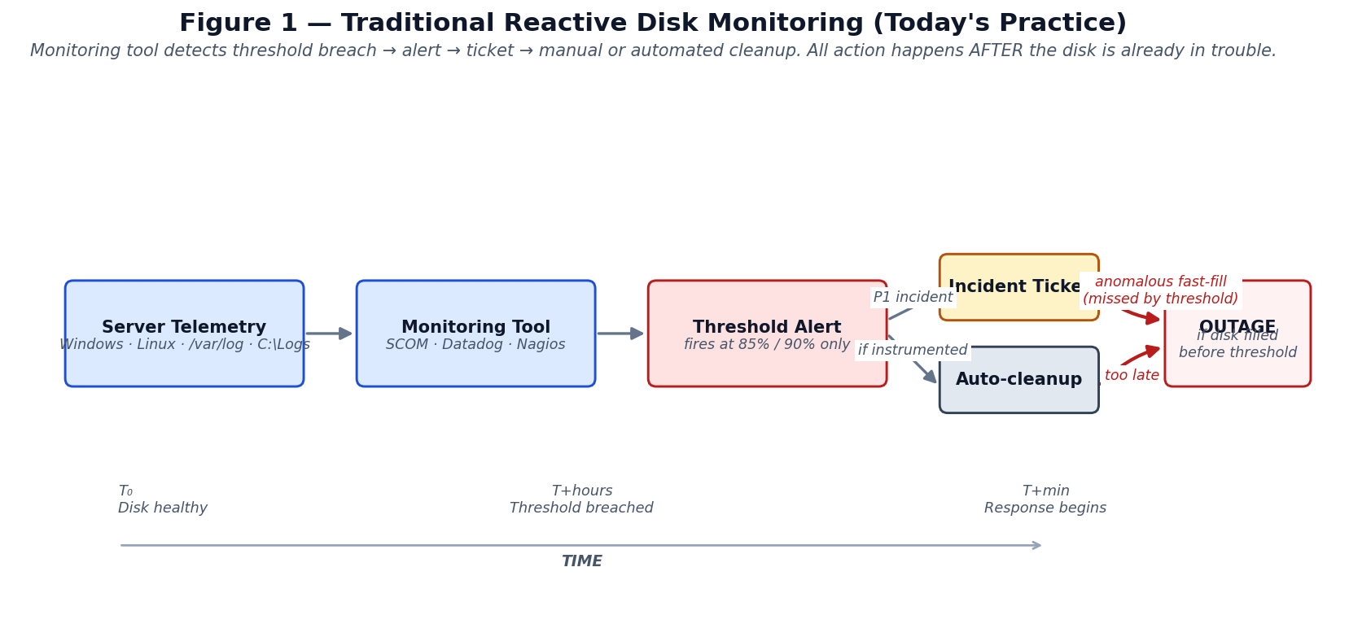
Figure 1
Server telemetry is collected by a per-host agent (e.g., the Datadog Agent, the SCOM management agent, or NRPE for Nagios) and shipped to a centralized monitoring platform. The platform evaluates each host’s disk usage against a static threshold; once the threshold is crossed, an alert is dispatched. The alert traverses a paging or ticketing pipeline (typically PagerDuty, Opsgenie, or ServiceNow), and an Ops engineer is either notified to investigate manually or, in mature environments, an automated runbook is invoked to perform routine cleanup.
This architecture has worked reasonably well for two decades. It is easy to understand, easy to instrument, and produces clearly auditable events. It also has three structural weaknesses that become more problematic as estates grow and software complexity increases.

2.3 Threshold thresholds are necessarily conservative
The choice of alert threshold (85%, 90%, sometimes 95% on high-write-rate hosts) is a tradeoff. A low threshold produces too many false alarms and induces alert fatigue; a high threshold leaves too little buffer for response. In practice most teams settle in the 85–90% range for production fleets. The implication is that even when the system is working as designed, action begins only when 85–90% of the disk is already consumed — leaving 10–15% of capacity to absorb both the response time and any continued growth during that response.
For routine log accumulation this is generally sufficient: typical growth rates are sub-1 GB/hour, and 10% of even a modest 100 GB volume is 10 GB, which buys hours. The model breaks down when growth rates are 10× or 100× normal.

2.4 Anomalous fast-fill: when monitoring is too late
The dangerous failure mode is anomalous fast-fill. Common causes observed in practice include:
- DEBUG logging left enabled in production — a deploy or a feature flag inadvertently raises the log verbosity, generating hundreds of megabytes of stack-trace output per minute.
- Tight retry loops — a downstream dependency fails, an upstream service retries aggressively without backoff, and each failed retry generates a multi-line error log.
- Misconfigured rotation — a logrotate or service-managed rotation policy fails silently and the active log file grows unbounded.
- Build / batch artifacts — a CI agent or batch worker writes intermediate artifacts to a monitored partition without cleanup, particularly if the cleanup step is gated on successful completion of a step that itself fails.
In each of these scenarios the volume can saturate within tens of minutes. By the time a 90% threshold alert fires, there may be only a few minutes of buffer remaining. By the time a human engages or an automated cleanup completes — a process that itself depends on writable disk for its bookkeeping — the host may already be hard-down.

2.5 Reactive automation: a partial improvement
A common mitigation, observed across mature SRE organizations, is to attach automated cleanup playbooks to disk alerts. When the threshold fires, a script removes rotated log files, compresses old archives, or purges temporary directories. This reduces mean-time-to-recovery for routine cases but does not address the anomalous fast-fill problem because:
- The automation is still gated on the threshold alert, which is the source of the latency.
- The automation typically runs a static playbook regardless of why the disk is filling. If growth is anomalous (a runaway process), the cleanup masks the symptom and the volume re-fills within minutes. This pattern is well-documented in post-incident reports.

2.6 The case for prediction
The structural fix is to move action from “after the threshold breach” to “before.” This requires two capabilities the threshold model lacks:
- Trajectory awareness — the ability to read the rate-of-change and project forward, rather than reading only the instantaneous level.
- Pattern awareness — the ability to distinguish routine accumulation from anomalous growth, so that the right corrective action can be selected.
Both are well-studied problems in time-series analysis and machine learning. The question is how to combine them with operational governance (who is authorized to act, with what evidence, and with what audit trail) in a way that an enterprise IT organization can deploy with confidence. That combination is what the next sections describe.

3. From Reactive to Predictive

3.1 The Disk Guard approach
Figure 2 shows the predictive flow at the level of a single host.
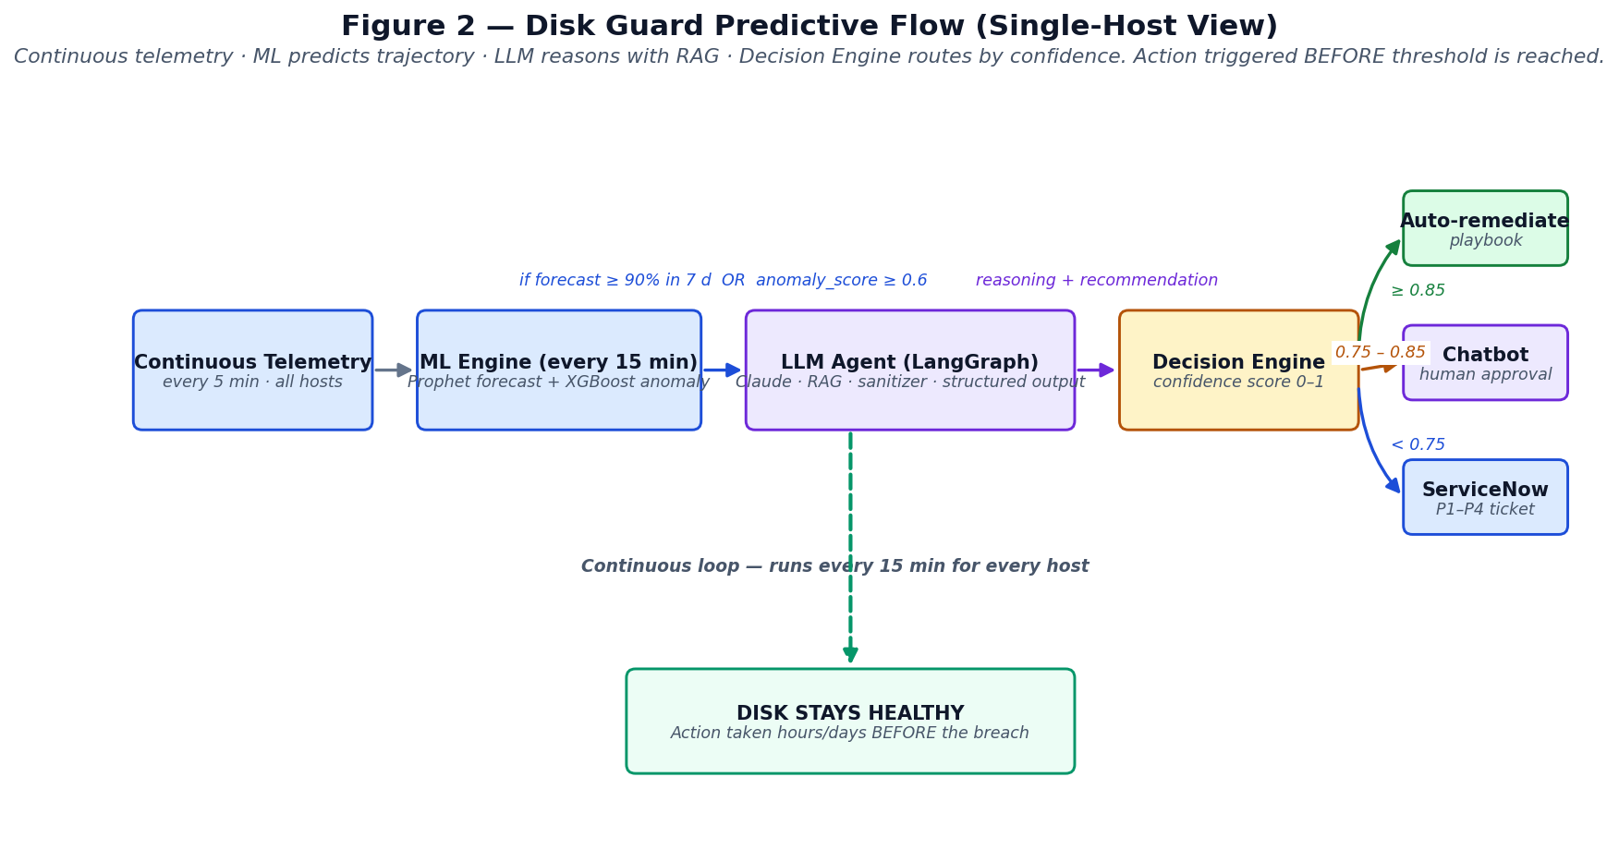
Figure 2
Telemetry is collected continuously, as in the traditional architecture. Rather than feeding an alert evaluator, however, telemetry feeds a machine learning pipeline that runs every fifteen minutes across every host. The pipeline produces two outputs per host: a Prophet forecast at multiple horizons (1, 3, 7, and 14 days), and an XGBoost anomaly score that quantifies how much the recent growth pattern deviates from the host’s historical baseline.
A host advances to the next stage only if either of two conditions is met: the forecast projects threshold breach within the preemptive horizon (default seven days), or the anomaly score exceeds a sensitivity threshold (default 0.6). When advanced, the host’s full context — its metadata, its current ML prediction, its file listing, and a sanitized set of retrieved runbook excerpts — is presented to a Claude-powered agent built on a LangGraph state machine.
The agent produces a structured JSON recommendation: clean, escalate anomaly, or no action. A Decision Engine then combines the agent’s self-confidence, the alignment between agent recommendation and ML signal, the strength of RAG grounding, and the host’s environmental risk profile into a single 0–1 score, which is mapped to one of three routes: auto-remediate (≥0.85), chatbot approval (0.75–0.85), or ServiceNow ticket only (<0.75).
The crucial observation is that this entire cycle completes in seconds to a few minutes from the moment growth begins. Because the system acts on trajectory rather than on level, it can intervene while the disk is still in a healthy band — typically 30–70% utilization — giving operators and on-call teams ample buffer.

3.2 Side-by-side comparison
Figure 3 contrasts the two approaches against a common incident scenario: a logger bug, introduced by a deploy, that begins writing several hundred megabytes of stack-trace output per minute to /var/log.
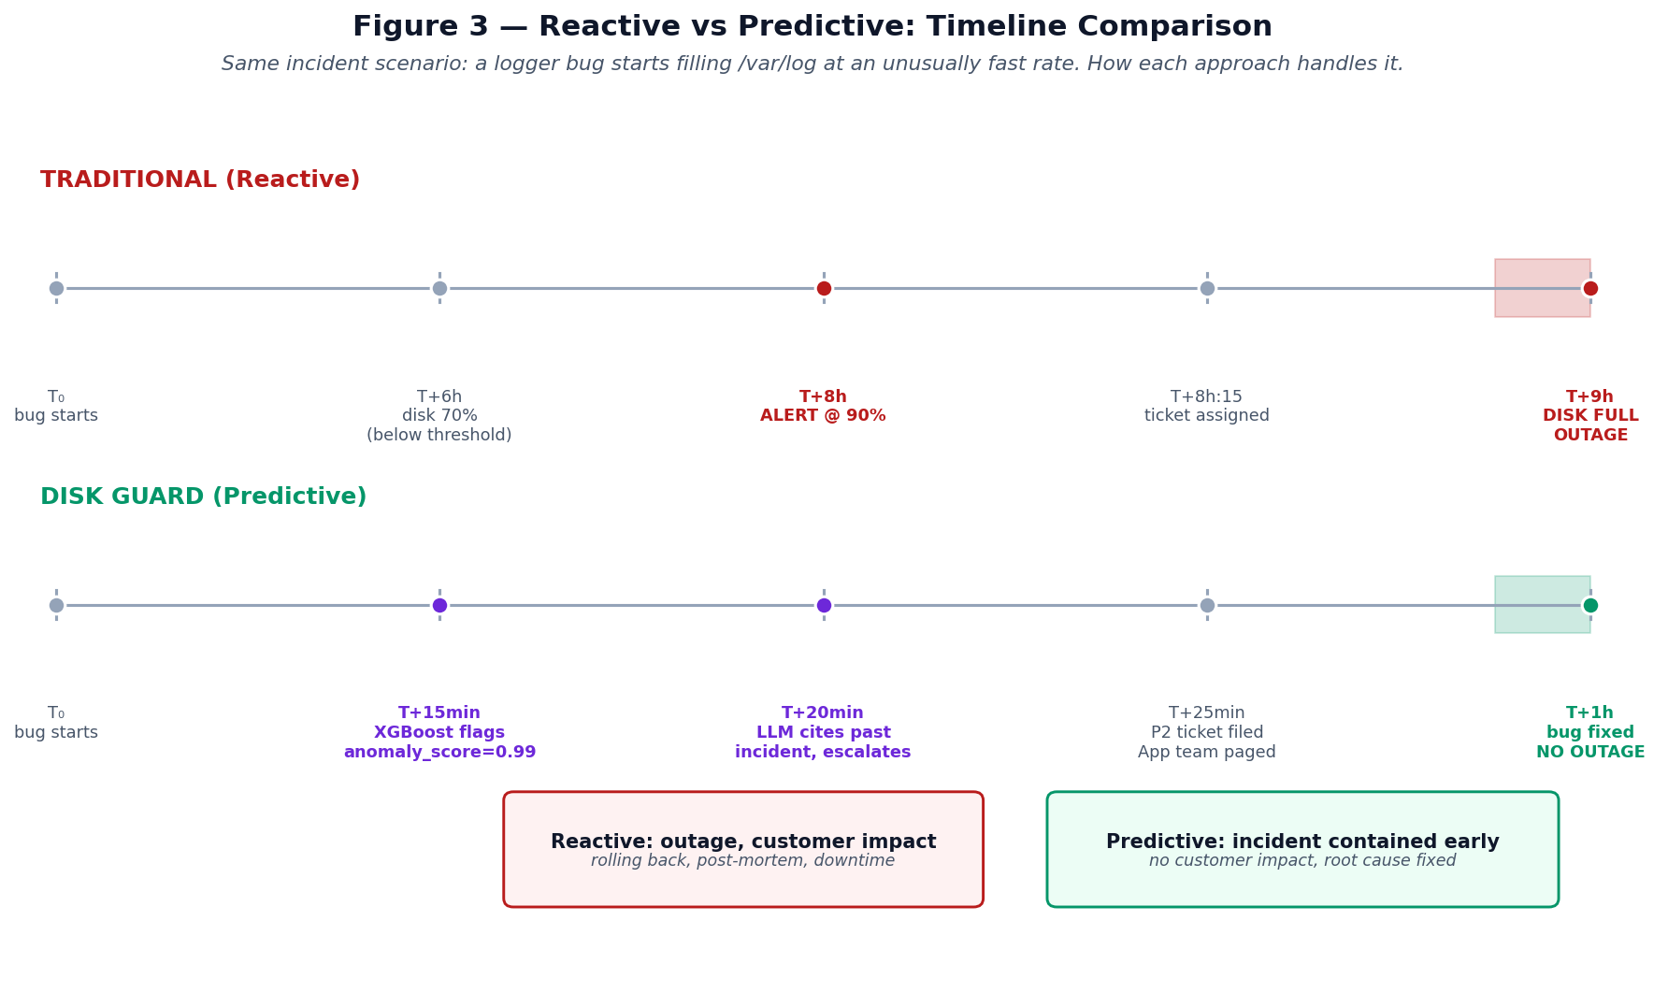
Figure 3
Under the traditional reactive model, the volume crosses 90% utilization at approximately T+8 hours, generating an alert. The incident ticket reaches the on-call engineer at T+8h:15. Even if the engineer responds within fifteen minutes, the volume is fully saturated by T+9h, and the host enters degraded or fully-failed state before remediation completes.
Under the Disk Guard predictive model, the XGBoost anomaly classifier detects the unusual growth pattern at the next ML cycle (T+15 minutes after the bug begins). The LLM agent runs at T+20 minutes, retrieves relevant past-incident records from the RAG corpus, recognizes the pattern, and recommends escalation rather than cleanup. A P2 ServiceNow ticket is filed at T+25 minutes and routed to the application team responsible for the offending deploy. The bug is identified and rolled back at approximately T+1 hour. The disk never saturates. There is no customer-facing outage.
The same telemetry stream — the same physical signal arriving at the monitoring infrastructure — produces fundamentally different operational outcomes depending on how it is consumed. Disk Guard is a different consumer of that stream.

4. System Architecture

4.1 Reference architecture
The complete Disk Guard architecture is shown in Figure 4 (architecture overview) and decomposed into four zones described below.
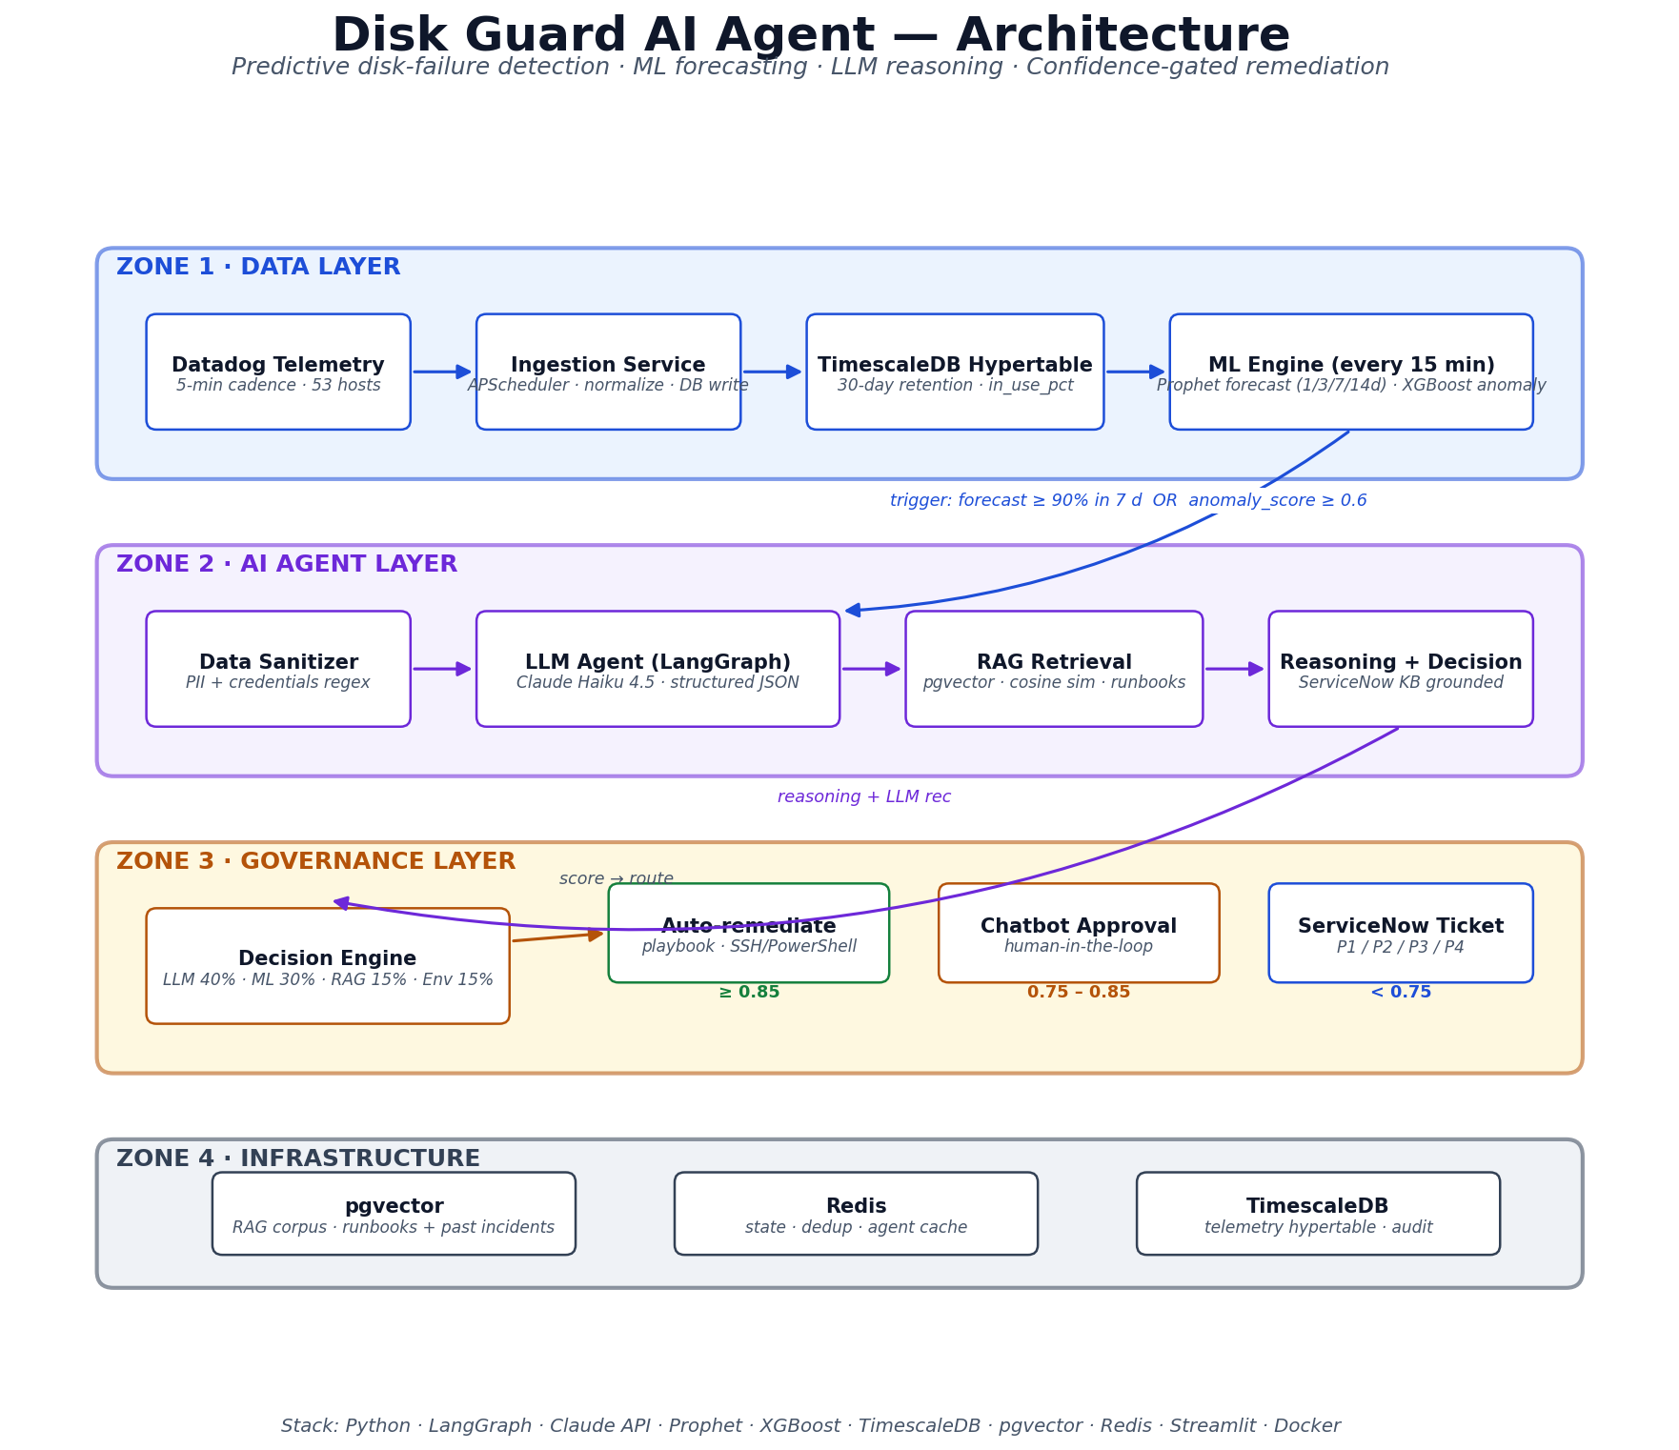
Figure 4
The four-zone organization mirrors the canonical layered structure of modern data-and-ML platforms: a Data Layer responsible for ingestion and storage, an AI Agent Layer responsible for reasoning, a Governance Layer responsible for authorizing and executing action, and an Infrastructure Layer providing supporting state and retrieval services.
Each zone has a well-defined contract with its neighbors. The Data Layer’s contract with the AI Agent Layer is “produce a triggered prediction”; the AI Agent Layer’s contract with the Governance Layer is “produce a structured recommendation with self-confidence”; and the Governance Layer’s contract with downstream systems (the host fleet, ServiceNow, the operator chatbot) is “execute the routed action with full audit.” This separation of concerns is what makes the system extensible — replacing Prophet with a different forecaster, or Claude with a different LLM, requires changes confined to a single zone.

4.2 Zone 1 — Data Layer
Telemetry ingests into a TimescaleDB hypertable, configured with 30-day retention. Each row in disk_telemetry records (timestamp, host_id, device, total_bytes, used_bytes, free_bytes, in_use_pct). For the POC, telemetry is generated by either (a) a synthetic generator that produces realistic growth patterns at the configured cadence across 50 simulated hosts, or (b) per-container telemetry agents running inside three real Linux Docker containers (web, app, and database roles).
An ingestion service, scheduled via APScheduler, runs every fifteen minutes. In a production deployment this service would poll the Datadog Metrics API and normalize the response; in the POC it synthesizes the next interval’s worth of samples to maintain a continuous time series.
A separate ML Engine runs at the same cadence, fitting per-host Prophet models on the recent history (default seven days), scoring each host’s feature vector through a pre-trained XGBoost binary classifier, and writing the resulting prediction (with all four forecast horizons, hours-to-90%, and the binary triggered_agent flag) into the ml_predictions table.

4.3 Zone 2 — AI Agent Layer
The agent is implemented as a six-node LangGraph state machine (Figure 5).
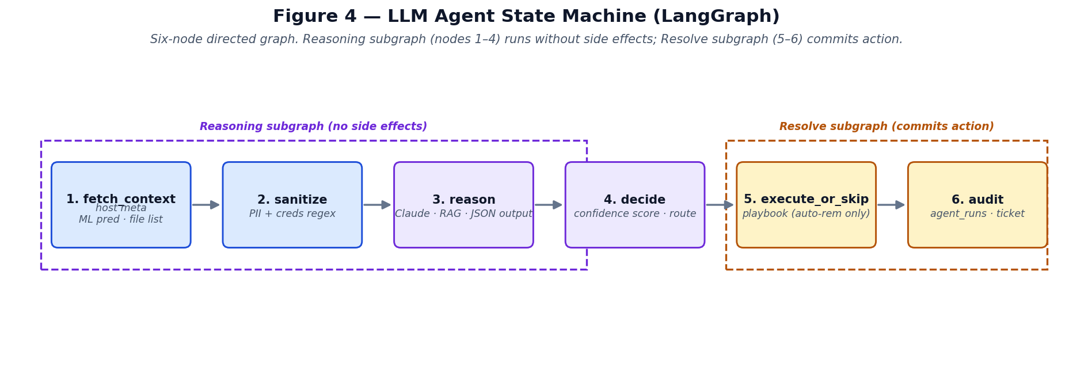
Figure 5
The graph splits cleanly into two subgraphs. The Reasoning subgraph (nodes 1–4) gathers context, sanitizes it, invokes the LLM, and computes the Decision Engine score. It produces no side effects — no audit row is written, no remediation is run, no ticket is filed. The Resolve subgraph (nodes 5–6) takes the output of Reasoning and commits the action: it executes the playbook if the route is auto-remediate, files the ticket if the verdict is escalated_anomaly, and writes the audit row.
This split serves both an architectural and a usability purpose. Architecturally, it allows a clean human-in-the-loop interception point: the system can present the reasoning to an operator and wait for explicit approval before committing. In the POC’s Streamlit interface the two subgraphs are exposed as two separate buttons (🧠 Reasoning, ✅ Resolve), allowing demonstrations to walk through each phase deliberately.
The fetch_context node populates the agent’s working memory from three sources: the host’s metadata (from the hosts table), the latest ML prediction (from ml_predictions), and a real-time directory listing obtained by docker exec against the host. The sanitize node passes all string-valued fields through a regex pipeline that removes thirteen classes of sensitive content (AWS access keys, Anthropic API keys, GitHub tokens, bearer tokens, private keys, embedded URL credentials, password command-line flags, email addresses, IPv4 addresses, MAC addresses, and several others), replacing each match with a category-tagged placeholder. The reason node serializes the sanitized context into a structured prompt and submits it to Claude Haiku 4.5 via LangChain Anthropic. The model is instructed to return a strict JSON object with four fields: recommendation, self_confidence, rationale, and key_evidence — a structured-output approach inspired by chain-of-thought [7] and ReAct [8] prompting patterns. The decide node converts the LLM output into a DecisionInput, hands it to the Decision Engine, and stores the returned DecisionResult in the agent’s state.

4.4 Zone 3 — Governance Layer
The Decision Engine is a pure function. Given a DecisionInput containing the LLM recommendation, the LLM self-confidence, the host’s ML signals, the count of retrieved RAG documents, and the host’s environment tag, it computes:
score = 0.40 × clip(llm_self_confidence)
+ 0.30 × ml_alignment(recommendation, anomaly_score, forecast_7d)
+ 0.15 × min(1.0, rag_doc_count / 4)
+ env_boost[environment] # prod: 0.05, staging: 0.10, dev: 0.15
The score is clamped to [0, 1] and routed:
- score ≥ 0.85 → auto_remediate
- 0.75 ≤ score < 0.85 → opsgpt_chat (chatbot approval)
- score < 0.75 → ticket_only (ServiceNow only)
Two hard rules override the score:
- If the LLM recommends clean but anomaly_score > 0.6, the score is capped below the auto-remediate threshold. The system never auto-cleans when the ML signal contradicts the LLM recommendation.
- If the LLM recommends escalate_anomaly, the score is floored at the chatbot threshold so that escalations always reach at least a human-in-the-loop review.
The Remediation Engine consumes auto-remediate routes. It selects a per-role playbook (web, app, or db, with a fallback for unknown roles), identifies candidate files via container find invocations, applies a fixed set of safety guards (minimum file age 24 hours, maximum 80 GB freed per run, maximum 200 files deleted per run, path whitelist verification), and deletes the surviving candidates via rm. The guards are absolute — they apply regardless of the LLM recommendation or the Decision Engine score.
A mock ServiceNow client implements the ticketing path. In production this would call the real ServiceNow Incident API; in the POC it inserts rows into a local servicenow_tickets table that mirrors the Incident table shape. Severity selection follows simple rules (escalate_anomaly → P2 to the application team for the affected role; imminent forecast breach → P2 to Infra-Capacity; routine ticket-only → P3). Each ticket links back to the agent_run that produced it.

4.5 Zone 4 — Infrastructure Layer
Three supporting services round out the architecture:
- pgvector stores the RAG corpus: synthesized runbooks, past-incident records (modeled after real ServiceNow KB entries), and disk-cleanup policy documents. Each document is embedded with the sentence-transformers/all-MiniLM-L6-v2 model into a 384-dimensional vector, indexed via HNSW for fast cosine similarity search.
- Redis holds short-lived state: session caches, deduplication keys for the agent loop, and a planned (not yet wired) cross-host event bus.
- TimescaleDB is shared with Zone 1 but additionally hosts the agent_runs audit table (one row per agent invocation, with full LLM reasoning, tool-call trace, RAG document IDs, and final verdict) and the servicenow_tickets mock table.

5. Implementation
The complete implementation is approximately 2,500 lines of Python plus SQL schemas and Docker Compose definitions. The code is organized into single-responsibility modules under services/ (one per architectural component), data/ (ingestion, generation, seeding), shared/ (config, schemas, DB pools), and ui/ (the Streamlit demonstration application).

5.1 Telemetry ingestion
The synthetic generator produces a fleet of 50 hosts following a stratified distribution across four behavioral patterns:
- stable (70%) — usage holds near a baseline with mild noise and a diurnal cycle.
- declining (15%) — slow steady drift toward the threshold at 0.5–2 GB/day.
- anomalous (10%) — stable for the first 80% of the window, then abrupt acceleration in the final 20%.
- critical (5%) — already above 90% utilization.
Stratified sampling guarantees that all four patterns appear in any fleet size, including the small (≤50 host) configurations used during demonstrations. The seed value is fixed, so the same fleet is reproduced across runs.
The three real demo containers (demo-web-01, demo-app-01, demo-db-01) each run an in-process Python agent that, every sixty seconds, walks its monitored directory, computes total bytes used, and inserts a row into disk_telemetry. This gives the demonstration a mixture of synthetic-only hosts and hosts with actual filesystems on which fill and remediation operations can be performed via docker exec.

5.2 ML Engine
The Prophet wrapper fits one model per host on the most recent seven days of telemetry. Configuration uses linear growth with daily seasonality, no weekly seasonality (most server log volumes do not show strong seven-day patterns at the granularity we need), and zero uncertainty samples (point estimates only, for performance). After fitting, the model produces a fourteen-day forward forecast at the host’s sample cadence; the output is post-processed to extract the projected in_use_pct at each of the configured horizons (1, 3, 7, 14 days) and the projected hours_to_90pct (interpolated from the first time the forecast crosses 90%).
The XGBoost classifier is a binary model trained on a feature vector derived from each host’s recent series:
mean, std, min, max, range,
slope_full, slope_recent_24h, slope_acceleration,
residual_std, max_abs_jump_24h, p90_minus_p10,
current_value
The training set is generated synthetically: 500 ephemeral hosts (not persisted to the demo fleet) with the same stratified pattern distribution, labeled anomalous=1 for the anomalous pattern and anomalous=0 for the others. With this clean labeling the classifier achieves 100% accuracy and 100% recall on a held-out 25% test split. The trained model is persisted to ml_artifacts/anomaly_xgb.json and loaded at inference time.
The full ML cycle (Prophet for 53 hosts plus XGBoost batch scoring) completes in approximately 8 seconds on commodity Apple Silicon hardware, comfortably within the 15-minute scheduling cadence.

5.3 LLM Agent
The agent’s system prompt instructs the model to apply a three-step decision framework: anomaly first (escalate if anomaly score is high and the file listing shows recent rapid growth in a small number of files), forecast with safe candidates (clean if the forecast projects breach within the preemptive window and the file listing contains genuinely-safe candidates such as rotated .gz archives older than 24 hours), and stable / no-safe-candidates (no action if the trajectory is stable or the only large files are active .log files).
The model is required to output a single JSON object:
{
"recommendation": "clean" | "escalate_anomaly" | "no_action",
"self_confidence": 0.0 .. 1.0,
"rationale": "2-4 sentences explaining the reasoning",
"key_evidence": ["bullet", "bullet", ...]
}
The user prompt is dynamically constructed and includes:
- Host metadata (id, hostname, role, environment, OS, monitored path, total disk capacity).
- The latest ML prediction (anomaly score, all four forecast horizons, hours-to-90%, triggered flag).
- The current file listing of the monitored path, sorted largest-first and capped at 30 entries, with size, age, and a heuristic active-log flag for each file.
- The top four most-similar runbook / past-incident excerpts retrieved from pgvector.
For the model itself we use Claude Haiku 4.5. At the scale of a single agent invocation (~3,000 input tokens, ~300 output tokens), cost is approximately $0.005 per run. A production fleet of 3,000 hosts running the agent at a conservative 5% trigger rate every fifteen minutes would cost approximately $50/day, which is below the cost of two hours of an SRE’s time per day at typical enterprise rates.

5.4 RAG corpus
The corpus consists of ten seeded documents covering the major content categories an enterprise would have:
- Per-role cleanup runbooks (Linux web, Linux app, Linux database, Windows generic).
- Anomaly-response procedures, including an explicit “do not auto-clean anomalous growth” runbook.
- A simulated past-incident record (INC-2024-0817) describing a real failure mode in which routine cleanup masked an upstream debug-logging bug, requiring a second outage before root cause was identified.
- Disk-cleanup safety policy.
- Log retention requirements by environment.
- Capacity-expansion guidance for hosts whose logs are all within-retention.
The presence of explicit past-incident content is essential: it is what allows the LLM, when faced with an anomalous growth pattern, to recognize the pattern and refuse to clean. In our demonstrations the LLM consistently retrieves and cites the simulated past-incident record when the current scenario matches.

5.5 Decision Engine
The Decision Engine is implemented as a single pure function with exhaustive unit tests. Its inputs and outputs are typed Pydantic models. The score weights and threshold values are read from configuration; defaults match the values cited in §4.4.
The engine is intentionally simple and explainable. Each component of the score is captured in a rationale list that becomes part of the audit row. An operator reviewing an audit trail can read, at a glance, why the engine routed a particular run to a particular destination.

5.6 Remediation Engine
Per-role playbooks are encoded as ordered lists of glob-and-min-age rules:
WEB_PLAYBOOK = Playbook(role="web", rules=(
CleanupRule(glob="*.log.[0-9]*", min_age_days=14, ...),
CleanupRule(glob="*.log.gz", min_age_days=21, ...),
CleanupRule(glob="*-archive-*.log*", min_age_days=14, ...),
))
The executor walks each rule’s matching files (via find inside the container), applies the four absolute safety guards in §4.4, and deletes survivors via rm -f. Every action is recorded.

5.7 ServiceNow integration
The mock client mirrors the ServiceNow Incident table shape: ticket_id (formatted as INC-YYYY-MM-NNNN with monotonic per-month sequencing), severity, status (with a five-state lifecycle: new → assigned → in_progress → resolved → closed), short_description, description, host_id, assignment_group, agent_run_id (linking back to the originating audit row), and a JSONB metadata blob.
The description field is auto-populated with a structured incident report containing the affected configuration item details, the latest ML signals, the agent’s verdict and confidence score, the LLM’s full reasoning, and a recommended next-steps section. In a real deployment this is precisely what the responding engineer reads before investigating.

6. Operational Workflow

6.1 The Monitor → Predict → Reason → Resolve flow
The Streamlit demonstration UI structures the operator interaction around four numbered stages:
Stage 1 — Monitor. The operator sees the host’s current disk-usage trajectory over the last 24 hours, 3 days, or 7 days. A “Fill Disk” simulator allows the operator to write sparse files into the container’s monitored path, optionally backfilling that many minutes of history at the new percentage so that the ML engine sees the change on its next cycle. This is purely a demonstration affordance — in production the monitor stage is read-only.
Stage 2 — Predict. The operator clicks “Run ML Prediction.” The system fits Prophet on the host’s recent telemetry, scores via the cached XGBoost model, and writes a row to ml_predictions. The five key signals (anomaly score, forecast at 1d, 7d, hours-to-90%, triggered flag) are displayed as metric cards. A freshness indicator below the metrics shows the prediction timestamp and age, so that repeated clicks produce a visible signal even when the underlying numbers are stable.
Stage 3 — Reasoning. The operator clicks “Run Reasoning.” The LangGraph reasoning subgraph executes: the host’s full context is gathered, sanitized, sent to Claude, and scored by the Decision Engine. The recommendation, self-confidence, route, and confidence score are displayed, along with the LLM’s plain-language rationale and key evidence list. Crucially, no audit row is written and no action is taken at this stage. The operator can read the agent’s reasoning and decide whether to commit.
Stage 4 — Resolve. The operator clicks “Resolve.” The Resolve subgraph executes: if the route is auto-remediate and the LLM recommended clean, the playbook runs and files are deleted. If the verdict is escalated_anomaly, a P2 ServiceNow ticket is filed and the ticket ID returned. If the route is opsgpt_chat, the run is recorded and surfaced on the chatbot page for human approval. The audit row is written to agent_runs regardless of route.
The two-stage commit (Reasoning then Resolve, exposed as separate buttons in the UI but as separate compiled LangGraph subgraphs in code) is the architecturally significant design choice. It allows operators in production deployments to require an explicit human review step before any side effect is committed, without sacrificing the auto-remediation path for high-confidence routine cleanups.

6.2 Confidence-gated routing
In the auto-remediation path, the Resolve subgraph runs the per-role cleanup playbook against the host. The playbook’s safety guards (minimum file age, per-run byte cap, per-run file cap, path whitelist) are applied at the executor level and bound the worst-case impact of any single run.
In the chatbot-approval path, the run is recorded with decision = opsgpt_chat. The chatbot page picks up such runs as pending; an operator can browse the LLM’s reasoning, ask follow-up questions in a chat input (which the LLM answers grounded in the run’s context), and finally click Approve or Deny. Approve triggers either a cleanup (if the LLM recommended clean) or a P2 ticket (if the LLM recommended escalate_anomaly); the button label adapts to make this explicit.
In the ticket-only path, a P3 ServiceNow ticket is filed with the full agent reasoning attached, but no automated action is taken. The responding engineer is the source of truth in this case; the ML and LLM have served only as decision support.

6.3 Worked example: anomalous-growth scenario
To make the routing logic concrete, consider the scenario shown in Figure 3. At T+15 minutes after a misconfigured logger begins writing 500 MB/minute to /var/log/app, the next ML cycle produces:
anomaly_score: 0.997
forecast_7d_pct: 100.0
hours_to_90pct: 24.1
triggered_agent: true
At T+20 minutes the LLM agent fires. The fetch_context node retrieves the host metadata (a production app server), the latest prediction above, the file listing (showing a single 64 GB app-debug.log file with mtime 0 days ago — i.e., still being written), and the top four RAG documents matching a query of “linux app server anomalous log growth”. The retrieved set includes the simulated past-incident record INC-2024-0817, which describes an essentially identical scenario.
The reason node submits the full context to Claude, which returns:
{
"recommendation": "escalate_anomaly",
"self_confidence": 0.98,
"rationale": "Anomaly score of 0.997 combined with a single massive
file (app-debug.log, 64 GB, age 0 days) exhibiting
explosive growth is a textbook upstream incident
signature. INC-2024-0817 demonstrates that cleanup of
anomalous growth merely delays the inevitable disk
fill; the correct response is to identify the
upstream cause and remediate it. Filing a P2 ticket
to the application team is the appropriate action.",
"key_evidence": [
"anomaly_score 0.997",
"single dominant file growing in real time",
"INC-2024-0817 past-incident pattern match"
]
}
The decide node hands this to the Decision Engine. The score calculation:
LLM self-confidence: 0.40 × 0.98 = 0.392
ML alignment (anomaly): 0.30 × 0.997 = 0.299
RAG grounding (4 docs): 0.15 × 1.00 = 0.150
Environment (prod): 0.050
-------
0.891
The escalate_anomaly hard rule floors the score at the chatbot threshold (already exceeded), so the route is auto_remediate. In the Resolve subgraph, the execute node observes that the LLM did not recommend clean and skips the playbook. The audit node sets verdict to escalated_anomaly and invokes the ServiceNow client, which files ticket INC-2026-05-0001 (P2, assignment group App-Support-app) with the agent’s full reasoning embedded in the description. The ticket ID is written back to the audit row.
The application team is paged. They identify the bug in the morning’s deploy, roll back, and the disk never reaches saturation. Disk Guard’s contribution was not the bug fix itself but the timely, well-grounded escalation. A reactive system would have produced a misleading “disk full” alert at T+8 hours, an automated cleanup that masked the problem, and a recurring failure that delayed root-cause analysis by hours. Disk Guard produced a correct upstream attribution within twenty-five minutes.

7. Validation

7.1 Test fleet and dataset
The POC is validated against a fleet of 53 hosts: 50 simulated (stratified across the four patterns of §5.1) plus three real Linux Docker containers (web, app, db roles). The simulated hosts produce 6,048 telemetry samples each across seven days at five-minute cadence for a total of approximately 100,800 rows in the disk_telemetry hypertable; the real containers report continuously thereafter at one-minute cadence.

7.2 Test scenarios
Two demonstration scenarios are run end-to-end and recorded in the audit trail:
Scenario A — Predictive cleanup of routine rotated logs. A demonstration host with no anomaly history is filled to approximately 85% utilization, with several large rotated .log.gz files of varying ages 30–90 days planted in the monitored directory. The ML cycle predicts forecast_7d ≈ 100% and anomaly_score ≈ 0.003. The LLM agent recommends clean, citing the host’s web role and the applicability of the web cleanup runbook. The Decision Engine scores the run at approximately 0.87, routing to auto-remediate. The remediation engine deletes the four rotated archives, freeing approximately 16 GB. The verdict is cleaned.
Scenario B — Anomalous-growth refusal. A demonstration host’s monitored directory is filled with a single 60 GB junk file written in seconds. The ML cycle predicts forecast_7d ≈ 100% and, after sufficient samples, anomaly_score ≈ 0.997. The LLM agent retrieves INC-2024-0817 from RAG and recommends escalate_anomaly. The Decision Engine scores approximately 0.89; the route is auto_remediate, but the execute node correctly skips remediation because the LLM did not recommend cleanup. The audit node files a P2 ServiceNow ticket and writes verdict escalated_anomaly. No files are deleted.
Both scenarios are reproducible from a clean state via ./scripts/demo_reset.sh, which preserves the seed history and trained model while wiping runtime artifacts.

7.3 Performance characteristics
- Full ML cycle (53 hosts): approximately 8 seconds end-to-end (Prophet fits dominate; XGBoost batch scoring is sub-second).
- Single-host on-demand prediction: approximately 3 seconds.
- End-to-end agent invocation (Reasoning + Resolve): 8–15 seconds, dominated by the Claude API round-trip.
- XGBoost holdout accuracy: 100% on a 125-host stratified test split derived from a 500-host ephemeral training set; in production with real labeled incident data, this number would be dictated by the quality of historical incident classification.

7.4 Cost characteristics
- Per-agent run LLM cost: approximately USD 0.005 at Claude Haiku 4.5 pricing.
- Storage: approximately 1 GB of TimescaleDB at 30-day retention for a 3,000-host fleet at five-minute cadence.
- Compute: the ML engine fits comfortably on a single general-purpose container; the LLM agent is bound by external API latency rather than local compute.

8. Discussion

8.1 Comparison with related work
Predictive disk monitoring is not itself a new idea — capacity-planning tools have offered linear extrapolation for decades, and the broader literature on online failure prediction is well-developed [10], [11]. What is novel about the present work is the integration of (a) modern time-series forecasting (Prophet [1], with its handling of changepoints and seasonality), (b) a dedicated gradient-boosted anomaly classifier [2] rather than a threshold rule on the forecast, (c) a language-model reasoning step [6] grounded in retrieved domain content [5], and (d) an explicit governance layer that converts model outputs into auditable operational decisions. Each of these components has been deployed in isolation in production AIOps systems [9]; their joint deployment, structured around the four-zone reference architecture and exposed through a coherent operator workflow, is the contribution.
A second observation is that this composition pattern generalizes to operations problems beyond disk management. The same architecture — forecasting a state variable, classifying anomalous trajectories, reasoning over retrieved runbooks, gating action by confidence — applies directly to service-restart prediction, backup-job-failure prediction, and capacity planning more broadly. The Disk Guard agent is one instance of a more general pattern.

8.2 Limitations of the POC
The POC has several explicit limitations.
Synthetic telemetry. All telemetry in the POC is synthesized rather than ingested from a real Datadog deployment. The synthetic patterns are realistic but bounded — real-world telemetry exhibits long-tail behaviors (server-room outages, planned maintenance windows, multi-modal seasonal patterns) that the synthetic generator does not attempt to reproduce. A first-tier production validation would be to replay the existing Datadog corpus through the system and measure trigger rates, false-positive rates, and time-to-action distributions.
Mock ServiceNow. The integration is local-only. Production deployment requires the organization-specific ServiceNow REST API client, OAuth/CMDB integration, and assignment-group routing rules.
Synthetic RAG corpus. The ten seeded documents are representative but small. A production deployment would mirror the customer’s actual runbook and KB content, with appropriate document-level access controls and a refresh pipeline.
Single-domain scope. The POC is disk-focused. The same architecture applies to other IT-Ops domains, but operationalizing each requires a domain-appropriate playbook library, role-specific RAG content, and domain-specific safety guards.
Demonstration scale. The 50-host simulated fleet is sufficient to exercise every architectural component but is two orders of magnitude below the 3,000-host scale claimed by the design. Validation at full scale requires Prophet model training and inference cost analysis, ML pipeline parallelization, and a horizontally-scaled telemetry ingestion path.
LLM dependency. The current implementation has a hard dependency on the Anthropic Claude API. If the API is unavailable, the ML pipeline continues to flag triggered hosts but the agent cannot run; in this degraded state the system defaults to the ticket-only route. A more robust deployment would include a local-model fallback for at least the reasoning step, accepting some loss of quality for resilience.

8.3 Production considerations
Several operational concerns must be addressed before production deployment:
- Credential management. The Anthropic API key, ServiceNow credentials, GitHub tokens, and database passwords must be sourced from a vault rather than environment variables. The Data Sanitizer reduces but does not eliminate the risk of credential exposure to the LLM; layered defenses (vault-managed secrets, network-level egress restrictions, content-aware DLP on outbound traffic) are appropriate.
- Action authorization. The auto_remediate path executes file deletions on production hosts. This requires careful per-host trust configuration: which hosts are eligible for auto-remediation, by which playbooks, and under what change-control regime. The default posture should be that no host receives auto-remediation until explicitly enrolled.
- Audit retention. Every agent invocation writes a row to agent_runs with full LLM reasoning. This is the system’s primary compliance artifact; retention should match or exceed organizational requirements for incident records (typically two to seven years).
- Drift monitoring. Both the Prophet model and the XGBoost classifier require periodic retraining as the fleet evolves. A scheduled retraining pipeline, with model-version pinning and rollback, is essential.

8.4 Generalization
The four-zone reference architecture generalizes to a broader class of IT-Operations problems. The same pattern — continuous telemetry, ML forecasting, anomaly classification, LLM reasoning over retrieved runbooks, confidence-scored governance — applies to:
- Service uptime prediction (forecast probability of process crash, reason about cause, route to restart-or-escalate).
- Backup completion (forecast job duration, classify anomalous slowness, escalate to backup operations).
- Storage capacity planning across SAN/NAS volumes.
- Network bandwidth saturation prediction.
The Disk Guard agent is best understood not as a standalone product but as the first instance of a reusable pattern.

9. Future Work
Several directions are immediately tractable:
- Real Datadog ingestion. Replace the synthetic generator with a Datadog Metrics API client, validate trigger and false-positive rates against a real production corpus.
- Per-host learned baselines. The current XGBoost classifier produces fleet-level anomaly scores. A per-host baseline (each host learning its own expected growth rate) would improve sensitivity for hosts with non-standard usage patterns.
- Cross-host correlation. Anomaly events on multiple hosts within a short window often share a common upstream cause (a deploy, a configuration push). A fleet-level correlator that recognizes such patterns and produces a single high-level escalation would reduce alert volume without losing signal.
- Local-model fallback. A locally-hosted small language model for the reasoning step would allow continued operation during Anthropic API outages, accepting some loss of reasoning quality for availability.
- Multi-domain agent library. A reusable framework for building per-tower agents (services, backups, storage, network) sharing the same architecture but parameterized for the domain’s specific playbooks, RAG content, and safety rules.
- Active learning from operator feedback. Approve / deny actions in the chatbot path are signals about the quality of the LLM’s recommendation. Using these signals to fine-tune prompts or to adjust the Decision Engine weights would allow the system to improve over time without requiring manual recalibration.

10. Conclusion
Disk-fill is a well-understood failure class with well-understood operational cost. The dominant mitigation today — threshold-based monitoring with reactive cleanup — handles routine cases reasonably well and fails badly at exactly the moments when getting it right matters most: the anomalous fast-fill cases driven by deploy regressions and runaway processes. The structural fix is simple to state: stop waiting for the threshold breach. Watch the trajectory instead. Act before the disk is in trouble, not after.
That is what I set out to build with Disk Guard AI Agent, and that is what this paper has described. The system continuously forecasts disk-fill trajectories using Prophet, classifies anomalous growth patterns with XGBoost, and asks a Claude-powered LangGraph agent — grounded in retrieved runbook and past-incident content — to reason about what to do. The resulting recommendation is then scored and routed by an explicit governance layer: auto-remediate when the system is confident enough to act on its own, route to the operator chatbot when human judgment is the safer call, or simply file a ticket when the signal is too weak to warrant either. Every step is auditable. Every action has a reason attached.
The system works. On the 53-host POC fleet it produces correct, explainable decisions in seconds rather than minutes. It tells routine cleanup opportunities apart from anomalous-growth incidents. When the LLM recommends escalation rather than cleanup — which it does whenever the past-incident corpus suggests cleanup would mask an upstream problem — the executor correctly refuses to delete files and a P2 ticket is filed instead. That last behavior is the one I am most pleased with, because it is exactly the failure mode that the threshold-based reactive systems get wrong.
The contribution is not a new algorithm. It is a working composition pattern: how to combine forecasting, anomaly detection, LLM reasoning, retrieval, and governance into a system that can be deployed in real IT-operations environments without giving up either safety or transparency. Disk is the first instance. The same pattern applies directly to service uptime, backup verification, storage capacity, and network bandwidth — anywhere the structure of predict the trajectory, reason about it, decide carefully, then act is the right way to organize the response.
The complete source code, architecture diagrams, demonstration scripts, and reproduction instructions are at the repository cited above. I welcome feedback, contributions, and replication on real production telemetry from anyone working on similar problems.

Acknowledgments
The author thanks Tata Consultancy Services for sponsoring the research program under which this work was developed, and the broader TCS Infrastructure Operations community for grounding insight on real-world disk-incident patterns. The author is also grateful to the open-source maintainers of Prophet, XGBoost, LangGraph, LangChain, sentence-transformers, pgvector, TimescaleDB, Redis, Streamlit, and Docker, whose work this implementation rests upon, and to Anthropic for the Claude API and SDK.
Disclosure of AI assistance. Portions of this manuscript were drafted with assistance from Anthropic’s Claude large language model (model: claude-haiku-4-5; integration: Anthropic Python SDK), under the direct guidance, factual review, and final editorial approval of the author. All technical claims, architectural decisions, implementation details, market estimates, and validation results reflect the author’s own work. The author is solely responsible for the content, accuracy, and conclusions of this paper, in accordance with the IEEE Author Center’s policy on the use of generative artificial intelligence in scientific writing.

References
[1] S. J. Taylor and B. Letham, “Forecasting at scale,” The American Statistician, vol. 72, no. 1, pp. 37–45, 2018. doi: 10.1080/00031305.2017.1380080
[2] T. Chen and C. Guestrin, “XGBoost: A scalable tree boosting system,” in Proc. 22nd ACM SIGKDD Int. Conf. on Knowledge Discovery and Data Mining (KDD ’16), San Francisco, CA, USA, 2016, pp. 785–794. doi: 10.1145/2939672.2939785
[3] N. Reimers and I. Gurevych, “Sentence-BERT: Sentence embeddings using Siamese BERT-networks,” in Proc. 2019 Conf. on Empirical Methods in Natural Language Processing and the 9th Int. Joint Conf. on Natural Language Processing (EMNLP-IJCNLP), Hong Kong, China, Nov. 2019, pp. 3982–3992. doi: 10.18653/v1/D19-1410
[4] Y. A. Malkov and D. A. Yashunin, “Efficient and robust approximate nearest neighbor search using Hierarchical Navigable Small World graphs,” IEEE Transactions on Pattern Analysis and Machine Intelligence, vol. 42, no. 4, pp. 824–836, Apr. 2020. doi: 10.1109/TPAMI.2018.2889473
[5] P. Lewis, E. Perez, A. Piktus, F. Petroni, V. Karpukhin, N. Goyal, H. Küttler, M. Lewis, W.-T. Yih, T. Rocktäschel, S. Riedel, and D. Kiela, “Retrieval-augmented generation for knowledge-intensive NLP tasks,” in Advances in Neural Information Processing Systems, vol. 33, 2020, pp. 9459–9474.
[6] T. B. Brown, B. Mann, N. Ryder, M. Subbiah, J. Kaplan, P. Dhariwal, A. Neelakantan, et al., “Language models are few-shot learners,” in Advances in Neural Information Processing Systems, vol. 33, 2020, pp. 1877–1901.
[7] J. Wei, X. Wang, D. Schuurmans, M. Bosma, B. Ichter, F. Xia, E. Chi, Q. Le, and D. Zhou, “Chain-of-thought prompting elicits reasoning in large language models,” in Advances in Neural Information Processing Systems, vol. 35, 2022, pp. 24824–24837.
[8] S. Yao, J. Zhao, D. Yu, N. Du, I. Shafran, K. Narasimhan, and Y. Cao, “ReAct: Synergizing reasoning and acting in language models,” in Proc. 11th Int. Conf. on Learning Representations (ICLR), Kigali, Rwanda, May 2023.
[9] P. Notaro, J. Cardoso, and M. Gerndt, “A survey of AIOps methods for failure management,” ACM Computing Surveys, vol. 53, no. 3, Article 53, pp. 1–45, 2021. doi: 10.1145/3464743
[10] F. Salfner, M. Lenk, and M. Malek, “A survey of online failure prediction methods,” ACM Computing Surveys, vol. 42, no. 3, Article 10, pp. 1–42, 2010. doi: 10.1145/1670679.1670680
[11] Q. Lin, K. Hsieh, Y. Dang, H. Zhang, K. Sui, Y. Xu, J.-G. Lou, C. Li, Y. Wu, R. Yao, M. Chintalapati, and D. Zhang, “Predicting node failure in cloud service systems,” in Proc. 2018 26th ACM Joint Meeting on European Software Engineering Conf. and Symp. on the Foundations of Software Engineering (ESEC/FSE), Lake Buena Vista, FL, USA, 2018, pp. 480–490. doi: 10.1145/3236024.3236060
[12] B. Beyer, C. Jones, J. Petoff, and N. R. Murphy, Site Reliability Engineering: How Google Runs Production Systems. Sebastopol, CA, USA: O’Reilly Media, 2016.
[13] A. Blázquez-García, A. Conde, U. Mori, and J. A. Lozano, “A review on outlier/anomaly detection in time series data,” ACM Computing Surveys, vol. 54, no. 3, Article 56, pp. 1–33, 2021. doi: 10.1145/3444690
[14] Anthropic, “The Claude 3 Model Family: Opus, Sonnet, Haiku (Model Card),” 2024. [Online]. Available: https://www-cdn.anthropic.com/de8ba9b01c9ab7cbabf5c33b80b7bbc618857627/Model_Card_Claude_3.pdf
[15] LangChain Inc., “LangGraph: Building stateful, multi-actor applications with large language models,” 2024. [Online]. Available: https://langchain-ai.github.io/langgraph/
[16] PostgreSQL Global Development Group, “PostgreSQL 17 Documentation,” 2024. [Online]. Available: https://www.postgresql.org/docs/17/
[17] Timescale Inc., “TimescaleDB: An open-source time-series database on PostgreSQL,” 2024. [Online]. Available: https://www.timescale.com/
[18] pgvector Contributors, “pgvector: Open-source vector similarity search for PostgreSQL,” 2024. [Online]. Available: https://github.com/pgvector/pgvector
[19] Datadog, “Disk integration and host metrics,” 2024. [Online]. Available: https://docs.datadoghq.com/integrations/disk/
[20] ServiceNow, “Now Platform — Incident Management,” 2024. [Online]. Available: https://www.servicenow.com/products/itsm/incident-management.html
[21] ITIC, “ITIC 2022 Hourly Cost of Downtime Survey: Hourly downtime costs rise; 91% of mid-sized & large enterprises say one hour of server downtime exceeds USD 300,000,” 2022. [Online]. Available: https://itic-corp.com/wp-content/uploads/2022/04/2022-Hourly-Cost-of-Downtime-Survey-results.pdf
[22] A. Lerner, “The cost of downtime,” Gartner Blog Network, Jul. 16, 2014 (widely cited industry baseline). [Online]. Available: https://blogs.gartner.com/andrew-lerner/2014/07/16/the-cost-of-downtime/

Appendix A — Tech Stack Summary
Layer | Component | Technology
Data | Telemetry store | TimescaleDB 2.17 (PostgreSQL 17 hypertables)
Data | Ingestion scheduling | APScheduler
Data | Forecasting | Prophet 1.3
Data | Anomaly classification | XGBoost 3.2
AI Agent | LLM provider | Anthropic Claude (Haiku 4.5)
AI Agent | Agent framework | LangGraph 0.2 + LangChain
AI Agent | Embeddings | sentence-transformers (all-MiniLM-L6-v2, 384-dim)
AI Agent | Sanitization | Custom regex pipeline (13 categories)
Governance | Decision Engine | Pure Python (Pydantic)
Governance | Remediation | Per-role playbooks via docker exec
Governance | Ticketing | Mock ServiceNow Incident table (production: REST API)
Infrastructure | RAG store | pgvector 0.8 (HNSW index, cosine similarity)
Infrastructure | State / cache | Redis 7.4
UI | Demonstration | Streamlit 1.57 + Plotly
Orchestration | Container runtime | Docker Compose (OrbStack on Apple Silicon)
Language | Implementation | Python 3.12
Testing | Unit + integration | pytest (39 tests)

Appendix B — Configuration Reference
Key configuration parameters (shared/config.py, with environment variable overrides):
# Pipeline cadence
SYNTHETIC_TELEMETRY_INTERVAL_MIN = 5
INGESTION_INTERVAL_MIN = 15
ML_RUN_INTERVAL_MIN = 15
# ML triggers
ML_TRIGGER_FILL_PCT = 90.0
ML_TRIGGER_HORIZON_DAYS = 7
ML_PREDICT_HORIZONS_DAYS = 1, 3, 7, 14
# Decision Engine thresholds
DECISION_AUTO_REMEDIATE_THRESHOLD = 0.85
DECISION_OPSGPT_CHAT_THRESHOLD = 0.75
# Embeddings
EMBEDDING_MODEL = sentence-transformers/all-MiniLM-L6-v2
EMBEDDING_DIM = 384
# LLM
OPSGPT_LLM_MODEL = claude-haiku-4-5

Appendix C — Repository Layout
opsgpt-disk-prediction-poc/
├── docker-compose.yml # Zone 1 + Zone 4 + 3 demo hosts
├── docker/
│ ├── timescaledb/init.sql # telemetry, predictions, audit, tickets
│ ├── pgvector/init.sql # knowledge_docs schema (RAG corpus)
│ └── demo-host/ # Linux container = one production server
├── data/
│ ├── synthetic_generator.py # 50 simulated hosts (stratified)
│ ├── seed_demo_hosts.py # 7-day history + disk alignment for real hosts
│ ├── seed_runbooks.py # 10-document RAG corpus
│ └── fill_disk.py # demo Fill Disk helper
├── shared/ # config, db pools, schemas, logging
├── services/
│ ├── ingestion/ # Zone 1: APScheduler + DB writer
│ ├── ml_engine/ # Zone 1: Prophet + XGBoost
│ ├── llm_agent/ # Zone 2: Claude + LangGraph + RAG
│ ├── decision_engine/ # Zone 3: confidence scoring + routing
│ ├── remediation/ # Zone 3: per-role playbooks
│ └── servicenow_mock/ # Zone 3: ticketing
├── ui/
│ ├── home.py # Fleet Overview (entry)
│ └── pages/
│ ├── 1_🖥️_Host_Detail.py # Monitor → Predict → Reason → Resolve
│ ├── 2_🤖_OpsGPT.py # chatbot for human approval
│ ├── 3_📋_Audit_Trail.py
│ └── 4_📨_Tickets.py
├── scripts/
│ ├── demo_reset.sh # fresh demo state in 30 s
│ ├── generate_architecture_diagram.py # Figure 4
│ └── generate_paper_diagrams.py # Figures 1-3, 5
├── docs/
│ └── disk-guard-whitepaper.md # this document
└── tests/ # 39 unit + integration tests

Document version 1.0. The accompanying repository is the source of truth; figures are regenerable via the scripts in scripts/. Feedback and pull requests are welcome at the cited repository URL.

