# Class Diagrams

## Introduction

CMS contains huge no of classes, in order to make class diagrams more readable, those have been categorized and a separate class diagram created for each category. Following is list of these categories

* Load Web Page
* Command Execution Flow
* State Machine and Command Response processing Flow

Following is brief explanation for same.

### Load Web page

This diagram shows a basic mechanism used by CMS to load a web page. The same mechanism is then applicable to load all other pages in CMS. The class diagram below shows the classes involved in loading the home page –

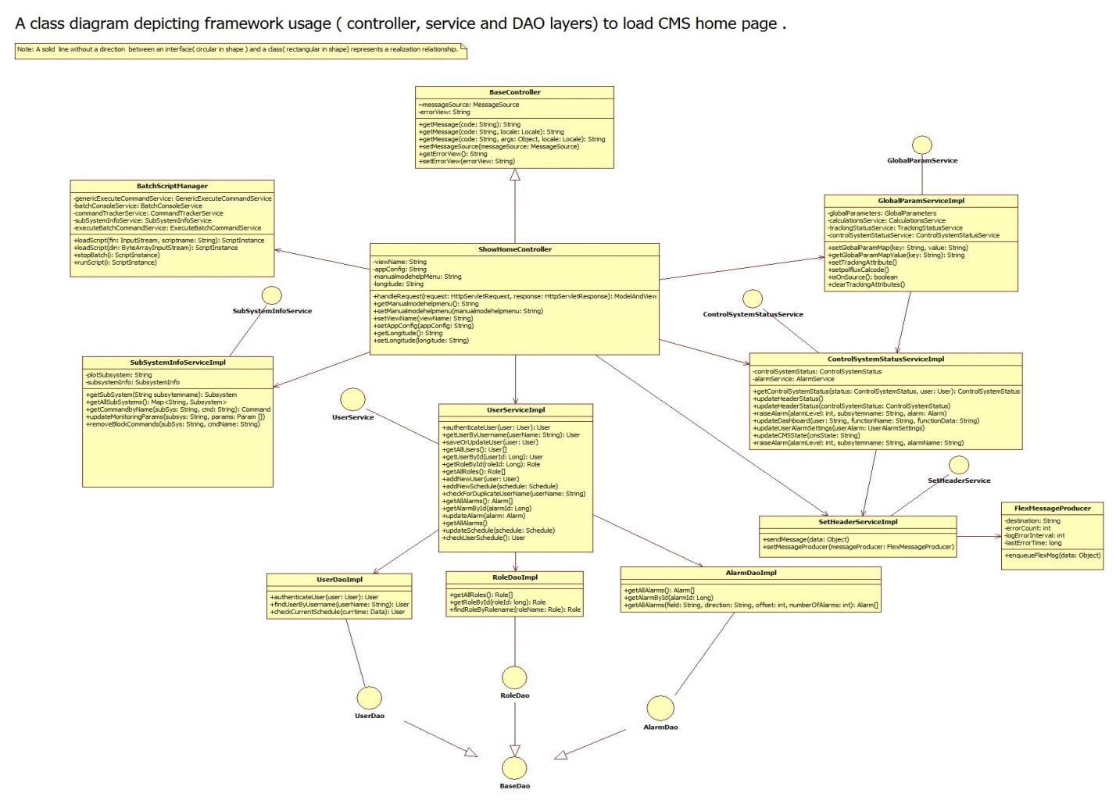

### Command Execution Flow

This diagram shows classes involved in command execution –

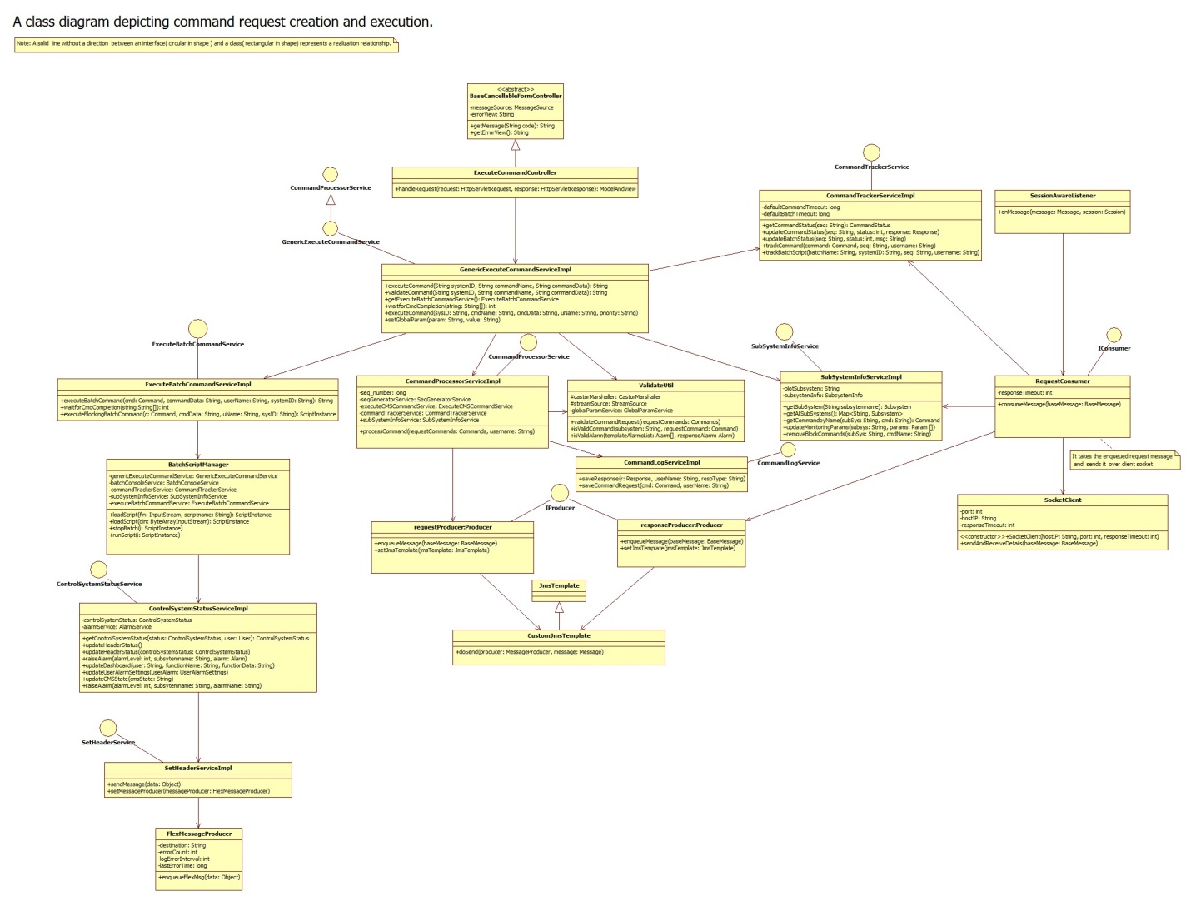

### State Machine and Command Response processing Flow

This diagram shows classes involved in state machine and command response processing –

