Global Parameter Configuration Document
Version 3.3

Table of Contents

1) Overview 3
2) Pre-Requisites 3
3) Addition of parameter in “globalparameter.properties” 4
4) Managing global parameters 4

Overview

Global parameter feature allows user to configure various configuration parameters. Global parameters are set of property name and value pairs. These property name and value pairs can be sent to various subsystems via commands, wherein these parameters act as command arguments.
For example trackobject command of servo subsystem, STRTDAS command from digital backend system uses various global parameters set though Expert tab, tune receiver respectively.

Pre-Requisites

Global parameter variables are configured in “globalparameter.properties” file.
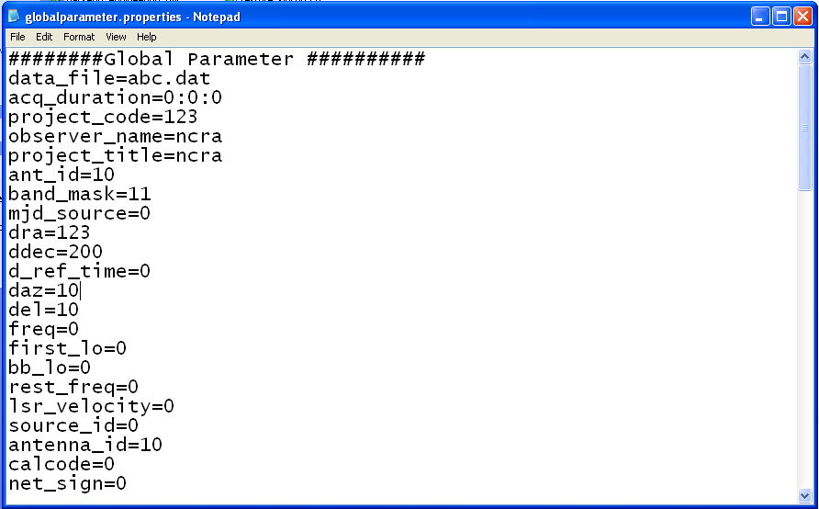

Addition of parameter in “globalparameter.properties”

- To add a new parameter as “globalparameter”, one needs to make an entry of the same in “globalparameter.properties” file.
Example:
User needs to add a new parameter say “newGlobalparam” as “globalparameter” data having data type as integer with the range of 0-1.
Make entry of “newGlobalparam” in “globalparameter.properties” with some default valid value say “0”.
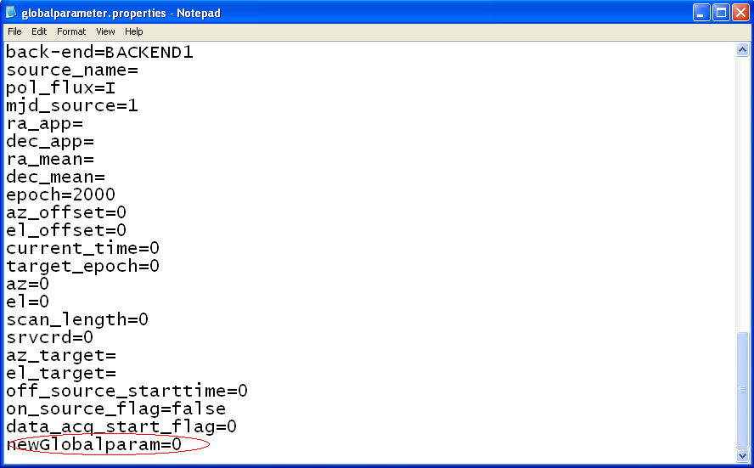

Managing global parameters

- A command named “loadProperty” of cms-commands.xml can be used to update global parameter values.
Configure the property “newGlobalparam” in “loadProperty” command of cms-commands.xml in <dependency_validations> tag as follows.
User also needs to specify validations for the added global property.
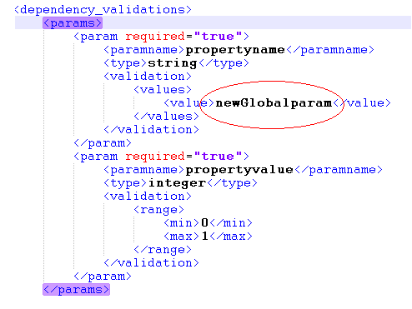

User can now change the value of the added global property through “Expert” tab.
- Specifying the added global property in command as getter or setter argument.
If user needs to send added global property as input to command/s of particular sub-system then user should specify the global parameter as input argument to particular command/s.
<global> tag is used to indicate whether a particular parameter is global or not.<global > tag only accepts “set” and “get” as valid values.
Example:
User needs to send the global parameter “newGlobalparam” as one of the argument to “trackobject” command of servo subsystem. Then user needs to add that parameter as follows in “servo_commands.xml” under two scenarios.
- User can set “<global>” tag value as “set”
It indicates that CMS will update the global parameter value during the execution of the command.
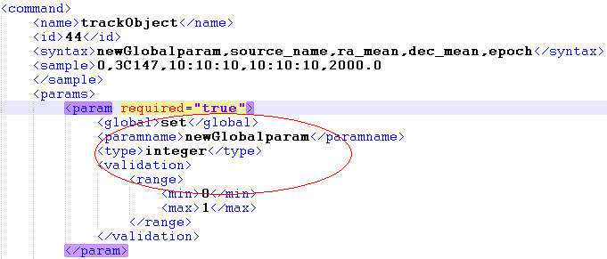

In this example, user will have to specify the “newGlobalparam” parameter value whenever user tries to execute the “trackobject” command as the <global> tag value is “set”. The value specified by user will be stored in”Global parameters" and can be used subsequently by other commands.

- User can set “<global>” tag value as “get”.
It indicates that the CMS will retrieve the pre-existing value from global parameter and set it as command argument.

