INDEX

A) How to Install Manually Filezilla on Local PC
B) How to use Filezilla
C) Managing File/Folder Permissions

NOTE

N-1: Please use FTP client (like Filezilla) which supports SFTP protocol for accessing persistent ftp servers.

N-2: For accessing persistent FTP server from client location, open 22 Port
from your side.

N-3: As mentioned in the FTP template given the right to project people to the root folder (“/”) on FTP server, once user create a new folder on root he becomes the owner of that folder, system will apply most restrictive permissions for groups & others. Explicitly owner of the folder has to manage folder permissions using their FTP Account through FTP client (like Filezilla).

- How to Install Filezilla Manually on Local PC

B.1) Download the “Filezilla” from Internet
Double click on the “Filezilla.exe” and click on OK. (Language by default is English)

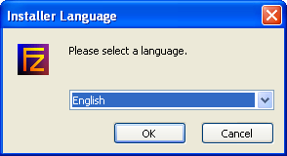

B.2) It will prompt you for License Agreement. Click on next.

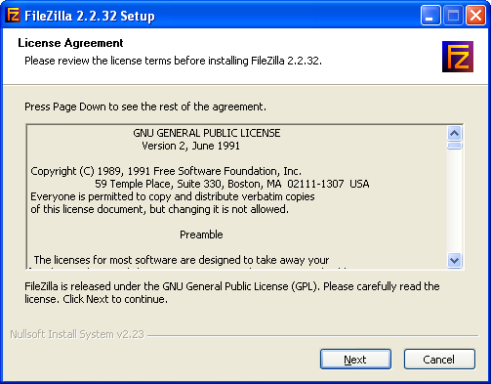

B.3) Next Screen will show Choose Components. It will offer you three installation types as Standard, Full, and Custom. Select one of that as per your requirement.

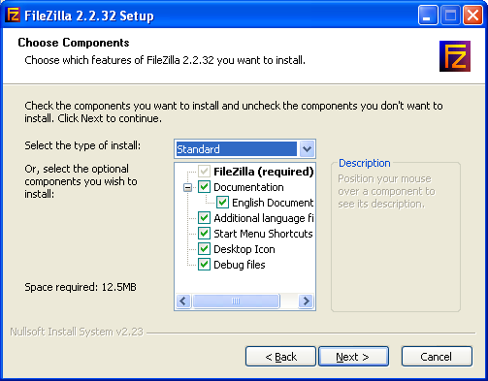

B.4) Next screen will give you to chance to select location to install software
(By default location is “C:\Program Files\FileZilla”). Click on next.

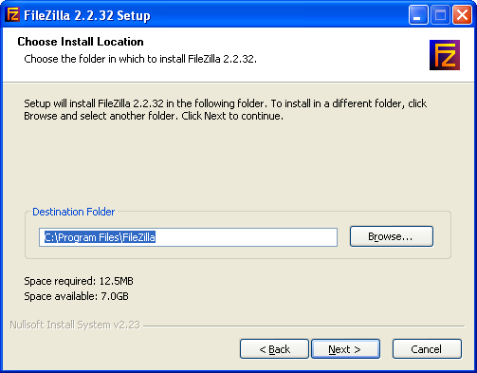

B .5) Next screen will give option to keep shortcut on “Start Menu”, click on next.

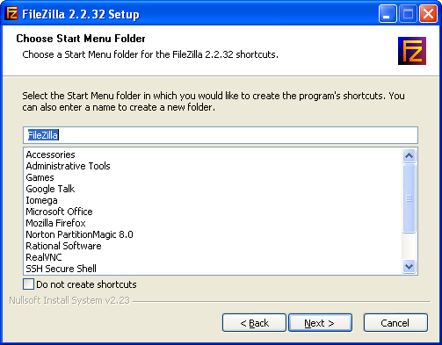

B.6) Next screen will offer you to configure secure mode and settings storage location,
select options according to your requirement and click on install tab.

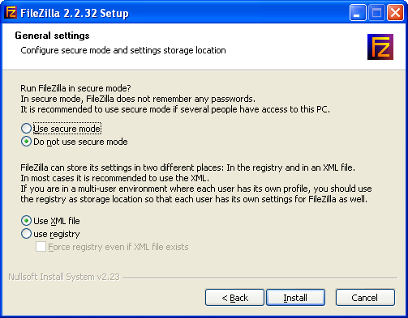

B.7) As soon as you click on install tab it will extract the exe and install the software in the specified folder in previous section “choose install Location”. Finally click on close.

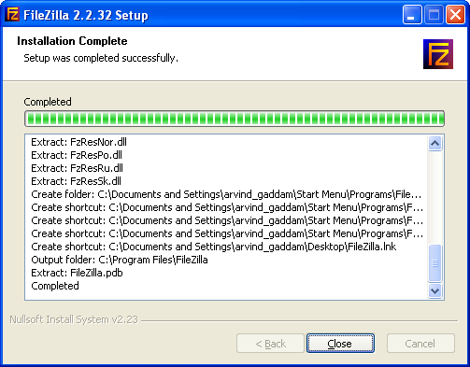

- HOW TO USE FILE- ZILLA

C.1] Open Filezilla

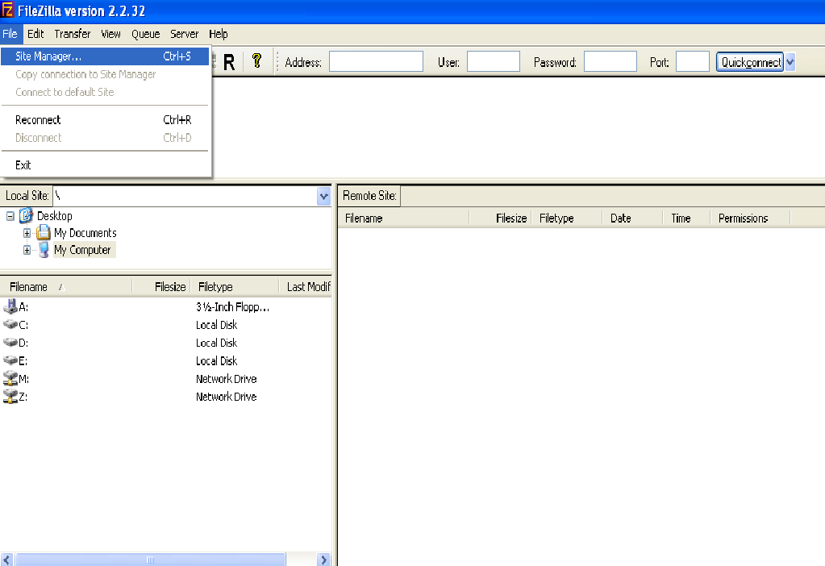

C.2] Create new site and assigned it name.

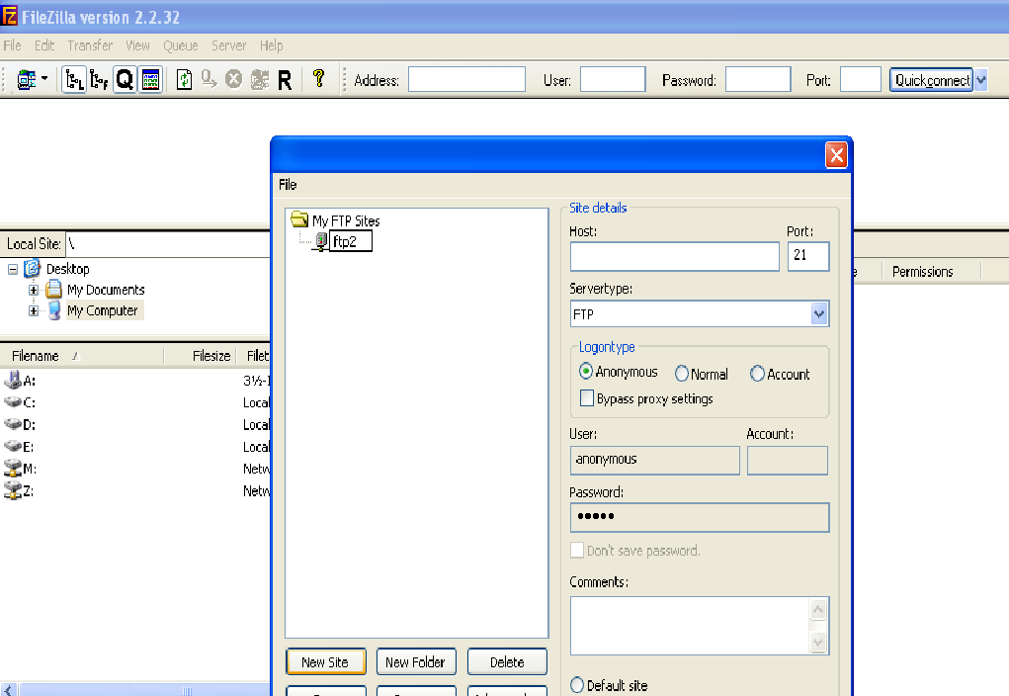

C.3] Fill the site details as follows, do not change Port manually, when you select Server type it will be automatically change the port to 22.
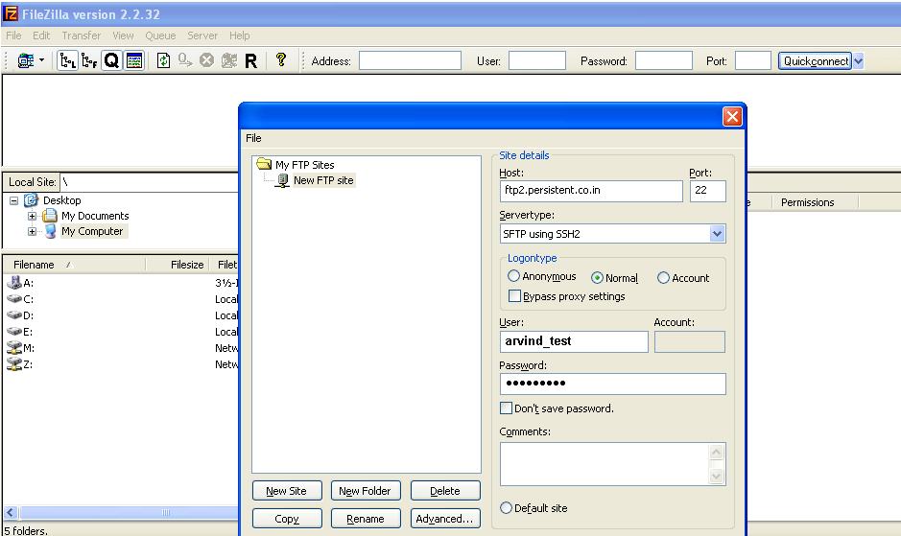

C.4] Press Connect button.

This is the way to connect Persistent ftp server.

Further queries contact corporateserversgroup@persistent.co.in

D) Managing File/Folder Permissions

- Login to the FTP Site with your FTP Account.

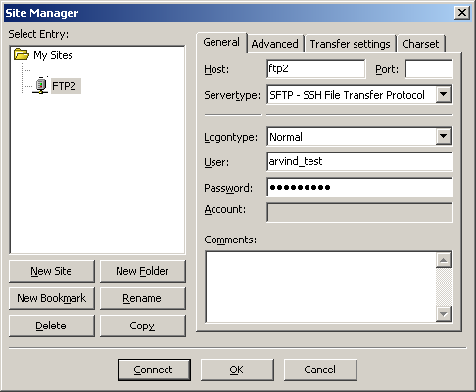

- Right click on the folder which is created by your FTP Account and select File permissions.

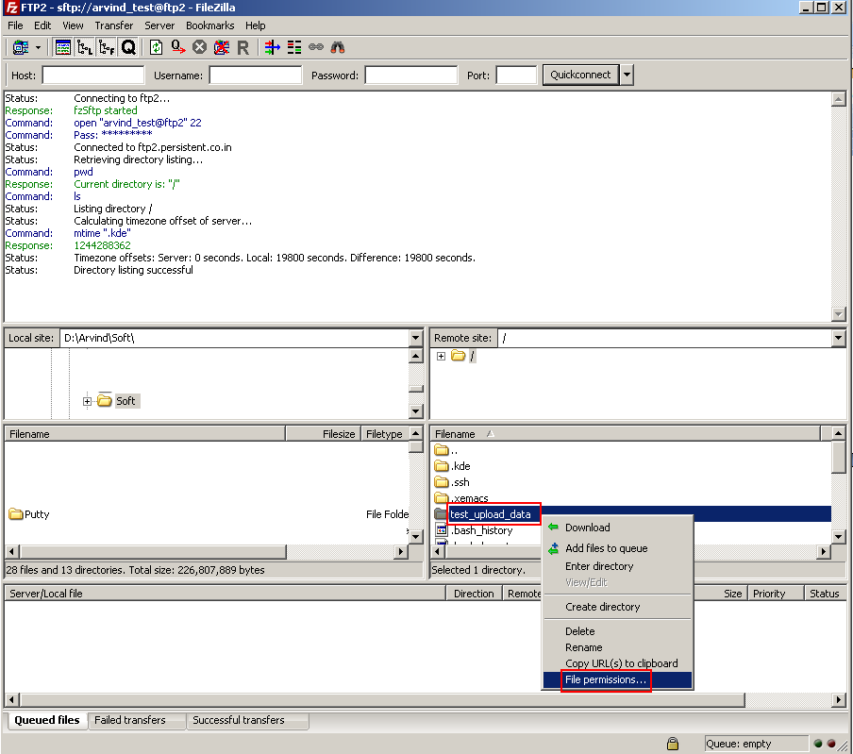

- Give write permissions to the “Public Permissions”

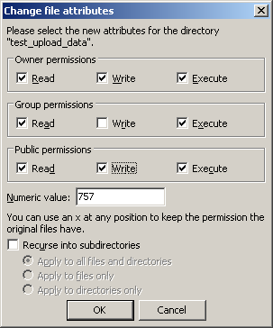

Select OK to save the permissions

Note: File/Folder permissions can be managed by owner/creator of the file/folder only.

================================================================

End OF File
================================================================

