WRAPPER (SERVER) USAGE

Wrapper_ version 4 folder contains Wrapper_server.c , CMS_server.c and CMS_client.c files.
Wrapper_sever.c: This is the wrapper simulator which acts as a server. This severs continuously listens on a port for the CMS commands. For every incoming client, Wrapper_server program opens new thread to give service to it. Once it receives complete CMS commands it gives immediate acknowledgement to the CMS client. Format of the CMS client commands and acknowledgement is shown below. After immediate acknowledgement Wrapper_server puts the command in to FIFO queue for further processing and terminates the thread.
Consumer thread continuously runs at the background. It checks for commands in queue for the processing. If commands are there, then it picks (delete) them from queue,*processes the command and sends final acknowledgement to CMS_server.
CMS_client: This is the sample program which sends commands to the wrapper. It reads config.txt file and sends it to Wrapper server. When CMS_client receivers the immediate acknowledgement it closes the connection with the server.
CMS_server.c: This is the sample program which acts as CMS server. It continuously listens on a port for the final acknowledgement.

FORMATS:
CMS_client commands:

<COMMANDS>
<TIMESTAMP></TIMESTAMP>
<COMMAND>
<SEQ>1</SEQ>
<ID>80</ID>
<NAME>POSITION</NAME>
<SYSTEMID>1</SYSTEMID>
<DATA>
<PARAM>
<NAME>SUBSYSTEMID</NAME>
<VALUE>1</VALUE>
</PARAM>
<PARAM>
<NAME>AX</NAME>
<VALUE>A</VALUE>
</PARAM>
<PARAM>
<NAME>ANG1</NAME>
<VALUE>10</VALUE>
</PARAM>
</DATA>
</COMMAND>
</COMMANDS>
<REQ_END>
Wrapper_server Immediate ACK format:

<responses>
<response>
<SEQ>1</SEQ>
<ID>80</ID>
<NAME>POSITION</NAME>
<SYSTEMID>1</SYSTEMID>
<event>10</event>
<code>10</code>
</response>
</responses>
<RESP_END>

Wrapper_server final ACK format:

<responses>
<response>
<SEQ>1</SEQ>
<ID>80</ID>
<NAME>POSITION</NAME>
<SYSTEMID>1</SYSTEMID>
<event>12</event>
<code>10</code>
</response>
</responses>
<RESP_END>
Note that the following section is command dependent and should reflect in the acknowledgement as it is.

<SEQ>1</SEQ>
<ID>80</ID>
<NAME>POSITION</NAME>
<SYSTEMID>1</SYSTEMID>

Every acknowledgement should end with <RESP_END>.
To run the simulator:
Step 1: run Wrapper_server.c
gcc Wrapper_server.c -lpthread

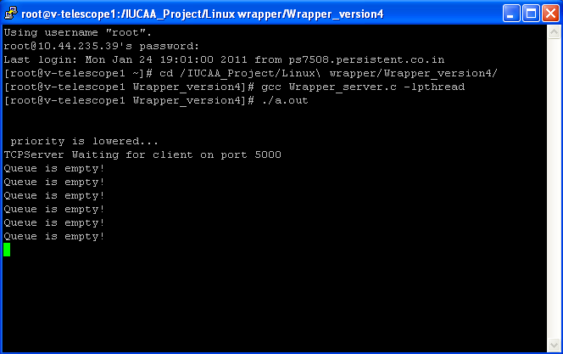
Step 2: run CMS_server.c

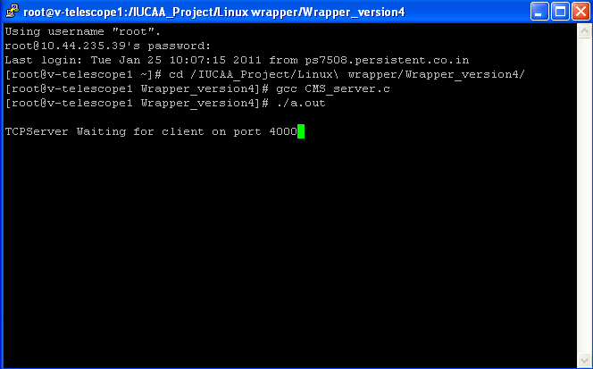

Step3 : run CMS_client.c

*note in CMS_client.c code there a variable int count =1. If you want to send multiple commands simultaneously to the wrapper then just set count= number.

Immediate Acknowledgement (CMS_client.c ) o/p
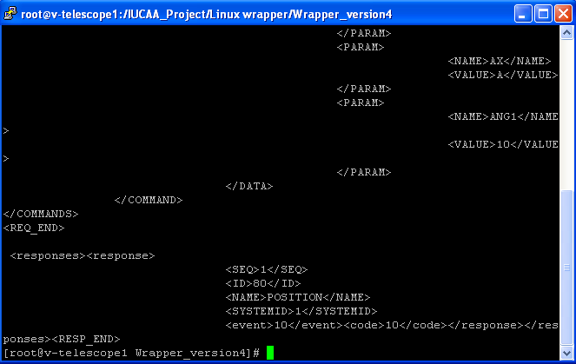

Queue operation (Wrapper_server.c) o/p
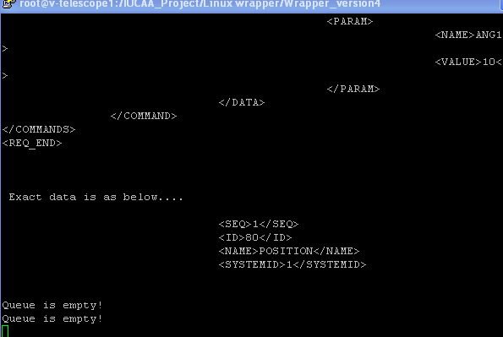

Final Acknowledgement (CMS_server) o/p
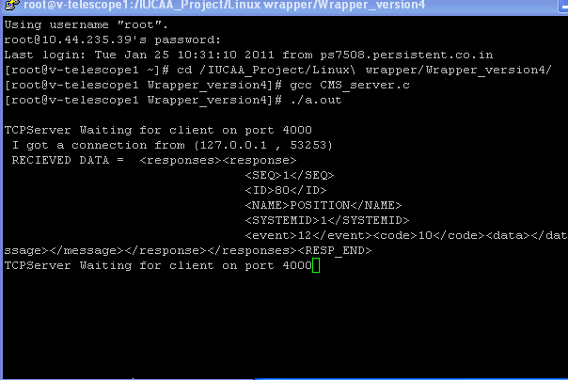

To change port numbers:
In Wrapper_server.c there are two definations
# define REQ_PORT 5000
# define RESP_PORT 4000

Change the port numbers it these ports are not avilable at your end.

