Successfully tested 3 antenna 2 sub-system at C01, C04 & C06 antenna

Date of Testing : 8th October 2014 – 11th October 2014- Online_v2 Team members

During October-2014 MTAC period, we have successfully tested three antenna two sub-systems at C01,C04 and C06 antenna. We have installed CISCO & HP make L2 Ethernet switch and two Rabbit MCM cards at C01,C04 & C06 for control and monitor of Broadband OF system and Sentinel system.

1. Broadband OF system testing:
The first level control and monitoring of Broadband OF system has been tested by interfacing Rabbit MCM with OF system hardware. The command for RF attenuation was send from all three paths,
1.1. Python environment - ONLINE-V2 - Rabbit MCM - OF hardware.
1.2. GUI environment - ONLINE-V2 - Rabbit MCM - OF hardware.
1.3. Terminal environment - ONLINE-V2 - Rabbit MCM - OF hardware.
The attenuation value was set by sending command to Rabbit MCM card in range of 0 to 31 dB, in step size of 1 dB. The RF power was going down by 2dB for entire range of attenuation values. This test was done in telemetry lab as well as C06 antenna shell. The changes in attenuation were reflecting in RF power at antenna base (OF Tx output port) and receiver room OF system (OF Rx Mon port) on spectrum analyzer.
2. Sentinel System Testing:
The control port of Rabbit MCM for sentinel system was tested by connecting 32 bit LED test jig. The digital mask was send to Rabbit MCM by three paths mentioned above. The shell temperature was monitored by connecting temperature sensor to channel 1 of MCM monitoring port. The temperature reading was displayed on ONLINE-V2 shared memory.
The OF system group was involved in setting up OF system and successful completion of testing.

Snapshot :
Python Environment user 2 :
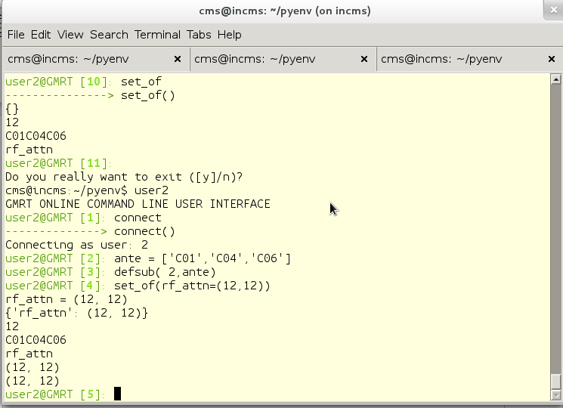

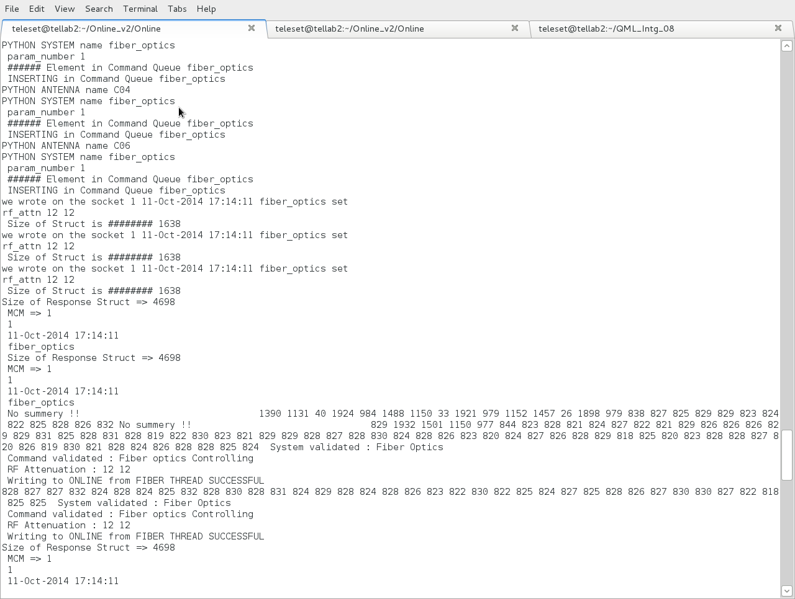
Output of Online_V2 screen :
Python Environment user 3 : Procedure from User3
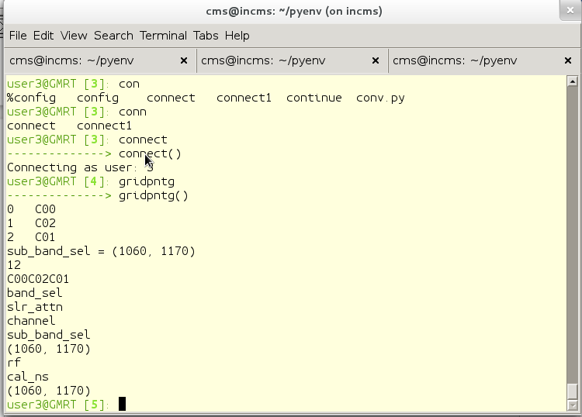
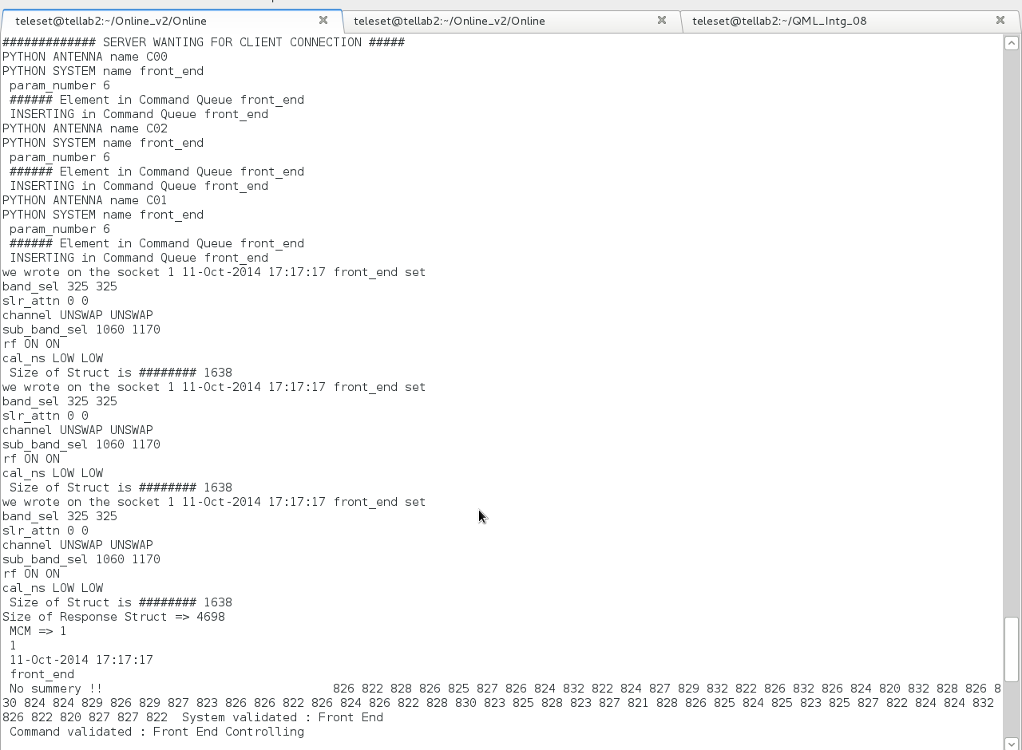
Online_V2 output Screen :

TOP Output :
With around 15 antenna sub-system connected to Online_v2, TOP output shows that Online_V2 program uses only 0.3% of CPU and 0.9% of Memory.
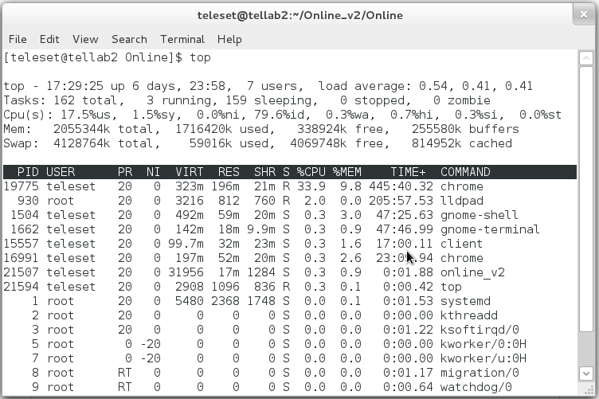
=> We also tested the stability and robustness of Online_v2 and Python environment by giving commands from user2 and user3 at a interval of 0.1 and 0.5 seconds. Both programs were able to executed commands without any problem.

