
National Center for Radio Astrophysics
Tata Institute of Fundamental Research,
Pune University Campus, Pune, INDIA

Technical Report
on
TELESET-ABCCOM Software Chain

Raju Uprade, Charu Kanade, Naresh Sisodiya, Jitendra Kodilkar

GMRT – Khodad

Email : rajsingh, cpk, naresh, jitendra @gmrt.ncra.tifr.res.in

Author : Raju Uprade | Date of issue :  03rd Aug 2012 | Scope : Current status and future development
Verified by : Raju Uparade | Date of issue :  03rd Aug 2012 | Scope : Current status and future development
Approved by : | Status/ Version : 1 | Internal Technical Report No.:
INDEX

- What was there

- What we did

- What needs to be done

- How we should proceed

- Result of testing

- Q and A with comments

What was there

TELESET - ABCCOM was developed by Mr. Lorrent Pommier along with Mr. Pramesh Rao

TELESET
SHARED MEMORY

TELEDISP

MULTI SERIAL PORT
@ 9.6 kbps

ABCCOM

SERVO SYSTEM

MCM DEVICE
DRIVER

RS-422 comm
@ 9.6 kbps

RS-485 comm
@ 9.6 kbps

IF/LO/FPS/FE/SENTINEL

Figure shows what was developed earlier

- TELESET-ABCCOM is developed using C++ and C which is very tightly coupled code.
- All communications were @ 9.6 kbps.
- Whole software was developed on Fedora Core – 3 ( kernel version 2.6.9)

What we did

TELESET
SHARED MEMORY

IF/LO/FPS/FE/SENTINEL
TELEDISP
Ethernet( TCP/IP
@ 100 Mbps

ABCCOM

SERVO SYSTEM

MCM DEVICE
DRIVER

RS-422 comm
@ 9.6 kbps

RS-485 comm
@ 9.6 kbps

Figure shows what modification and development we did

Work done on TELESET – ABCCOM software chain

- Communication link between TELESET-ABCCOM changed from serial to Ethernet (TCP/IP @100Mbps).

- Whole software chain including MCM device driver ported to FC9, FC16 and Ubuntu 11.04.

- Alternate Server design and Bit extraction code written for TELESET.

- Modified Teleset and Abccom for Sentinel System (Temperature Monitoring).

- Testing of all software in Telemetry Lab, Servo Lab, FE Lab ,ABR Lab and at Antenna Base.

- Successfully tested whole software chain at C00,C04 And C12 during maintenance period.

- Had problem with LO Monitoring, modified the software,now can fully control and monitor all Antenna sub-systems.

- Software fine Tuning And Optimization:

DOMON time prior modification:

LO Domon ( Not working)
IF Domon | 30 sec
FE Domon | 20 sec
FPS Domon | 10 sec

DOMON time after modification:

LO Domon (Working) | 15 sec
IF Domon | 20 sec
FE Domon | 10 sec
FPS Domon | 5 sec
SEN Domon | 5 sec

- Successfully tested Teleset and Abccom at C12 Antenna after software fine tuning & optimization.

- Mr. Madhav Mishal build combined RS- 485 & RS-422 converter card which is driven by taping power from USB port, successfully tested the circuit in C00, C04 and C12 antennas.

- We have tested the USB to Serial port interface card in C00, C04 and C12 by sending commands to servo system and getting the required acknowledgment.

- Teleset and Abccom software tested successfully in Lab with rabbit program on serial communication.
What need to be done

Control & Monitor
GUI
CEB
Control & Monitoring
System
Correlator

Pulsar
Database
Server

Ethernet Link
@ 100/1000 Mbps
Data Acquisition

Analog Back End

Ethernet / OF Network
@ 100/1000 Mbps

Antenna - 30

Antenna - 1
Local
C & M
System
Antenna Switch
VOIP
Phone

Video
Camera

MCM 1
Sentinel
MCM 2
IF System
MCM 3
OF System
Servo / FPS

Figure shows final full fledge TELESET-ABCCOM software chain

There are certain things which we need to do for final system like :

- Ethernet communication between ABCCOM and MCM/SERVO.
- Final design and development of GUI ( Control and Monitor ).
- Interaction with other system like Data acquisition, Correlator, Pulsar, Base band and MCM analog receiver system.
- Development of Multi-user and Multi-Subarray features in Teleset.
- Some error is there in MJD calculation of ABCCOM program which needs to be sorted out.
- Designing Astronomical display.
- Through testing with performance tuning and software optimization.

How we should proceed
- All requirement has to be gathered from all users like astronomers, engineers operators etc.
- All requirement specifications has to be properly documented.
- After finalizing system requirement document, overall system architecture has to be drawn.
- Proper distribution of functionality between different architectural blocks.
- Communication protocol between different architectural blocks.
- Through testing with performance tuning and software optimization.

Results of Testing at C00 Antenna
Teledisp showing the IF system monitoring data
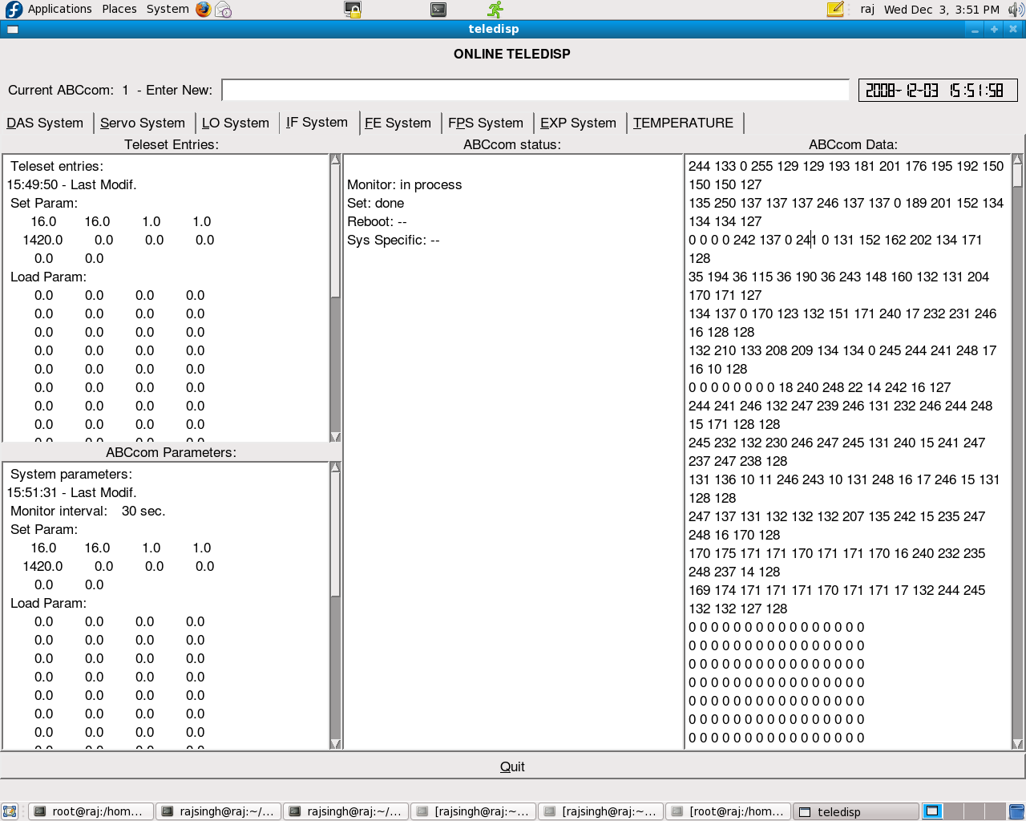

Teledisp showing the Servo system monitoring parameters
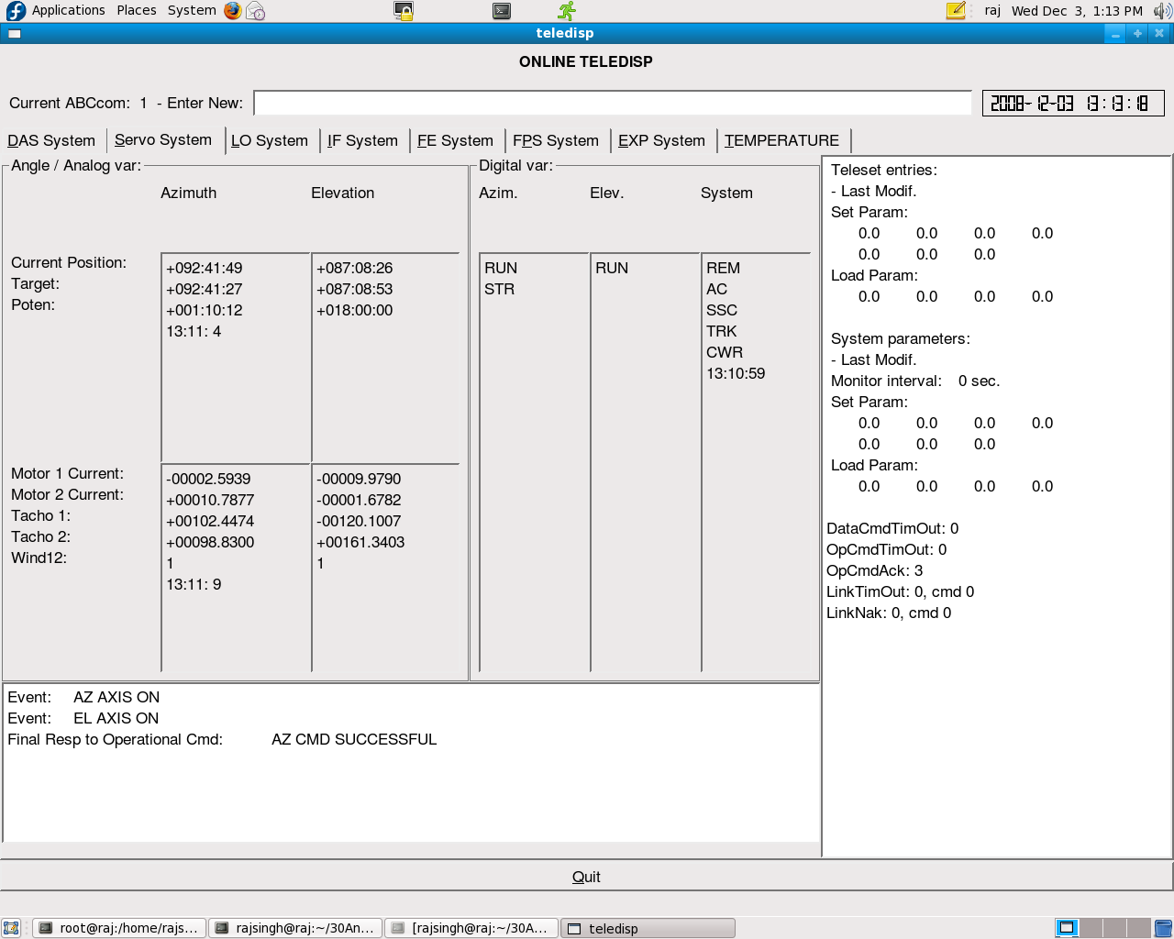

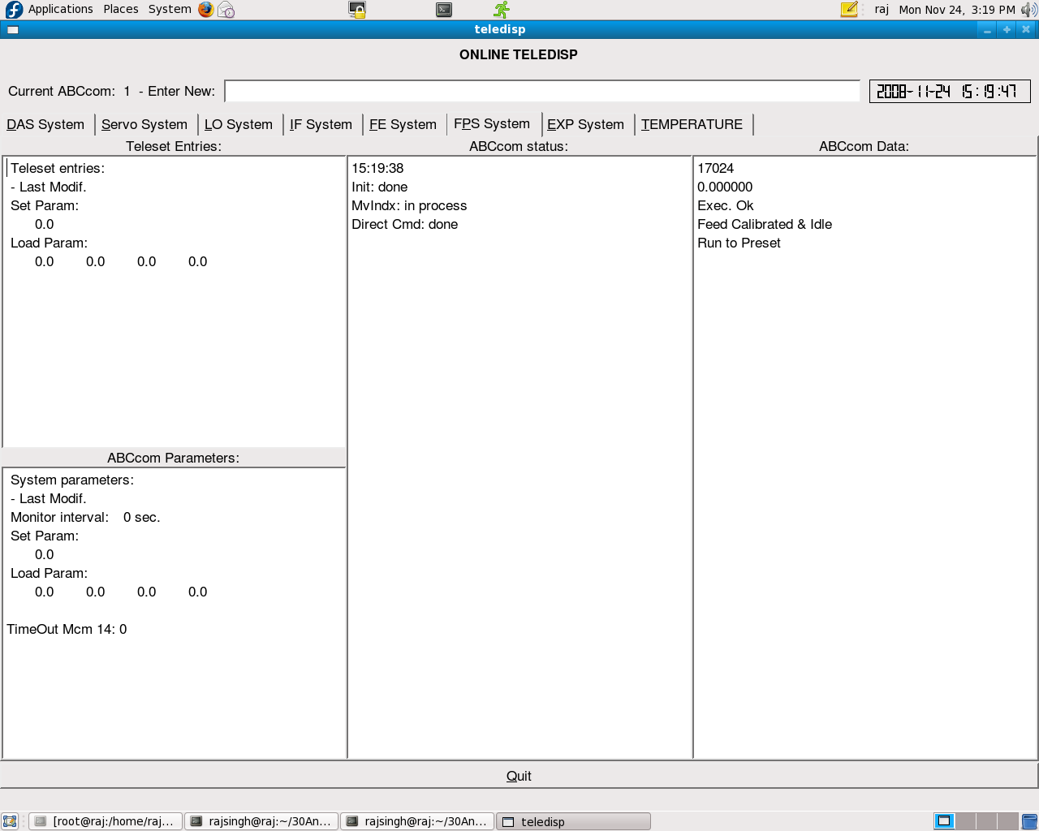
Teledisp showing the FPS monitoring parameters

Teledisp showing the FE system monitoring parameters
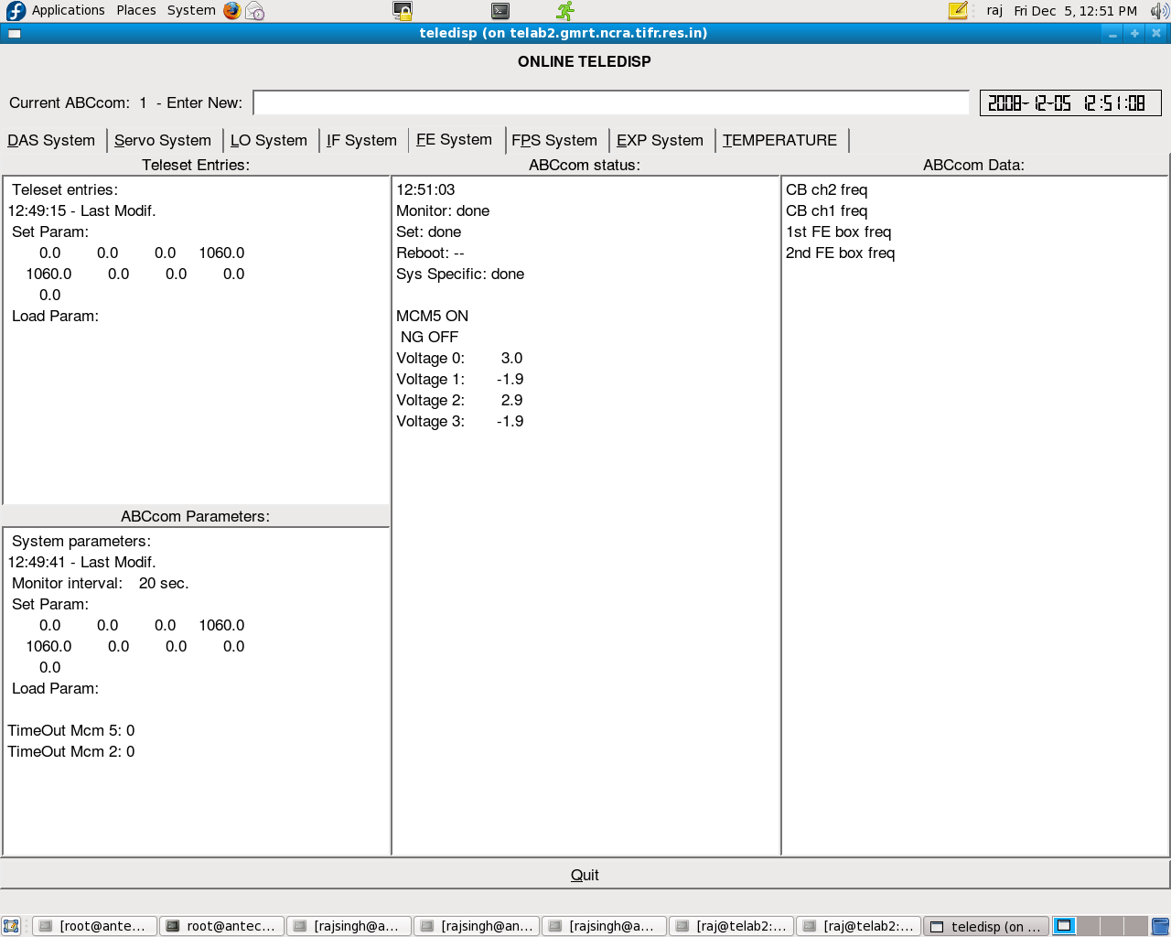

Teledisp display in Expert command mode
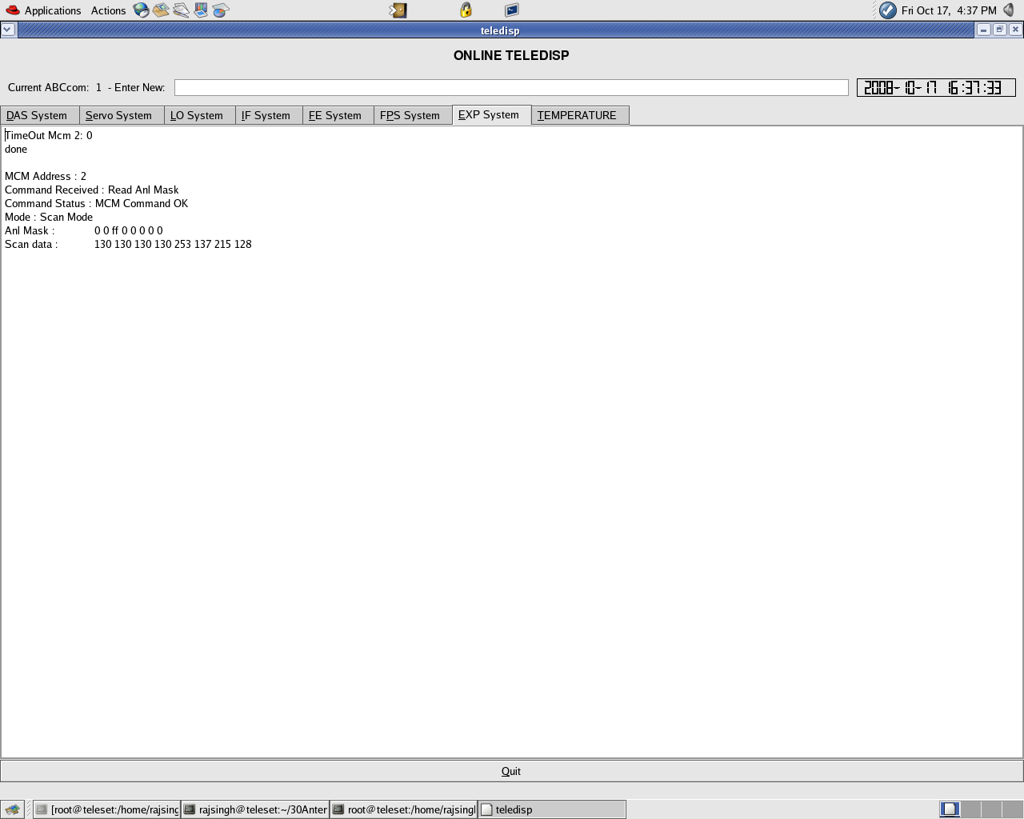

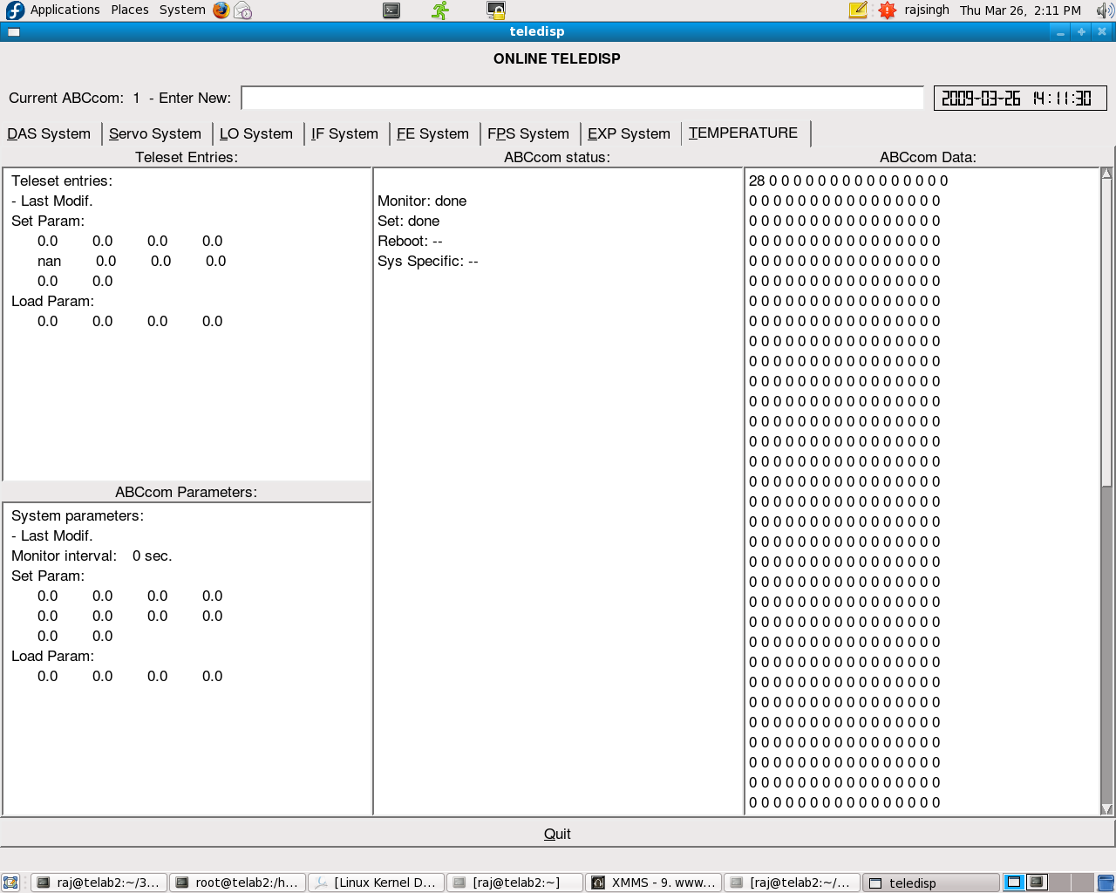
Teledisp showing Temperature

Q and A with comments
1. Why TELESET-ABCCOM was ported to FC9, FC16 and Ubuntu ?
TELESET-ABCCOM was originally developed using FC3 as operating system on Cerebra machines. During the 2008 maintenance period both Cerebra machines got crashed. So we purchased new HP core 2 duo machines. We tried installing FC3 on new machines. But because of major hardware changes, we were unable to do so. Hence we installed FC9 which was latest at that time. We struggled with porting mcmcdriver on FC9, but finally we succeed in porting all software to FC9 operating system. To find and resolve any porting issues with recent kernel changes we keep porting all software to new operating systems like FC16, Ubuntu 11.04 etc.

2. Why it was ported to Ethernet ?
In version 1 of TELESET-ABCCOM software chain, multi serial port card was used to communicate between TELESET and ABCCOM. This multi serial card set up was good for lab set up with 9.6 kbps. But it was not possible to communicate with any Antenna from CEB building.
So when we took over this project, it was decide to go for Ethernet communication between TELESET-ABCCOM.

Advantages

- 100 Mbps speed over 9.6 kbps.
- Direct control of any Antenna with Ethernet connection from CEB building.
- No need of PC router and COMH machines.
- Improved functionality and flexibility.

Comments :

- Basic TELESET-ABCCOM set up has been thoroughly tested. Once it is integrated with other systems like base band, correlator, New analog system, pulsar system. It can become a complete online system.
- If we put a continuous hard work of some 2-3 years on TELESET-ABCCOM, it can become a very good quality In House developed Online software.
- This complete software chain will follows Ethernet communication which will give us a better and very fast communication medium between CEB, Antenna and antenna sub-systems.

